**User Manual**

**Group 4**

* **Instructions of how to use the game:**

1. Press Y to start the game or N to leave the game

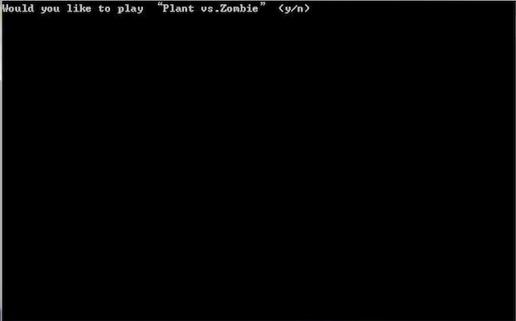

1. Please insert your name, it should contain at least one alphabetic character



1. Choose the role press h for plant, or z for zombies

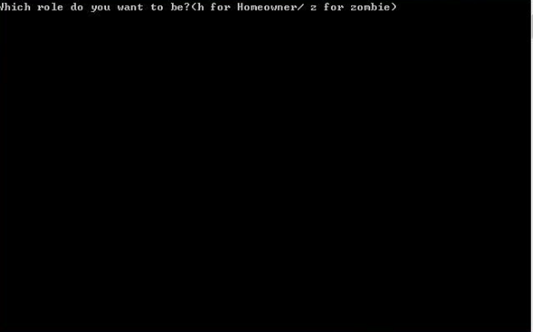

1. **Zombie role**
   1. Press yes or no if you want to create zombie

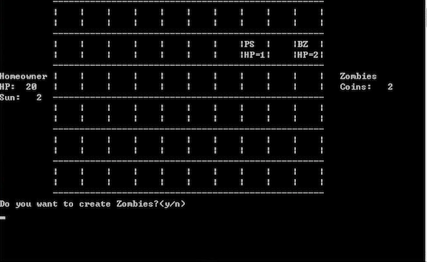

* 1. To buy zombie make sure you have enough coins, type the number of the zombie you would like to buy

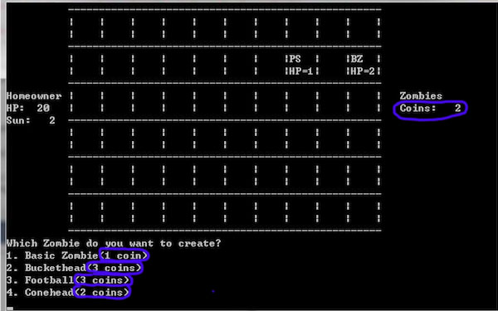

* 1. Choose where to insert zombie only horizontal points 0 – 5 (X) make sure the grid is not occupied

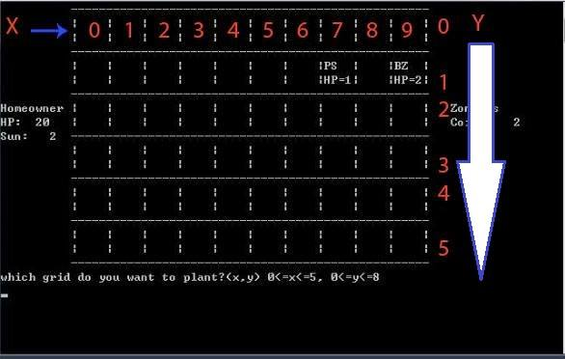

* 1. The game would ask you if you want to buy more zombies press Y or N. If Y repeat **step 4.2 – 4.3 Make sure you have enough coins**

1. **Homeowner role** 
   1. Press y for yes or n for no create plant

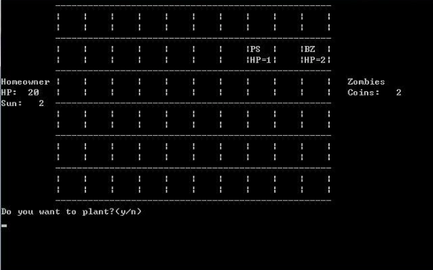

* 1. To buy plant make sure you have enough sun, type the number of the plant you would like to buy

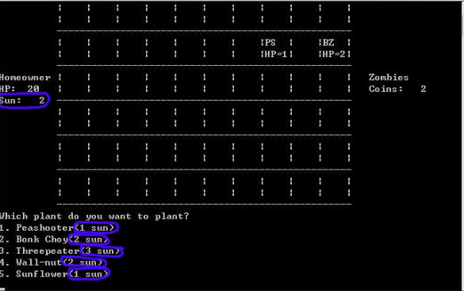

* 1. Choose where to insert plant choose horizontal (X) 0 – 5 and vertical (Y) 0-9 make sure the grid is not occupied



* 1. The game would ask you if you want to buy more zombies press Y or N. If Y repeat **step 5.2 – 5.3 Make sure you have enough coins**

1. **If you press N** the computer would make move press any key 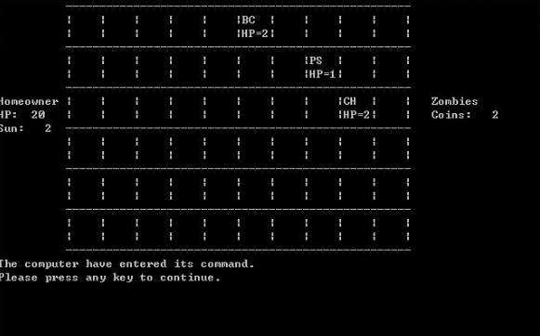
2. Plants would attack press any key every time that the game ask you

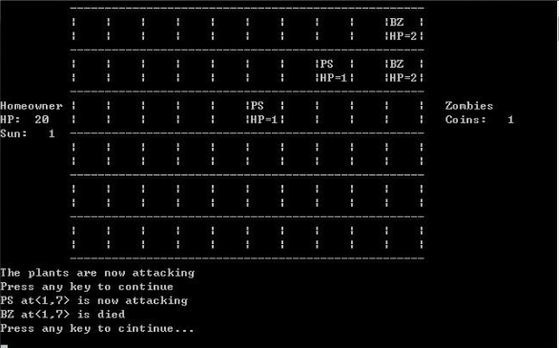

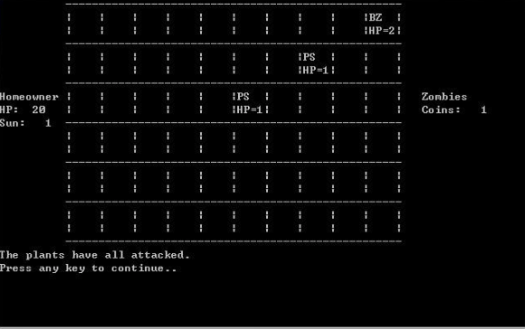

1. Zombies would move press any key every time that the game ask you

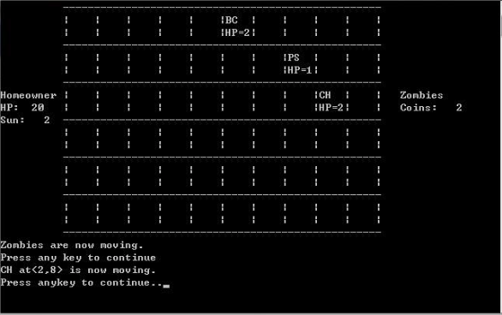

1. Zombies would attack press any key every time that the game ask you

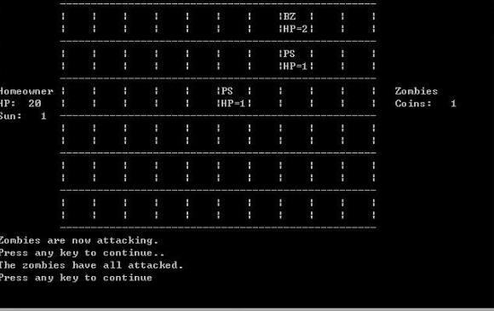

1. If Zombie reaches the homeowner house it would deduct the HP from homeowner

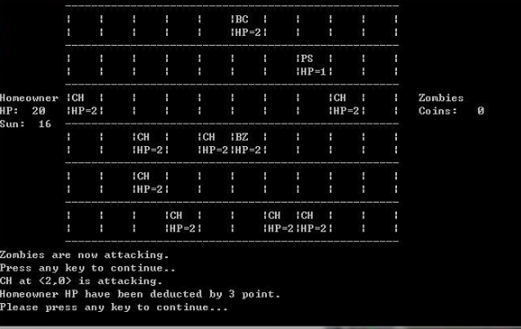

1. **Game over**

* **Useful Information**

***Plants information***

|  |  |  |  |  |  |  |
| --- | --- | --- | --- | --- | --- | --- |
| **Plant** | **Damage**  **All are constant integers** | **HP**  **All are constant**  **integers** | **Attack Range**  **All are constants integer** | **Cost (Number of “sun”)**  **All are constants integer** | **Remark** | **Abbreviation** |
| Peashooter | Normal = **2** | Low = **1** | Long = **2** | Low = **1** |  | PS |
| Bonk Choy | Heavy = **3** | Normal =**2** | Short = **1** | Normal = **2** |  | BC |
| Threepeater | Heavy = **3** | Low = **1** | Long = **2** | High = **3** |  | TP |
| Wall-nut | None = **0** | High = **3** | None = **0** | Normal = **2** |  | WN |
| Sunflower | None = **0** | Low = **1** | None = **0** | Low = **1** |  | SF |

***Zombies information***

|  |  |  |  |  |  |  |
| --- | --- | --- | --- | --- | --- | --- |
| **Zombie** | **Damage**  **All are constant integers** | **HP**  **All are constant**  **integers** | **Attack Range** | **Cost (Number of “coins”)**  **All are constants integer** | **Speed** | **Abbreviation** |
| Basic Zombie | Normal = **2** | Normal = **2** | Short | Low = **1** | Normal = **2** | BZ |
| Buckethead | Normal = **2** | High =**3** | Short | High **= 3** | Normal = **2** | BH |
| Football | Weak = **1** | High = **3** | Short | High **= 3** | Fast = **3** | FB |
| Conehead | Heavy= **3** | Normal = **2** | Short | Normal = **2** | Slow = **1** | CH |