電通二乙微處理器實驗 實驗結報

實驗名稱 | Lab10-BLE
組別 | 08 | 組員 | 05050812-黃馨毅

- 實驗目的
- 開啟藍芽，搜尋看可不可以搜到769。
- 開啟藍芽，更改URL的網址。
- 開啟藍芽，控制7697燈的開關。
- 實驗步驟
a.下載範例程式 BeaconAdvertiset，修改 configAsIBeacon 中的 Major/Minor，為自 己學號後四碼。
b. 執行範例程式 EddystonURLadvertisement ，將 URL 修改為自己的網址，由手機 App 搜尋 7697 Beacon。
c.下載範例程式 SimplePeripheral，將 UUID 前八碼 ”19B10010” 改成自己的學號”，將所有 “BLE LED” 字串改成自己的名字;接著使用BLE Scanner掃描到自己7697，輸入01跟00，7697就會亮以及滅掉。
- 程式碼
a.
#include <LBLE.h>
#include <LBLEPeriphral.h>

void setup() {
//Initialize serial and wait for port to open:
Serial.begin(9600);

// Initialize BLE subsystem
Serial.println("BLE begin");
LBLE.begin();
while (!LBLE.ready()) {
delay(100);
}
Serial.println("BLE ready");

// configure our advertisement data as iBeacon.
LBLEAdvertisementData beaconData;

// This is a common AirLocate example UUID.
LBLEUuid uuid("E2C56DB5-DFFB-48D2-B060-D0F5A71096E0");
beaconData.configAsIBeacon(uuid,812,812, -40);

Serial.print("Start advertising iBeacon with uuid=");
Serial.println(uuid);

// start advertising it
LBLEPeripheral.advertise(beaconData);
}

void loop() {
// The underlying framework will advertise periodically.
// we simply wait here.
//
// You can use iBeacon apps such as
// "Locate Beacon" by Radius Networks on iOS devices
// to locate this beacon.
delay(3000);
}
b.
#include <LBLE.h>
#include <LBLEPeriphral.h>

void setup() {
//Initialize serial and wait for port to open:
Serial.begin(115200);

// Initialize BLE subsystem
Serial.println("BLE begin");
LBLE.begin();
while (!LBLE.ready()) {
delay(100);
}
Serial.println("BLE ready");

// configure our advertisement data as iBeacon.
LBLEAdvertisementData beaconData;

// make an Eddystone-URL beacon that board casts
// https://labs.mediatek.com
// Note 1: You can obmit the suffix and tail part, e.g.
// https://goo.gl/Aq18zF
// can be constructed with
// configAsEddystoneURL(EDDY_HTTPS, "goo.gl/Aq18zF");
// Note 2: Note that total url length must not exceed 17 bytes.
//
// Please refer to https://github.com/google/eddystone/tree/master/eddystone-url#url-scheme-prefix
// to know how the prefix/suffix/tails are expanded.
beaconData.configAsEddystoneURL(EDDY_HTTPS, "05050812", EDDY_DOT_COM);

Serial.print("Start advertising Eddystone-URL");

// start advertising it
LBLEPeripheral.advertiseAsBeacon(beaconData);
}

void loop() {
// The underlying framework will advertise periodically.
// we simply wait here.
//
// You should be able to search this beacon with tools such as "Beacon Tools" on iOS or
// "Physical Web" app on Android.
delay(3000);
}
c.
Serial.print("Device Address = [");
Serial.print(LBLE.getDeviceAddress());
Serial.println("]");

// configure our advertisement data.
// In this case, we simply create an advertisement that represents an
// connectable device with a device name
LBLEAdvertisementData advertisement;
advertisement.configAsConnectableDevice("Hello Ken");

// Configure our device's Generic Access Profile's device name
// Ususally this is the same as the name in the advertisement data.
LBLEPeripheral.setName("Hello Ken");

// Add characteristics into ledService
ledService.addAttribute(switchCharacteristic);

// Add service to GATT server (peripheral)
LBLEPeripheral.addService(ledService);

// start the GATT server - it is now
// available to connect
LBLEPeripheral.begin();

// start advertisment
LBLEPeripheral.advertise(advertisement);
}

void loop() {
delay(1000);

Serial.print("conected=");
Serial.println(LBLEPeripheral.connected());

if (digitalRead(6))
{
Serial.println("disconnect all!");
LBLEPeripheral.disconnectAll();
}

if (switchCharacteristic.isWritten()) {
const char value = switchCharacteristic.getValue();
switch (value) {
case 1:
digitalWrite(LED_BUILTIN, HIGH);
break;
case 0:
digitalWrite(LED_BUILTIN, LOW);
break;
default:
Serial.println("Unknown value written");
break;
}
}

}

- 實驗結果及分析
a.藍芽搜尋到812
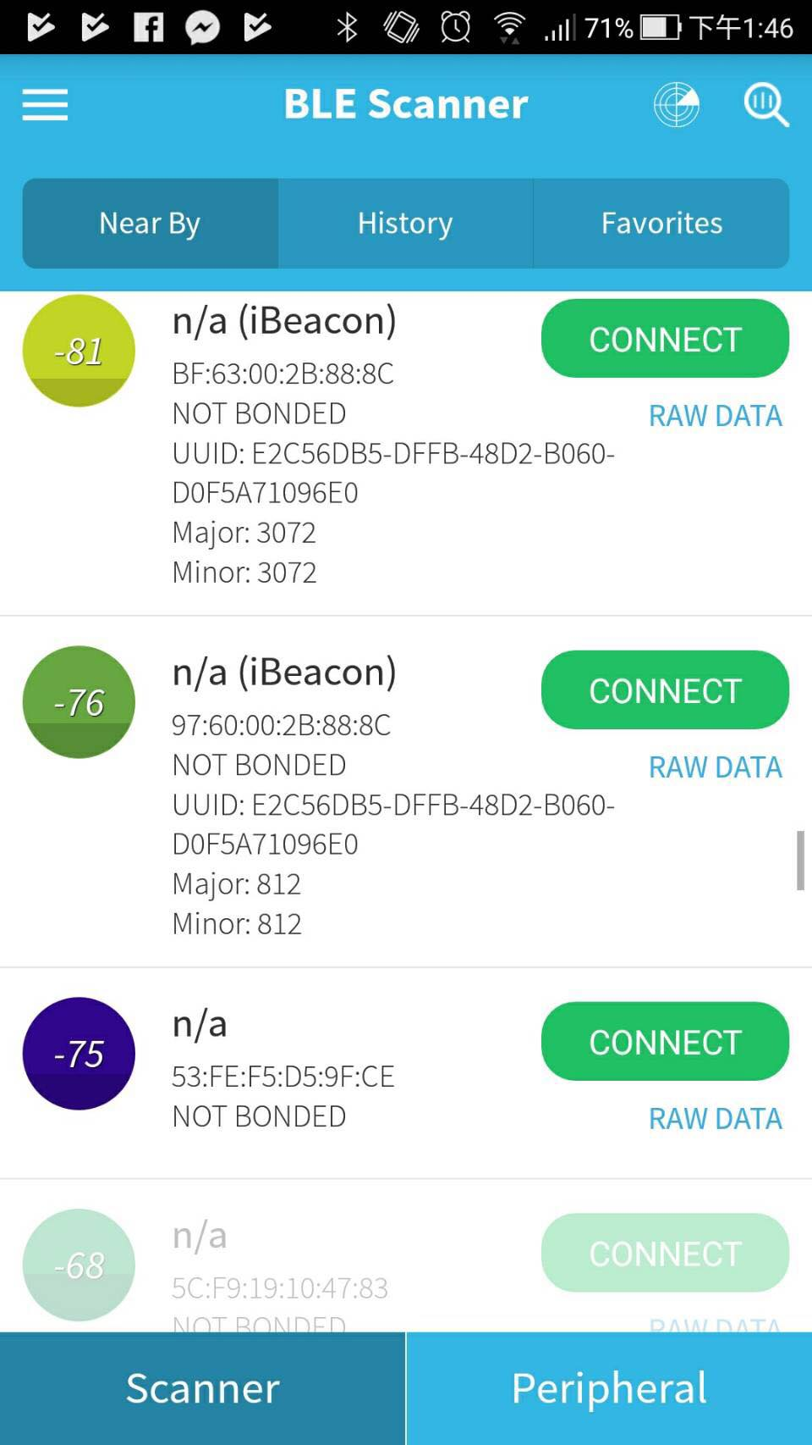

b.URL網址改為自己的學號。
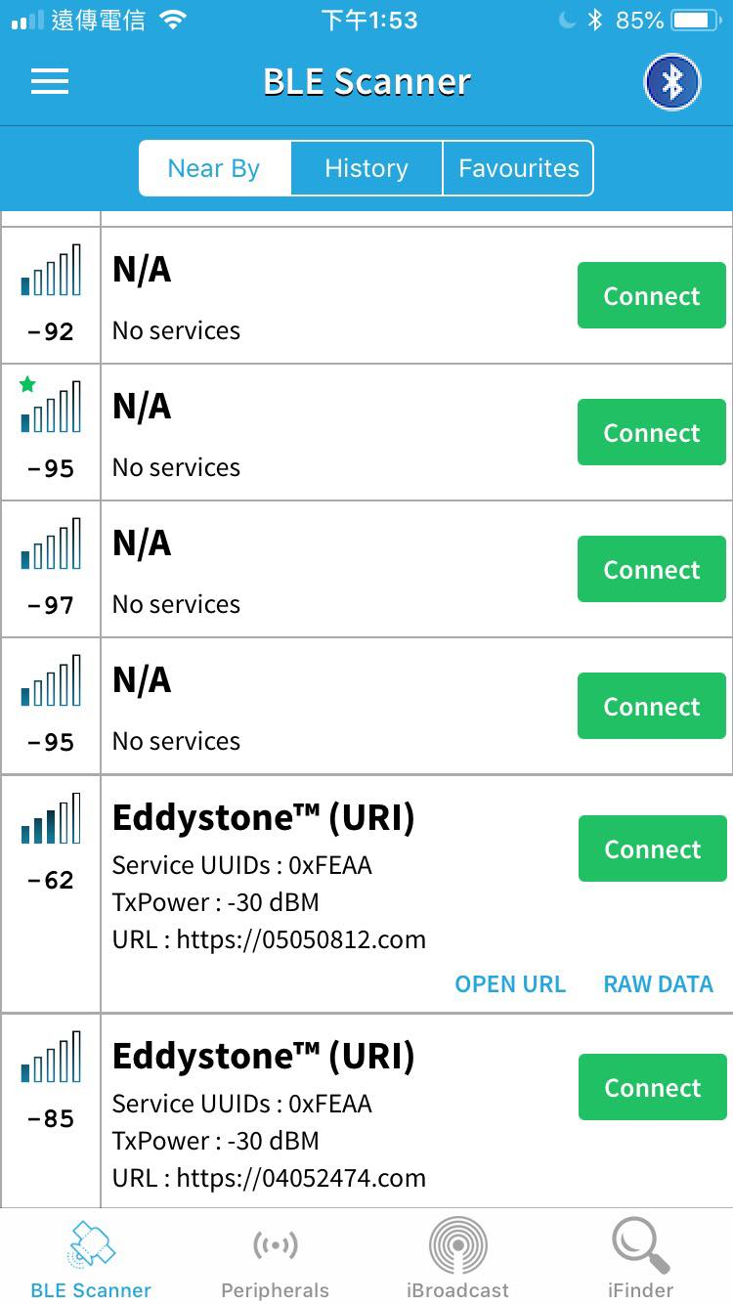

c.連到7697後，輸入00跟01可以控制燈的開關。
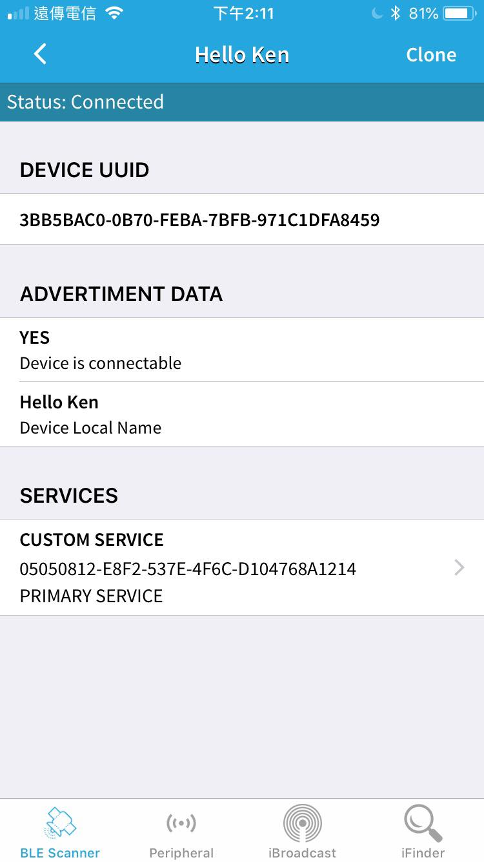
- 心得討論
這次的實驗很快就完成了，讓我大概了解BLE的用法，而且原來藍芽是這樣子用出來的，以後物聯網技術會越來越茁壯，想必藍芽技術也很重要。
- 修正電路圖
- 修正程式碼

