**Update About us:**

1. **You can access the list on by going on this page:**

<http://143.198.214.24:2337/admin/plugins/content-manager/collectionType/application::static.static>

You should be showing this page:

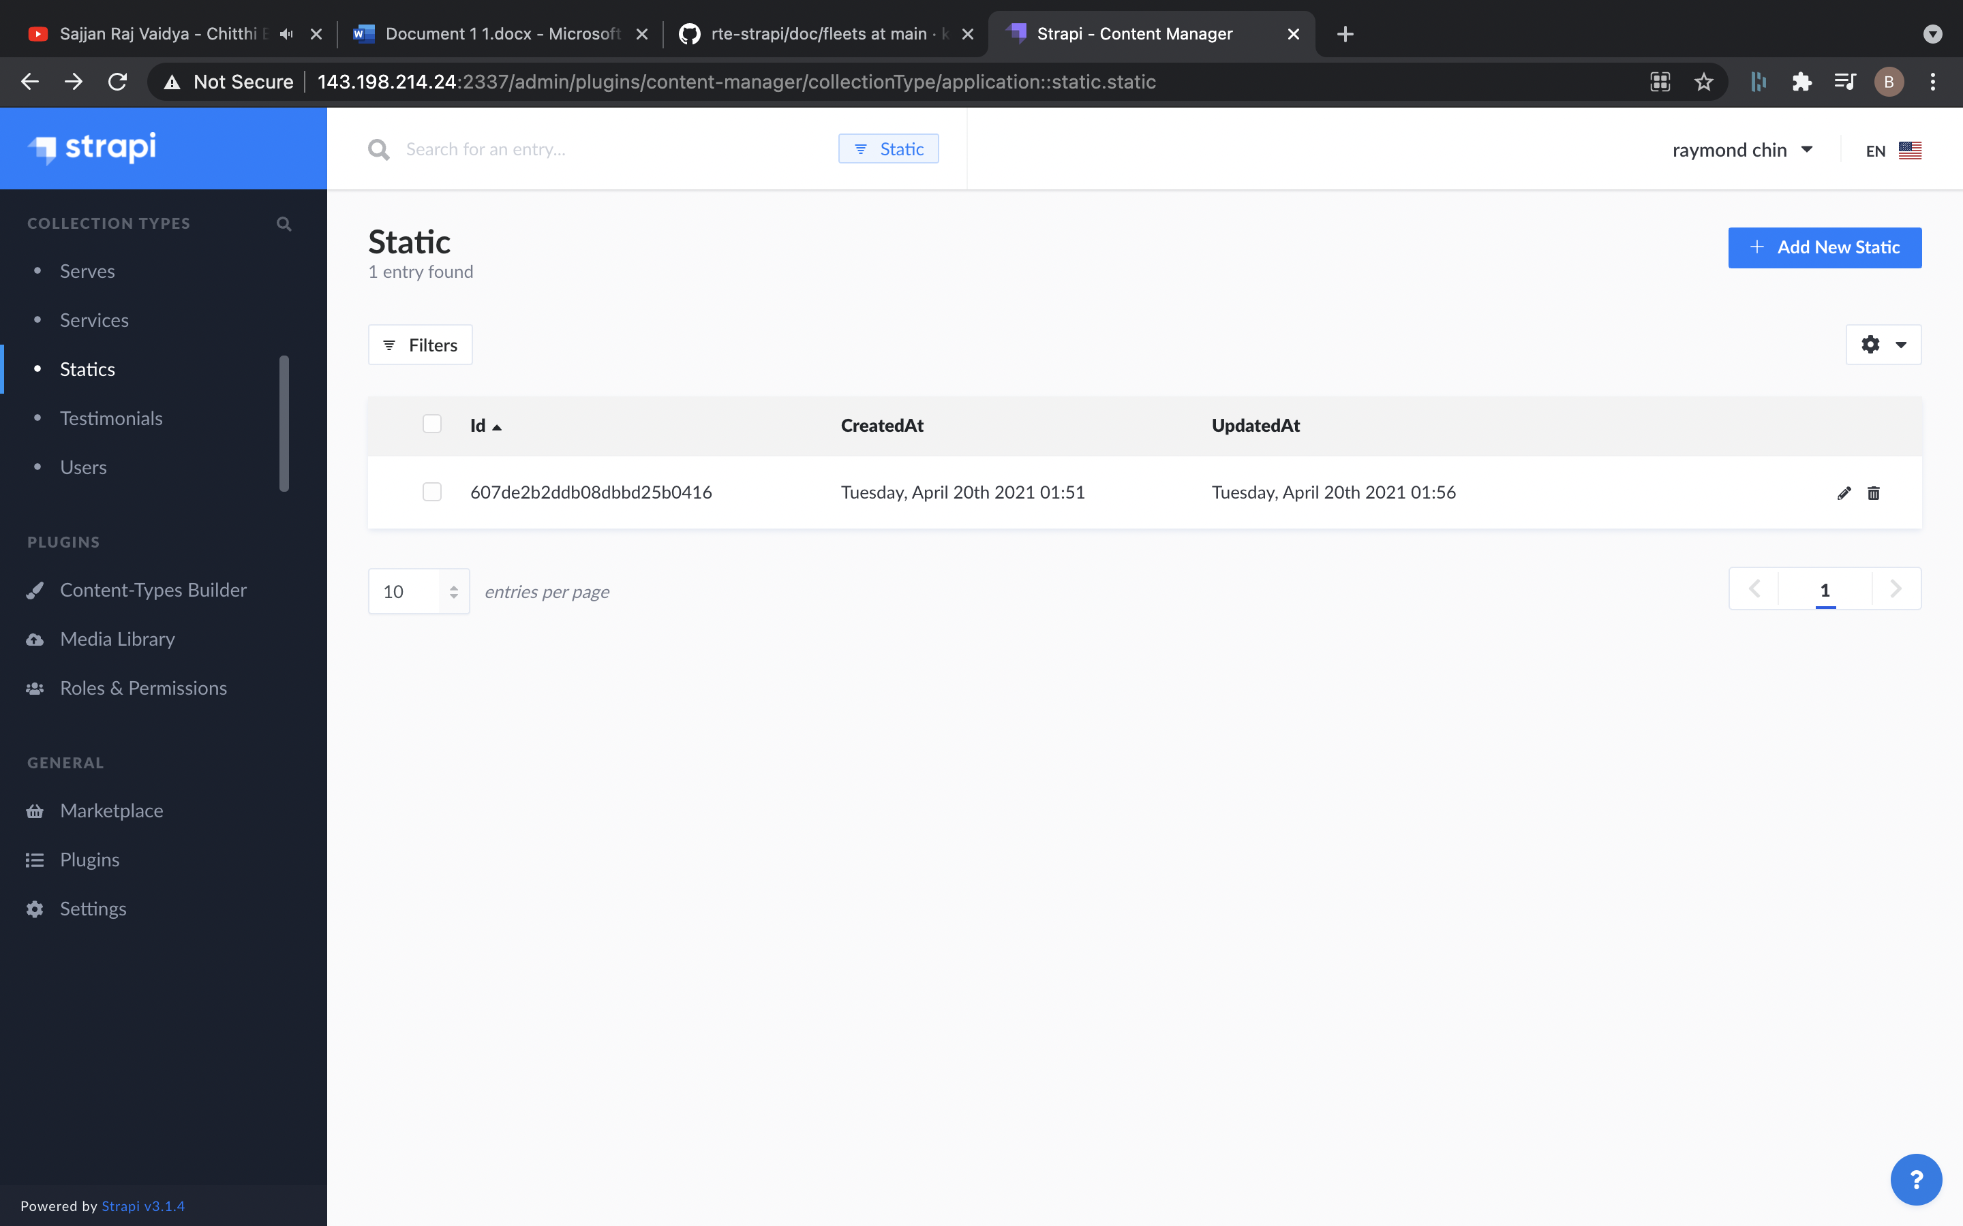

1. **Click on the first and only static item:**
2. **You will go to detail page as:**

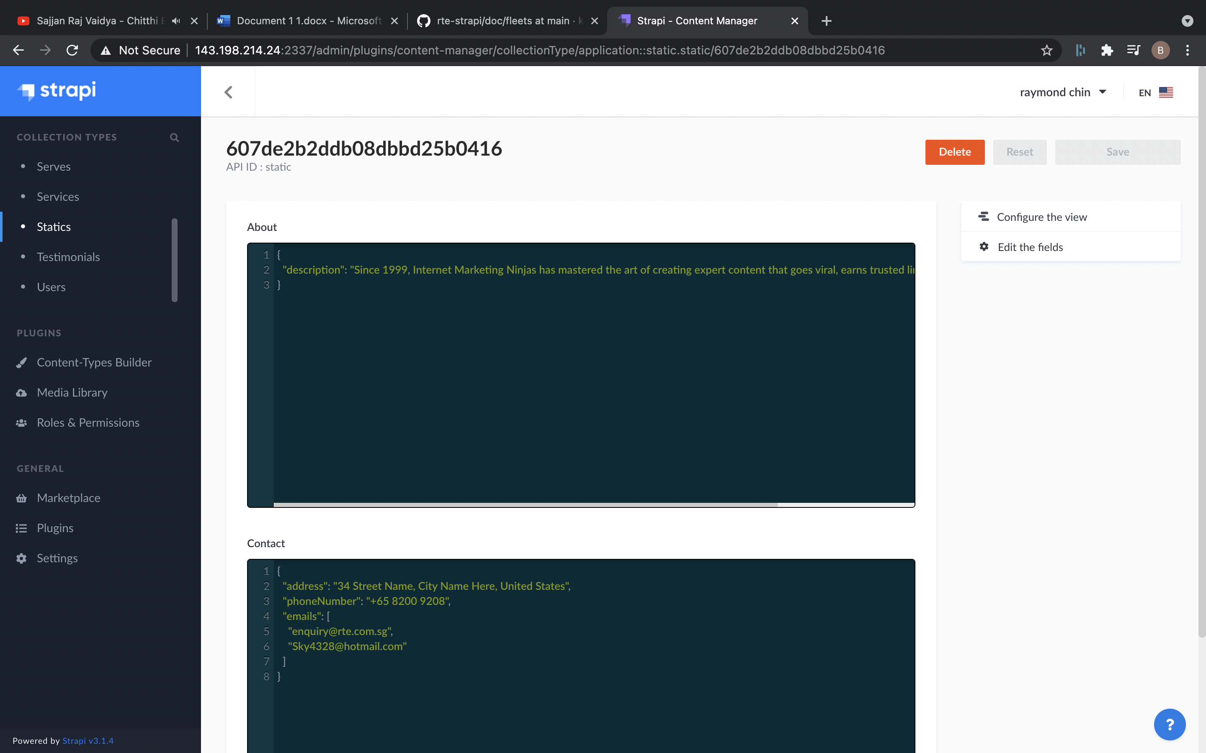

1. **Update the text of description in about field.**
2. **Click Save to Update About Us.**

**Update Contact Information :**

1. **You can access the list on by going on this page:**

<http://143.198.214.24:2337/admin/plugins/content-manager/collectionType/application::static.static>

You should be showing this page:



1. **Click on the first and only static item:**
2. **You will go to detail page as:**



1. **Update the Contact Fields as:**

**a. address: This will be address of company that can be shown.**

**b. phoneNumber: This will be the phone number of company.**

**c. emails: You can add multiple email as shown below.**

**{**

**"address": "34 Street Name, City Name Here, United States",**

**"phoneNumber": "+65 8200 9208",**

**"emails": [**

**"enquiry@rte.com.sg",**

**"Sky4328@hotmail.com"**

**]**

**}**

1. **Click Save to Update.**