**Step for List:**

1. **You can access the list on by going on this page:**

<http://143.198.214.24:2337/admin/plugins/content-manager/collectionType/application::testimonial.testimonial>

You should be showing this page:

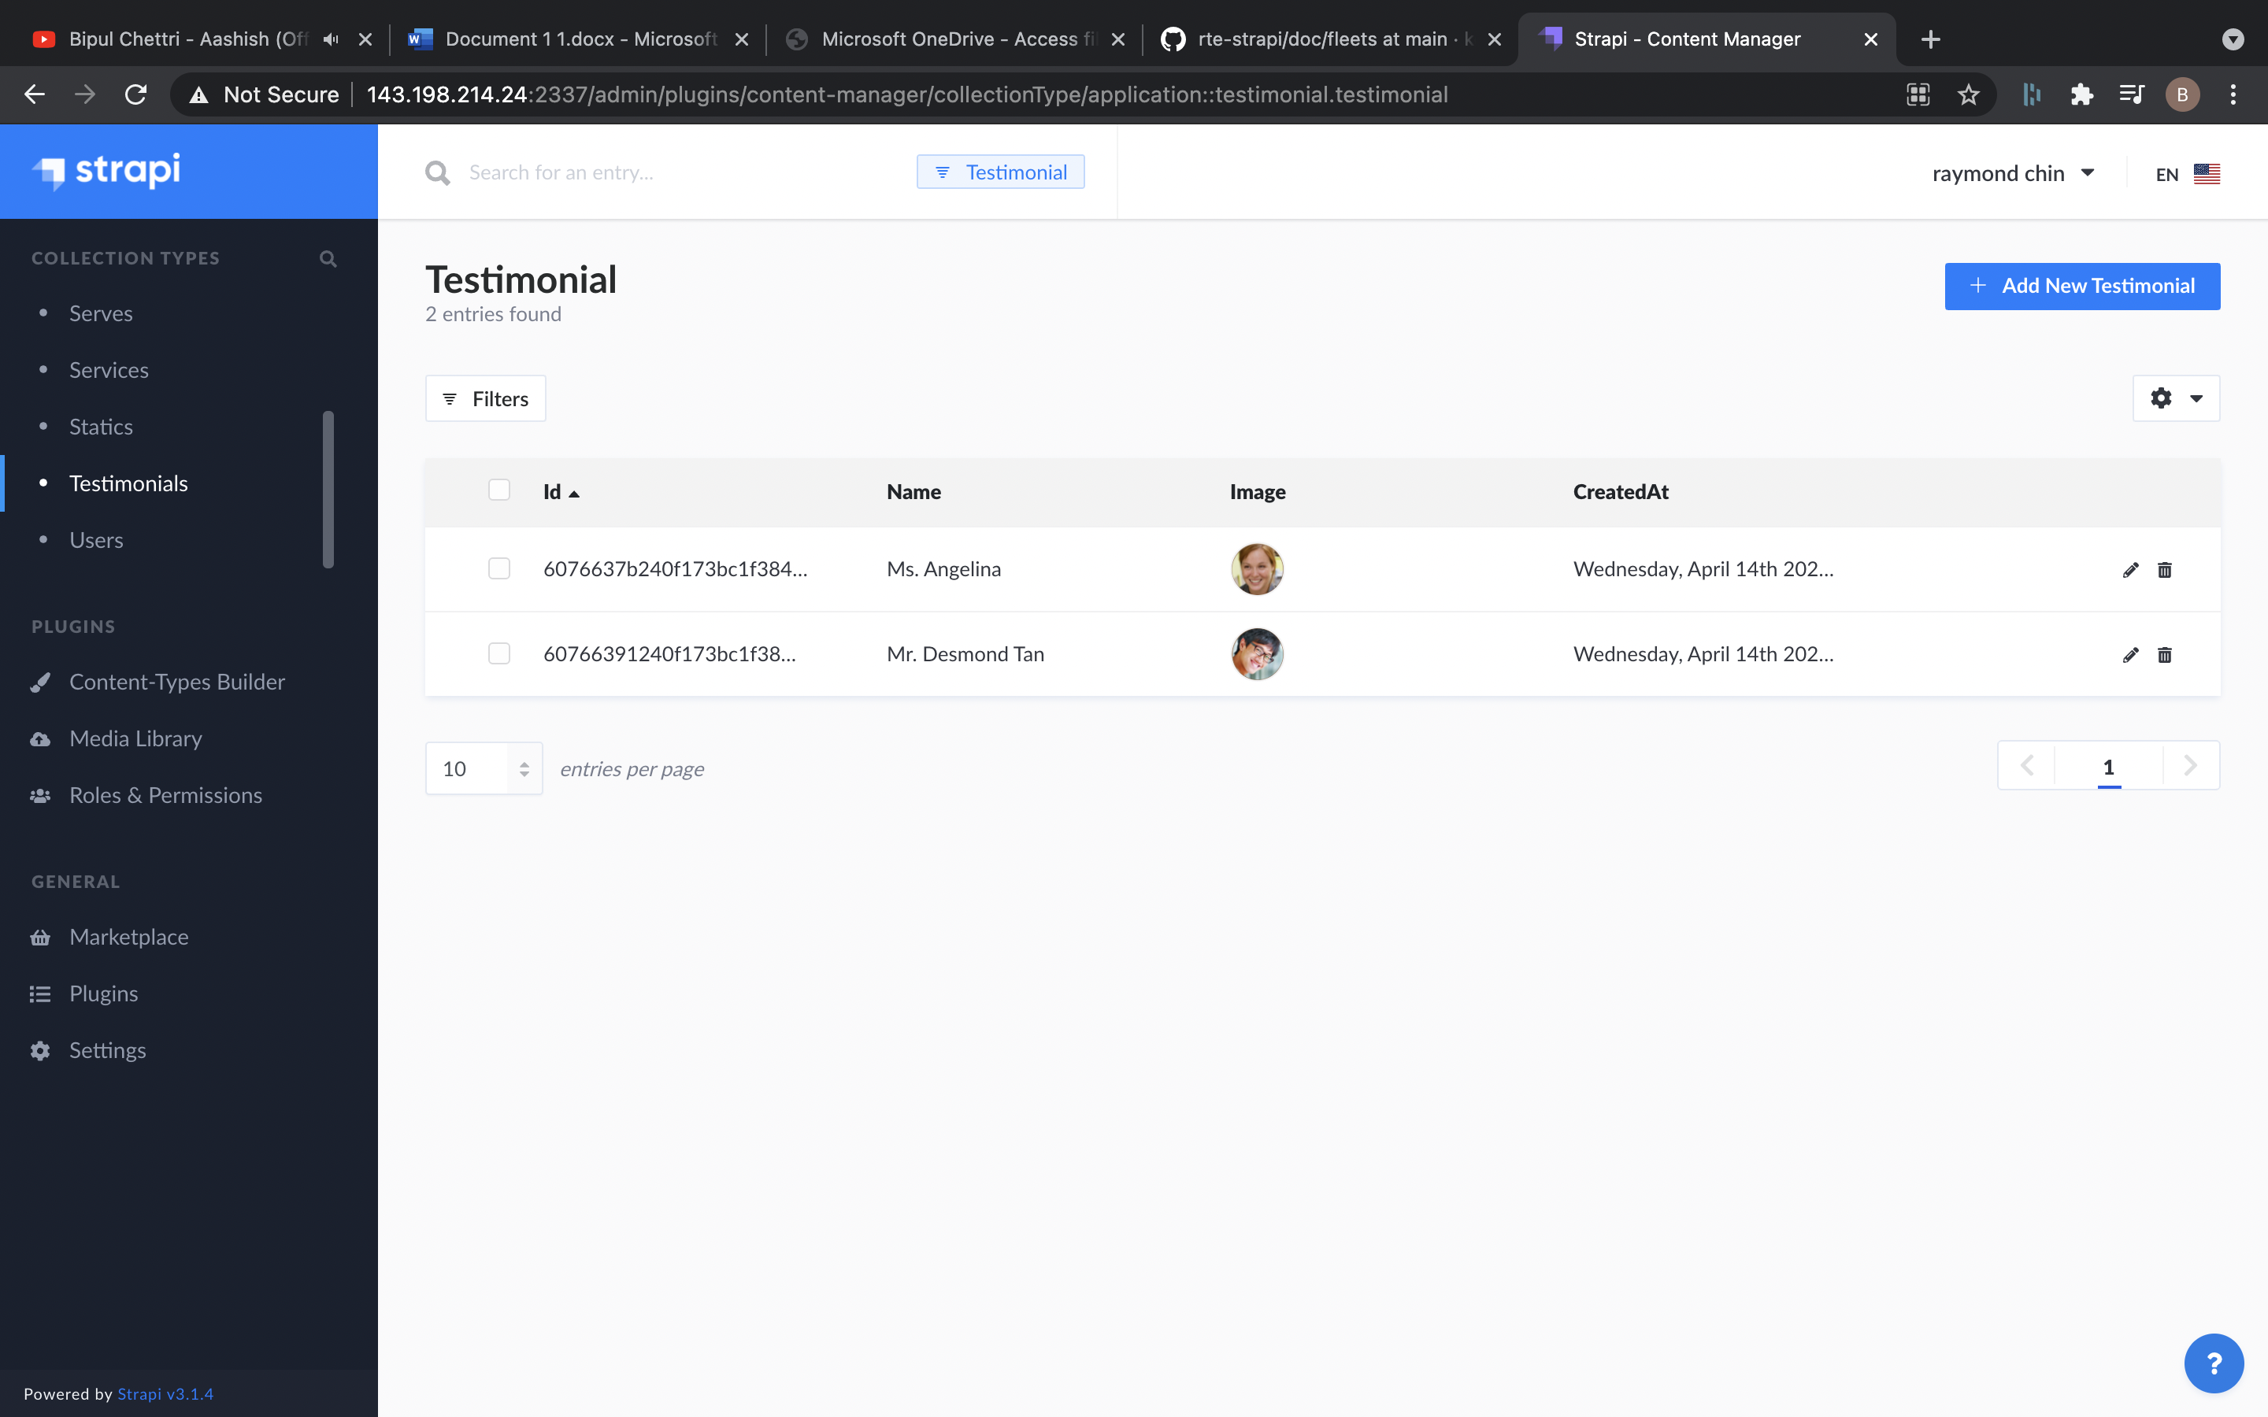

## **Steps for Add:**

### **1. Visit link to add new:**

<http://143.198.214.24:2337/admin/plugins/content-manager/collectionType/application::testimonial.testimonial/create>

This should be the page shown:

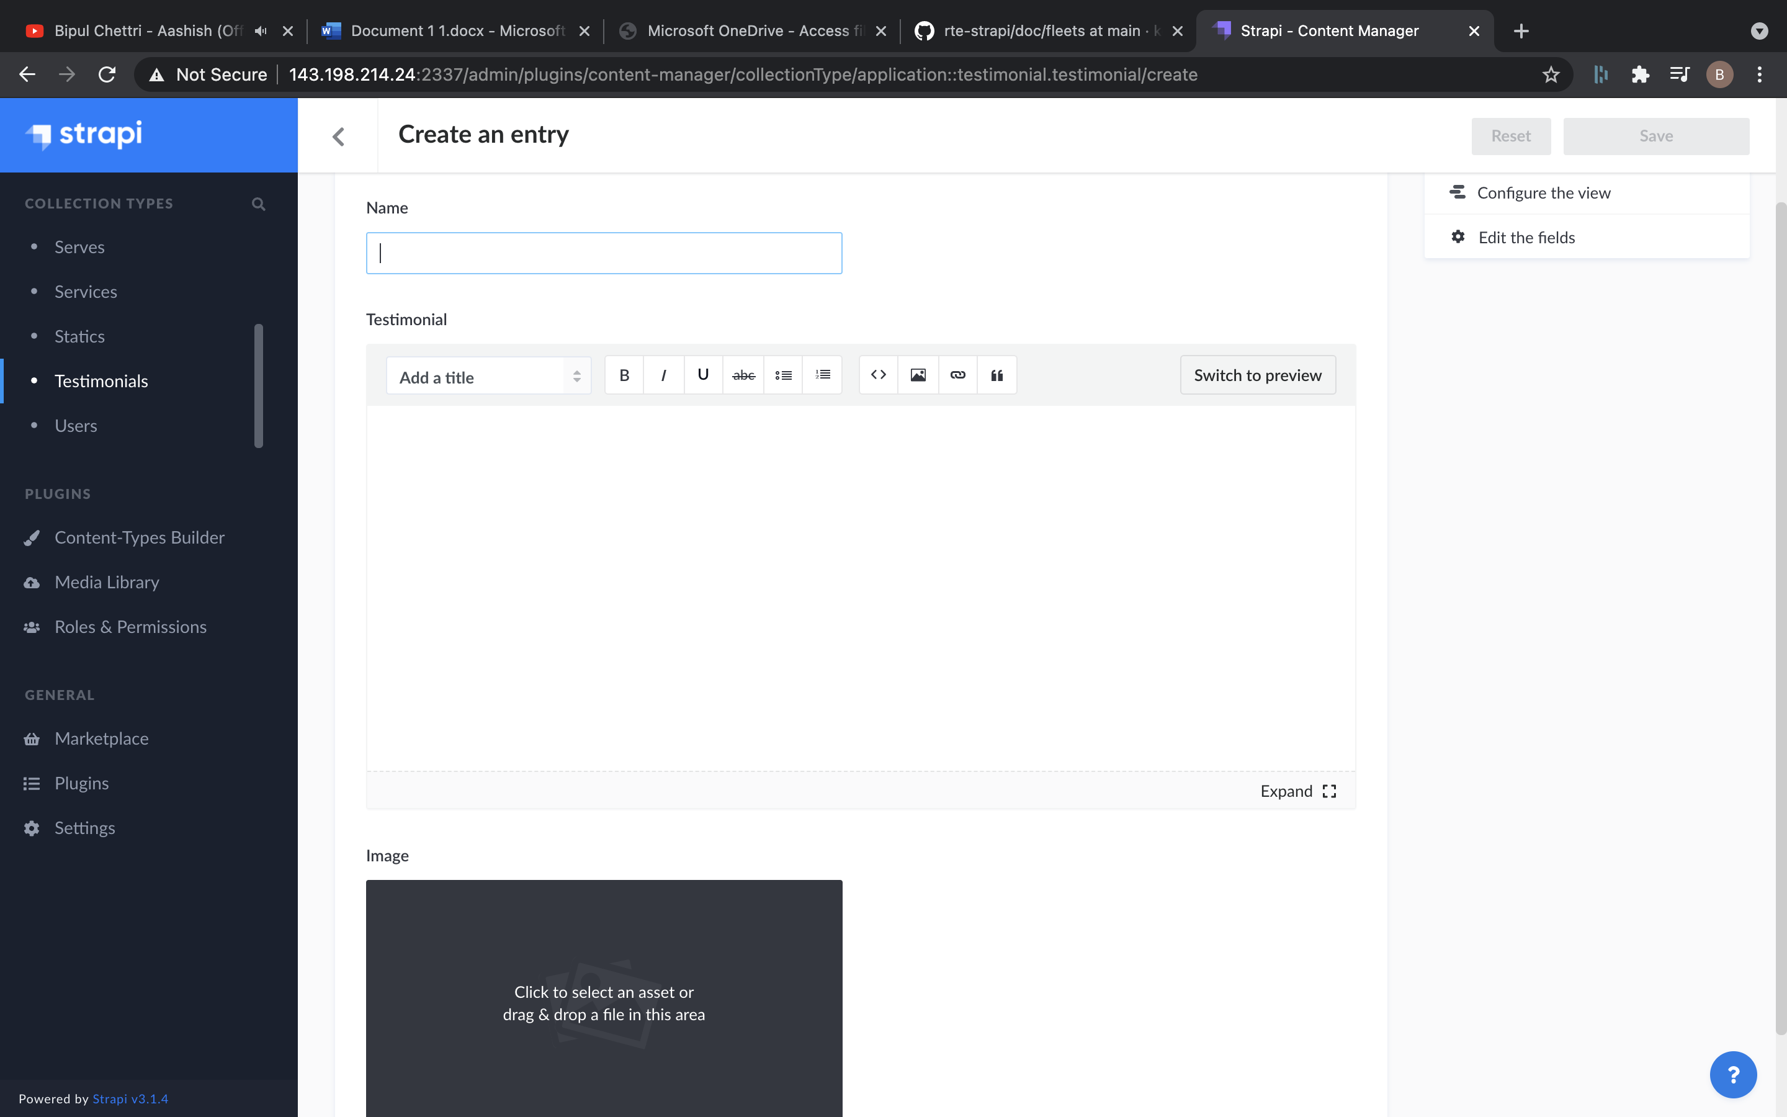

### **2. Add the details for new:**

a. Name: This will be name of the user.

b. Testimonial: This will be Testimonial of user.

c. Image: This will be user image. This is not required.

### **3. Click on save button on top right to save the new.**

## **Steps for delete:**

### **1. Go to List:**

<http://143.198.214.24:2337/admin/plugins/content-manager/collectionType/application::testimonial.testimonial>

### **2. Click on data that need to delete:**

It should open the detail, confirm all the details and make sure:

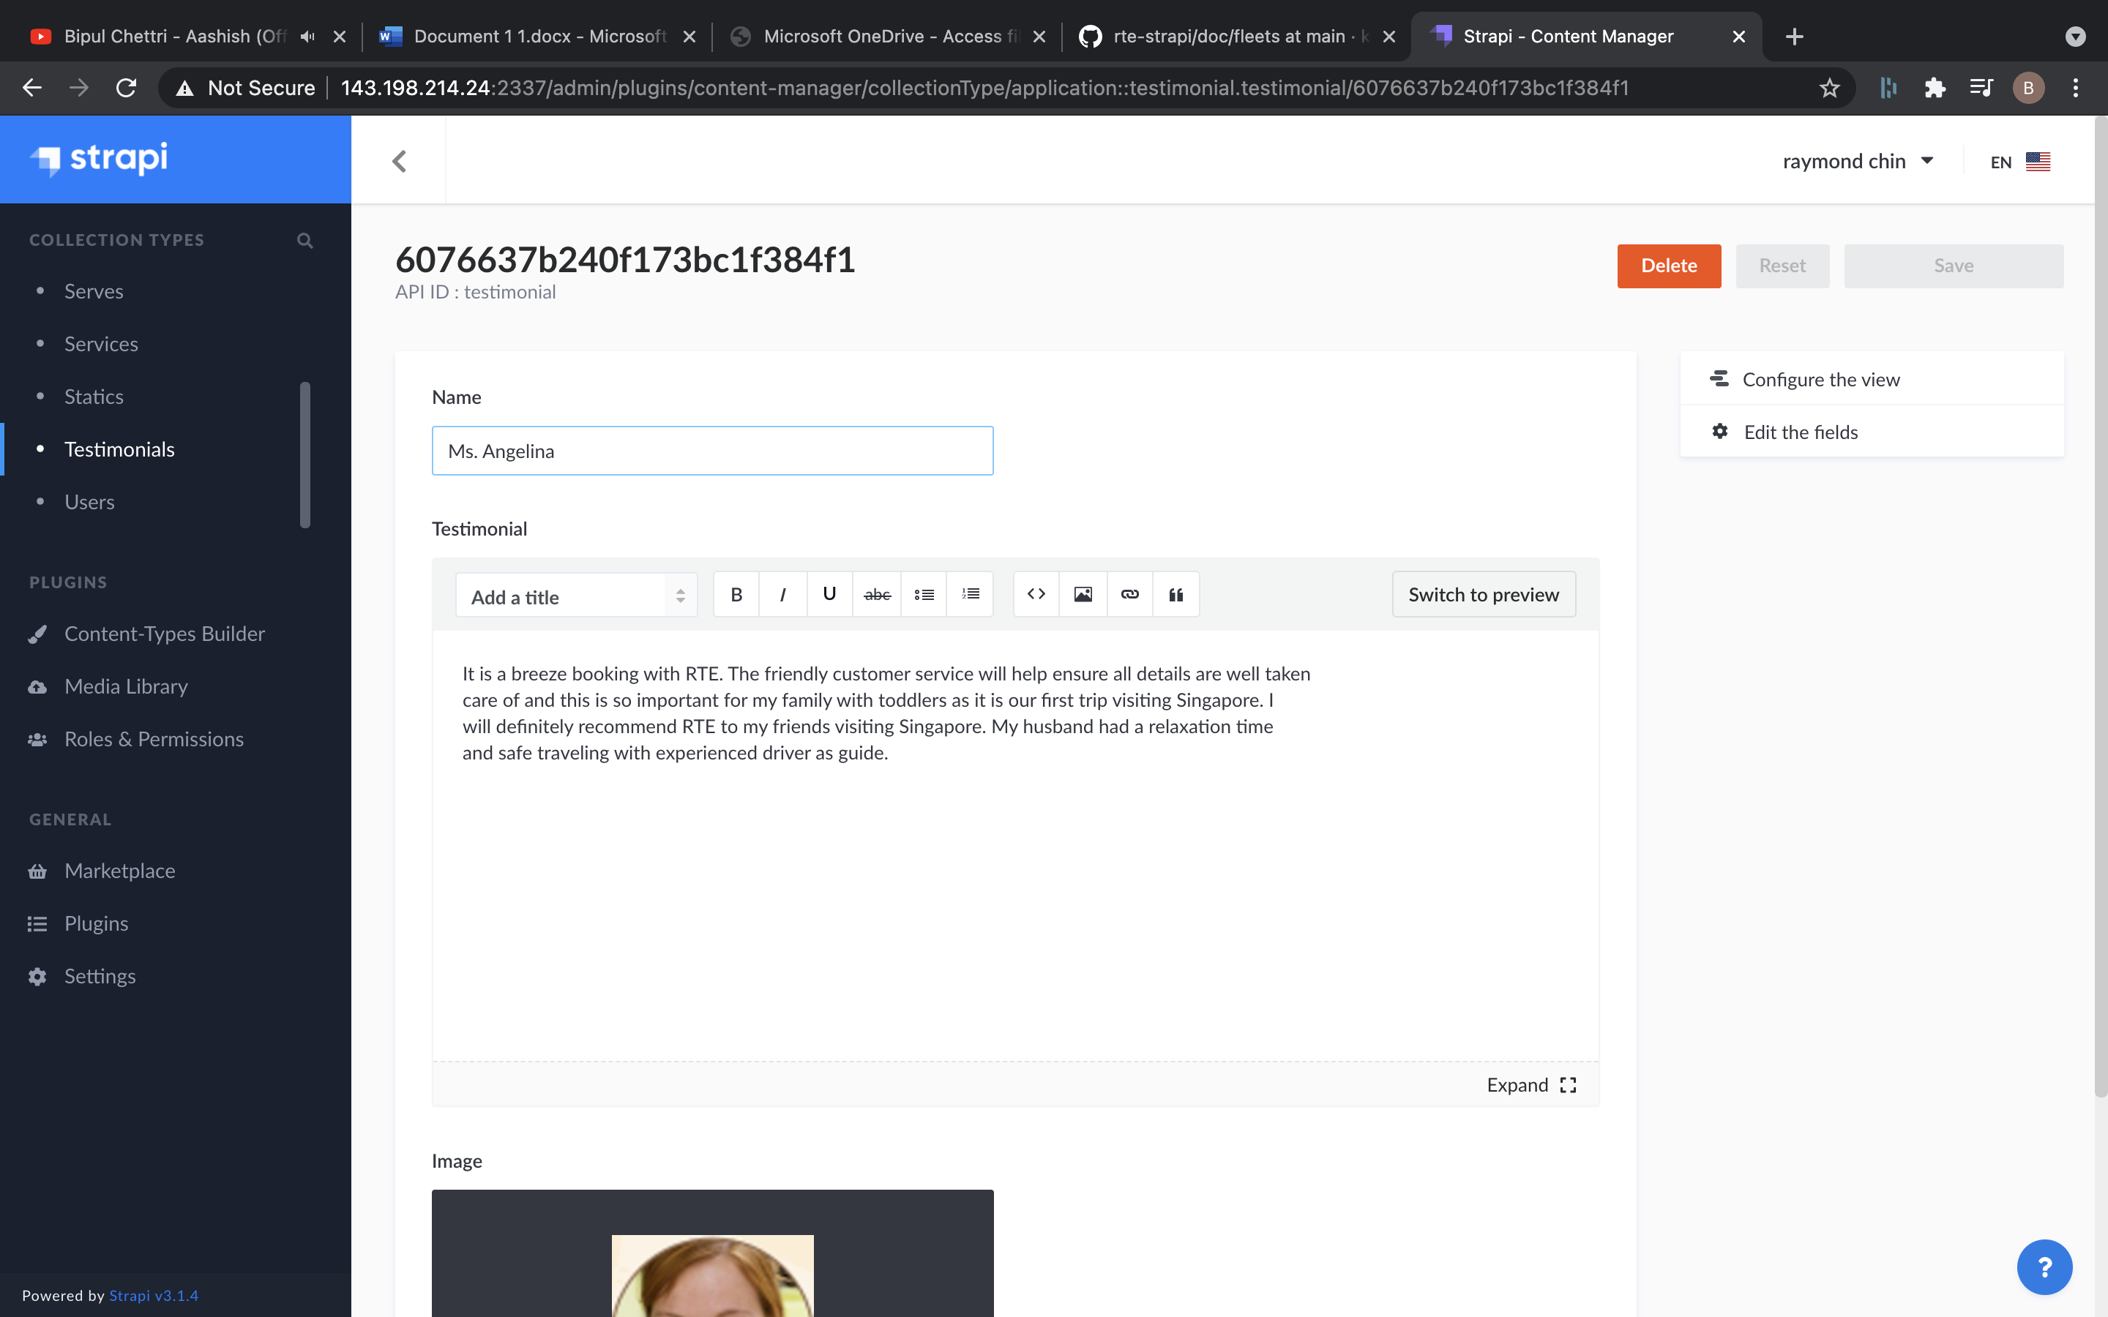

### **3. Click on delete button on top right:**

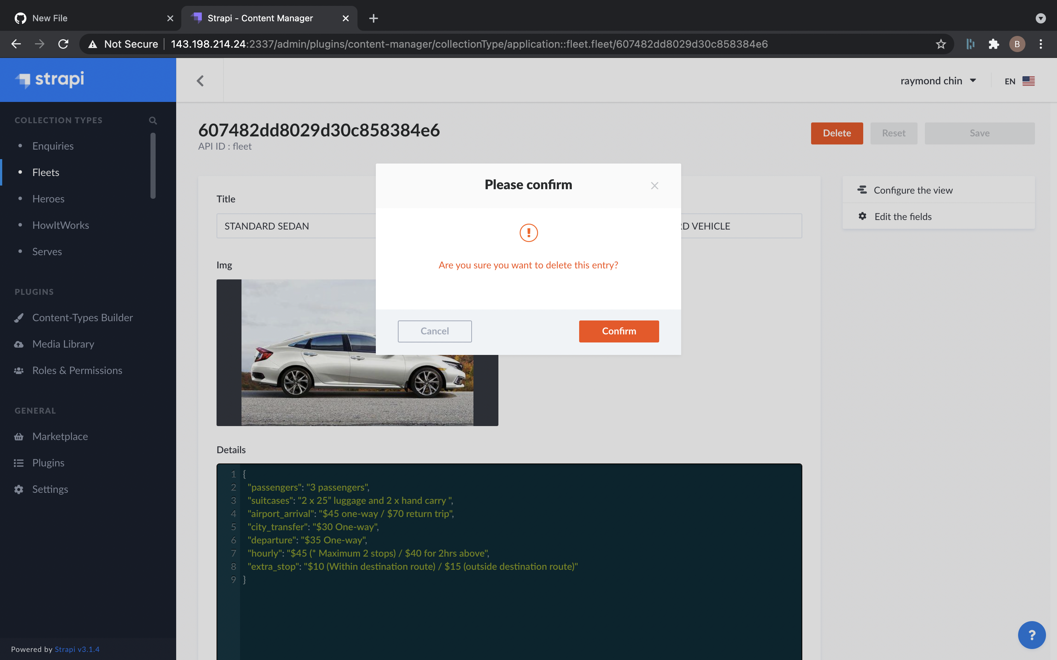

### **4. Click on Confirm to Delete.**

## **Steps for Edit:**

### **1. Go to List:**

<http://143.198.214.24:2337/admin/plugins/content-manager/collectionType/application::testimonial.testimonial>

### **2. Click on data that need to edit:**

It should open the detail, confirm all the details and make sure:



### **3. Edit the details:**

a. Name: This will be name of the user.

b. Testimonial: This will be Testimonial of user.

c. Image: This will be user image. This is not required.

### **4. Click on save button on top right to edit.**