# COMP3015

# Data Communication and Networking

# Additional Individual Assignment

## Student Name: Fong Ming To

## Student ID: 19220456

## Question1

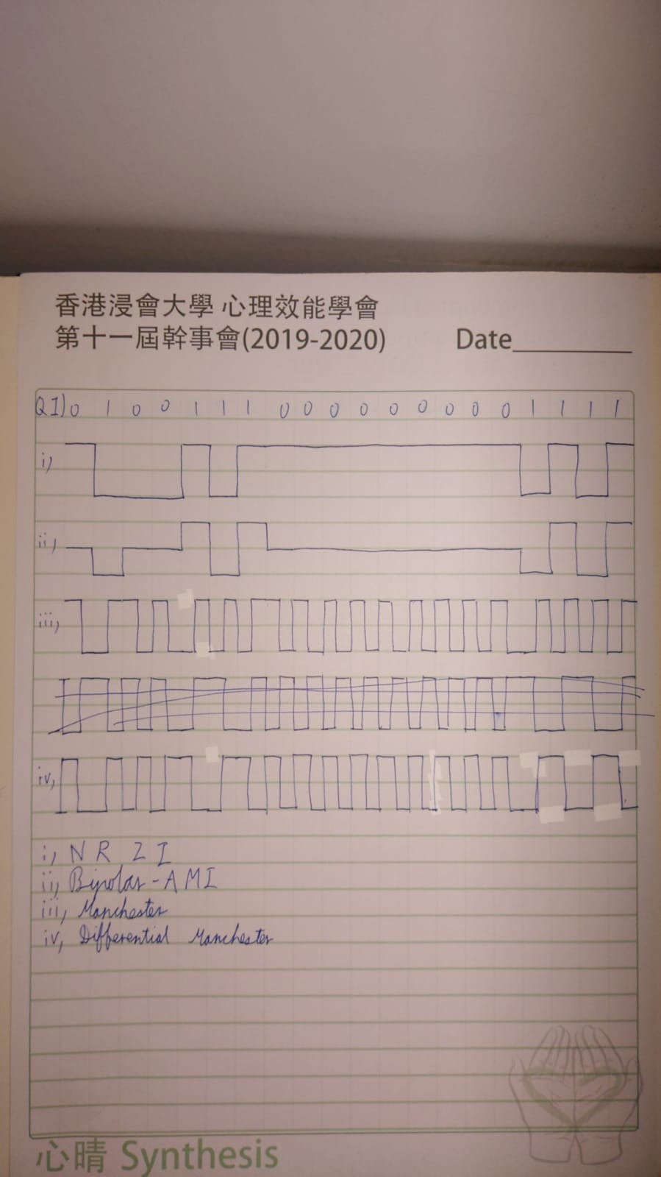

## Question2

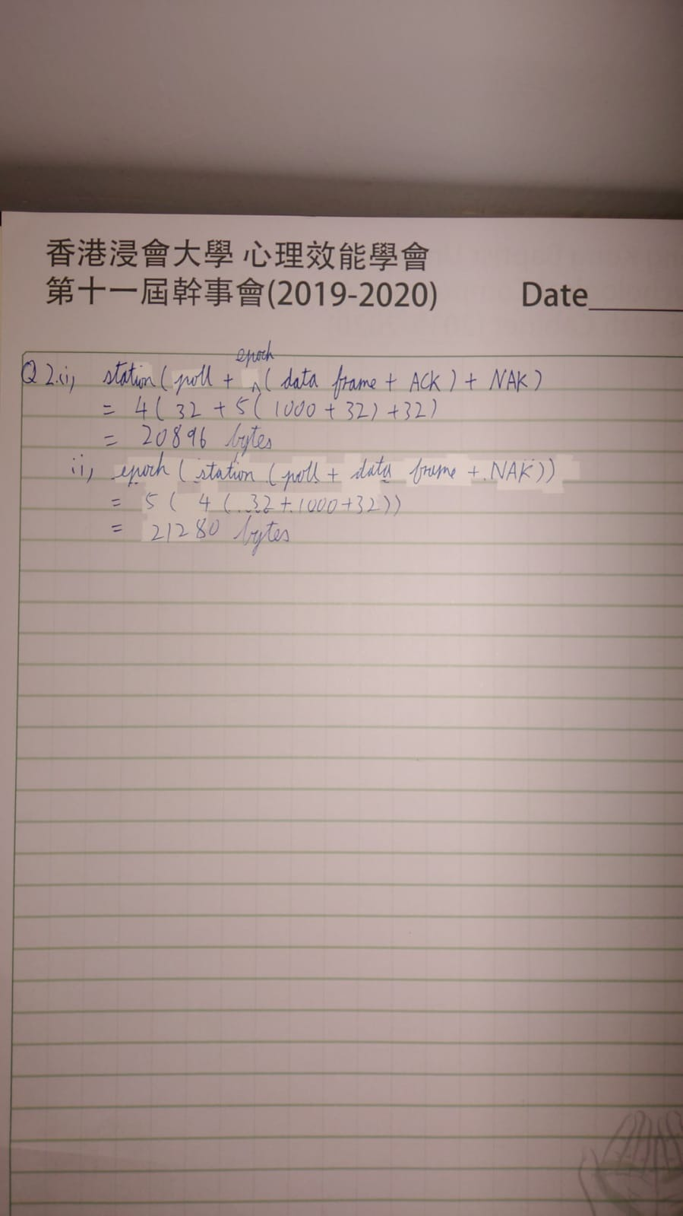

Answer:

1. Station (poll + epoch (data frame + ACK) + NAK)

= 4(32+5(1000 + 32) +32)

=20896 bytes

1. Epoch (station (poll + data frame + NAK))

= 5(4(32+1000+32))

=21280 bytes

## Question3

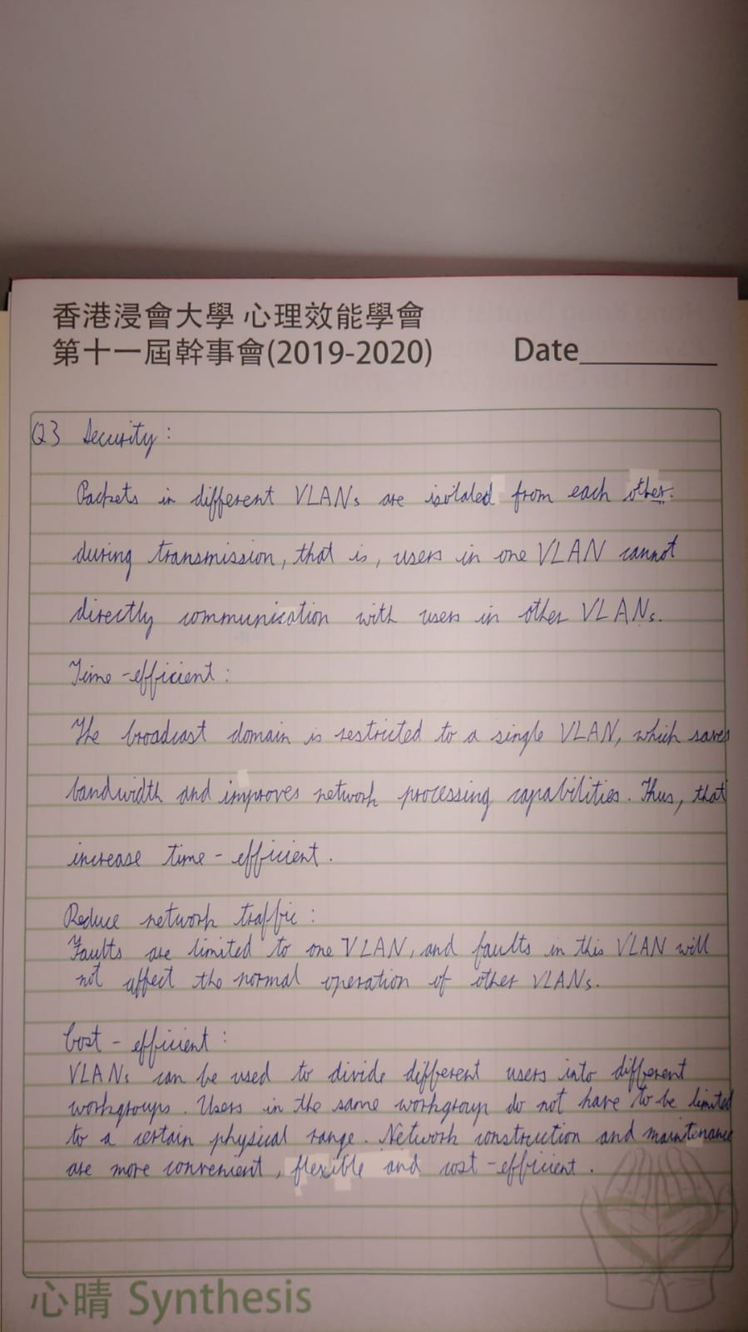

Answer:

Security:

Packets in different VLANs are isolated from each other during transmission, that is, users in one VLAN cannot directly communicate with users in other VLANs.

Time-efficient:

The broadcast domain is restricted to one VLAN, which saves bandwidth and improves network processing capabilities. Thus, that increases time efficiently.

Reduce network traffic:

Faults are limited to one VLAN, and faults in this VLAN will not affect the normal operation of other VLANs.

Cost-efficient:

VLANs can be used to divide different users into different workgroups. Users in the same workgroup do not have to be limited to a certain physical range. Network construction and maintenance are more convenient, flexible and cost-efficient.