# Additional Individual Assignment

# Human Computer Interaction

# COMP4045

## Student ID: 19220456

## Student Name: Fong Ming To

## Question 1a

Scenario title: " how a guest could order a sandwich?"

Assumptions: Client has already installed hotel provide app to connect sandwich making robot and order it. The client has got a hotel number and password when he has already check-in the hotel

Scenario: " Alice feels so hungry and wants to get some eat, so she takes her phone and opens the app, she wants to find a sandwich which is tasty. In the app interface, the needs to enter her hotel room number and password, if the account is valid, the page will move on to the home page. Otherwise, it will show the error message. Every sandwich will be shown on the home page, and she can scroll the window to view another sandwich. Alice has entered her account information and enter to home page, she clicks the sandwich and moves to order page. Then, she inputs the order information such as the sandwich amount and ingredients. She clicks the “Place order” button to send the request to the hotel system. The hotel system gets her order information and orders a sandwich-making robot to start working to make a sandwich. At the same moment, Hotel system will send the information about the sandwich-making progress and the delivery time to Alice. Alice sees the app top right-hand side time button that is “delivery time: 3:00 p.m.” and she can clicks the time to view the progress of the sandwich. She thinks to have a lot of time so she goes to work."

## Question 1b

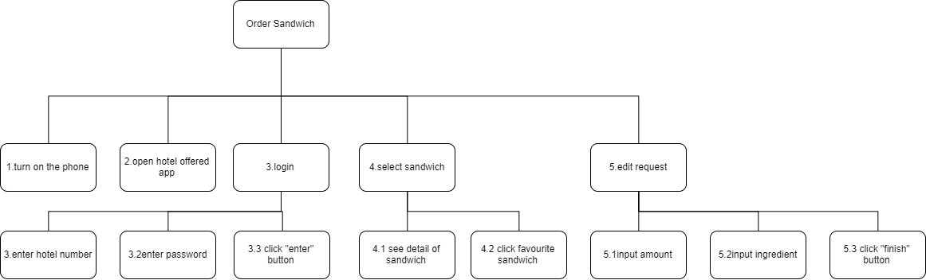

## Question 1c

Manipulating style is the most suitable for supporting this task because this task has a lot of operating and entry such as scroll the window and input the order information.

## Question 1d

|  |  |
| --- | --- |
|  |  |
| 1.Alice feels so hungry and wants to get some eat, so she takes her phone and opens the app. | 2.Alice has entered information(password and hotel number) and enter to home page |
|  |  |
| 3.she clicks the sandwich | 4.she edit the order information such as the sandwich amount and ingredients. |
| |  | | --- | |  | | C:\Users\ken\AppData\Local\Microsoft\Windows\INetCache\Content.MSO\97B10F87.tmp |
| 5.Alice see the time and waiting bot arrive. | 6.Sandwich is delivered by the automated delivery system |

## Question 2a

Proximity is the art of grouping related items together into single visual units of information so it can facilitate memory, reading, learning, perception.

Alignment is creating visual connections between elements, or groups of elements, by aligning them so it can facilitate memory, reading, speaking, attention.

Consistency is creating visual unity throughout a system by repeating visual elements (e.g., colors, shapes, textures, etc.) and styles so it can facilitate memory, learning.

Contrast is creating visual attraction by making different items or groups of items very different so it can facilitate attention, reading, learning, perception.

## Question 2b

Layout design problem:

* The information does not group together
* The text and textbox too close
* The button does not intuitive
* The content does not align

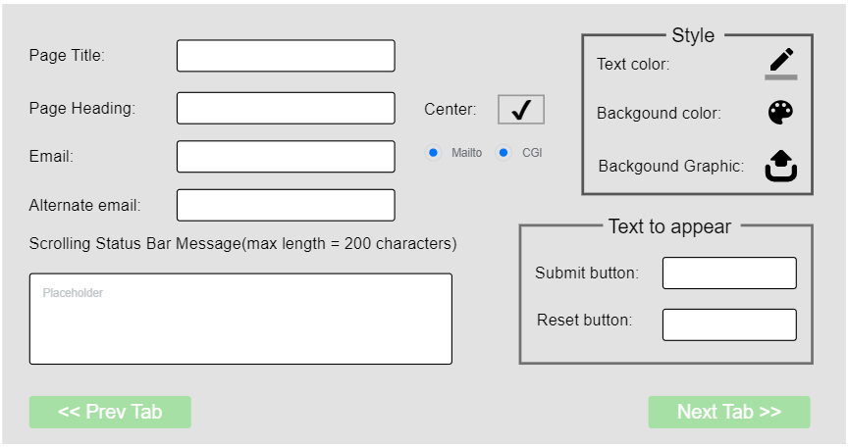

## Question 3a

Problem 1: Color coding not consistent    

Problem 2: too little contrast 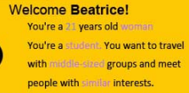

Propose color scheme: **Complementary colors**

## Question 3b

Complementary colors are two colors that are opposite each other on the color wheel, such as purple-yellow and red-green so I think this is suitable in this high-contrast composition website. Left-hand side background is purple-yellow and the right-hand side background is red-green. Text color is white color and button color correspond to the background color.

## Question 4a

Answer: cognitive walkthrough and heuristic evaluation

## Question 4b

they differ based on the severity of problems and the coverage of some usability attributes. A cognitive walkthrough would be the preferred method for evaluating systems intended for novice users and heuristic evaluation for users who have experience with similar systems.

The benefits of heuristic evaluation:

* It is an inexpensive usability testing methods that can test the product based on number of in-house UX experts
* It is a quick testing tool as it doesn’t require to prepare a representative user sample to do the testing
* It can be used to element the common usability problems that don’t need a feedback from the end user
* It can be used prior to other usability testing methods to focus on the user-specific usability issues

The benefits of cognitive walkthrough:

* Task-oriented
* Can be done during the early stages of design
* Can identify requirements gaps
* More cost effective and fast compared with usability testing

## Question 5a

**Set goal:**

booking a flight ticket on the Web.

**Form intention:**

Check out Hong Kong airlines website.

**Specify what to do:**

Search airline website from the browser. Click the "Book a trip" button and submit information. Find the button used to buy the ticket and click it. Enter related information such as credit card number, phone number, identification, etc. Double confirm information is correct. Click the button for booking ticket. Waiting for the success message. Take a copy of the confirmation.

**Execute action sequence:**

Move mouse, click on mouse button.

**Check what happens at the interface:**

See a new page pop up on the screen.

**Interpreting state:**

I have lost my money and time but I got a flight ticket.

**Evaluate it with respect to the goal:**

I got a flight ticket

## Question 5b

**Gulf of execution:** The mismatch between the user’s intentions and the allowable actions, it will appear in the “Specify what to do” because there is no book a trip function.

**Gulf of evaluation:** The mismatch between the system’s representation and the user’s expectations, it will appear in the “Specify what to do” because there are no corresponding tickets.