**TABLE OF CONTENTS**

CHAPTER ONE 2

INTRODUCTION 2

1.1 INTRODUCTION 2

1.2 PROBLEM STATEMENT 2

1.3 PROJECT SCOPE 2

1.4 AIMS AND OBJECTIVES 3

1.5 SIGNIFICANCE OF PROJECT 4

1.6 PROJECT BENEFICIARIES 5

CHAPTER TWO 6

REVIEW OF LITERATURE AND TOOLS 6

2.1 REVIEW OF THE EXISTING SYSTEM 6

2.2 LIMITATION OF THE EXISTING SYSTEM 6

2.3 PROPOSED SYSTEM 6

2.4 FEATURES OF THE PROPOSED SYSTEM 7

2.5 LIMITATIONS OF THE PROPOSED SYSTEM 7

CHAPTER THREE 8

METHODOLOGY 8

3.1 REQUIREMENTS SPECIFICATIONS 8

3.1.1 FUNCTIONAL REQUIREMENTS 8

3.1.2 NON-FUNCTIONAL REQUIREMENTS 9

3.2 ARCHITECTURAL REVIEW 10

3.3 TECHNOLOGICAL REVIEW 10

3.4 UML MODEL 11

3.6 USERS OF SYSTEM 15

3.7 USER INTERFACE 16

CHAPTER FOUR 19

IMPLEMENTATION AND TESTING 19

4.1 SYSTEM TESTING 19

# **CHAPTER ONE**

## **INTRODUCTION**

**RAILWAY RESERVATION SYSTEM**

### INTRODUCTION

The Railway Reservation System is a sophisticated software solution that intends to revolutionize the traditional railway ticket booking process, making it more efficient and user-friendly. The system is designed to offer a seamless, automated, and convenient experience for passengers while significantly reducing the burden on railway authorities.

The aim of this project is to develop a railway reservation system to cater to the growing demand for the use of trains in railway stations .

### PROBLEM STATEMENT

The current manual railway reservation system is replete with challenges, including long queues, human errors, inefficiencies in ticket distribution, and limited scalability. Passengers often face the inconvenience of waiting for extended periods, which is exacerbated during peak travel seasons. The primary goal of this project is to address these challenges by transitioning to an automated booking system.

### PROJECT SCOPE

The project scope is a comprehensive digital transformation of the railway ticket booking process. It encompasses the development of a web-based railway reservation system that enables passengers to seamlessly book, modify, and cancel train reservations. This system will encompass various critical aspects of the booking process.

It covers the following key functionalities:

* **User Registration:** Passengers can create accounts by providing necessary information, including name, contact details, and security credentials.
* **Authentication:** Users can securely log in using their username and password, ensuring the confidentiality of their personal information.
* **Search Filters:** Passengers can search for trains based on criteria like origin, destination, date, time.
* **Seat Availability:** Real-time information on seat availability and occupancy rates for selected trains is displayed to users.
* **Passenger Details:** Passengers can input the names of all travelers and their contact information when booking multiple seats.
* **Payment Options:** Multiple secure payment options are available, including credit/debit cards, digital wallets, and net banking.
* **Confirmation:** Passengers receive a booking confirmation with a unique PNR (Passenger Name Record) after successful payment.
* **User Profile:** Passengers can view and update their profile information, including contact details, preferences, and password changes.
* **Booking History:** Users can access their booking history, view past reservations, and reprint tickets as needed.
* **Ticket Cancellation:** The system allows users to cancel reservations within specified timeframes, with refunds and cancellation charges as applicable.
* **Dashboard Access:** Railway authorities have access to a dedicated administrative dashboard.
* **Real-time Monitoring:** Railway personnel can monitor bookings, train schedules, occupancy rates, and revenue collection in real time.

### AIMS AND OBJECTIVES

The aim of this project is to develop a railway reservation to cater for the growing demand for trains in railway stations.

The following goals will be established during the completion of this project:

1. To completely automate and streamline the railway ticket booking process, reducing the dependency on manual methods.
2. To minimize errors and enhance the accuracy of reservations, instilling trust and reliability in the system.
3. To prioritize user experience by providing an intuitive and responsive platform for passengers.
4. To empower railway authorities with enhanced control over bookings, revenue management, and decision-making.

### SIGNIFICANCE OF PROJECT

An e-commerce project with an AI chatbot embedded within it can hold significant advantages for both the vendors and its customers. Here are some of the key benefits and the overall significance of such a combination:

**1. Improved Passenger Convenience:** The project significantly enhances the convenience of booking train tickets. Passengers no longer have to endure long queues at ticket counters or rely on cumbersome manual processes. They can effortlessly book, modify, or cancel reservations online, reducing the time and effort required to secure their travel plans.

**2. Operational Efficiency:** Railway authorities benefit from the project by gaining better control over bookings and train schedules. The administrative dashboard provides real-time insights into occupancy rates, revenue collection, and exceptional cases. This improved oversight allows for more efficient resource allocation, reducing operational challenges during peak travel seasons.

**3. Error Reduction:** The project aims to minimize errors and discrepancies in reservations, resulting in a more reliable and accurate booking system. With an automated process, the likelihood of human errors associated with manual booking is greatly reduced. Passengers can have confidence in the accuracy of their reservations, which in turn leads to increased customer satisfaction.

**4. Revenue Enhancement:** The project has the potential to boost revenue for the railway system. Through improved control over bookings, the railway authorities can optimize pricing strategies, allocate resources more effectively, and gain valuable insights into passenger travel patterns. This, in turn, can lead to increased revenue generation and financial stability for the railway system.

### 1.6 PROJECT BENEFICIARIES

Our railway reservation system can benefit various stakeholders involved in the project. Here are the key beneficiaries:

**Passengers:** Will experience a streamlined, error-free booking process with a high level of convenience.

**Railway Authorities:** Will gain complete control over bookings, revenue management, and access to valuable passenger data for future planning.

**Booking Agents:** Will have access to a user-friendly reservation platform to assist passengers, making the booking process more efficient and error-free.

# **CHAPTER TWO**

## **REVIEW OF LITERATURE AND TOOLS**

### 2.1 REVIEW OF THE EXISTING SYSTEM

The current manual railway reservation system involves extended queues at booking counters, manual record-keeping, and a high probability of human errors during the booking process. The system is ill-suited for adapting to changes in passenger demands and is vulnerable to inefficiencies, particularly during peak travel seasons.

### 2.2 LIMITATION OF THE EXISTING SYSTEM

* **Manual and Time-Consuming Process:** Lengthy booking procedures lead to long queues and inconvenience for passengers.
* **Frequent Errors and Discrepancies:** The manual nature of the system often results in errors, leading to passenger dissatisfaction and disputes.
* **Difficulty in Handling Peak Seasons:** The existing system struggles to cope with peak travel seasons, resulting in overcrowding, booking errors, and operational challenges.
* **Limited Scalability:** The system is unable to adapt to changing passenger demands and technological advancements, limiting its ability to accommodate increased demand or system improvements.

### 2.3 PROPOSED SYSTEM

The proposed Railway Reservation System is a modern, web-based platform that will revolutionize the process of booking train tickets. This platform will enable passengers to book, modify, and cancel reservations online, offering a user-friendly interface and real-time updates on seat availability.

### 2.4 FEATURES OF THE PROPOSED SYSTEM

* **Online Booking with Seat Selection:** Passengers can book train tickets online and select their preferred seats, including class and location on the train.
* **Multiple Payment Options**: The system will offer various secure payment options, including integration with trusted online payment gateways for seamless and secure transactions.
* **User Accounts:** Passengers can create and manage user accounts, allowing them to view booking history, update personal details, and make reservations more conveniently.
* **Real-time Availability Updates:** Passengers will have access to real-time updates on seat availability, ensuring that they have the most current information.
* **Administrative Dashboard:** Railway authorities will have access to an administrative dashboard that allows them to monitor bookings, manage train schedules, and address exceptional cases promptly

### 2.5 LIMITATIONS OF THE PROPOSED SYSTEM

* **Dependency on Internet Connectivity:** Passengers and railway authorities will need a reliable internet connection to access and use the system effectively.
* **Potential System Downtime for Maintenance:** Scheduled maintenance and updates may lead to temporary system downtime, but these will be planned during off-peak hours to minimize disruptions.
* **Dependency on Third-Party Payment Gateways:** The system relies on third-party payment gateways for secure and efficient payment processing, subject to their availability and performance.

# **CHAPTER THREE**

## **METHODOLOGY**

### 3.1 REQUIREMENTS SPECIFICATIONS

The purpose of this document is to define the requirements for an advanced Railway Reservation System. The system aims to provide a seamless reservation experience and improve customer engagement.

### FUNCTIONAL REQUIREMENTS

1. **User Registration and Login**

* Users must be able to create accounts, log in securely, and recover their passwords if forgotten.

1. **Train Search and Selection**

* Passengers should have the ability to search for trains based on criteria such as origin, destination, date, time, and class.

1. **Seat Selection and Booking**

* Passengers must be able to view available seats, select their preferred seats, and complete the booking process, which includes selecting the class, number of passengers, and payment method.

1. **Payment Processing**

* The system must securely handle payments through various methods, including credit/debit cards, digital wallets, and net banking, with a confirmation receipt sent to the user upon successful payment.

1. **Reservation Modification and Cancellation**

* Passengers should have the option to modify or cancel reservations within a defined time frame, subject to applicable rules, charges, and notifications.

1. **Administrative Dashboard:**

* Railway authorities should have access to a secure administrative dashboard for real-time monitoring of bookings, train schedules, occupancy rates, revenue collection, and the ability to address exceptional cases such as ticket cancellations and disputes.

### 3.1.2 NON-FUNCTIONAL REQUIREMENTS

**1. High System Availability**

* The system should aim for 99.9% uptime to ensure passengers can book tickets at any time without disruptions. Maintenance schedules will be communicated in advance.

1. **Secure Payment Processing**

User data, including personal information, payment details, and chatbot interactions, must be protected using encryption and secure authentication mechanisms.

1. **Scalability**

* The system should be designed for horizontal scalability, allowing it to handle surges in booking demand during peak travel seasons without performance degradation.

1. **User-Friendly and Responsive UI**

* The user interface should be intuitive, responsive, and accessible across various devices, catering to users of varying technical backgrounds.

1. **Maintainability**

* The code-base should be well-structured and documented to facilitate easy maintenance and updates in the future.
* The development team should follow coding best practices and version control to ensure code maintainability.

1. **Response Time for Customer Support**

* The customer support ticketing system should prioritize quick response times to resolve user queries and issues efficiently.

1. **Reliability**

* The platform should be highly reliable and available at all times, with minimal downtime or service disruptions.
* Measures such as regular backups and fault tolerance should be implemented to ensure data integrity and system stability.

### 3.2 ARCHITECTURAL REVIEW

**1. Overall Architecture:**

The architectural design of the system is well-structured and modular, allowing for easy scalability and maintainability. It consists of various interconnected components, each responsible for specific functionalities.

* **User Interface (Client):** The user interacts with the system through a web browser or a dedicated mobile application. This component provides an intuitive and user-friendly experience, making it easy for passengers to navigate the booking process.
* **Application Logic (Server):** The server component handles user requests, processes bookings, and communicates with the database. It is responsible for authentication, payment processing, and coordinating various system functions.
* **Database (Backend):** The database stores information about trains, seats, users, reservations, and transactions. The system's architecture will employ a three-tier structure, separating the presentation, application logic, and data storage layers.

### 3.3 TECHNOLOGICAL REVIEW

**1. Frontend Technologies:**

* Frontend Frameworks: HTML, CSS and Javascript is used to build interactive and responsive user interfaces.

**2. Backend Technologies:**

* Programming Language: PHP is chosen as the backend language based on the development team's expertise and system requirements.

**3. Database Management:**

* My SQL Database: Utilize MySQL database to handle unstructured or semi-structured data and handling scalability requirements.

### 3.4 UML MODEL

* **Flowchart**

### 

* **Database** **Schema**

1. Passenger

#. Name

*. First name

*. Last name

#. Address

#. Phone no.

1. Ticket

#. Ticket no.

*. Waiting

*. Confirmed

*. Cancelled

1. Reservation counter
2. Administrator
3. Train

#. Train no

#. Train name

#. Source

#. Destination

1. Seat

#. Seat no.

#. Compartment no.

### 3.6 USERS OF SYSTEM

1. **Passengers:**

• Role: End-users of the system.

• Privileges: Access to the booking platform, seat selection, payment processing, and reservation management.

1. **Administrators:**

• Role: Railway authority personnel responsible for system oversight.

• Privileges: Access to the administrative dashboard for real-time monitoring, management of train schedules, and handling exceptional cases.

1. **Booking Agents:**

• Role: Assisting passengers in using the reservation system

### 3.7 USER INTERFACE

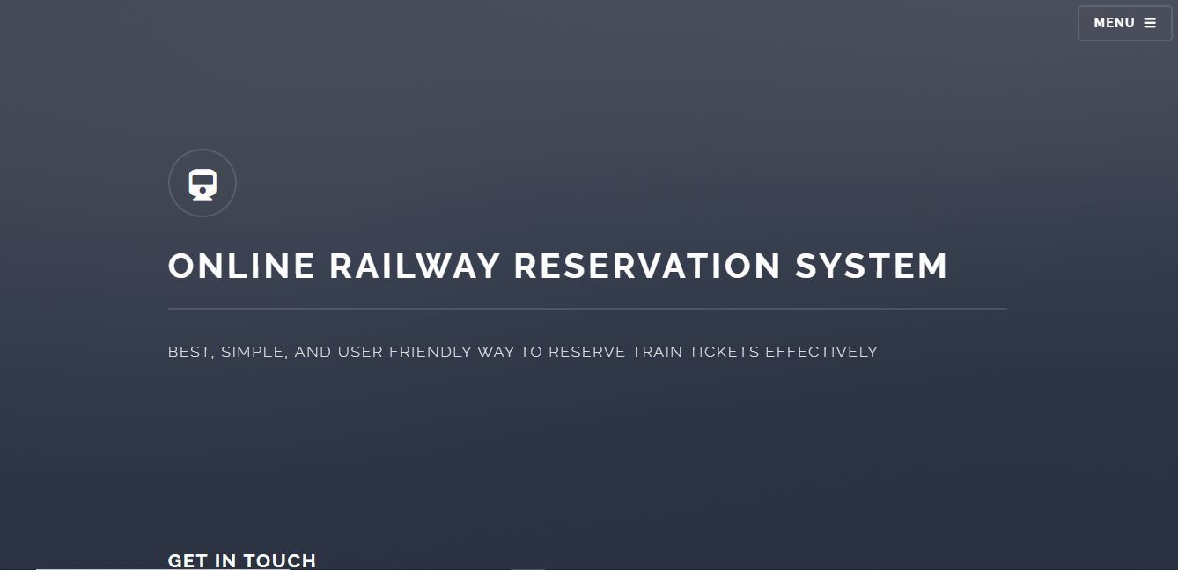

**HOMEPAGE**

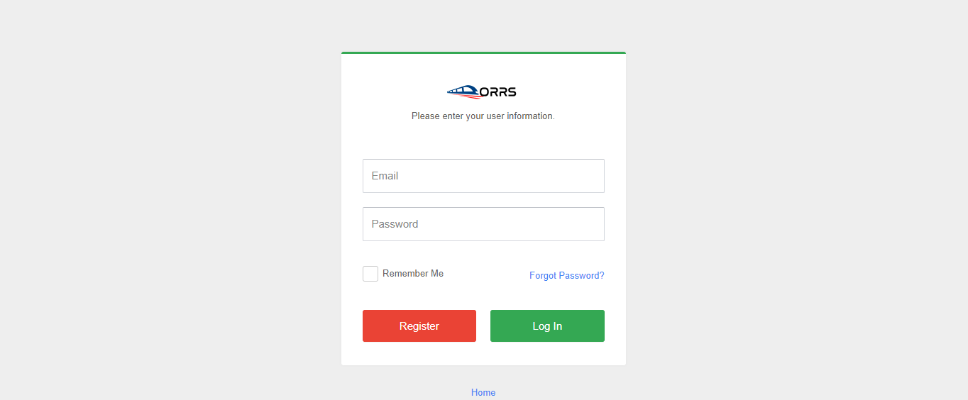

**REGISTRATION**

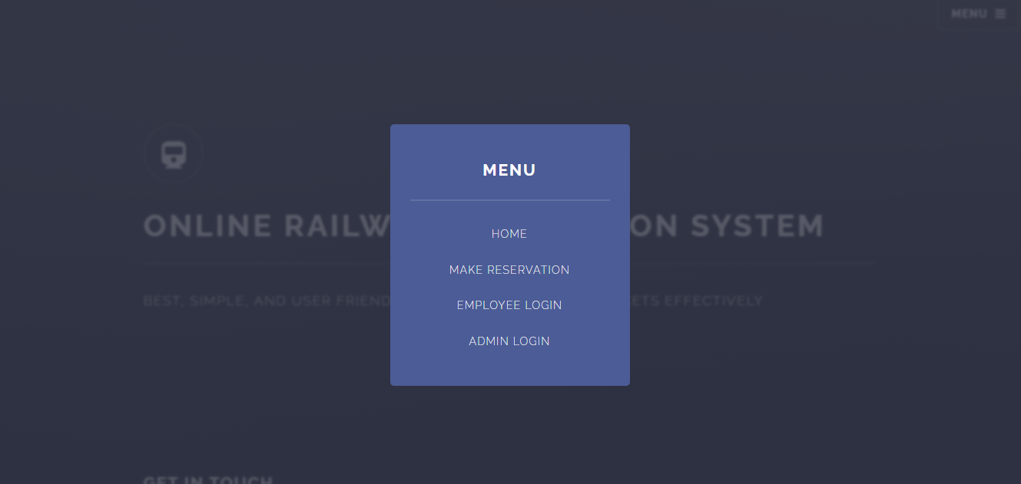

**MENU**

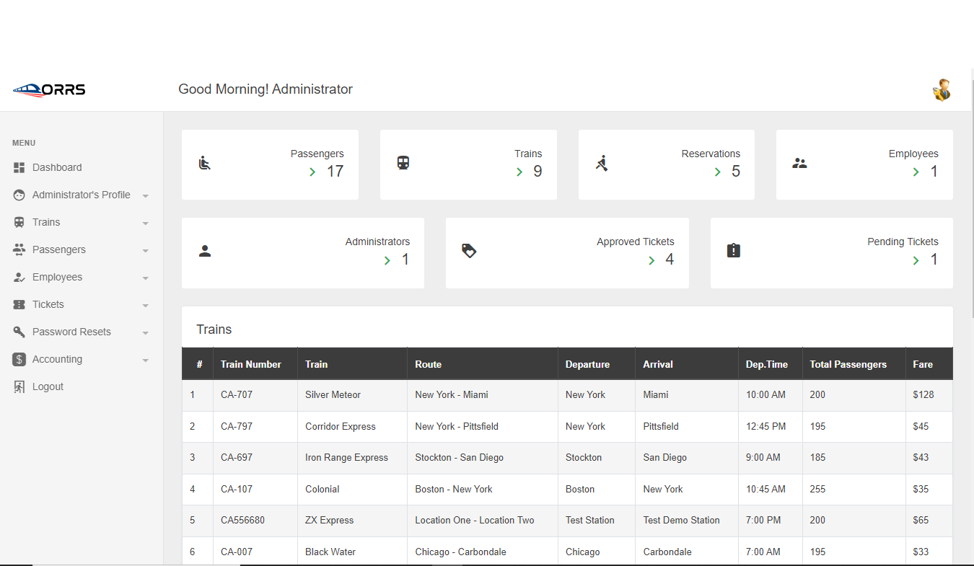

**ADMIN PANEL**

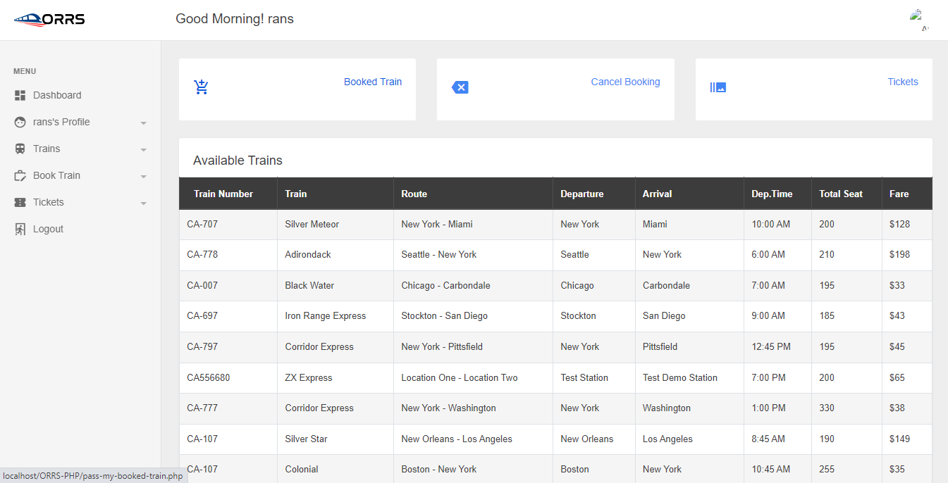

**PASSENGER DASHBOARD**

# **CHAPTER FOUR**

## **IMPLEMENTATION AND TESTING**

**SYSTEM TESTING**

**Stage 1: User Registration and Authentication**

**Step 1: User Registration**

1. Visit the Railway Reservation System website or mobile app.

2. Click on the "Sign Up" or "Register" button.

3. Fill out the registration form with your personal information, including your name, contact details, and desired username and password.

4. Verify your email address by clicking on the verification link sent to your email.

**Step 2: User Authentication**

1. Return to the system's login page.

2. Enter your registered username and password.

3. Click the "Login" button.

4. You are now successfully logged into the system.

**Stage 2: Train Search and Selection**

**Step 1: Search for Trains**

1. On the system's main dashboard, enter your journey details, including the origin, destination, date of travel, time preferences, and class (e.g., economy or business).

2. Click the "Search" or "Find Trains" button.

**Step 2: View and Select Trains**

1. A list of available trains matching your criteria will be displayed.

2. Review the train options, departure times, and seat availability.

3. Select your preferred train by clicking on it.

**Stage 3: Seat Selection and Booking**

**Step 1: Select Seats**

**1. The system will display a seat map for the selected train.**

**2. Choose your desired seats by clicking on the available seats in the desired class.**

**3. The selected seats will be added to your booking.**

**Step 2: Confirm and Book**

1. Review your seat selection, and if satisfied, click the "Book" 2. The system will prompt you to enter the names and contact details of passengers traveling with you.

3. Confirm the fare and click "Continue"

**Stage 4: User Accounts**

**Step 1: Access User Account**

1. Click on your profile or account settings.

2. Log in using your registered username and password if you're not already logged in.

**Step 2: View Booking History**

1. In your user account, access the "Booking History" or "My Reservations" section.

2. You can view a list of your past and current reservations, including details like travel date and PNR numbers.

**Step 3: Ticket Cancellation**

1. To cancel a reservation, click on the specific booking you want to cancel.

2. Follow the system's cancellation procedure and confirm the cancellation.

**Stage 5: Real-time Availability Updates**

**Step 1: Check Seat Availability**

1. To check real-time seat availability, go to the system's main dashboard.

2. Enter your journey details and click "Search" or "Find Trains" to access the available trains.

3. Seat availability for each train will be displayed alongside the train options.

**Stage 6: Ticket Confirmation and Alerts**

**Step 1: Booking Confirmation**

1. After successfully booking a ticket, the system will provide a booking confirmation on the screen.