**Suse Linux new server SAP server Build actifio clone**

**SOP: SAP environment new suse server build through SELS enterprise Linux SAP through actifio backups and clone aption.**

**Prerequisite:**

1. Get server requirements from SAP basis, DB team, Application owners.
   1. Request for new hostname and IP make sure they are in correct VLAN using standard vlan for Virtual machines in CDC.
   2. Identify source server which is going to be clones to new server. Check total size VM size and system resources like CPU, Memory, cluster name, VLAN. Target cluster always will be non-prod-linux2.
   3. Capture disk information from VMware and OS on source servers.
   4. Identify list of accounts need to be rename on target or clone server based on SID.
   5. Identify how many servers need to be cloned and like CI/APP and DB or only one server.
   6. Identify Data store based on total VM size. If the VM is more than 1.5 TB always use separate data store for DB and CI.
   7. Identify ESX hostname in NON-PROD-Linux cluster and check with backup or storage team if they can able to see in actifio appliances for restore.
   8. Check with DB Team placing DB in backup and copy archive logs to safer location to avoid re-work. Or they are going to use crash consistency .This point very critical.
   9. Verify vSphere resource capacity exists in VMware before beginning the VM build;
      * Is there enough Memory capacity
      * Is there enough CPU capacity
      * Is there enough capacity in data store.

**Implementation task:**

1. Check source server part of actifio backups by login into VC console and check at tasks and events from initiator “DRIV\\svc_actifio”.

2. Inform DB Team put DB in backup mode and copy archive logs to safer location to avoid re-work and this should be in source server only. Nothing required for APP/CI servers.

3. Inform storage team use VM name only while restore backup to VM to ESX host or cluster example CDCVILLX290 only not with source servername xxxxdate time.

4. Inform storage team always use clone option to restore even through may take longer time and its simple affective. If the vm size more than 3 TB and we don’t have single data store with free size 3 GB use mount option(this option always EP1 landscape DB servers.

5. Once restore been completed and appears in inventory and verify all the hardware resources restored as per source machine like number of disks,CPU and network.

6. Change VLAN to other dummy other than Unix VLAN’s with double digit number. Uncheck/disable network card. Make sure network interface should not active after we power on VM.

7. Power ON VM and observer boot process. Login to the VM using GUI and verify all the file system been mounted. Perform same for CI server.

8.Disable all cron jobs of root and oraSID and SIDadm

9. Make sure no SAP/oracle process running and if required use kill -9 commands.

**OS related changes.**

1. Change hostname and IP and gateway use . Use GUI to change hostname and IP’s from yast. Applications 🡪system tools 🡪yast 🡪network settings 🡪overview 🡪 EDIT

Capture MAC ID of VM and delete old configurations.

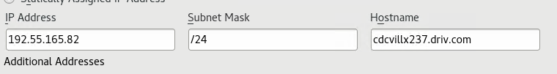

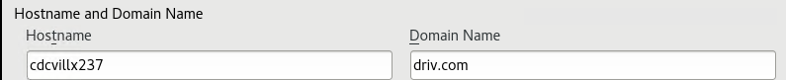

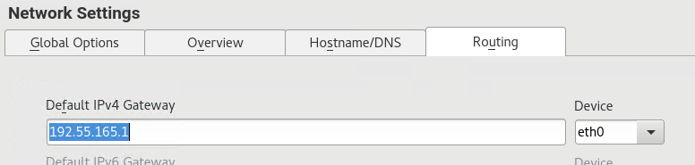

Login to CI/DB server disable cronjobs root , oraSID and SAP related, SOX audit’s related scripts. Re-check any application specific ID’s using crob jobs were enabling or not. Always disable them.

Check DB and CI server for NFS related mounts from another environment comment out (on CI) and /etc/fstab.

Check for any SAP process is running on CI/APP server and kill them. Disable or stop oracle OEM related process and make sure no sap related process running on before we enable network.

Enable network settings at VM and point to correct VLAN.

Login to the server using ssh.

Umount /oracle/SID,/usr/sap/SID, /sapmnt/SID mount points.

Go to /oracle use move comment to rename new SID mv example :EQ5 ES1. Perform same to sap mounts like /usr/sap and /sapmnt.

Update NEW SID on /etc/fstab on servers like DB/CI . Run mount -a . Validate through df and compare the size with source server.

Update NEW SID on /etc/exports on CI server and make sure NFS server is up and running. Run Exportfs –a.

Change all DB related mount point permissions to new SID on /oracle/SID.

Change all SAP related mount point permissions to new SID on all oracle and SAP related mount points.

Oracle :chown -R orasid:dba

SAP: chown -R sidadm: sapsys

chown -R oraeq3:dba oraarch

chown -R oraeq3:dba sapdata1

chown -R oraeq3:dba origlogA

chown -R oraeq3:dba mirrlogA

chown -R oraeq3:dba origlogB

chown -R oraeq3:dba mirrlogB

Login to DB server update /etc/fstab NFS mounts with NEW SID. Change the permission to new SID.

Mount it manually or use mount –a command.

Check for link folders in CI/APP server for /usr/SAP or /sapmnt.

Transport related mounts need to mount based on BASIS team inputs only.

Update main.cf as per new hostname.

**User steps for user ID rename as per SID.**

usermod -l eqtadm eq5adm

usermod -l oraeqt oraeq5

usermod -l oraes1 oraeq5

cdcvillx222:/usr/sap # id eq5adm

uid=2603(eq5adm) gid=700(sapsys) groups=800(dba),900(oper),1000(sapinst),700(sapsys)

cdcvillx222:/usr/sap # grep eq5adm /etc/passwd

eq5adm:x:2603:700:SAP System Administrator:/home/eq5adm:/bin/csh

cdcvillx222:/usr/sap # cd /home

cdcvillx222:/home # ls -ld eq5adm/

drwxr-xr-x 7 eq5adm root 4096 Oct 27 21:30 eq5adm/

cdcvillx222:/home # mv eq5adm es1adm

cdcvillx222:/home # usermod -l es1adm eq5adm

cdcvillx222:/home # vi /etc/passwd

cdcvillx222:/home # pwconv

cdcvillx222:/home # usermod -l oraes1 oraeq5

cdcvillx222:/home # id oraes1

uid=2604(oraes1) gid=800(dba) groups=900(oper),1000(sapinst),800(dba)

cdcvillx222:/home # su - oraes1

RDM to regular disk through storage vmotion.

Always better to convert RDM disks of first 2 disks of 50 GB when VM is power off.

Avoid datastore location same as present RDM disk location.

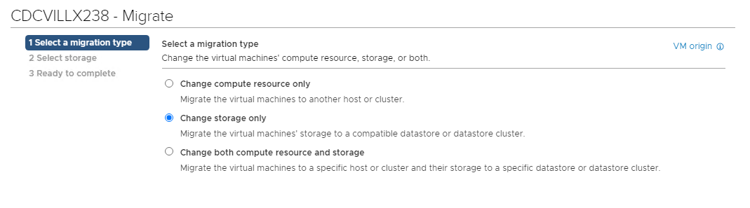

Enable configure per disk

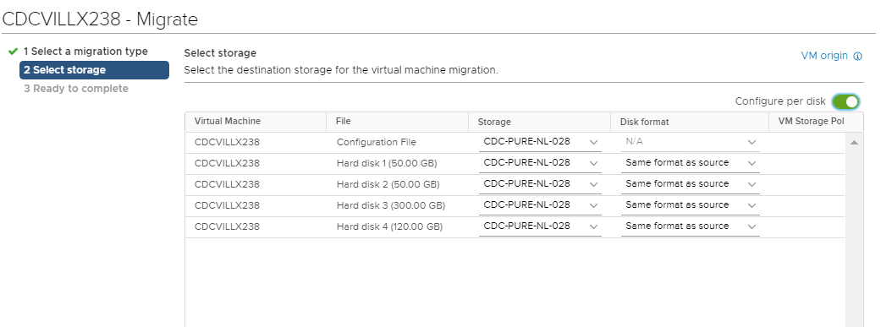

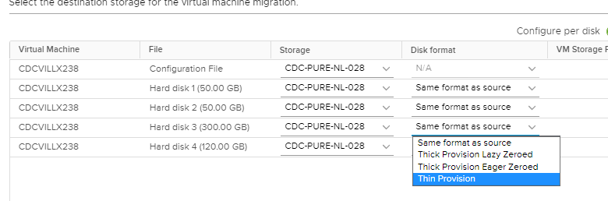

Identify disk and select storage and browse and select correct data store. Always use disk format thick provision eager zeroed for sap related mount point. For OS and other oracle base use thick provision lazy zeroed or get data from rvtools as a reference.

Once all the diks were completed and check with actifio if they can able to backup the VM. Once conversion completed dik mode should be dependent only. To make this change we need to power off the VM.

