Methods
Power analysis: We conducted a power analysis to determine the number of subjects required to detect differences between three separate groups in a one-way ANOVA using a power of 0.90 and an α of 0.05. We based our effect size on data for final step length asymmetry (Sombric and Torres-Oviedo 2019) and strides to plateau (Malone and Bastian 2016).
###
Subjects: Participants in the split-belt walking study (n = 45; 24W, 21M) with an average age of 24.5 ± 4.79 (mean ± standard deviation) years all signed a consent form approved by the Institutional Review Board at the University of Colorado Boulder. Participants were healthy and reported no known neurological or balance disorders and had no recent injuries affecting the lower limb. All participants were compensated for their time. Participants were evenly divided into randomly assigned effort conditions—high, low, and control—which were differentiated by the additional weight worn in a vest during the task. Three participants were excluded because they were unable to walk comfortably on the treadmill or unable to let go of the handrails during fast tied or split-belt blocks. Ultimately, the three groups (low, high, and control) consisted of 15 participants each. Of the participants in the low or high effort conditions, 22 returned for a second visit within 14 days to repeat the task in the opposite condition (11 participants high- low and 11 participants low – high, see figure 5c).
Experimental setup: All participants walked on a treadmill with a separate belt for each foot (Bertec Instrumented Treadmill). Participants wore a weighted vest which contained no additional weight (control condition), 5% of bodyweight (low effort condition), or 15 % of bodyweight (high effort condition). Weight was added to the vest weight in 1.13 kg (2.5 lbs.) increments, so percentage body weight was rounded down from 5% bodyweight in the low effort condition and rounded up from 15% bodyweight in the high effort condition. Treadmill speeds were always 0.5 m/s (slow speed) or 1.5 m/s (fast speed) and accelerated from a stop at a rate of 0.5 m/s. During tied blocks, the two belts moved at the same speed. During split blocks, one belt moved at the fast speed while the other moved at the slow speed. Participants were randomly assigned a “fast leg,” right or left, and the assignments were kept even within groups. For participants who visited the lab twice and completed the task in high effort and low effort conditions, the order of conditions was counterbalanced while participants’ “fast leg” was consistent between visits so that any observed changes in learning would not be confounded with differences in generalization.
Protocol: Participants completed seven walking blocks with short (less than 30 second) pauses between blocks. Participants were warned of stops or starts by a series of three beeps and instructed to prepare to grab the handrails if needed, but let go within 5 seconds of the trial starting to minimize effects of handrail grasping on the adaptation process (Buurke et al. 2019). The first block consisted of 1 minute walking with both belts at slow speed. This was included to help accustom participants to walking on the two separate belts. The second and third blocks were two minutes each tied at the fast and slow speed respectively to record baseline gait parameters during symmetrical walking. During the learning block, the split-belt perturbation (belt ratio 3:1 with speeds at 1.5 m/s and 0.5 m/s) was introduced and remained constant for 10 minutes while participants walked continuously. Following learning, adaptation was washed out during a 15-minute block of continuous walking at the slow speed. During relearning, the belt speeds split again for 10 minutes, keeping fast leg consistent with the first learning block. Participants finished the task with 2 minutes walking at the tied slow speed to ensure a safe return to overground walking.
Data Collection: During each block of the walking task, ground reaction forces and moments were collected via force plates embedded in the treadmill belts at a sampling rate of 1000Hz. Motion capture data based on a Plug-In Gait model with 16 reflective markers placed on the lower body was collected at 100 Hz (Vicon Vero Cameras; Vicon Nexus software). The Plug-In Gait Model, shown for one side of the body includes markers on the right and left toe, heel, malleolus (ankle), knee, thigh, and anterior and posterior superior iliac crests (pelvis). Data was processed in Vicon Nexus software and analyzed using custom MATLAB scripts.
Metrics: We will define a stride as the movement between a heel strike and the subsequent heel strike on the same foot. Stance is the movement while the foot is on the ground, starting with a heel strike and finishing with a toe off. Swing is the movement while the foot is in the air, after toe off and before the next heel strike. A step corresponds to the stance and swing for a single leg. Step length (SL) is calculated as the distance between the feet at the time of forward foot heel strike. Step time is the time between heel strikes on opposite feet.
The primary metric for learning in split-belt adaptation is step length asymmetry (SLA), defined as
 | $$SLA = \frac{{SL}_{fast} - {SL}_{slow}}{{SL}_{fast}+ {SL}_{slow}}.$$ | Equation 1
Step length asymmetry describes the ratio of step lengths between the leg on the fast belt and the leg on the slow belt and tends gradually toward symmetry (SLA = 0) over the course of learning.
Step width was calculated as the frontal plane distance between the heel markers at the time of heel strike, so that right side step width was the distance between the heels at the time of right heel strike (Donelan et al. 2001).
Statistics: As is common in split-belt literature, blocks of trials representing initial (strides 1-5), early (strides 6-30), late (strides 31-200), and plateau (final 30 strides) were compared using One-way ANOVA (Day et al. 2018; Leech et al. 2018; Sombric and Torres-Oviedo 2020).
 | $${\hat{y}}_{n+1} = α{\hat{y}}_{n} + β(y - {\hat{y}}_{n}).$$ | Equation 6
State space learning model: To examine learning rates, we fit step length asymmetry using the state space learning model.
The state space model predicted the participant’s estimate of the rotation, $\hat{y}$, on a given trial $n$, based on recall of the estimate on previous trial and error on the previous trial. The estimate from the previous trial was weighted by a remembering factor, α, which described how much of the previous estimate is remembered in the new estimate. The error from the previous trial is $(y - {\hat{y}}_{n})$, the difference between the actual rotation and the estimated rotation, was weighted by a learning rate, β, which described the participant’s sensitivity to error. Both remembering factor and learning rate are in the interval [0,1].
We fitted the model in a custom script using MATLAB’s fmincon function to minimize mean squared error. The state space model captures two important characteristics of motor learning: the rate of learning, describing how quickly a participant adjusts their gait to improve symmetry, and the extent of learning, describing the how close the participant’s asymmetry asymptote is to symmetry. The extent of learning is a function of the forgetting factor and the learning rate because, in the model, the asymptote is the error value at which the remembering term and the error term cancel one another out so that the forgotten portion of the previous trial is recovered by the error term. We compared the terms of state space learning fits between groups using one-way ANOVAs. Results were similar when the data was fit across all strides of the learning block to when the data was fit using only the first 200 strides, therefore the state space fits for the asymmetry curves include all strides in the learning block.
Exponential fit of learning: As a secondary check to compare curves, we fit step length asymmetry curves to a single exponential function using MATLAB’s fminsearch function to minimize mean squared error. We calculated fit parameters according to an exponential function: $SLA\left(t\right)=Ae^{βt}+ c$, and interpreted the coefficient as the change in symmetry from the start of learning to the end( $A = ∆SLA$), the constant as the final value of asymmetry after adaptation $c = {SLA}_{final}$ , and the rate term $β$ as the learning rate. As with the state space learning rate, relatively higher values indicated more complete learning in fewer strides. Results for exponential learning rates were compared using one-way ANOVAs. As in the state space fit, results were similar when the data was fit across all strides of the learning block to when the data was fit using only the first 200 strides, therefore the exponential models for the asymmetry curves include all strides in the learning block.
Bootstrapping: To estimate the population distribution, we bootstrapped the state space and exponential fit data in two ways and reevaluated the comparisons between groups. In the first bootstrapping protocol, individual’s SLA curves were sampled with replacement, averaged, and fit using the state space and exponential models described above. In the second bootstrapping protocol, individuals’ fit parameters were sampled with replacement. In protocols and for both models, bootstrapping was repeated 10000 times.
Linear mixed effects regression: We used linear mixed effects models (LMER) to examine the predictive power of effort-related variables. These models were run using the lmer function in custom R Studio scripts. To linearize the data, we applied a log transformation on the trial number. The limitation of this transformation is that the log transform used to linearize the data linear fit is biased by trials early in the testing session. Since this is where we expect differences in learning rate to appear, it is difficult to parse whether the significant results are representative of the data or a consequence of the LMER bias.
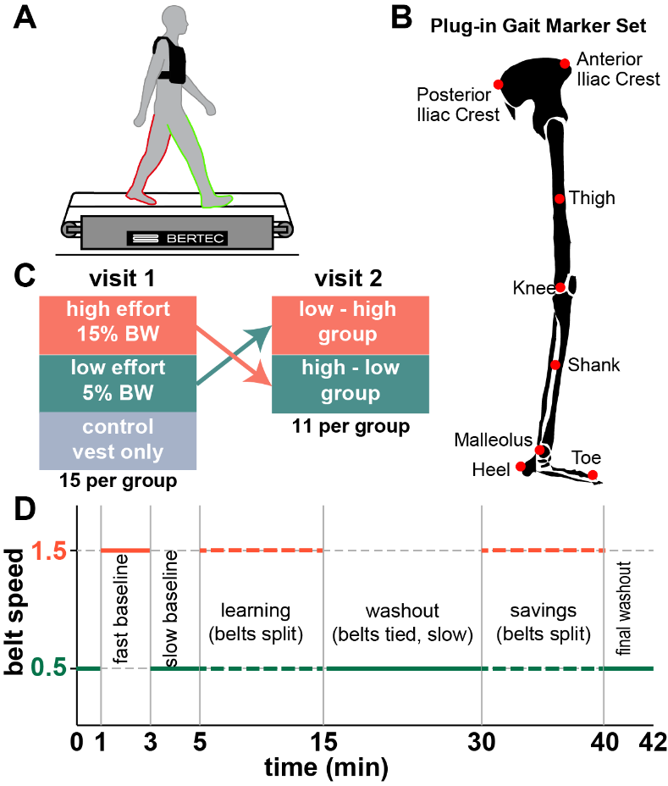
Figure 5: Split-belt methods
Methods for split belt walking task. A) split-belt walking shown with different belts for each leg. Handrails on either side are not shown. B) Plug-In Gait marker placement for the right side. Marker placement is mirrored on the left. C) Crossover study design. D) Protocol for baseline, learning, washout, and savings blocks.

