RESULTS: the role of effort in adaptation to split-belt locomotion\
Last paragraph of the introduction (the question part):
During movement, humans move using strategies and speeds that are consistent with minimum effort. When learning new movements or adjusting their movements to novel environments, the process of learning is characterized by a reduction in error. In several common motor learning paradigms, the error-reduction process is paralleled by decreasing metabolic cost (Finley et al. 2013; Huang et al. 2012; Huang and Ahmed 2014). In the case of split-belt walking, we consider step length asymmetry, the difference between step length on the fast and slow leg divided by the total length of the stride, to be the error metric and we define progress toward 0 (perfect symmetry) as learning. This step length adaptation is accompanied by reductions in metabolic cost, so that error and effort decrease in tandem during learning (Finley et al. 2013).
We ask whether the motor system is trying to reduce error, effort, or both? Does one cost contribute more to drive the learning process? We posit that effort itself might play an important role in driving or modulating learning and investigate this possibility using a split-belt learning task where effort is modulated by adding a weighted vest to the participant for the duration of the walking task.
Last paragraph of introduction (the results part):
Despite the important role of effort in movement selection and clear trends of effort reduction over the course of adaptation and learning, we found no evidence of a causal or modifying role of basic effort costs in motor adaptation to a split-belt perturbation. We measured the step length asymmetry for three different effort conditions over two 10-minute split-belt adaptation blocks separated by a 15-minute washout. Each effort condition included 15 participants unfamiliar with split-belt perturbation and wearing a weighted vest (15% bodyweight, 5% bodyweight, and vest only for the high, low, and control conditions). The progression of step length asymmetry over strides in the split belt perturbation blocks did not differ between the three groups in either of the split-belt adaptation blocks during the first visit. Step length asymmetry aftereffects were similar between groups during washout. Step width asymmetry, step time asymmetry, and variabilities related to each of these metrics and their constituent measures were also similar between groups. A subset of individuals in the high and low effort groups returned to the lab for a second visit, completing the task in the opposite effort condition. Their data showed strong savings with no difference between groups or related to the order of effort conditions. While effort may not mediate motor adaptation, our findings imply that increasing the effort cost of movements as part of a rehabilitation protocol could improve strength without impairing learning or adaptation.
RESULTS
Participants across effort conditions walked with symmetrical gaits during baseline.
All participants completed 2-minute blocks of symmetrical walking on the treadmill at the fast speed (1.5 m/s) and at the slow speed (0.5 m/s) while wearing the weighted vest. Step length was similar between groups in fast and slow baseline. The mean step length for the last 30 strides was 674 ± 10.2 mm for the high effort group, 681 ± 12.2 mm for the low effort group, and 672 ± 14.3 mm for the control group (one-way ANOVA: p = 0.866). For slow baseline, mean step lengths were 400 ± 8.8 mm for the high effort group, 395 ± 12.1 mm for the low effort group, and 401 ± 10.0 mm for the control group (one-way ANOVA: p = 0.903). Similar to step length comparisons, fast and slow baseline step times were similar between effort groups (One-way ANOVA for fast baseline: p = 0.708; for slow baseline: p = 0.957).
Step length variance in fast baseline was similar between the high, low, and control effort groups (one-way ANOVA: p = 0.283). Variance in slow baseline remained similar between groups (One-way ANOVA: p = 0.121). Step length variance decreased slightly between the fast and slow baseline for the high effort group (p = 0.003). Decreases in the other two groups were nonsignificant (low effort p = 0.199, control p = 0.233).
All groups had symmetrical steps for each of the fast and slow baseline conditions. Step length asymmetry measures for the last 30 strides of baseline were compared to symmetry (asymmetry = 0) using t-tests.
t-test for baseline symmetry | High effort | Low effort | control
Fast baseline | p = 0.709 | p = 0.891 | p = 0.631
Slow baseline | p = 0.360 | p = 0.306 | p = 0.125

To clarify whether the added weight affected walking stability, we analyzed step width during baseline walking. Step widths were similar between effort conditions in both baseline (ANOVA fast: p = 0.745; slow: p = 0.148). Step width variance was also similar between groups (fast: ANOVA p = 0.783; slow: ANOVA p = 0.147).
Braking and propulsion differed between effort groups during fast baseline walking.
Since prior work has implicated ground reaction forces as mediators of split-belt adaptation (Ogawa et al. 2014; Sombric et al. 2019), we compared ground reaction profiles between effort groups, looking first at peak braking and propulsion and then at push-off impulse. For this analysis, forces are normalized to bodyweight (not including the group-specific added weight).
Normalized peak braking forces differed between groups in fast baseline walking (one-way ANOVA p = 0.018) driven by a difference between the high and low effort groups (t-test p_{high-low} = 0.010) while neither of the other pairwise comparisons revealed significant differences (p_{high-control} = 0.186; p_{low-control} = 0.099). In slow baseline, the magnitude of braking forces did not differ between groups (one way ANOVA: p = 0.130).
Normalized peak push off forces differed between effort groups in the fast baseline walking condition (one way ANOVA: p = 0.001). Pairwise comparisons indicated differences between the high effort groups and the other two conditions, low effort and control (p_{high-low} < 0.001; p_{high-control} = 0.009; p_{low-control} = 0.576). In the slow walking baseline condition, there was no differences between peak braking forces (one way ANOVA: p = 0.371).
We also compared push off impulse (time integrated propulsive force) between groups. Impulse sums push off force across the duration of stance, when the foot is on the treadmill belt, and may reveal differences in propulsion that might not be apparent in the peak push off metrics due to stance duration and stride frequency. Propulsive impulse was significantly different between effort groups in the fast baseline condition (one-way ANOVA: p = 0.014). The difference was driven by differences between the high and low effort group (t-tests: p_{high-low} < 0.001; p_{high-control} = 0.053; p_{low-control} = 0.494). There were no differences between groups in the slow baseline block (one way ANOVA: p = 0.430).
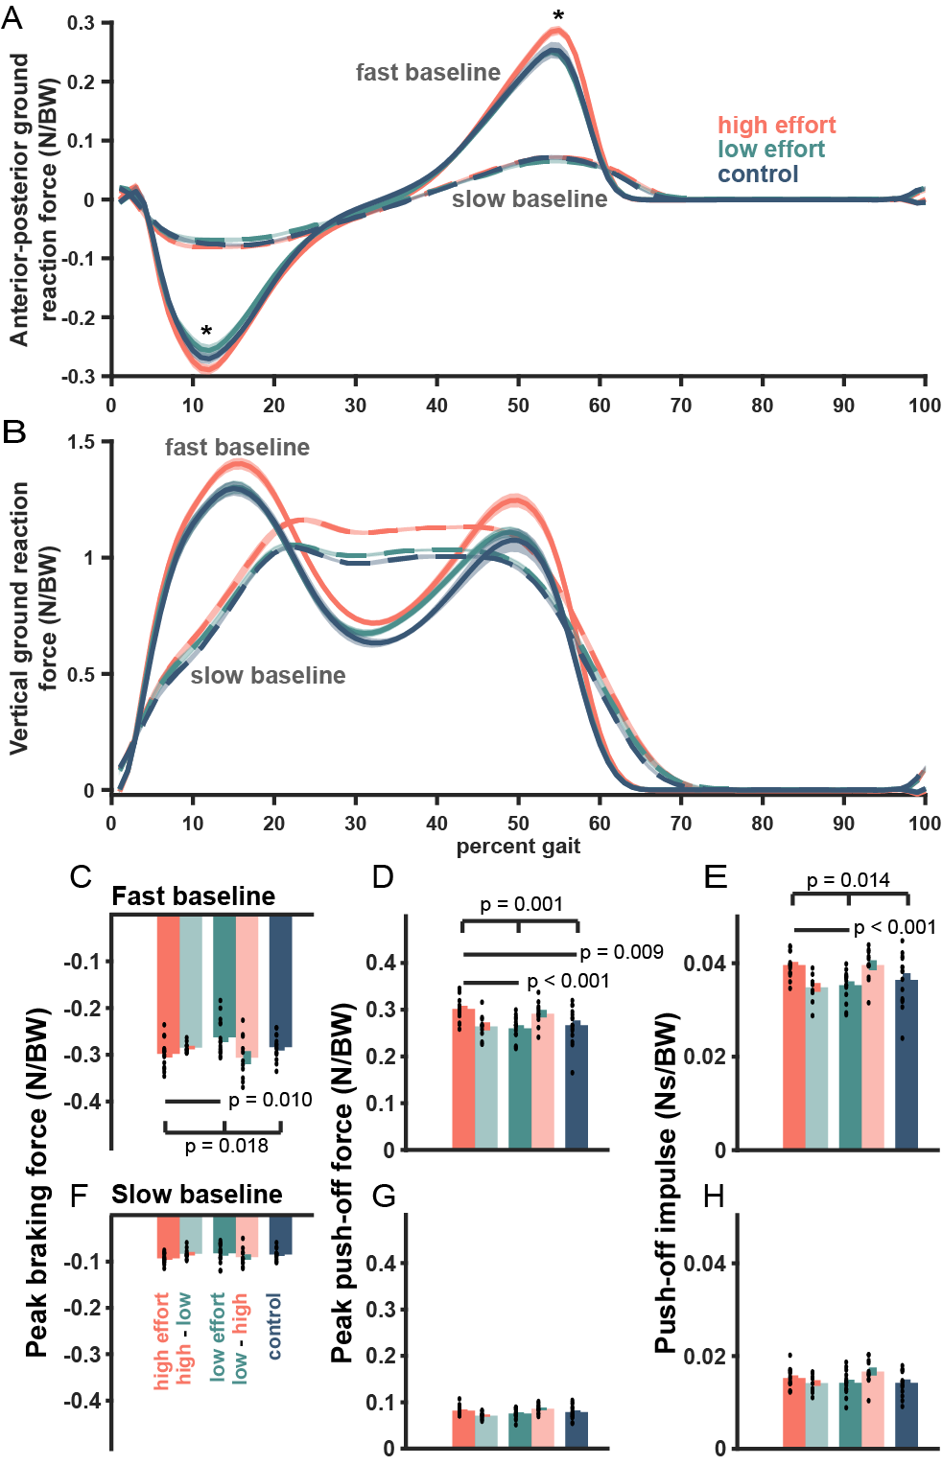
Figure #: Baseline ground reaction forces normalized by bodyweight (not including weight added to differentiate effort condition). A) Anterior-posterior ground reaction forces for slow baseline (dashed) and fast baseline (solid). The high effort group has significantly higher magnitudes of peak braking and peak push off force. B) Vertical ground reaction forces for slow and fast baseline. C) Peak braking force during fast baseline showing differences between the three effort groups (p = 0.018), driven by the higher magnitude braking in the high effort group versus the low effort group (p = 0.010). D) Peak push off force during fast baseline showing differences between the three effort groups including significant differences between the high effort group and the low effort group (p = 1.4e-04) and between the high effort group and the control group (p = 0.008). E) Push off impulse during fast baseline showing differences between the three effort groups including between high effort and low effort (p = 4.2e-04). The difference between high effort and control was trending toward significance with p = 0.053. F) Peak braking force for slow baseline. G) Peak push off force for slow baseline. H) Push off impulse for slow baseline.

ADAPTATION
Participants in the high, low, and control effort groups adjusted their step lengths toward symmetry at similar rates and reduced their asymmetry to similar final values.
Over the course of exposure to the split-belt, the step length asymmetry progresses from asymmetry toward symmetry. For strides early in the block, step length asymmetry is negative for all groups indicating that participants responded to the split-belt perturbation by taking longer steps on the slow leg. Over time, participants in all groups adjusted their relative fast and slow step lengths to be more similar, although a slight bias toward longer steps on the slow leg persisted for the duration of the 10-minute learning block.
Binned comparison. To match common split-belt analyses in the literature, we compared step length asymmetry during blocks of trials representing different phases of the learning process (initial: strides 1-5, early: strides 6-30, late: strides 31-200, and plateau: final 30 strides) using one-way ANOVA (Leech et al. 2018). We found no difference between groups at any phase of the learning process. (ANOVA on initial bin: p = 0.464; early bin: p = 0.110; late bin: p = 0. 298; and plateau bin: p = 0.361). Pairwise comparisons of the high effort, low effort, and control groups also yielded no significant differences.
Pair compared | Initial | Early | Late | Plateau
High v Low | p = 0.332 | p = 0.070 | p = 0.127 | p = 0.219
High v Control | p = 0.882 | p = 0.841 | p = 0.438 | p = 0.163
Low v Control | p = 0.296 | p = 0.102 | p = 0.433 | p = 0.726

We used the same binned learning phases to assess step length variability. We first established that step length variance did not differ between the fast and slow legs for any group during any phase of learning.
Fast v. Slow leg | Initial | Early | Late | Final
High effort | p = 0.333 | p = 0.310 | p = 0.625 | p = 0.233
Low effort | p = 0.560 | p = 0.695 | p = 0. 902 | p = 0. 556
Control | p = 0. 226 | p = 0. 557 | p = 0. 827 | p = 0. 640
Since there was no difference between the fast and slow legs, we considered the fast and slow legs together to compare step length variability between groups during the binned learning phases. Our results suggested similar variance regardless of effort condition. The variance was (One-way ANOVA between groups on initial bin: p = 0.273; early bin: p = 0.182; late bin: p = 0. 273; and plateau bin: p = 0.304). Finally, we assessed variance of step length asymmetry and found no differences between asymmetry variability (ANOVA on initial bin: p = 0.170; early bin: p = 0.565; late bin: p = 0. 217; and plateau bin: p = 0.271).
Steps to plateau. For initial learning, the first stride to the plateau was 172.6 ± 35.35 strides for the high effort condition, 182.6 ± 21.53 strides for the low effort condition, and 156.5 ± 31.15 strides for the control condition (One-way ANOVA: p = 0.825).
State space fit. Each participant’s SLA curve was fitted with a state space model including a remembering factor (α) and a learning rate (β). Remembering factor represents what proportion of the asymmetry from the previous stride is carried forward into the next and learning rate captures sensitivity to asymmetry. A high learning rate indicates a high sensitivity to error and will result in rapid initial progress toward symmetry. Both remembering factor and learning rate were similar between groups.
State space fit parameter | High effort | Low effort | Control effort | One-way ANOVA
Remembering factor (α) | 0.97 ± 0.005 | 0.98 ± 0.005 | 0.97 ± 0.005 | p = 0.657
Learning rate ($β$) | 0.01 ± 0.001 | 0.01 ± 0.001 | 0.01 ± 0.002 | p = 0.554
Initial asymmetry (${\hat{y}}_{1}$) | -0.43 ± 0.028 | -0.48 ± 0.039 | -0.43 ± 0.031 | p = 0.463

Exponential fit. Step length asymmetry curves were descriptively modeled for each participant using a single exponential function. In the fit function, the exponential coefficient represents the change in asymmetry ($∆SLA$), the exponential rate (β) represents the learning rate, and the exponential constant represents the final asymmetry or plateau (${SLA}_{final}$).
Exponential fit parameter | High effort | Low effort | Control effort | One-way ANOVA
Coefficient ($∆SLA$) | -2.07 ± 1.657 | -0.45 ± 0.040 | 2.91 ± 2.490 | p = 0.597
Learning rate ($β$) | 0.03 ± 0.007 | 0.03 ± 0.005 | 0.05 ± 0.011 | p = 0.222
Constant (${SLA}_{final}$) | 1.59 ± 1.653 | -0.07 ± 0.023 | 2.39 ± 2.487 | p = 0.591

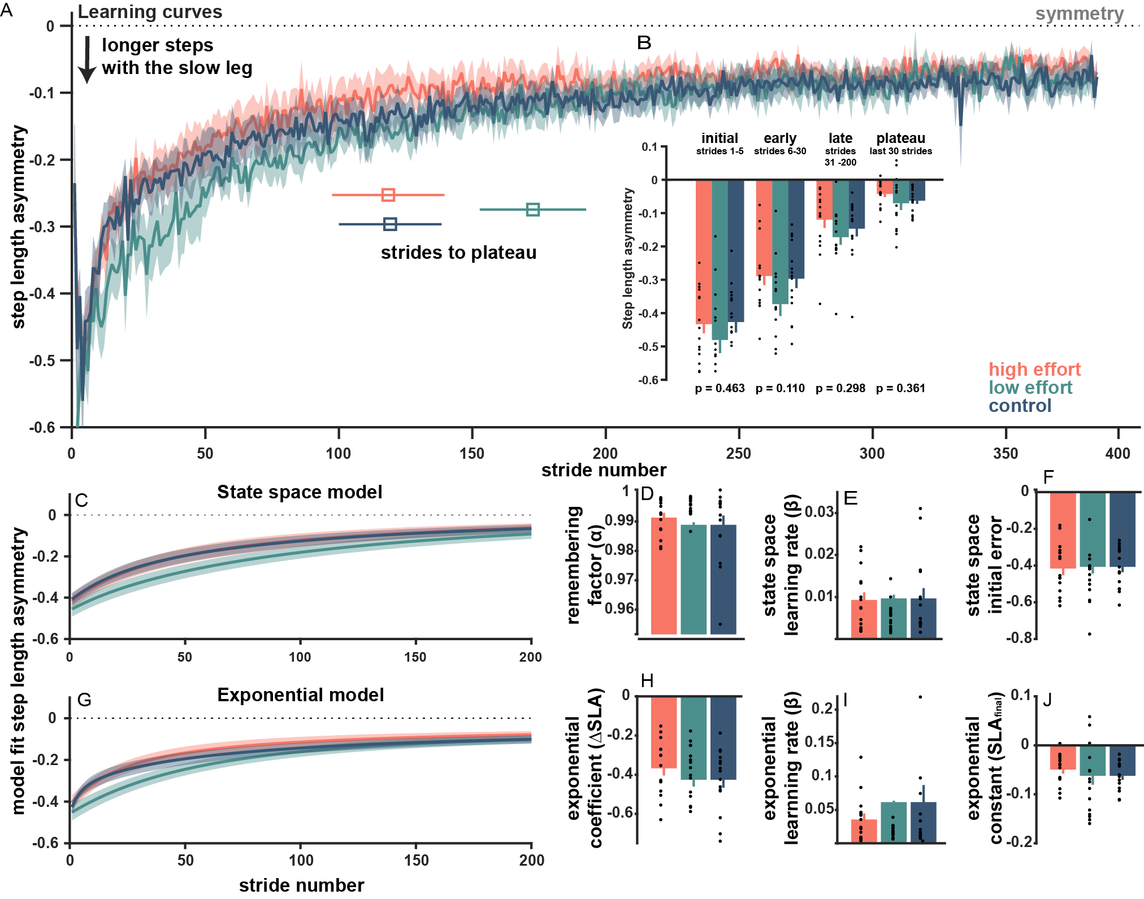
Figure #: Initial adaptation to the split-belt perturbation. A) step length asymmetry across strides during the 10-minute split-belt adaptation block for each of the three effort groups including average strides to plateau. B) Binned step length asymmetry for the initial learning block comparing the average asymmetry during the first 5 strides (initial), strides 6 – 30 (early), strides 31 – 200 (late), and the last 30 strides (plateau). C) State space model fit curves. The plotted curves are the average of unique, individual subject fits and show the slight divergence of the low effort group early in the adaptation block. D-F) Remembering factor, state space learning rate, and state space initial error for each group. G) Exponential model fit curves, curves shown are the average of individual fit curves showing the slight divergence of the low effort group early in adaptation as well as potential differences in the plateau phase of the adaptation block. H-J) exponential fit parameters including the exponential coefficient, the exponential learning rate, and the exponential constant.
Participants showed similar step length asymmetry aftereffects during washout.
Binned comparison. As in the split-belt block, we compared blocks of trials from different phases of washout where participants were readjusting the tied-speed belt walking. We found no difference between groups at any phase. (Initial bin: p = 0.699; early bin: p = 0.740; late bin: p = 0. 900; and plateau bin: p = 0.560). By the end of the 15-minute washout block, where participants walked at 0.5 m/s, asymmetry was 0.02 ± 0.002 for the high effort group, 0.01 ± 0.003 for the low effort group, and 0.01 ± 0.003 for the control group. When compared against slow baseline, the control group had returned to baseline symmetry (p_{control} = 0.778), but the high and low effort groups remained slightly asymmetric (with longer steps on the fast leg) (p_{high} = 0.044; p_{low}=0.013). When tested against perfect symmetry, both the low and control groups were fully symmetric during the washout plateau (p_{low}=0.383; p_{control} = 0.144), but on average the high effort group remained asymmetric (p_{high} = 0.006), biased toward longer steps on the fast leg.
We also compared step length variability during washout, finding no difference between legs previously exposed to the fast or slow belt except in the low effort group, which showed higher step length variance in the slow leg during the last 30 strides of washout (p = 0.020). Given the range of variability between subjects, this finding may be spurious. Using variability measures from both legs combined, we found no differences between groups’ step lengths (ANOVA on initial bin: p = 0.501; early bin: p = 0.530; late bin: p = 0. 611; and plateau bin: p = 0.635) or step length asymmetry (ANOVA on initial bin: p = 0.825; early bin: p = 0.984; late bin: p = 0. 319; and plateau bin: p = 0.880) during washout. All three groups returned to variabilities consistent with slow baseline during the plateau bin (paired t-test between the washout plateau and slow baseline variability p_{high}= 0.351; p_{low}= 0.538; p_{control} = 0.102).
Strides to plateau. For rehabilitation applications, researchers are interested in extending the magnitude and duration of aftereffects following a bout of split-belt training. For washout after initial learning, the first stride to the plateau was 91.1 ± 18.46 for the high effort condition, 97.3 ±19.43 for the low effort condition, and 97.9 ±19.04 for the control condition (one-way ANOVA: p = 0.962).
State space fit. For washout, step length asymmetry curves were fitted with a state space model to capture the decay of aftereffects of the split-belt perturbation. Remembering factors and learning rates were similar between groups, though in a pairwise comparison remembering factor is higher in the high effort group than in the control (p_{high-control} = 0.044).
State space fit parameter | High effort | Low effort | Control effort | One-way ANOVA
Remembering factor (α) | 0.99 ± 0.004 | 0.98 ± 0.006 | 0.97 ± 0.005 | p = 0.155
Learning rate ($β$) | 0.01 ± 0.002 | 0.03 ± 0.012 | 0.02 ± 0.010 | p = 0.311
Initial asymmetry (${\hat{y}}_{1}$) | 0.34 ± 0.048 | 0.34 ± 0.046 | 0.33 ± 0.062 | p = 0.571

Exponential fit. Exponential curve fits of washout indicated no differences in the magnitude or decay of aftereffects between groups.
Exponential fit parameter | High effort | Low effort | Control effort | One-way ANOVA
Coefficient ($∆SLA$) | 0.43 ± 0.098 | 0.37 ± 0.067 | 0.73 ± 0.265 | p = 0.292
Learning rate ($β$) | 0.05 ± 0.016 | 0.08 ± 0.029 | 0.10 ± 0.043 | p = 0.505
Constant (${SLA}_{final}$) | -0.06 ± 0.095 | 0.02 ± 0.012 | -0.26 ± 0.277 | p = 0.501

FIGURE: washout, binned comparison, curvefits, strides to plateau
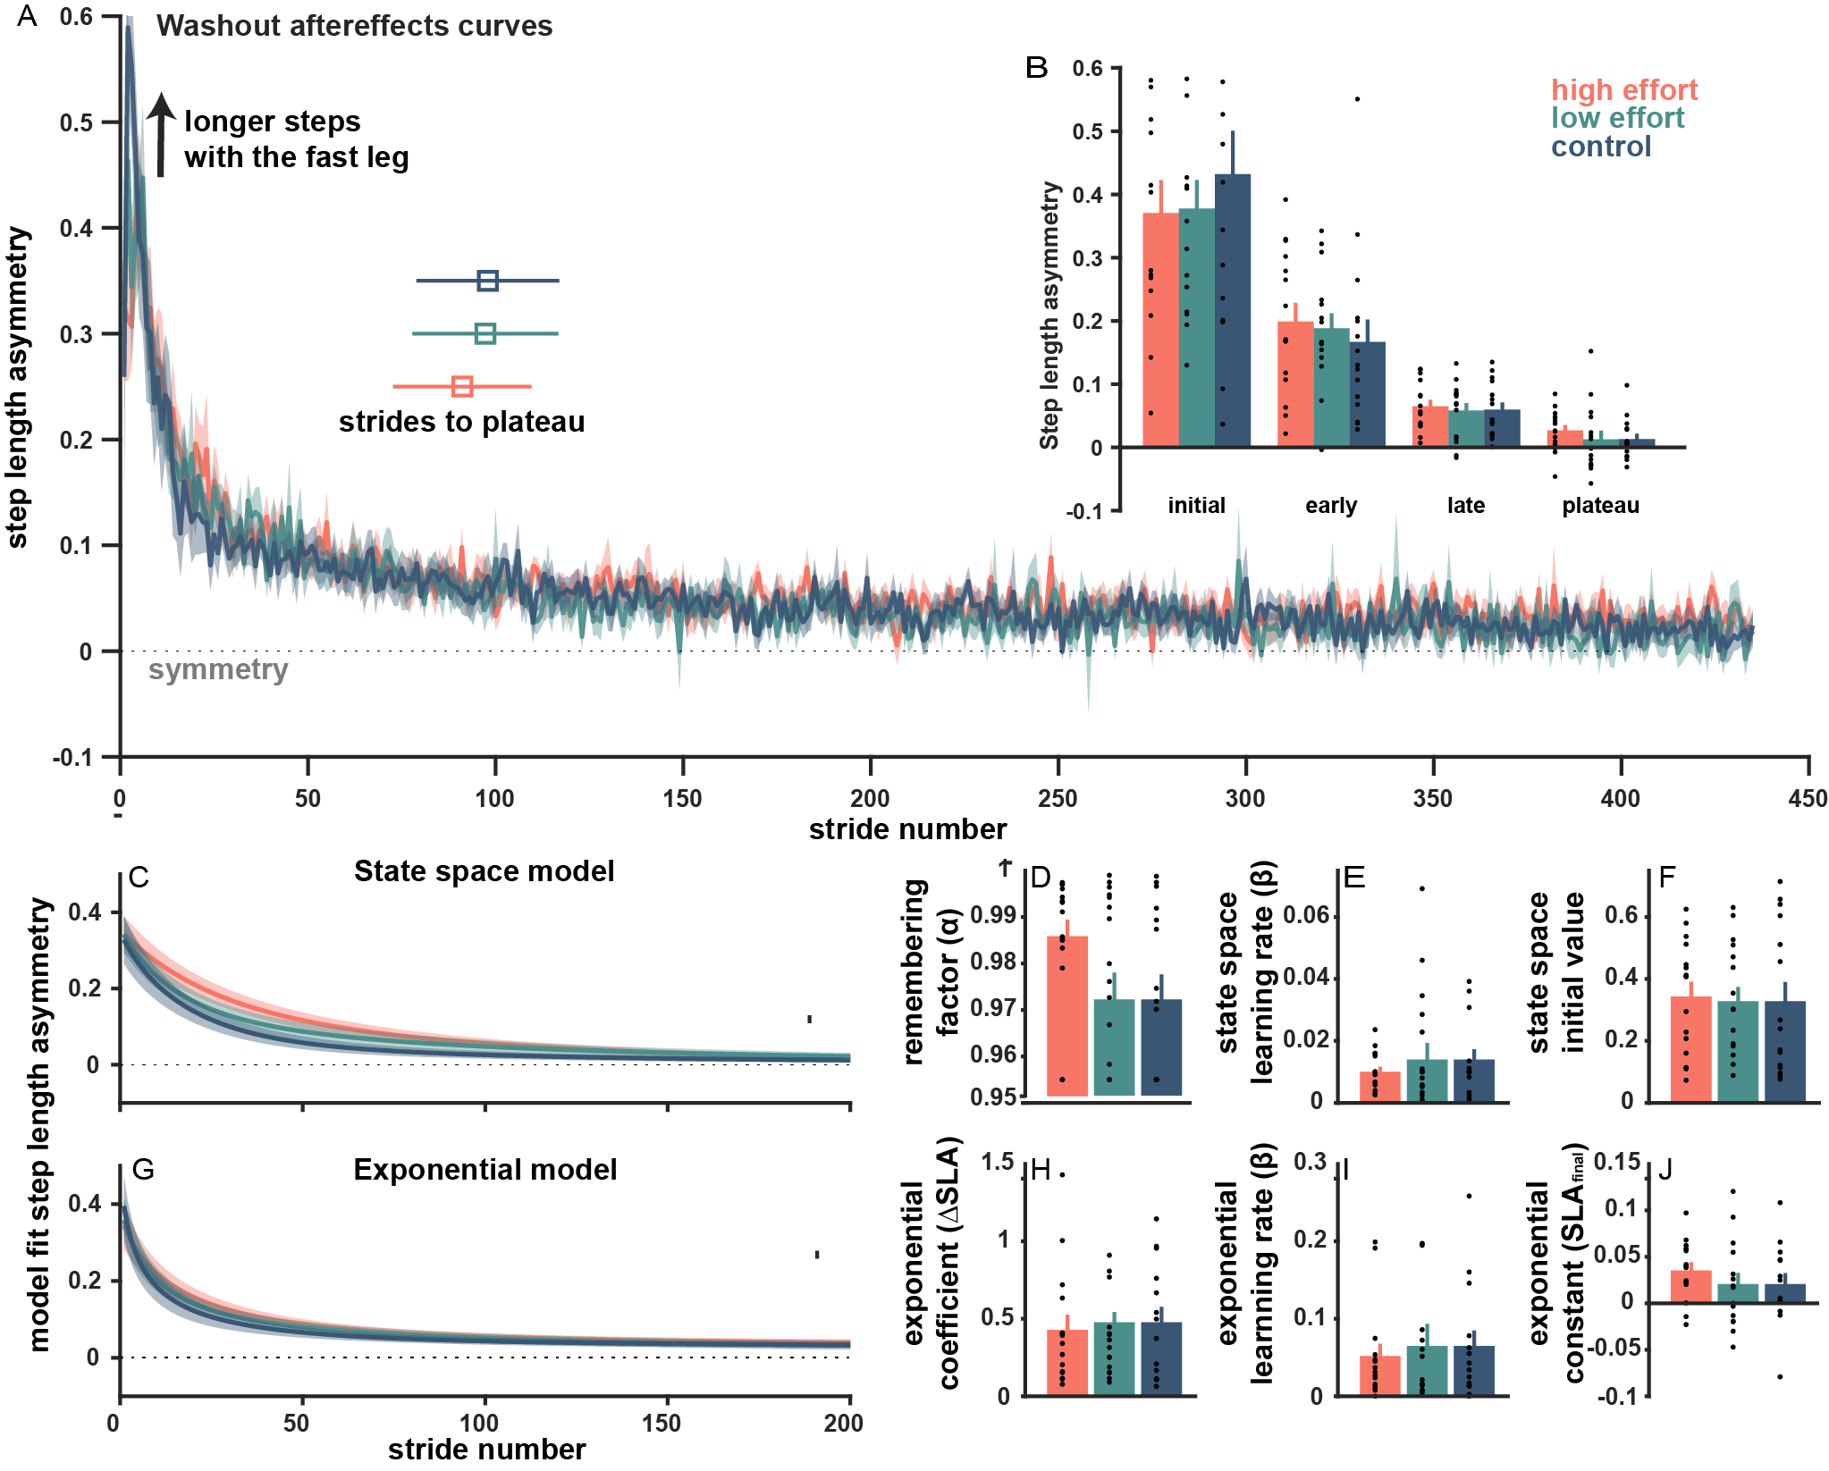
Figure #: Step length asymmetry during washout following split-belt adaptation. A) step length asymmetry across strides during the 15-minute tied-belt washout block for each of the three effort groups including average strides to plateau. B) Binned step length asymmetry for initial, early, late, and final washout aftereffects. C) State space model fit curves. The plotted curves are the average of unique, individual subject fits. D-F) Remembering factor, state space learning rate, and state space initial error for each group. G) Exponential model fit curves, curves shown are the average of individual fit curves. H-J) exponential fit parameters including the exponential coefficient, the exponential learning rate, and the exponential constant.

Learning was faster on the second exposure to the split-belt and similar between groups.
Binned comparison. In relearning, binned trials from the four phases showed no difference between groups at any phase. (Initial bin: p = 0.987; early bin: p = 0.579; late bin: p = 0. 218; and plateau bin: p = 0.216). In a pairwise comparison, the high effort groups was significantly nearer to symmetry in the late and plateau phases.
Steps to plateau. All groups reached an asymmetry plateau in fewer strides during relearning: 45.3 ± 10.09 strides for the high effort condition, 68.4 ± 13.45 strides for the low effort condition, and 91.1± 35.68 strides for the control condition, but did not differ between groups (ANOVA p = 0.371).
State space fit. State space models fits had similar parameters for all groups during relearning.
State space fit parameter | High effort | Low effort | Control effort | One-way ANOVA
Remembering factor (α) | 0.99 ± 0.002 | 0.99 ± 0.004 | 0.99 ± 0.001 | p = 0.322
Learning rate ($β$) | 0.01 ± 0.002 | 0.01 ± 0.007 | 0.00 ± 0.002 | p = 0.294
Initial asymmetry (${\hat{y}}_{1}$) | -0.14 ± 0.023 | -0.16 ± 0.023 | -0.16 ± 0.014 | p = 0.760

Exponential fit. Similarly, exponential fits had similar parameters for all groups during relearning.
Exponential fit parameter | High effort | Low effort | Control effort | One-way ANOVA
Coefficient ($∆SLA$) | -0.30 ± 0.183 | -0.11 ± 0.013 | -0.25 ± 0.162 | p = 0.618
Learning rate ($β$) | 0.04 ± 0.008 | 0.02 ± 0.006 | 0.02 ± 0.006 | p = 0.232
Constant (${SLA}_{final}$) | 0.16 ± 0.188 | -0.03 ± 0.017 | 0.11 ± 0.168 | p = 0.639

FIGURE: relearning curves, binned learning blocks (with pairwise significant markers)
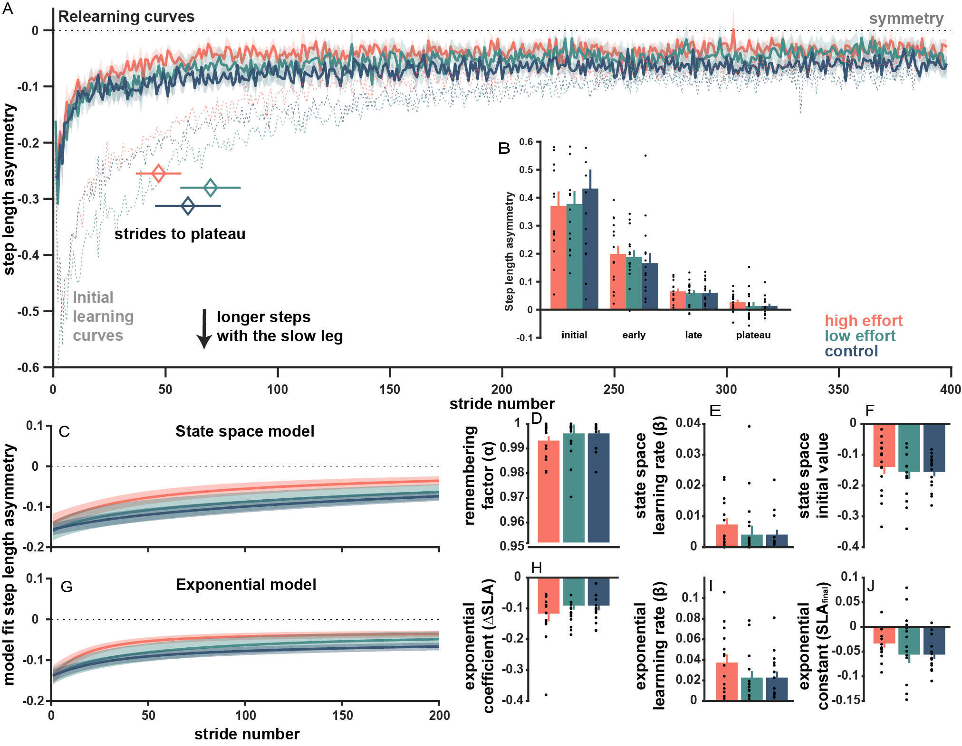
Figure #: Step length asymmetry during relearning the split-belt adaptation during their second exposure. A) step length asymmetry across strides during the 10-minute split-belt relearning block for each of the three effort groups including average strides to plateau. The dashed lines represent learning curves from the initial exposure to the split-belt. B) Binned step length asymmetry for initial, early, late, and final relearning. C) State space model fit curves. The plotted curves are the average of unique, individual subject fits. D-F) Remembering factor, state space learning rate, and state space initial error for each group. G) Exponential model fit curves, curves shown are the average of individual fit curves. H-J) exponential fit parameters including the exponential coefficient, the exponential learning rate, and the exponential constant.

Among individuals who completed both high and low effort conditions, savings was strong and there was no evidence of an effect of effort condition order on learning measures.
A subset of participants in the high and low effort groups returned to the lab on a separate day to complete the walking task in the opposite effort condition. During the second visit, we compared the high-low and low-high groups using t-tests.
Binned comparison. We binned the learning, washout, and relearning blocks from the second visit into initial, early, late, and plateau phases, finding no differences between the two groups during any phase in any block.
 | Initial | Early | Late | Plateau
Learning | p = 0.390 | p = 0.411 | p = 0.901 | p = 0.752
Washout | p = 0.284 | p = 0.423 | p = 0.193 | p = 0.402
Relearning | p = 0.922 | p = 0.768 | p = 0.943 | p = 0.954

Strides to plateau. On learning during the second visit, the high-low and low-high groups preserved the shorter time to symmetry that was observed in relearning. The high-low group had 39.5 ± 17.37 strides to symmetry and the low-high group had 51.8± 12.13 strides to symmetry during learning (p = 0.574). During washout, both groups washed out the perturbation quickly, in 48.7 ± 17.69 strides for the high-low and 50.6 ± 20.41 strides for the low-high group (p = 0.946). Finally, in relearning on the second visit, there was improvement from the earlier learning block with the high-low group achieving symmetry in 26.2 ± 6.67 strides and the low-high group achieving symmetry in 34.1 ± 11.95 strides (p = 0.585).
Compare second visit learning to first visit relearning
Model fits. We fit both state and single exponential models to step length asymmetry curves in learning, washout, and relearning blocks for the second visit. We identified no differences for either state space or exponential curve fit parameters between groups in any block.
FIGURE: visit 2
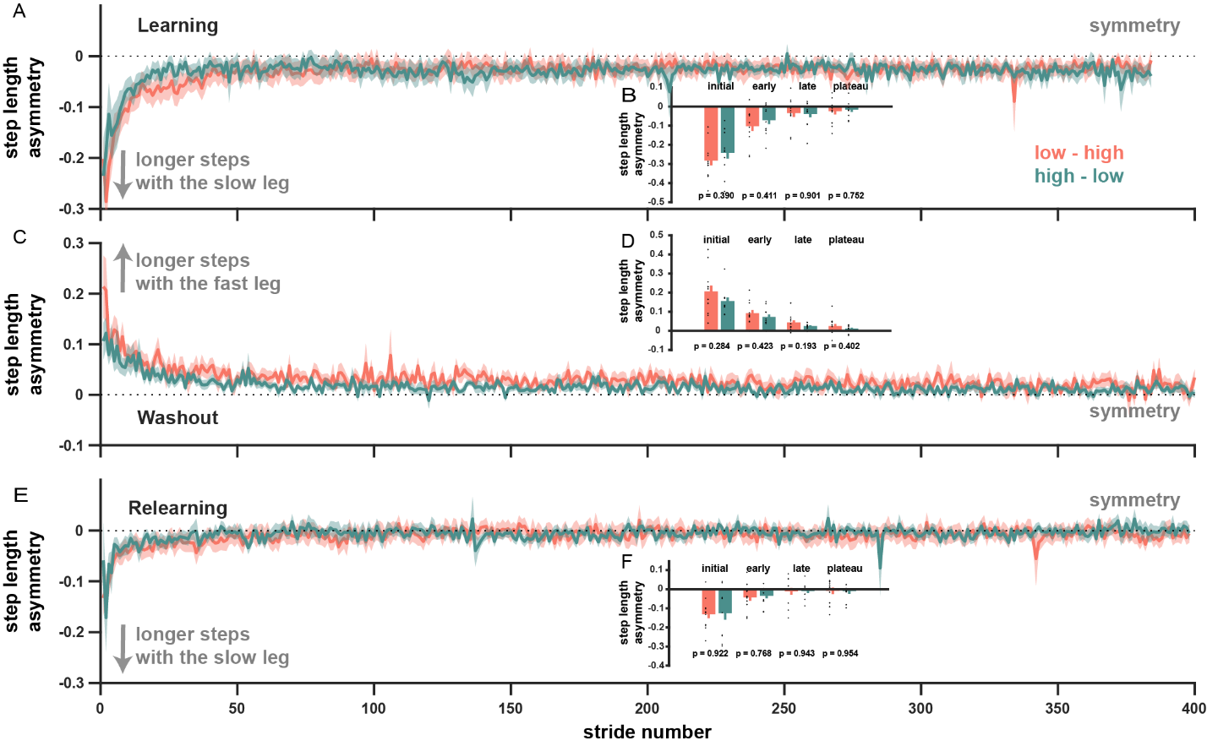
Figure #: Step length asymmetry during the second visit for the subset of high and low effort participants that returned to the lab for a second visit and completed the task in the opposite condition. A) step length asymmetry across strides during the first split-belt block, this is participants’ third exposure to the split-belt. The color of the plot line represents the current effort condition. B) Binned step length asymmetry for initial, early, late, and final learning. C-D) steplength asymmetry during washout including binned asymmetry measures for initial, early, late, and final learning. E-F) step length asymmetry across strides during the second split-belt block, this is participants’ fourth exposure to the split-belt.

Linear mixed effects models for learning parameters across all split-belt exposures suggests no effect of effort condition or effort condition order.
We used a linear mixed effects model (LMER) to compare learning parameters across split-belt exposures. While the data for participants that completed both visits (and four exposures) might be suited to a repeated measures ANOVA, a nested LMER allowed us to include the data from participants that completed the task only once with two exposures. Importantly, we are not using the LMER to model step length asymmetry over the course of the learning process, rather we are predicting single learning parameters that describe the progress of symmetry over strides in each exposure (ie: one learning rate per exposure or one plateau value per exposure).
We used a model including fixed effects of effort condition, exposure, and number of visits
$$learning parameter \sim effort condition + exposure * number of visits + (1 + number of visits | subject)$$
Effort conditions and the number of visits were included as categorical factors. The term $(1 + number of visits | subject)$fits a random slope and intercept each subject within each group corresponding to the number of visits. We also generated models using a continuous variable, added weight (as a percentage of bodyweight), as a fixed effect to replace the categorical effort condition fixed effect.
Over the course of the four exposures, we were interested in the progression of learning across the four exposures to the split belt condition. State space learning rates were constrained between 0 and 1, so a logarithmic linking function was applied to normalize the distribution. Since asymmetries are constrained between -1 and 1, we transformed asymmetry measures using an inverse hyperbolic tangent.
We ran model fits for state space and exponential learning rates to look for changes in adaptation and for the step length asymmetry plateau to look for changes in the extent of adaptation. We identified no significant predictors in any of the models, suggesting that the roles of effort condition, number of visits, and exposure number were not strong drivers of any learning parameters.
We considered only the 22 participants that visited the lab twice and participated in both effort conditions, using the model
$$learning parameter \sim effort condition + exposure + order of visits + (1 | subject)$$
For these participants, the exposure number was a significant predictor for state space learning rate (estimate: 0.592; CI: [how do I get this with hglm?]; p = 6.74e-08), exponential learning rate (estimate: 0.209; CI: [###]; p = 0.013), and step length asymmetry plateau (estimate: 0.007; CI: [0.001, 0.014]; p = 0.031). The fixed effects of effort condition and the order of visits did not significantly predict any of the learning parameters.
Step time and step time asymmetries were similar between groups
Step time during baseline: During fast and slow baseline, step times for the high effort group were 0.50± 0.007s and 0.85 ± 0.020s; for the low effort group step times were 0.50 ± 0.008s and 0.84 ± 0.027s; and for the control group were 0.50 ± 0.010s and 0.85 ± 0.023s. For all groups, the difference between step times in fast and slow baseline was significant (p_{high} = 1.9e-12; p_{low} = 5.1e-10; p_{control} = 4.0e-12) with shorter step times in the fast baseline. Comparing the step times between effort groups showed no significant differences (One-way ANOVA for fast baseline: p = 0.708; for slow baseline: p = 0.957).
Step time during adaptation: Similar to previously published data on step time asymmetry (CITATIONS), step time asymmetry during the split-belt block were near zero in initial adaptation, but quickly increased to a positive steady state asymmetry. Positive asymmetry indicates longer duration steps on the fast leg (driven by a longer duration of swing). We compared step time for blocks of trials from different phases of learning (initial, early, late, and plateau) using one-way ANOVA. There were no differences between groups in any phase (initial bin: p = 0.585; early bin: p = 0.271; late bin: p = 0. 426; and plateau bin: p = 0.346).
Step width was similar between effort conditions and unchanged within subjects who completed the task in low and high effort.
Step width during baseline: Step width is one proxy for stability during walking. Taking wider steps increases the base of support and is one strategy for countering instability. Despite this, previous studies have not observed changes in step width associated with split-belt walking (Darter et al. 2018). Given the addition of weight to the upper body in the high effort conditions, we compared step width values and step width variance between effort groups to assess the effect of added weight on stability.
During fast and slow baseline blocks, step widths were unaffected by effort condition (ANOVA fast: p = 0.745; slow: p = 0.148). Pairwise comparisons between groups were also nonsignificant (t-tests: p_{high-low}= 0.517; p_{high-control} = 0.699; p_{low-control} = 0.982). Step widths were similar between fast and slow baseline (t-tests: p_{high} = 0.063; p_{low} = 0.953; p_{control} = 0.393), trending toward wider steps in fast baseline.
Step width variability has also been implicated in balance and fall risk (Maki 1997). In fast and slow baseline, step width variance was similar between groups (Fast baseline: ANOVA p = 0.783, t-test between groups p_{high-low}= 0.749; p_{high-control} = 0.752; p_{low-control} = 0.878; Slow baseline: ANOVA p = 0.147, t-test between groups p_{high-low}= 0.943; p_{high-control} = 0.084; p_{low-control} = 0.072). Slow baseline had lower step width variance than fast baseline for all three groups (p_{high}= 0.002; p_{low} = 0.003; p_{control} = 0.013).
Step width variability did not change between effort conditions for individual subjects. For participants that participated in both high and low effort conditions, we compared step width variance during the last 20 strides of baseline in each effort condition. Paired t-tests of variance indicated no differences between the low and high effort condition in either the fast (p = 0.634) or slow (p = 0.271) baseline blocks. When separated into the ordered group conditions (high-low and low-high), there were still no differences in the fast baseline walking (p_{high-low group}= 0.900; p_{low-high group}= 0.645). For the slow baseline, the variance was significantly higher in the low effort condition for participants in the low-high group (experienced the low effort condition first; p = 0.020). There was no change in variance for the high-low group (p = 0.179).
Step width during adaptation: Step widths did not differ between the fast and slow leg during learning for any group (p_{high} = 0.142; p_{low} = 0.848; p_{control} = 0.707) and so resulted in no asymmetry. Accordingly, we assessed step width after combining the data from the fast and slow legs. Comparing initial step width (during the first 5 strides) to plateau step width (last 30 trials), we found that step width did not change over the course of the learning block (p_{high} = 0.454; p_{low} = 0.289; p_{control} = 0.136).
During learning, the high, low, and control groups had step widths of 141.9 ± 8.43 mm, 166.1 +/- 10.09 mm, and 161.0 +/- 9.27 mm which did not differ from step widths observed in slow baseline (p_{high} = 0.598; p_{low} = 0.830; p_{control} = 0.700). Step widths were similar across groups (ANOVA p = 0.166; pairwise t-tests p_{high-low}= 0.747; p_{high-control} = 0.698; p_{low-control} = 0.836).
Similarly, step width variability at the end of learning was similar between effort groups (ANOVA: p = 0.286. In late learning, the high effort group’s step variance was higher than slow baseline (p = 0.009), but similar to that of fast baseline (fast: p = 0.562). For low and control groups, step width variability in late learning did not differ from slow baseline (p_{low} = 0.126; p_{control} = 0.184).

%%%%%%%%%%%%%%%%%%%%%%%%%%%%%%%%%%%%%%%%%%%%%%%%%%%
Other, probably extra
Baseline
We did not counterbalance the order of baseline walking and all slow baseline data was collected after the fast baseline data, so we cannot assess for an order effect. We did include an initial one-minute familiarization at the slow walking speed which preceded fast baseline. When we compare that familiarization with the slow baseline block following the fast baseline, we found no difference (paired t-tests comparing slow familiarization to slow baseline: p_{high} = 0.334, p_{low} = 0.448, p_{control} = 0.256).
For participants in the high-low and low-high groups, we tested for a within subject effect of effort on step length variability. Collectively, paired t-tests comparing variance between effort conditions showed no differences between effort condition in fast (p = 0.634) or slow baseline (p = 0.271). Sorting the data into smaller groups based on effort condition order (high-low and low-high), there remained no difference between high and low effort in baseline walking within those groups (p_{high-low group}= 0.900; p_{low-high group}= 0.645).
Second visit state space and exponential fit parameters
State space model fit. We also fit a state space model to curves during the learning, washout, and relearning blocks for data collected on the second visit. We identified no differences between the state space curve fits for each group.
VISIT 2: LEARNING
State space fit parameter | Low- high | High-low | One-way ANOVA
Remembering factor (α) | 0.98± 0.005 | 0.97 ± 0.011 | p = 0.144
Learning rate ($β$) | 0.02 ± 0.008 | 0.07± 0.023 | p = 0.078
Initial asymmetry (${\hat{y}}_{1}$) | -0.17 ± 0.029 | -0.16 ± 0.042 | p = 0.868

VISIT 2: WASHOUT
State space fit parameter | Low-High | High-low | One-way ANOVA
Remembering factor (α) | 0.98 ± 0.009 | 0.98 ± 0.010 | p = 0.931
Learning rate ($β$) | 0.03 ± 0.018 | 0.03 ± 0.019 | p = 0.795
Initial asymmetry (${\hat{y}}_{1}$) | 0.15 ± 0.022 | 0.10 ± 0.024 | p = 0.228

VISIT 2: RELEARNING
State space fit parameter | Low-high | High-low | One-way ANOVA
Remembering factor (α) | 0.98 ± 0.009 | 0.97 ± 0.012 | p = 0.592
Learning rate ($β$) | 0.04± 0.018 | 0.06 ± 0.025 | p = 0.510
Initial asymmetry (${\hat{y}}_{1}$) | -0.06 ± 0.022 | -0.05 ± 0.020 | p = 0.667

Exponential model fit. We fit an exponential model learning, washout, and relearning blocks during the second visit. We identified no differences between the state space curve fits for each group.
VISIT 2: LEARNING
Exponential fit parameter | High effort | Low effort | One-way ANOVA
Coefficient ($∆SLA$) | -0.14416 ± 0.026566 | -0.21745 ± 0.094995 | p = 0.448
Learning rate ($β$) | 0.065005 ± 0.017924 | 0.12322 ± 0.029587 | p = 0.102
Constant (${SLA}_{final}$) | -0.029467 ± 0.019407 | -0.02657 ± 0.011457 | p = 0.902

VISIT 2: WASHOUT
Exponential fit parameter | Low-high | High-low | One-way ANOVA
Coefficient ($∆SLA$) | 0.12293 ± 0.021956 | 0.11308 ± 0.029036 | p = 0.787
Learning rate ($β$) | 0.047444 ± 0.012249 | 0.078314 ± 0.037211 | p = 0.422
Constant (${SLA}_{final}$) | 0.018722 ± 0.016646 | 0.016111 ± 0.0044375 | p = 0.886

VISIT 2: RELEARNING
Exponential fit parameter | Low-high | High-low | One-way ANOVA
Coefficient ($∆SLA$) | -0.061815 ± 0.01866 | -0.050096 ± 0.021366 | p = 0.683
Learning rate ($β$) | 0.044745 ± 0.017331 | 0.06351 ± 0.030536 | p = 0.591
Constant (${SLA}_{final}$) | -0.0098533 ± 0.01886 | -0.0058988 ± 0.013625 | p = 0.869

