RESULTS: the role of effort in adaptation to split-belt locomotion
Last paragraph of the introduction (the question part):
During movement, humans move using strategies and speeds that are consistent with minimum effort. When learning new movements or adjusting their movements to novel environments, the process of learning is characterized by a reduction in error. In several common motor learning paradigms, the error-reduction process is paralleled by decreasing metabolic cost (Finley et al. 2013; Huang et al. 2012; Huang and Ahmed 2014). In the case of split-belt walking, we consider step length asymmetry, the difference between step length on the fast and slow leg divided by the total length of the stride, to be the error metric and we define progress toward 0 (perfect symmetry) as learning. This step length adaptation is accompanied by reductions in metabolic cost, so that error and effort decrease in tandem during learning (Finley et al. 2013).
Last paragraph of introduction (the results part):
Despite the important role of effort in movement selection and clear trends of effort reduction over the course of adaptation and learning, we found no evidence of a causal or modifying role of background, task-irrelevant effort costs on adaptation to a split-belt perturbation. We measured the step length asymmetry for three different effort conditions over two 10-minute split-belt adaptation blocks separated by a 15-minute washout. Each effort condition included 15 participants unfamiliar with split-belt perturbation and wearing a weighted vest (15% bodyweight, 5% bodyweight, and vest only for the high, low, and control conditions).

RESULTS
Important thoughts to start the results section and are generally important across experimental blocks…###
The progression of step length asymmetry over strides in the split belt perturbation blocks did not differ between the three groups in the split-belt learning, washout, or relearning blocks during the first visit. Step widths and step times were also similar between groups. The subset of individuals in the high and low effort groups that returned to the lab for a second visit showed strong savings with no difference between groups or related to the order of effort conditions. While effort may not mediate motor adaptation, our findings imply that increasing the effort cost of movements as part of a rehabilitation protocol could improve strength without impairing learning or adaptation.

BASELINE

Participants across effort conditions walked with symmetrical gaits during baseline.
As a measure of baseline walking performance, all participants completed 2-minute blocks of symmetrical walking on the treadmill at the fast speed (1.5 m/s) and at the slow speed (0.5 m/s) while wearing the weighted vest. Step length was similar between groups in fast and slow baseline. In fast baseline walking, at 1.5 m/s, mean step length for the last 30 strides was 675 ± 8.0 mm for the high effort group, 678 ± 10.2 mm for the low effort group, and 683 ± 11.9 mm for the control group (one-way ANOVA: p = 0.864). For slow baseline, mean step lengths were 394 ± 7.8 mm for the high effort group, 389 ± 11.1 mm for the low effort group, and 407 ± 10.7 mm for the control group (one-way ANOVA: p = 0.447). Similar to step length comparisons, fast and slow step times and step widths were similar between effort groups (Step time one-way ANOVA for fast baseline: p = 0.734; for slow baseline: p = 0.513; Step width one-way ANOVA for fast baseline: p =0.387; for slow baseline: p = 0.197).
Step length variance in fast baseline was similar between the high, low, and control effort groups (one-way ANOVA: p = 0.876). Variance between groups in slow baseline was also similar (One-way ANOVA: p = 0.504). Step length variance increased slightly from fast to slow baseline for the high effort and control groups (p_{high} = 7.5e-04; p_{control}= 0.047), while the increase in variability was nonsignificant in the low effort group (p_{low}= 0.055).
We verified that all groups had symmetric step lengths in fast and slow baseline by checking comparing the step length asymmetry for last 30 strides in the two baseline conditions to full symmetry (asymmetry = 0) using t-tests.
t-test for baseline symmetry | High effort | Low effort | Control
Fast baseline | p = 0.135 | p = 0.362 | p = 0.857
Slow baseline | p = 0.324 | p = 0.270 | p = 0.878

Braking and propulsion differed between effort groups during fast baseline walking.
Since prior work has implicated ground reaction forces as mediators of split-belt adaptation (Ogawa et al. 2014; Sombric et al. 2019), we compared ground reaction profiles between effort groups, looking first at peak braking and propulsion and then at push-off impulse. For this analysis, forces are normalized to bodyweight (not including the group-specific additional weight).
Normalized peak braking forces differed between groups in fast baseline walking (one-way ANOVA p = 0.004) driven by a difference between the high effort and other two effort groups (t-test p_{high-low} = 0.001; p_{high-control} = 0.011). The pairwise comparison between the low effort and control groups revealed significant differences (p_{low-control} = 0.564). In slow baseline, the magnitude of braking forces did not differ between groups (one way ANOVA: p = 0.161).
Normalized peak push off forces differed between effort groups in the fast baseline walking condition (one way ANOVA: p = 5.73e-05). Pairwise comparisons indicated differences between the high effort groups and the other two conditions, low effort and control (p_{high-low} = 6.44e-05; p_{high-control} = 2.70e-04; p_{low-control} = 0.835). In the slow walking baseline condition, there was no differences between peak braking forces (one way ANOVA: p = 0.260).
We also compared push off impulse (time integrated propulsive force) between groups. Impulse sums push off force across the duration of stance, when the foot is on the treadmill belt, and may reveal differences in propulsion that might not be apparent in the peak push off metrics due to difference in stance duration and stride frequency. Propulsive impulse was significantly different between effort groups in the fast baseline condition (one-way ANOVA: p = 0.023). The difference was driven by differences between the high and low effort group (t-tests: p_{high-low} = 0.003; p_{high-control} = 0.04; p_{low-control} = 0.750). There were no differences between groups in the slow baseline block (one way ANOVA: p = 0.357).
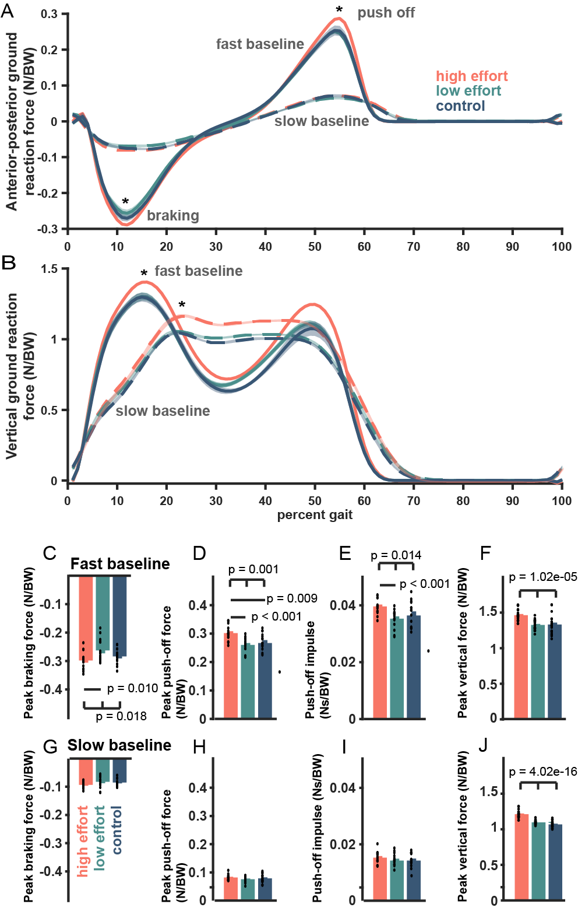
Figure #: Baseline ground reaction forces normalized by bodyweight (not including weight added to differentiate effort condition). A) Anterior-posterior ground reaction forces for slow baseline (dashed) and fast baseline (solid). The high effort group has significantly higher magnitudes of peak braking and peak push off force. B) Vertical ground reaction forces for slow and fast baseline. C) Peak braking force during fast baseline showing differences between the three effort groups (p = 0.018), driven by the higher magnitude braking in the high effort group versus the low effort group (p = 0.010). D) Peak push off force during fast baseline showing differences between the three effort groups including significant differences between the high effort group and the low effort group (p = 1.4e-04) and between the high effort group and the control group (p = 0.008). E) Push off impulse during fast baseline showing differences between the three effort groups including between high effort and low effort (p = 4.2e-04). The difference between high effort and control was trending toward significance with p = 0.053. F) Peak braking force for slow baseline. G) Peak push off force for slow baseline. H) Push off impulse for slow baseline.

ADAPTATION

Participants in the high, low, and control effort groups adjusted their step lengths toward symmetry similarly and achieved similar final asymmetry.
Over the course of exposure to the split-belt, the step length asymmetry progresses from asymmetry toward symmetry. For strides early in the block, step length asymmetry is negative for all groups indicating that participants responded to the split-belt perturbation by taking longer steps on the slow leg. Over time, participants in all groups adjusted their relative fast and slow step lengths to be more similar, although a slight bias toward longer steps on the slow leg persisted for the duration of the 10-minute learning block.
Binned comparison. To match common split-belt analyses in the literature, we compared step length asymmetry during blocks of trials representing different phases of the learning process (initial: strides 1-5, early: strides 6-30, late: strides 31-200, and plateau: final 30 strides) using one-way ANOVA (Leech et al. 2018). We found no difference between groups at any phase of the learning process. (ANOVA on initial bin: p = 0.731; early bin: p = 0.913; late bin: p = 0. 942; and plateau bin: p = 0.603). Pairwise comparisons of the high effort, low effort, and control groups also yielded no significant differences.
Pair compared | Initial | Early | Late | Plateau
High v Low | p = 0.457 | p = 0.931 | p = 0.736 | p = 0.493
High v Control | p = 0.722 | p = 0.691 | p = 0.894 | p = 0.762
Low v Control | p = 0.653 | p = 0.749 | p = 0.821 | p = 0.318
Extent of adaptation. By the end of the initial 10-minute adaptation block, asymmetry was -0.08 ± 0.004 for the high effort group,-0.06 ± 0.004 for the low effort group, and 0.08 ± 0.004 for the control group. None of the groups achieved their slow baseline symmetry over the course of the learning block (paired t-tests between learning plateau and slow baseline step length asymmetry: p_{high} = 3.67e-06; p_{low} = 0.001; p_{control} = 1.37e-05). For thoroughness, we also compared plateau learning against perfect symmetry (step length asymmetry equal to 0): none of the groups achieved symmetry during adaptation (p_{high} = 0.001; p_{low} = 0.005; p_{control} = 4.26e-04).
Step length variability. Wanting to use the same binned learning phases to assess step length variability, we first established that step length variance did not differ between the fast and slow legs for any group during any phase of learning. The following table shows the comparisons of step length variability between the fast and slow leg as assessed over each of the four binned phases of learning.
Fast v. Slow leg | Initial | Early | Late | Final
High effort | p = 0.551 | p = 0.353 | p = 0.360 | p = 0.106
Low effort | p = 0.650 | p = 0.787 | p = 0. 832 | p = 0. 879
Control | p = 0. 093 | p = 0. 975 | p = 0. 614 | p = 0. 323
Since there was no difference between the fast and slow legs, we considered the fast and slow legs together to compare step length variability between groups. Our results suggested similar variance regardless of effort condition. The variance was (One-way ANOVA between groups on initial bin: p = 0.123; early bin: p = 0.161; late bin: p = 0. 222; and plateau bin: p = 0.258). Finally, we assessed variance of step length asymmetry and found no differences between asymmetry variability (ANOVA on initial bin: p = 0.249; early bin: p = 0.987; late bin: p = 0. 160; and plateau bin: p = 0.189).
Steps to plateau. For initial learning, the first stride to the plateau was 128 ± 16.90 strides for the high effort condition, 170 ± 17.17 strides for the low effort condition, and135 ± 15.49 strides for the control condition (One-way ANOVA: p = 0.197).
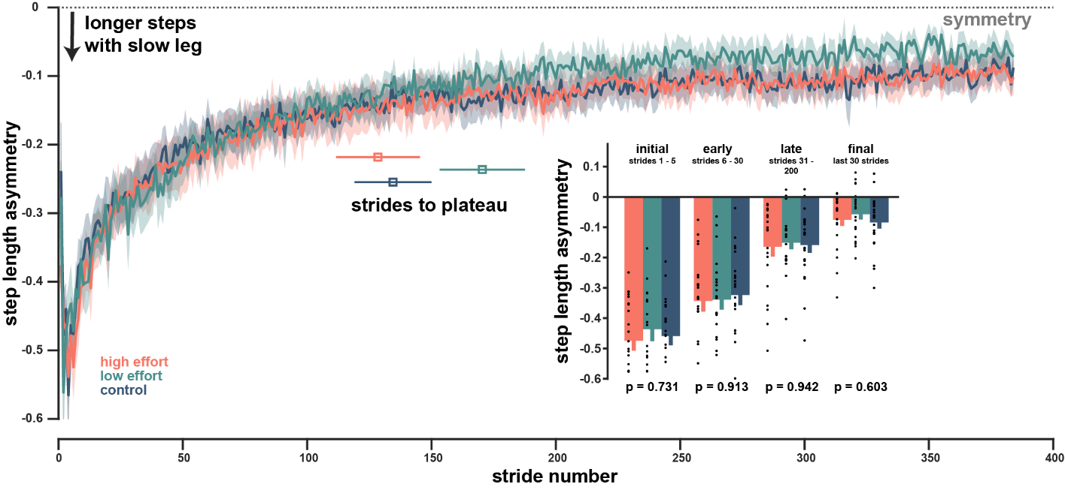
Figure #: Initial adaptation to the split-belt perturbation. A) step length asymmetry across strides during the 10-minute split-belt adaptation block for each of the three effort groups including average strides to plateau. B) Binned step length asymmetry for the initial learning block comparing the average asymmetry during the first 5 strides (initial), strides 6 – 30 (early), strides 31 – 200 (late), and the last 30 strides (plateau). C) State space model fit curves. The plotted curves are the average of unique, individual subject fits and show the slight divergence of the low effort group early in the adaptation block. D-F) Remembering factor, state space learning rate, and state space initial error for each group. G) Exponential model fit curves, curves shown are the average of individual fit curves showing the slight divergence of the low effort group early in adaptation as well as potential differences in the plateau phase of the adaptation block. H-J) exponential fit parameters including the exponential coefficient, the exponential learning rate, and the exponential constant.

State space fit. Each participant’s SLA curve was fitted with a state space model including a remembering factor (α) and a learning rate (β). Remembering factor represents what proportion of the asymmetry from the previous stride is carried forward into the next and learning rate captures sensitivity to asymmetry. A high learning rate indicates a high sensitivity to error and will result in rapid initial progress toward symmetry. Both remembering factor and learning rate were similar between groups.
State space fit parameter | High effort | Low effort | Control effort | One-way ANOVA
Remembering factor (α) | 0.99 ± 0.003 | 0.99 ± 0.003 | 0.99 ± 0.003 | p = 0.730
Learning rate ($β$) | 0.01 ± 0.001 | 0.008 ± 0.002 | 0.01 ± 0.005 | p = 0.383
Initial asymmetry (${\hat{y}}_{1}$) | -0.47 ± 0.040 | -0.42 ± 0.035 | -0.42 ± 0.030 | p = 0.577
Exponential fit. Step length asymmetry curves were descriptively modeled for each participant using a single exponential function. In the fit function, the exponential coefficient represents the change in asymmetry ($∆SLA$), the exponential rate (β) represents the learning rate, and the exponential constant represents the final asymmetry or plateau (${SLA}_{final}$).
Exponential fit parameter | High effort | Low effort | Control effort | One-way ANOVA
Coefficient ($∆SLA$) | -0.38 ± 0.030 | -0.36 ± 0.029 | -0.41 ± 0.032 | p = 0.536
Learning rate ($β$) | 0.03 ± 0.007 | 0.02 ± 0.002 | 0.05 ± 0.019 | p = 0.082
Constant (${SLA}_{final}$) | -0.07 ± 0.015 | -0.06 ± 0.016 | -0.06 ± 0.027 | p = 0.868

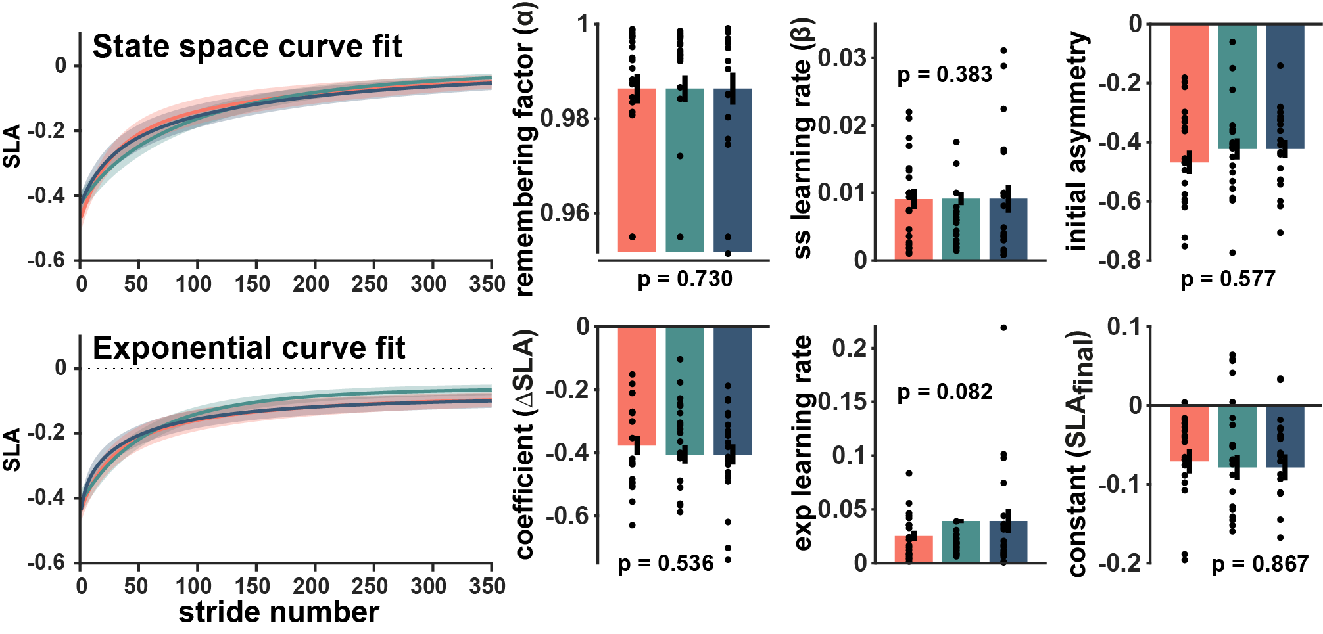
Figure #:

WASHOUT

Participants showed similar step length asymmetry aftereffects during washout.
Binned comparison. As in the split-belt block, we compared blocks of trials from different phases of washout where participants were readjusting the tied-speed belt walking. We found no difference between groups at any phase. (Initial bin: p = 0.685; early bin: p = 0.671; late bin: p = 0. 487; and plateau bin: p = 0.541). By the end of the 15-minute washout block, where participants walked at 0.5 m/s, asymmetry was -4.4e-03 ± 4.35e-03 for the high effort group, 0.02 ± 0.004 for the low effort group, and 4.6e-03 ± 2.77e-03 for the control group. When compared against slow baseline, the low effort and control groups had returned to baseline symmetry (p_{low}=0.053; p_{control} = 0.682), but the high effort group remained slightly asymmetric (with longer steps on the slow leg) (p_{high} = 0.015). A three groups were fully symmetric (step length asymmetry equal to zero during the washout plateau: p_{high} = 0.826; p_{low}=0.224; p_{control} = 0.726.
We also compared step length variability during washout, finding no difference between legs previously exposed to the fast or slow belt for any phase of washout. Using variability measures from both legs combined, we found no differences between groups’ step lengths (ANOVA on initial bin: p = 0.374; early bin: p = 0.457; late bin: p = 0. 556; and plateau bin: p = 0.597) or variability of step length asymmetry (ANOVA on initial bin: p = 0.578; early bin: p = 0.983; late bin: p = 0. 341; and plateau bin: p = 0.150) during washout. All three groups returned to variabilities consistent with slow baseline during the plateau bin (paired t-test between the washout plateau and slow baseline variability p_{high}= 0.556; p_{low}= 0.211; p_{control} = 0.094).
Strides to plateau. For washout after initial learning, the first stride to the plateau was 99.3 ± 14.59 strides for the high effort condition, 87.2 ± 15.71 strides for the low effort condition, and 95.0 ± 14.90 strides for the control condition (one-way ANOVA: p = 0.855).
State space fit. For washout, step length asymmetry curves were fitted with a state space model to capture the decay of aftereffects of the split-belt perturbation. Remembering factors and learning rates were similar between groups.
State space fit parameter | High effort | Low effort | Control effort | One-way ANOVA
Remembering factor (α) | 0.97682 ± 0.0047611 | 0.97038 ± 0.0046565 | 0.96643 ± 0.0053293 | p = 0.329
Learning rate ($β$) | 0.031243 ± 0.010308 | 0.03061 ± 0.0095475 | 0.031806 ± 0.011347 | p = 0.997
Initial asymmetry (${\hat{y}}_{1}$) | 0.33488 ± 0.040077 | 0.36387 ± 0.039217 | 0.32947 ± 0.050734 | p = 0.848
Exponential fit. Exponential curve fits of washout indicated no differences in the magnitude or decay of aftereffects between groups.
Exponential fit parameter | High effort | Low effort | Control effort | One-way ANOVA
Coefficient ($∆SLA$) | 0.42805 ± 0.07318 | : 0.30795 ± 0.072019 | 0.56319 ± 0.19905 | p = 0.383
Learning rate ($β$) | 0.053517 ± 0.011797 | 0.074845 ± 0.021262 | 0.086275 ± 0.031403 | p = 0.594
Constant (${SLA}_{final}$) | -0.063333 ± 0.069389 | 0.021694 ± 0.015831 | -0.18671 ± 0.19743 | p = 0.478

FIGURE: washout, binned comparison, curvefits, strides to plateau
Figure #: Step length asymmetry during washout following split-belt adaptation. A) step length asymmetry across strides during the 15-minute tied-belt washout block for each of the three effort groups including average strides to plateau. B) Binned step length asymmetry for initial, early, late, and final washout aftereffects. C) State space model fit curves. The plotted curves are the average of unique, individual subject fits. D-F) Remembering factor, state space learning rate, and state space initial error for each group. G) Exponential model fit curves, curves shown are the average of individual fit curves. H-J) exponential fit parameters including the exponential coefficient, the exponential learning rate, and the exponential constant.

RELEARNING

Learning was faster on the second exposure to the split-belt and similar between groups.
Previous work has repeatedly demonstrated that participants have remarkable recall of the split-belt walking task (Buurke et al. 2022; Day et al. 2018; Leech et al. 2018, 2018; Malone et al. 2011; Mawase et al. 2014) and more ###. Faster relearning can make gait training sessions more efficient and different retention and relearning behaviors might indicate different ways the learning is stored or accessed as sensitive to effort cost.
Binned comparison. In relearning, binned trials from the four phases showed no difference between groups at any phase. (Initial bin: p = 0.576; early bin: p = 0.551; late bin: p = 0. 344; and plateau bin: p = 0.247). At the end of participants’ second split-belt exposure, a 10-minute relearning block, the step length asymmetry plateau for the high effort group was -0.06 ± 0.005, for the low effort group was -0.03 ± 0.003, and the control effort group was -0.08 ± 0.005. When compared to slow baseline walking, none of the three groups reached full symmetry during the relearning block (paired t-test comparing plateau relearning and slow baseline step length asymmetry: p_{high}= 3.97e-04; p_{low}= 0.029; p_{control} = 2.23e-04). Relearning plateau was nonsymmetric for all groups (p_{high}= 0.009; p_{low}= 0.038; p_{control} = 0.001).
Steps to plateau. All groups reached an asymmetry plateau in fewer strides during relearning: 56.6 ± 10.52 strides for the high effort condition, 63.1 ± 10.56 strides for the low effort condition, and 52.7 ± 11.31 strides for the control condition, but did not differ between groups (ANOVA p = 0.807).
State space fit. State space models fits had similar parameters for all groups during relearning.
State space fit parameter | High effort | Low effort | Control effort | One-way ANOVA
Remembering factor (α) | 0.99 ± 0.002 | 0.98 ± 0.005 | 0.99 ± 0.003 | p = 0.074
Learning rate ($β$) | 0.007 ± 0.002 | 0.021 ± 0.010 | 0.01 ± 0.007 | p = 0.330
Initial asymmetry (${\hat{y}}_{1}$) | -0.18 ± 0.031 | -0.15 ± 0.020 | -0.19 ± 0.026 | p = 0.567
Exponential fit. Similarly, exponential fits had similar parameters for all groups during relearning.
Exponential fit parameter | High effort | Low effort | Control effort | One-way ANOVA
Coefficient ($∆SLA$) | -0.25 ± 0.131 | -0.13 ± 0.022 | -0.36 ± 0.190 | p = 0.464
Learning rate ($β$) | 0.03 ± 0.007 | 0.02 ± 0.005 | 0.02 ± 0.005 | p = 0.302
Constant (${SLA}_{final}$) | 0.08 ± 0.136 | -0.03 ± 0.015 | 0.20 ± 0.188 | p = 0.471

Figure #: Step length asymmetry during relearning the split-belt adaptation during their second exposure. A) step length asymmetry across strides during the 10-minute split-belt relearning block for each of the three effort groups including average strides to plateau. The dashed lines represent learning curves from the initial exposure to the split-belt. B) Binned step length asymmetry for initial, early, late, and final relearning. C) State space model fit curves. The plotted curves are the average of unique, individual subject fits. D-F) Remembering factor, state space learning rate, and state space initial error for each group. G) Exponential model fit curves, curves shown are the average of individual fit curves. H-J) exponential fit parameters including the exponential coefficient, the exponential learning rate, and the exponential constant.

SECOND VISIT

Among individuals who completed both high and low effort conditions, savings was strong and there was no evidence of an effect of effort condition order on learning measures.
A subset of participants in the high and low effort groups returned to the lab on a separate day to complete the walking task in the opposite effort condition. During the second visit, we compared the high-low and low-high groups using t-tests.
Binned comparison. We binned the learning, washout, and relearning blocks from the second visit into initial, early, late, and plateau phases, finding no differences between the two groups during any phase in any block.
 | Initial | Early | Late | Plateau
Learning | p = 0.389 | p = 0.411 | p = 0.901 | p = 0.752
Washout | p = 0.284 | p = 0.423 | p = 0.193 | p = 0.402
Relearning | p = 0.922 | p = 0.768 | p = 0.943 | p = 0.954
Strides to plateau. On learning during the second visit, the high-low and low-high groups preserved the shorter time to symmetry that was observed in relearning. The high-low group had 39.5 ± 17.37 strides to symmetry and the low-high group had 51.8± 12.13 strides to symmetry during learning (p = 0.574). During washout, both groups washed out the perturbation quickly, in 48.7 ± 17.69 strides for the high-low and 50.6 ± 20.41 strides for the low-high group (p = 0.946). Finally, in relearning on the second visit, there was improvement from the earlier learning block with the high-low group achieving symmetry in 26.2 ± 6.67 strides and the low-high group achieving symmetry in 34.1 ± 11.95 strides (p = 0.585)
Model fits. We fit both state and single exponential models to step length asymmetry curves in learning, washout, and relearning blocks for the second visit. We identified no differences for either state space or exponential curve fit parameters between groups in any block (paired t-test, state space remembering factor: p = 0.144; state space learning rate: p = 0.078; state space initial asymmetry: p = 0. 868; exponential coefficient: p = 0.448; exponential learning rate: p = 0.102; exponential constant: p = 0.902 ).

Figure #: Step length asymmetry during the second visit for the subset of high and low effort participants that returned to the lab for a second visit and completed the task in the opposite condition. A) step length asymmetry across strides during the first split-belt block, this is participants’ third exposure to the split-belt. The color of the plot line represents the current effort condition. B) Binned step length asymmetry for initial, early, late, and final learning. C-D) steplength asymmetry during washout including binned asymmetry measures for initial, early, late, and final learning. E-F) step length asymmetry across strides during the second split-belt block, this is participants’ fourth exposure to the split-belt.

Linear mixed effects models for learning parameters across all split-belt exposures suggest no effect of effort condition or effort condition order.
Importantly, we are not using the LMER to model step length asymmetry over the course of the learning process, rather we are predict single learning parameters that describe learning in a given split-belt exposure (ie: one learning rate per participant per exposure or one plateau value per participant per exposure).
To investigate the role of effort condition on any given exposure, we used a nested linear mixed effects model. While the data for participants that completed both visits (and four exposures) might be suited to a repeated measures ANOVA, a nested LMER allowed us to include the data from participants that completed the task only once with two exposures. For this question, we used aa model based on effort condition, exposure and, relatedly, the number of visits to the lab:
$$learning parameter \sim effort condition+exposure*number of visits+\left(1+number of visits \right| subject).$$
Effort conditions and the number of visits were included as categorical factors. The term $(1 + number of visits | subject)$fits a random slope and intercept each subject within each group corresponding to the number of visits.
Over the course of the four exposures, we were interested in the progression of learning across the four exposures to the split belt condition. State space learning rates were constrained between 0 and 1, so a logarithmic linking function was applied to normalize the distribution. Since asymmetries are constrained between -1 and 1, we transformed asymmetry measures using an inverse hyperbolic tangent to generate asymmetry on an unbounded range. We focused our mixed effects model fits on state space and exponential learning rates, to look for changes in adaptation, and on the step length asymmetry plateau, to look for changes in the extent of adaptation.
Using the nested mixed effect model to check for an effect of effort condition on state space learning rate, exponential learning rate, and step length asymmetry plateau, we identified no significant fixed effects for effort condition and split-belt exposure in state space learning rate, exponential learning rate, or step length asymmetry plateau (aside from an expected interaction between exposure and number of visits which reached significance in step length asymmetry plateau).
For the individuals that completed the task in both effort conditions, we used a pared down model to investigate the effect on the effort condition at the first exposure to the split-belt perturbation. We included fixed effects of first effort condition and exposure:
$learning parameter \sim effort condition of first visit+exposure+\left(1 \right|subject)$.
We identified a significant fixed effect of exposure in state space learning rate (exposure estimate: 0.207; CI: [, ] ; p = 9.79e-04 ) and the categorical variable corresponding to the first visit effort condition was nonsignificant. Neither fixed effect was significant for the exponential learning rate or the step length asymmetry plateau.
Potential additions: 1) We also generated models using a continuous variable, added weight (as a percentage of bodyweight), as a fixed effect to replace the categorical effort condition fixed effect. 2) model considering only the subjects that completed both visits
Step times and step time asymmetry were similar between groups
Step time during baseline: During fast and slow baseline, step times were 0.49± 0.006s and 0.83 ± 0.017s for the high effort group, 0.50 ± 0.007s and 0.82 ± 0.023s for the low effort group, and 0.50 ± 0.008s and 0.86 ± 0.023s for the control group. There were no differences in step times between groups (One-way ANOVA for fast baseline: p = 0.734; for slow baseline: p = 0.513).
Step time during adaptation: Similar to previously published data on step time asymmetry (CITATIONS), step time asymmetry was near zero during initial adaptation to split-belt walking, but quickly increased to a positive steady state asymmetry. Positive asymmetry indicates longer duration steps on the fast leg (driven by a longer duration of swing). We compared step time for blocks of trials from different phases of learning (initial, early, late, and plateau) using one-way ANOVA. There were no differences between groups in any phase (initial bin: p = 0.483; early bin: p = 0.149; late bin: p = 0. 143; and plateau bin: p = 0.310).
Step width and step width variability were similar between effort conditions and unchanged during learning.
Step width is one proxy for stability during walking. Taking wider steps increases the base of support and is one strategy for countering instability and people walk with a wide gait when first introduced to tied-belt walking on a split-belt treadmill (Zeni and Higginson 2010). Despite this, previous studies have not observed changes in step width associated with split-belt adaptation (Darter et al. 2018). Given the addition of weight to the upper body in the high effort conditions, we compared step width values and step width variance between effort groups to assess the effect of added weight on stability.
Step width during baseline: To clarify whether the added weight affected walking stability in tied belt-speed treadmill walking, we analyzed step width during baseline. Step widths were similar between effort conditions in both baseline blocks. Fast baseline step width was 165.8 ± 9.10 mm for the high effort group, 173.2 ± 10.80 mm for the low effort group, and 185.0 ± 9.19 mm for the control effort group (ANOVA fast: p = 0.387). Slow baseline step width was 155.6 ± 9.05 mm for the high effort group, 178.7 ± 11.32 mm for the low effort group, and 176.2 ± 8.90 mm for the control group (ANOVA slow: p = 0.197). Step width variance was also similar between groups (ANOVA fast p = 0.730; ANOVA slow p = 0.274). Step widths were not different between fast and slow baseline for any effort condition groups (p_{high}= 0.219; p_{low} = 0.240; p_{control} = 0.141).
Step width during adaptation: Step widths did not differ between the fast and slow leg during learning for any group (p_{high} = 0.316; p_{low} = 0.854; p_{control} = 0.739) and so resulted in no asymmetry. Accordingly, we assessed step width after combining the data from the fast and slow legs. During learning, step widths were similar across groups. Step width was 156.9 ± 8.64 mm for the high effort group, 175.3 ± 8.77 mm for the low effort group, and 175.6 ± 9.79 mm for the control group (ANOVA p = 0.262). Comparing initial step width (during the first 5 strides) to plateau step width (last 30 trials), we found that step width did not change over the course of the learning block (p_{high} = 0.751; p_{low} = 0.754; p_{control} = 0.117).
Step width variability: Step width variability has also been implicated in balance and fall risk (Maki 1997). In fast and slow baseline, step width variability was similar between groups (ANOVA fast p = 0.599; ANOVA slow p = 0.159). Slow baseline had lower step width variance than fast baseline for the high effort and control groups, but not for the low effort group (p_{high}= 3.10e-05; p_{low} = 0.774; p_{control} = 0.027). Step width variability decreased during learning for all groups (t-test comparison for each group between the first 30 steps and the last 30 steps of learning: p_{high} = 1.46e-08; p_{low} = 6.97e-07; p_{control} = 2.08e-08). Step width variability at the end of learning was similar between effort groups (ANOVA: p = 0.326).

