KENAN MAMEDOFF  Senior iOS Engineer  Novo mesto, Slovenia | +386 40 801 740 | 🇪🇺 EU resident  contact@mamedoff.me  linkedin.com/in/kmamedoff | 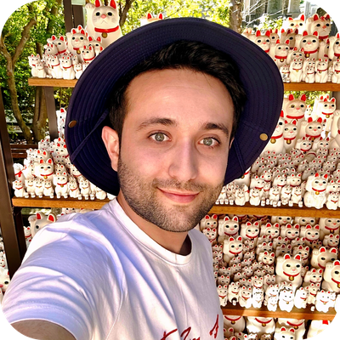

PROFESSIONAL SUMMARY
Senior iOS engineer and team lead with 12 years of software development experience delivering production applications across mobile banking, cryptocurrency, accessibility, healthcare, industrial IoT, and consumer products. Combines hands-on Swift expertise with architecture ownership, product delivery, technical leadership, and mentoring. Creator of SözTap, a word game that reached #1 on the Azerbaijani App Store; led iOS delivery for RockWallet and contributed to a multi-award-winning Slovenian mobile banking application. Passionate about tech, traveling, music, and movies.
🇦🇱 🇦🇹 🇦🇿 🇧🇪 🇧🇦 🇧🇷 🇰🇭 🇨🇴 🇭🇷 🇨🇿 🇪🇪 🇫🇮 🇫🇷 🇩🇪 🇬🇷 🇭🇺 🇮🇹 🇯🇵 🇰🇪 🇱🇦 🇱🇻 🇲🇾 🇲🇨 🇳🇱 🇵🇪 🇵🇱 🇵🇹 🇶🇦 🇸🇦 🇷🇸 🇸🇬 🇸🇮 🇪🇸 🇹🇿 🇹🇭 🇹🇷 🇻🇦 🇻🇳
CORE SKILLS
iOS Engineering: Swift, SwiftUI, UIKit, Combine, Swift Concurrency, async/await, URLSession, Core Data, Core Graphics, WebKit, StoreKit, UserNotifications
Architecture: MVVM, VIP, MVC, Redux-style state management, protocol-oriented programming, dependency injection, modular architecture, Swift Package Manager
Quality & Delivery: Swift Testing, XCTest, XCUITest, CI/CD, App Store Connect, TestFlight, IAP, code review, debugging, performance tuning, localization, accessibility
Leadership & Product: Team leadership, hiring, mentoring, sprint planning, estimation, task distribution, stakeholder collaboration, Agile/Scrum

PROFESSIONAL EXPERIENCE
Senior iOS Developer & Team Lead | Equaleyes 2019
Teranode (nChain) | 2022–2024 - Concurrent engagement
Slovenia + International teams
• Lead end-to-end iOS delivery for large-scale products, translating business requirements into scalable solutions and production-ready App Store releases.
• Coordinate distributed teams across Slovenia, the USA, Canada, the UK, and India, owning planning, estimation, task allocation, technical alignment, and delivery risk.
• Design and build complex applications across banking, cryptocurrency, accessibility, healthcare, industrial IoT, and business domains.
• Shape architecture and engineering standards through modular design, reusable components, API integrations, code reviews, automated testing, and CI/CD.
• Modernize legacy codebases, resolve critical production issues, and improve application performance, stability, maintainability, and accessibility.
• Partner with product, design, QA, backend, and management stakeholders throughout the full development lifecycle.
• Recruit, onboard, and mentor developers, strengthening technical ownership, code quality, and team effectiveness.
Web Developer | Naval LLC 2014 - 2018
• Developed and maintained web applications for client projects, building the foundation for later full-time specialization in mobile engineering.
• Worked directly with product requirements, implementation, troubleshooting, and delivery in a small-team environment.

PROFESSIONAL PROJECT PORTFOLIO
OTP banka (formerly NovaKBM) | Mobile banking: Contributed to iOS development in Swift for the award-winning application. The app achieved 577K+ installations and was named Slovenia’s best-rated mobile banking app four times by Elaborat. |  | 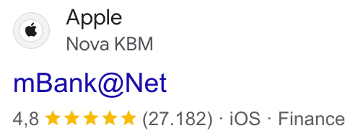
RockWallet | Cryptocurrency wallet: Led iOS delivery for a secure digital wallet supporting account setup, buying, selling, swapping, sending, and receiving digital assets. Delivered KYC/AML onboarding, identity verification, biometric authentication, external verification integrations, transaction monitoring, access controls, and advanced wallet functionality, enabling wallet setup in approximately 90 seconds. Coordinated planning, mentoring, production troubleshooting, releases, and CI/CD across distributed teams in the USA, Canada, Slovenia, and India. |  | 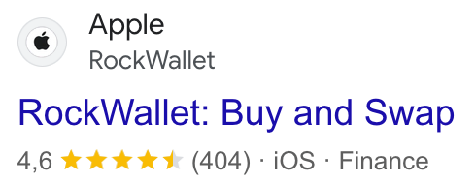
SandCastle by G+D (Giesecke+Devrient) | CBDC digital wallet: Developed security-critical iOS functionality in Swift for a next-generation digital wallet supporting central bank digital currency (CBDC) use cases. Delivered Keycloak-based authentication, secure wallet access, peer-to-peer transfers, QR-based transactions, NFC-enabled smart-card scanning and management, encrypted data handling, and secure credential storage using the iOS Keychain. Worked within G+D’s rigorous engineering environment, adhering to strict coding, architecture, review, and security standards for sensitive digital-payment systems. |  | 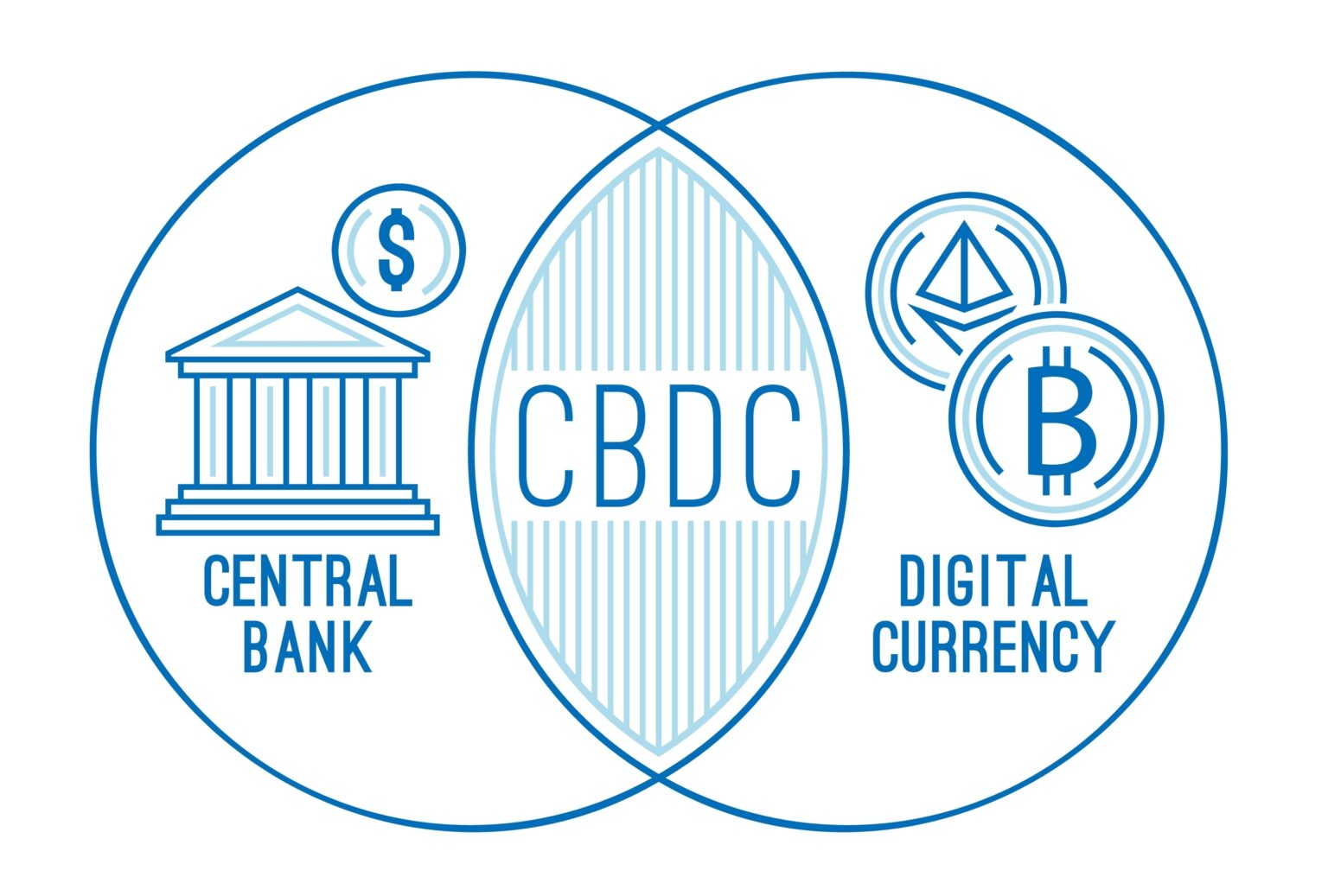
Autistica – Molehill Mountain | Autism research: Contributed to digital product work for the UK's leading autism research charity in collaboration with King's College London.
Gedeon Richter Live | Pharmaceutical and biotechnology: Delivered mobile functionality for a life-sciences product and supported reliable production releases.
London Blockchain Conference | Blockchain, AI & Web3: Contributed to the iOS application supporting a global conference that brings together leaders from business, government, and technology around the real-world adoption of blockchain, AI, and Web3.
MyChoicePad 2 | Accessibility and communication: Developed and maintained iOS functionality supporting language and communication development.
BioEnergyUnit | Smart furnaces: Contributed to mobile experiences for smart-furnace monitoring and control.
MyMetraKey | Smart lockers: Developed and maintained iOS functionality for smart-locker access and management.
E-Livestock | Livestock management and traceability: Contributed to a digital platform improving livestock management and traceability.
Fumis | Biomass combustion control electronics: Supported mobile integration and production functionality for combustion-control systems.
Fumis AIR | Digital stove control: Contributed to the iOS experience for digital stove monitoring and control.
Better Ideas Faster | Productivity: Delivered mobile features for fast capture and organization of creative ideas.
Pattern | Wellbeing: Contributed to a mobile product in the wellbeing and business domain.

INDEPENDENT PRODUCTS
SözTap | #1 word game in Azerbaijan: Created and independently shipped the original iOS word game; owned concept, UX, visual design, engineering, testing, App Store release, marketing, analytics, and ongoing support.  SözTap 2 | Independent iOS title: Designed, developed, released, and supported the second product in the SözTap series.  SözTap Online | Online word-game product: Built and shipped an online edition within the SözTap product family. |  | 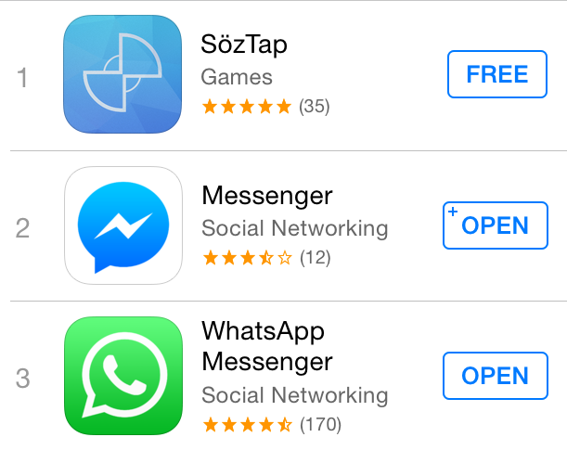
Eject | iOS game: Owned end-to-end product design, engineering, release, and maintenance.
NetworkerKit | Modular networking library: Built a lightweight, reusable networking library used across production applications with URLSession, async/await, and modern Swift Concurrency.
Weblate Localization | Developer tooling: Built a tool that streamlines Weblate internationalization workflows, making localization faster, easier, and more adaptable.
SwiftUI Previews for VS Code | Developer tooling: Built and published a VS Code extension that brings native SwiftUI previews to VS Code through Apple’s Xcode 27 headless MCP server, with support for preview variants, localization, project configuration, and refresh-on-save.

SELECTED TECHNICAL ACHIEVEMENTS
• Reduced UI-layer code by approximately 50% by applying SwiftUI and Combine to production features.
• Migrated a networking stack to async/await, improving stability, readability, and long-term maintainability.
• Built an automated test-sign-deploy CI/CD pipeline that supports daily releases.
• Took dozens of applications from initial setup to production, including phased releases, in-app purchases, and tester-group management.
• Revitalized a 7-year-old legacy application by removing dead code and dependencies and substantially improving cold-start performance on low-spec hardware.
• Decomposed a legacy monolith into 10+ Swift Package Manager modules, significantly reducing build times and improving ownership boundaries.
• Engineered localization for 8 languages while supporting accessibility compliance across critical user journeys.
• Introduced targeted unit, integration, and UI testing with Swift Testing, XCTest, and XCUITest to prevent regressions in critical features and flows.

EDUCATION
Bachelor of Economics | Sumgait State University, Azerbaijan 2013 - 2017

