Fluorescence Polarization-based High Throughput Screening Assays Identify Novel Cardiac Troponin Modulators



Priyanka Parijat1, Saraswathi Ponnam1, Seetharamaiah Attili1, Kenneth S. Campbell2, Mohammed El-Mezgueldi1,3, Mark Pfuhl1 and Thomas Kampourakis1,*

1Randall Centre for Cell and Molecular Biophysics; and British Heart Foundation Centre of Research Excellence, King’s College London, London, SE1 1UL, United Kingdom

Division of Cardiovascular Medicine and Department of Physiology, and, University of Kentucky, Lexington, Kentucky

3Institute for Biological Sciences (ISSB-P), Mohammed VI Polytechnic University, Benguerir, Morocco

**\*Corresponding author:**

Thomas Kampourakis ([thomas.kampourakis@kcl.ac.uk](mailto:thomas.kampourakis@kcl.ac.uk))

**Running title:** Small molecule effectors of cardiac troponin

**Keywords**

cardiac muscle regulation; cardiac troponin; high throughput screen; small molecules; heart failure

**Abstract**

The large unmet demand for new heart failure therapeutics is widely acknowledged. Current heart failure therapies based on neurohumoral modulation are mainly aimed at symptomatic relief, do not treat the underlying etiologies and are frequently associated with unwanted side effects. Over the last decades the contractile myofilaments themselves have emerged as an attractive target for the development of new therapeutics for both systolic and diastolic heart failure. However, the clinical use of myofilament-directed drugs has been limited, and further progress has been hampered by incomplete understanding of myofilament function on the molecular level and screening technologies for small molecules that accurately reproduce this function in vitro. In this study we have designed, validated and characterized new high throughput screening platforms for small molecule effectors targeting the interactions between the troponin C and troponin I subunits of the cardiac troponin complex. Fluorescence polarization-based assays were used to screen commercially available compound libraries, and hits were validated using secondary screens and orthogonal assays. Hit compound-troponin interactions were characterized using isothermal titration calorimetry and NMR spectroscopy to identify interaction sites. We identified NS5806 as novel calcium sensitizer that stabilizes active troponin. NS5806 binds the trimeric complex of N-lobe of cTnC, Ca2+ and the switch region of cTnI with low micromolar affinity and favorable thermodynamic profile. In good agreement, NS5806 greatly increased the calcium sensitivity and maximal isometric force of demembranated human donor myocardium. Our results suggest that sarcomeric protein-directed screening platforms are suitable for the development of compounds that module cardiac myofilament function. (250 words)

**Introduction**

Heart failure and heart disease remain the predominant causes for death world-wide and are a significant burden for both the healthcare systems and global economies (1, 2). Current heart failure therapies are primarily aimed at symptomatic relief via either neurohumoral modulation or the implantation of cardiac assist devices, but usually do not treat the underlying etiologies of heart failure and can cause unwanted side-effects (3). For example, although commonly used inotropes such as dobutamine increase cardiac output, treatment is usually associated with severe side effects such as arrhythmias and hypotension (4, 5). Consequently there is a largely unmet demand for new pharmacological therapies for heart disease and heart failure.

It has become increasingly evident that cardiac myofilament proteins are important regulators of heart muscle function during both health and disease states. This is highlighted by the fact that mutations in the genes encoding for the molecular motor b-cardiac myosin, the cardiac isoform of myosin binding protein-C, the cardiac troponin subunits and tropomyosin are found in the majority of patients suffering from inherited Hypertrophic Cardiomyopathy (HCM) (6). Additionally, post-translational modifications of these sarcomeric proteins are important regulators of both systolic and diastolic function (7, 8), and protein hypo-phosphorylation has been frequently associated with heart muscle dysfunction and heart failure in both human patients and animal models (9, 10).

Cardiac myofilament contraction is initiated by the Ca2+-dependent activation of the actin-containing thin filaments. Calcium binding to the troponin complex at the beginning of systole leads to a structural re-arrangement of tropomyosin on the surface of the thin filament that exposes myosin-binding sites on actin (Fig. 1A). Subsequently, myosin heads from the neighboring thick filaments strongly attach to actin and undergo the working stroke coupled to the release of ATP hydrolysis products. The working stroke pulls the thin filaments towards the center of the sarcomere leading to muscle shortening and force generation. Conversely, calcium release from troponin triggers the de-activation of the thin filament, followed by the dissociation of myosin heads from actin and the onset of mechanical relaxation (11).

The calcium-binding subunit of the trimeric troponin complex, cardiac troponin C (cTnC), can interact with the inhibitory subunit, cardiac troponin I (cTnI), via both its globular N-terminal (NcTnC) and C-terminal (CcTnC) domains, each consisting of two EF-hand motifs (12) (Fig. 1B). Although, CcTnC is constitutively bound to the anchoring region of cTnI (cTnIAR), which anchors cTnC in the troponin complex, Ca2+ binding to sites III and IV during the increase in the cytosolic free Ca2+ concentration ([Ca2+]i) at the beginning of systole has been proposed to affect heart muscle function (13). Moreover, cardiomyopathy-associated mutations in CcTnC and have been shown to alter the interaction of cTnC with cTnIAR and modulate myofilament calcium sensitivity (14), underlining the functional significance of the interaction.

In contrast, NcTnC is found in a closed apo-conformation during low [Ca2+]i and Ca2+ binding to a single site in NcTnC causes changes in the conformational equilibrium of the domain which allows interaction with switch peptide or switch region of cTnI (cTnISP). Recent advance in cryo-electron microscopy of isolated thin filaments have allowed to characterize the subsequent structural changes at the molecular level and demonstrated that the Ca2+-dependent association of NcTnC and cTnISP removes the inhibitory region and the C-terminal tail of troponin I of actin and tropomyosin, activating the thin filament (15).

It follows that the structural OFF/ON transition of the cardiac thin filaments controlled by cTnC-cTnI interactions is a potentially important therapeutic target for the development of compounds with either activating (inotropic) or inhibiting (lusitropic) properties. Such therapeutic interventions would avoid unwanted side effects associated with traditional therapies targeting either the intra-cellular calcium flux or signaling pathways (16). However, the development of effective thin filament directed small molecule effectors has been largely impeded by incomplete understanding of the myofilament structure-function relationship at the molecular level and screening assays that accurately reproduce this function in-vitro. In fact, the majority of currently available small molecule effectors that target cTnC were either identified by homology to other calcium binding proteins of the EF-hand family such as calmodulin (17), or via phenotypical screenings (18). Not surprisingly, the majority of identified small molecules either bind other protein targets with much higher affinity (e.g. EMD 57033 (19)) or are promiscuous in vivo (e.g. EGCg (20)). Currently only Levosimendan, an NcTnC agonist, is used as part of acute heart failure therapy as an inotropic support and even in this case the molecular targets and mechanisms involved are not fully understood (21, 22).

We have previously reported the development of a high throughput screening (HTS) for the calcium-dependent interaction of the cTnISP with the cTnC (23). Here, in an analogous approach, we have developed, characterized and validated an HTS assay for the interaction of the cTnIAR with the C-lobe of cTnC. The newly developed assay is robust and sensitive, and requires minimal reagents, making it ideal for larger screening campaigns. Using the two developed assay systems targeting either the NcTnC or CcTnC interactions with cTnI, we performed multiple pilot screens of three commercially available compound libraries with more than 3000 compounds in total. Hit compounds were confirmed and validated in secondary screens and orthogonal assays using isolated cardiac myofilaments. Hit compounds-cTnC interactions were characterized using a wide range of biophysical techniques including isothermal titration calorimetry (ITC) and NMR spectroscopy, that allow us to define their interaction modes, binding affinities and interaction sites. Lastly, we tested for the functional effects of compounds in demembranated human myocardium and identified NS5806 as a potential scaffold for the development of new class of calcium sensitizers that stabilize active cardiac troponin. Both the developed HTS assays and identified compounds are suitable platforms for the development of novel cardiac troponin-directed therapeutical interventions for heart failure.

**Results and Discussion**

**Design and Validation of High Throughput Screens that Target Cardiac Troponin**

Both the N- and C-terminal lobe of cardiac troponin C have been shown to be the target of small molecule effectors that modulate cardiac myofilament function both *in vitro* and *in vivo* (24, 25). We have previously published the design and validation of a high throughput screening (HTS) assay that targets the interaction between the N-terminal lobe of cTnC (NcTnC) and the switch region of cardiac troponin I (cTnISP) (23). In a complementary approach, here we have designed a similar HTS assay for the interaction of the C-terminal lobe of cTnC (CcTnC) with the anchoring region of cTnI (cTnIAR) (Fig. 1C). Cardiomyopathy-associated mutations in CcTnC (e.g. Gly159Asp) have been shown to alter its interaction with cTnIAR and thereby modulate myofilament calcium sensitivity (14, 26), underlining the functional significance of this interaction.

To monitor the interaction of cTnC with cTnIAR in vitro, we have conjugated 6-carboxy-fluoresceine (FAM) to the N-terminus of a peptide corresponding to amino acid residues 39-64 of human cTnI (FAM-cTnIAR). Titration of increasing concentrations of cTnC into 1 nmol/L FAM-cTnIAR increased the FP measured from the FAM probe in a concentration dependent manner, indicating protein complex formation (Fig. S1A). Data points were fitted to a single-site binding model, which gave a Kd of about 1 nmol/L. We further confirmed the interaction using Microscale Thermophoresis (MST). Alexa647-labelled cTnC was titrated against increasing concentrations of FAM-cTnIAR, which resulted in a binding isotherm with a Kd of about 3 nmol/L (Fig. S1A, inset). The measured Kd values are in very good agreement with previously published results using surface plasmon resonance spectroscopy using an unmodified peptide (Kd of about 3 nmol/L) (27), suggesting that FAM-attachment to the designed cTnIAR peptide had no or little effect on its interaction with CcTnC.

We further validated the specificity of the interaction between cTnC and FAM-cTnIAR by titrating increasing concentrations of unlabelled cTnIAR peptide into a mixture of 2 nmol/L FAM-cTnIAR and 5 nmol/L cTnC, and monitored the reaction via changes in FP. The unlabelled peptide decreased the FP in a concentration-dependent manner with an EC50 of about 2.6 nmol/L, indicating specific replacement of the FAM-labelled with the unlabelled peptide in the protein complex (Fig. S1B). Moreover, the interaction of cTnC and FAM-cTnIAR is very stable and was not affected by DMSO concentration of up to 10% (v/v) (Fig. S1C).

We calculated the Z’-factor of our HTS by adding either DMSO or 50 nmol/L unlabelled cTnIAR peptide to 30 mL assay mixture containing 2 nmol/L FAM-cTnIAR and 5 nmol/L cTnC in 384-well plates (28) (Fig. S1D). The calculated Z’-factor and signal-to-noise (S/N) ratio of about 0.8 and 44, respectively, suggest an excellent assay. Moreover, low material requirements (i.e. low nanomolar concentration of reagents) made the developed assay highly cost-efficient and therefore very suitable for HTS applications.

**Pilot Screens of Commercially Available Compound Libraries and Hit Validation**

Using the developed cTnISP and cTnIAR HTS assays we performed single concentration screens of three commercially available compound libraries (ENZO Screenwell V2, TOCRIScreen and Sigma LOPAC® 1280) with a total of >3000 compounds in 384-well format (Fig. 1D). Negative and positive control wells were included in each plate and gave consistent Z’-factors of about 0.8 for each screening plate. Each compound was tested at a concentration of 50 mmol/L and 10 mmol/L for the cTnISP and cTnIAR screen, respectively. Hits were defined as compounds that changed the average FP value more than five-times the standard deviation (SD) (Fig. 1D, red lines). Moreover, compounds that either increased or decreased the total fluorescence intensity (FI) more than five-times the SD were removed from further analysis, indicating either compound aggregation or unspecific interactions with the fluorophore or protein complex.

Although we identified a large number of compounds that decreased the FP values in the cTnC/cTnISP screenand therefore could act as potential inhibitors of the NcTnC-cTnI switch peptide interaction (23), we primarily focused on compounds that *increased* the interaction of cTnC and cTnISP, as indicated by an increase in the measured FP values (i.e. activators). Such compounds could potentially increase thin filament activation during cardiac systole and could be developed into positive inotropes (18, 29). Of the initial 11 primary hits that significantly increased the FP value, seven could either not be confirmed in secondary assays using higher replicate numbers or were chemically not suitable for further investigations (e.g. calpeptin). The four remaining compounds (NS5806, NS3632, CFTR Inh172 and 5-HPP-33) were further validated using dose-response analysis and an orthogonal assay. All four compounds increased the FP from a mixture of FAM-cTnISP and cTnC in a concentration dependent manner (Fig. 2A), suggesting an increase in the affinity of cTnC for the FAM-labelled switch peptide, with the strongest increase observed for NS5806 and NS3623 (Fig. 2A). These results were mirrored in an orthogonal assay measuring the ATPase activity of isolated bovine cardiac myofibrils at submaximal calcium activation (corresponding to about 30% of maximal activation) in the presence of increasing drug concentration (Fig. 2B). Both NS5806 and NS3623 significantly increased the ATPase activity of myofibrils in a dose-dependent manner, whereas CFTR Inh172 and 5-HPP-33 showed no or little activation of myofibrillar ATPase in concentrations of up to 100 mmol/L. NS5806 showed the strongest activating effect with an increase in ATPase activity of over 60% with respect to the control at the highest concentration tested.

Similarly, we identified 15 primary hits in the cTnIAR screen that decreased the FP from which 11 were excluded during secondary screens or based on their chemical properties (Fig. 1D). The remaining four compounds (Claramine, Furamidine, Icaritine and KT 203) decreased the FP from the cTnC FAM-cTnIAR mixture in a concentration dependent manner, suggesting inhibition of the protein-peptide interaction (Fig. 2C). Surprisingly, we observed a sudden increase in the FP for both Claramine and Furamidine at higher drug concentrations (>10 mmol/L), potentially indicating assay interference. However, total fluorescence intensity of the assay mixture was not affected by either Claramine of Furamidine at concentrations of up to 100 mmol/L, suggesting that the sudden increase in FP is not caused by compound aggregation (Fig. S2). This is further supported by high solubility of both compounds in aqueous solutions (>25 mmol/L). We tested for the functional effects of the remaining four hit compounds by measuring the ATPase activity of bovine cardiac myofibrils at sub-maximal activation, corresponding to about 70% of the maximal ATPase activity (Fig. 2D). Both Icaritin and KT203 showed no effect on myofibrillar ATPase activity in a concentration range of up to 100 mmol/L and were excluded from further analysis. In contrast, Claramine and Furamidine decreased myofibrilar ATPase activity by about 40-50%.

NS5806, Furamidine and Claramine were chosen for further biophysical and functional characterization. Their chemical structures are shown in Figure 2E.

**Biophysical Characterization of NS5806 Binding to cTnC**

Binding of hit compounds to cTnC was confirmed using isothermal titration calorimetry (ITC). Although NS5806 increased cTnISP binding to cTnC (Fig. 2A), the compound only weakly interacted with the Ca2+-saturated N-lobe of cTnC (NcTnC) with an estimated steady-state dissociation constant Kd of about 60 mmol/L (Fig. 3A). This is mirrored in the thermodynamic properties with DH ≈ -2 kJ/mol and TDS ≈ 2.1 kJ/mol. Similarly, NS5806 only weakly bound to a Ca2+-free cChimera construct consisting of NcTnC C-terminally conjugated to the switch region of cTnI (30), which, however, could not be reliably quantified using ITC. In contrast, NS5806 showed very clear saturable binding to the Ca2+-saturated cChimera with a Kd of 7.6 ± 0.3 mmol/L and stoichiometry of about 1:1 (means ± SEM, n=4). Moreover, the interaction has both favorable enthalpic (DH = -11.4 ± 0.8 kJ/mol) and entropic contributions (TDS = 17.6 ± 0.9 kJ/mol), suggesting that the NS5806-cChimera complex is stabilized by both hydrophilic and hydrophobic interactions.

In contrast to skeletal TnC, NcTnC remains mostly in its closed conformation in the Ca2+-bound state and only adopts the fully open conformation in the presence of the cTnI switch peptide (31). Similarly, the cChimera has recently been shown to adopt its closed conformation in the absence of Ca2+ (32). Taken together with the ITC data presented above, these results suggest that NS5806 preferentially binds to NcTnC in its open conformation when bound to the cTnI switch peptide. A compound with similar properties, RPI-194, was recently identified using an NMR-based structural screening approach (33). RPI-194 weakly binds isolated NcTnC but shows micromolar affinity to a Ca2+-saturated cChimera of NcTnC C-terminally linked to the switch region of cTnI.

We mapped the NS5806 binding site on Ca2+-saturated cTnC using two-dimensional 1H-15N-HSQC NMR spectroscopy (Fig. 3B). NS5806 titration into cTnC gave modest chemical shift perturbations (Dd, CSPs) between 0.1-0.15 ppm with the binding occurring in the fast-exchange regime suggesting fast binding/unbinding kinetics. For NS5806 the largest CSPs are clustered tightly around the hydrophobic residues Ile36 and Val72 of the antiparallel b-sheet and the adjacent loops of the N-lobe, next to the calcium binding site II, suggesting that NS5806 binds deeply into the hydrophobic groove of Ca2+-NcTnC. In contrast, lower CSPs are seen in the C-lobe in all four helices. No significant CSPs for the hydrophobic residues Ile112 and Ile148 of the central b-sheet indicates that NS5806 is not buried deep in the hydrophobic center of CcTnC and likely only weakly interacts with its the surface. A very similar behavior has been reported for the inhibitor W-7, which interacts with both the N-lobe and C-lobe of isolated cTnC, but exclusively binds to NcTnC in the presence of cTnI, suggesting unspecific interaction with the hydrophobic groove of CcTnC (34, 35).

We further tested for the effects of NS5806 on the Ca2+ binding affinity of cChimera (Fig. 3C). In the absence of NS5806, cChimera binds Ca2+ with a Kd of 1.8 ± 0.2 mmol/L (mean ± SEM, n=5), which is significantly lower than the Kd previously reported for NcTnC alone using ITC (Kd of ~15 mmol/L) but higher than for cChimera using NMR spectroscopy (30, 36). In the presence of NS5806 the Ca2+-affinity of cChimera is slightly increased with a Kd of 1.2 ± 0.2 mmol/L, which however, did not reach statistical significance (P=0.07 for an unpaired, two-tailed student’s t-test).

NS5806 has been shown to act as an activator of voltage-gated potassium channel Kv4.3 by binding to potassium channel-interacting proteins (KChIPs) and increase their affinity for the channel. KChIPs are calcium-binding proteins containing several EF-hand motifs in their C-terminal domain and NS5806 has been shown to bind close to the hydrophobic pocket near EF-hand 4 of KChIP3 in the Ca2+-bound state (37). Structural alignment of KChIP1 bound to a fragment of Kv4.3 (PDB 2I2R) shows a high degree of structural similarity with NcTnC bound to the switch peptide of cTnI (PDB 1MXL) with an RMSD of 1.65 Å (Fig. S3). This suggests that NS5806 might occupy a similar hydrophobic pocket created by the NcTnC-cTnISP interface and stabilize this interaction, in good agreement with the ITC and NMR data discussed above.

**Biophysical Characterization of Furamidine Binding to cTnC**

The ITC isotherm for Furamidine binding to full length cTnC is shown in Figure 4A. Furamidine binds Ca2+-saturated cTnC in a roughly 1:1 stoichiometry with a Kd of 11.9 ± 5.5 mmol/L (means ± SEM, n=3). The interaction has both a favorable enthalpic (DH = -19.4 ± 3 1.7 kJ/mol) and entropic contributions (TDS = 7.7 ± 3 kJ/mol).

Furamidine was discovered in the primary screen as a potential inhibitor of the cTnC-cTnIAR interaction and we quantified its effect on the protein-cTnIAR peptide interaction using ITC. Titration of an unlabelled cTnIAR peptide into cTnC gave a very clear and saturable binding isotherm with a Kd of 17.9 ± 2.6 nmol/L (means ± SEM, n=3) (Fig. 4B), in good agreement with the binding affinities estimated by FP and MST described above. In contrast, in the presence of excess Furamidine the binding affinity of cTnC for cTnIAR is reduced by several orders of magnitude with a Kd of 4.2 ± 0.5 mmol/L (Fig. 4B, left), suggesting that Furamidine either reduces the affinity of cTnC for the anchoring region of cTnI or directly competes for the same interaction site.

We mapped the Furamidine binding site on cTnC using two-dimensional 1H-15N-HSQC NMR spectroscopy. A small section of the HSQC spectrum of free cTnC (blue) superimposed with the spectrum at about 1:1 molar ratio of added Furamidine (purple) is shown in Figure 4C. Furamidine binding occurs in the fast-exchange regime, suggesting fast binding/unbinding kinetics of the drug to the protein. Quantitative analysis of the chemical shift perturbations (CSPs) shows a cluster of highly significant values in only the C-lobe of cTnC around residues 120-130 (Fig. 4C, bottom), suggesting that Furamidine does not interact with NcTnC. Mapping of the CSPs to the Ca2+-bound structure of cTnC (PDB 1AJ4) shows a defined interaction surface in the C-lobe distal to the calcium binding sites III and IV (Fig. 4D, top). No significant CSPs for the hydrophobic residues Ile112 and Ile148 of the central b-sheet indicates that Furamidine is not buried deep in the hydrophobic pocket of CcTnC. Using the CSPs to define the interaction surface, we performed flexible docking in AutoDock Vina to determine Furamidine’s potential binding modes (Fig. 4D, bottom) (38). The in-silico results suggest that Furamidine sits in the hydrophobic groove of the cTnC C-lobe, which is normally occupied by the anchoring region of cTnI in the troponin complex (Fig. 4D, cyan helix). Taken together these results suggest that Furamidine might directly compete with cTnIAR for the same binding site in CcTnC.

The Furamidine results are broadly similar to previously published studies showing that the calcium sensitizer EMD 57033 binds to the C-lobe of cTnC with micromolar affinity (39, 40). However, EMD 57033 had no significant effect on the CcTnC and cTnIAR interaction as measured by NMR spectroscopy, in stark contrast to Furamidine which significantly lowered the affinity by several orders of magnitude. EMD 57033 sits deep in the hydrophobic pocket of CcTnC as evident by contacts between Ile112 and Ile148 with its thiadiazone group and stabilizes a more open conformation of the domain by contacts with residues Leu117 and Leu121 on the F-helix that pull it away from helix E to helix G. These structural rearrangements are similar to the effects of cTnIAR binding to CcTnC (41), indicating that these changes are a pre-requisite for the interaction of the two proteins. In contrast, similar contacts are largely missing for Furamidine, suggesting that it does not stabilize the open conformation of CcTnC. Alternatively, Furamidine binding to CcTnC might stabilize its closed conformation, which might be the molecular basis of its inhibitory effect on the interaction between CcTnC and the cTnI anchoring region.

**Biophysical Characterization of Claramine Binding to cTnC**

Claramine binds to isolated cTnC with Kd of 21.6 ± 1.8 mmol/L (means ± SEM, n=3), which is about two-times weaker compared to Furamidine. The weaker binding is mirrored in the thermodynamic parameters (DH = -4.6 ± 1.3 kJ/mol and TDS = 21.8 ± 1.3 kJ/mol) and suggests a mostly entropy-driven interaction likely mediated via hydrophobic interactions of its steroid group with the hydrophobic pocket of CcTnC.

Titration of Claramine into cTnC was monitored via 1H-15N-HSQC NMR spectroscopy to determine its binding site. Claramine only produced modest CSPs in cTnC, although in the slow exchange regime, which were mostly localized to its C-terminal domain but over a broad interaction surface surrounding the hydrophobic pocket. Similar to Furamidine, small or no CSPs for residues Ile112 and Ile148 suggest that Claramine is not buried deep in the hydrophobic cleft of CcTnC and likely resides near its opening. Interestingly, the largest CSPs were observed for residues Asp113 and Glu116, which are part of CcTnC Ca2+-binding site III. In good agreement with the relatively weak and potentially unspecific interaction, Claramine had no or little effect on the interaction between the cTnC and the anchoring region of cTnI as measured by ITC. The estimated steady-state dissociation constants Kd in the presence of Claramine was about 40 nmol/L, which is only marginally higher compared to the control in the absence of the drug.

**Functional Effects of Hit Compounds in the Calcium Sensitivity of Human Heart tissue**

We tested for the functional effects of hit compounds by measuring the calcium sensitivity of force development of chemically demembranated human donor ventricular tissue in the absence and in the presence of 100 mmol/L compounds (Fig. 6). Force-pCa (pCa = -log10[Ca2+]) relations for each preparation was measured in the absence and in the presence of each compound, so that each muscle preparation served as its own control. Time-matched control experiments showed no significant differences in the calcium sensitivity as indicated by pCa50 (pCa50 = -log10[Ca2+] for half maximal activation), steepness of the force-pCa relation (nH) and maximal active isometric force after the first and second force-pCa titration in the absence of drugs (Fig. S4), suggesting very little preparation rundown. Measured pCa50 and nH values for demembranated human donor samples are in very good agreement with previously published results (42).

NS5806 strongly increased the calcium sensitivity of force development of demembranated human muscle strips as indicated by an increase in pCa50 by about 0.2 pCa. Similarly, there was a trend towards a lower steepness of the force-pCa relation as indicated by the Hill coefficients (nH), which however, did not reach statistical significance (Fig. 5A and B). Moreover, NS5806 increased the maximal active isometric force at full calcium activation (pCa 4.5) by about 10%. The net effect is a large increase in the active force development of human cardiac muscle at calcium concentrations close to the value measured in intact muscle cells during systole (pCa 5.8-6). The functional effects of NS5806 are in very good agreement with the idea that the compound stabilizes the interaction between cTnC, Ca2+ and the switch region of cTnI in situ and therefore acts as a calcium sensitizer of the contractile myofilaments. Interestingly, the functional effects of NS5806 on demembranted cardiac muscle fibres (i.e. increase in maximal force production) are different to those reported for the troponin activator RPI-194 (33), suggesting that both molecules stabilize activated troponin via distinct mechanisms.

In contrast, Claramine had no or little effect on the force-pCa relation of demembranated human cardiac muscle cells (Fig. 5A and 5B). Furamadine slightly increased the calcium sensitivity of demembranated human cardiac muscle strips but had no effect on the steepness of the force-pCa relation or maximal force development. It is likely that the high binding affinity and local concentrations of CcTnC and cTnIAR in the myofilaments cannot be overcome by small molecule effectors that bind CcTnC with only micromolar affinity in the concentration range tested (≤100 mmol/L).

**Conclusions**

The myofilaments have become an attractive therapeutic target for the treatment of both cardiomyopathies and heart failure (25, 43), potentially increasing efficacy and avoiding unwanted side effects associated with current therapies. Recently, the cardiac myosin-specific inhibitor Mavacamten (now known as CamzyosTM) was approved by the FDA for the treatment of obstructive HCM (44).

Here, we developed novel HTS assays that directly target the interactions of the cTnC- and cTnI-subunits of the cardiac troponin complex. The assays are robust and sensitive, and identified biological active compounds even from small compound libraries. Moreover, hit rates of about 0.13% after secondary screens and about 0.07% after orthogonal assay suggests manageable number of compounds even with very large libraries (>100000 compounds). Using these assays we identified NS5806 as a novel calcium sensitizer, which binds to and stabilizes the trimeric complex of NcTnC, Ca2+ and the switch region of cTnI. NS5806 has similar functional properties to TA1 (18), a cardiac troponin agonist currently undergoing Phase I clinical trials, albeit with lower potency. Although Furamidine did not have a strong functional effect on cardiac myofilament function, it is a useful scaffold for the development of future lead compounds that target the C-lobe of cTnC. Furamidine is the first identified compound that specifically binds the CcTnC with micromolar affinity and reduces its affinity for the anchoring region of cTnI. Taken together, our results suggest that sarcomere-directed targeted screening strategies are suitable to identify biologically active compounds that can be developed into new heart failure therapeutics.

**Methods**

**Production of Proteins and Peptides**

Full length human cardiac troponin C (cTnC) and its N-terminal domain (NcTnC), and human cChimera construct containing NcTnC C-terminally conjugated to the switch region of cardiac troponin I (cTnI) were expressed from a modified pET6a vector in BL21 (DE3)-RIPL cells (Agilent Technologies Inc.) fused to a hexa-histidine tag and TEV protease site. Proteins were purified on HisTrapFF columns (GE Heatlhcare), and histidine-tag was removed by treating proteins overnight with 1:100 stoichiometry of hexahistidine-tagged TEV protease. TEV protease and histidine-tag were removed by applying the mixture onto a 1 ml HisTrapFF column, and the flow-through containing the purified protein was collected. Protein purity was estimated to be >95% by SDS-PAGE and electron spray ionization mass spectrometry (ESI-MS). The N-terminally 6-carboxy-fluoresceine (FAM) labelled A162H-mutated switch region peptide of human cardiac troponin I (sequence: TLRRVRISADAMMQALLGARHKESLDLR) and the N-terminally FAM-labelled anchoring region peptide of human cardiac troponin I (FAM-cTnIAR; sequence: SKISASRKLQLKTLLLQIAKQELERE) were purchased from Fisher Scientific (>99% purity, TFA removed).

Protein expression with 15N isotope labelling was performed as described previously (45). The protein was purified on a 5 mL HisTrap FF6 column as per the manufacturers protocol. The his-tag was subsequently cleaved using TEV protease and removed along with other contaminating proteins by a second application on the 5 mL HisTrap FF6 column. Purity of the protein was judged by SDS-PAGE to be > 95%. The purified protein was buffer exchanged using a PD10 desalting column and concentrated using a Vivaspin 20 concentrator with 5 kDa cutoff. All measurements were carried out in NMR buffer (composition in mmol/L: 20 HEPES pH 7.2, 100 NaCl, 5 CaCl2, 2 DTT, 0.02% (w/v) NaN3) with 10% (v/v) D2O in a total volume of 350 mL using a Shigemi tube.

**High Throughput Screening**

The high throughput screen protocol using the FAM-labelled cTnISP has been previously described (23). Libraries were reformatted from 96-well plates to Greiner 384-well black plates using a GILSON PipetMax. The plates were sealed with adhesive foil and stored at -20°C until further use. 30 mL of master mix containing 2 nmol/L FAM-cTnIAR and 5 nmol/L cTnC in assay buffer (20 mmol/L Tris-HCl pH 7, 100 mmol/L NaCl, 1 mmol/L CaCl2, 1mmol/L DTT) were added to each well of a black Greiner 384-well plate, and either DMSO or 50 nmol/L unlabelled cTnIAR peptide were added to two columns per plate as negative and positive controls, respectively. A total of 40 nL of 10 mmol/L compound stocks were transferred to each well using a Mosquito liquid handler system (final DMSO concentration of 0.1% (v/v)). The plates were incubated in the dark for 30 min at 25°C, and the fluorescence polarization from each well was measured using a ClarioStar Plate reader with appropriate excitation and emission filter settings. Dose-response curves were constructed by serial dilution of compounds in DMSO and adding a fixed volume to a mixture of peptide and cTnC.

**Myofibrilar ATPase Activity Measurements**

Bovine cardiac myofibrils (CMF) were freshly prepared from bovine ventricle as previously described (46). The NADH-coupled ATPase assay was adapted to test the effects of drugs on bovine cardiac myofibrils (47). Briefly, buffers with varying free [Ca2+] were prepared by adding the appropriate concentrations of EGTA and CaCl2 calculated using the MAXCHELATOR software. A substrate mix (composition: 220 µmol/L NADH, 2 mmol/L phospho-enolpyruvate and 2 mmol/L ATP) and an enzyme mix (composition: 0.5 mg ml-1 myofibrils, 40 U ml-1 Lactate Dehydrogenase and 200 U ml-1 Pyruvate Kinase) were prepared for a final reaction volume of 40 mL. 20 mL Enzyme mix was added to individual wells using a 12-well multichannel pipette. Appropriate concentrations of drugs were added to each well and the plate was shaken at 1000 rpm for 5 mins on a plate shaker and further incubated at room temperature for 10 mins. Substrate mix was dispensed into each well using the Gilson PipetMax. The plate was briefly spun down to ensure removal of air bubbles. The reaction was followed by recording the fluorescence intensity of each well with excitation at 380 nm and emission at 470nm, for 10 mins scanning the plate every 30 seconds. ATPase rates were extracted by linear regression to datapoints in GraphPad Prism.

**Isothermal Titration Calorimetry**

Thermodynamic parameters for the appropriate drugs binding to NcTnC, cChimera and cTnC were determined in ITC buffer (composition in mmol/L: 20 MOPS, 100 KCl, 1 MgCl2, 1 CaCl2, pH 7) using a MicroCal ITC200 titration calorimeter (Malvern Panalytical). The protein stock solutions were dialysed against ITC buffer overnight. The sample cell and injection syringe were extensively cleaned with decalcified water and then with ITC buffer. The reaction cell was loaded with 180 µmol/L NcTnC solution, 200 µmol/L cTnC, 150. 20 or 40 injections of drugs or peptides were titrated into protein solution with 3 min intervals between injections. The first injection was ignored and correction for the heat of dilution was made by subtracting the last injection from all injection points. The temperature was kept constant at 25ºC, and stirring speed was at 1000 rpm. ITC data were analyzed using Origin 7 ITC data analysis software (OriginLab Corp., Northampton, MA).

**Microscale Thermophoresis**

MST experiments were performed on a Monolith NT.115 instrument (NanoTemper) in interaction buffer containing 20 mmol/L MOPS, pH 7, 1 mmol/L CaCl2, 50 mmol/L KCl, 1 mmol/L DTT and 0.05% (v/v) Tween-20. Human cTnC was labelled with Alexa 647-NHS (Molecular Probes, Inc; ThermoFisher Scientific) according to the manufacturer’s instructions, and dye incorporation (efficiency of >80%) was confirmed by HPLC and ESI-MS. Labelled cTnC was gel-filtered into the interaction buffer. Titration experiments were performed with a fixed concentration of 100 nmol/L of Alexa647-labelled cTnC in premium capillaries.

**NMR Spectroscopy**

All NMR experiments were carried out on a Bruker Avance III 800 MHz spectrometer at T=298K. Standard 1H-15N HSQC experiments with flip back pulse and watergate were used as provided by the manufacturer. Spectra were recorded with spectral widths of 15.61 and 27 ppm for 1H and 15N, respectively using 2048 and 250 points giving a FID resolution of 12.2 and 17.5 Hz. Data was collected with 32 scans preceded by 8 dummy scans. Spectra were processed using Bruker Topspin 4.1.4 to a matrix of 4096x2048 complex points. FIDs were apodized with Sine2 window functions shifted by 3 and 2.5. Water suppression was enhanced using Qfil followed by a polynomial baseline correction. Ligands were dissolved in DMSO at a stock concentration of 50 mM. Appropriate quantities of stock were added to the NMR samples to reach the desired concentration.

Processed spectra were analysed in CCPNMR 2.4.2 and 2.5 (48). Backbone amide assignments for full length human cardiac TnC were obtained from combining BMRB entries 4994 and 25797 supplemented by a 15N 3D-NOESY-HSQC experiment to resolve ambiguities. Out of 161 amino acids in the construct only three (K6, A7, M85) could not be assigned in this way. For interaction mapping reference HSQC experiments were recorded with protein concentrations of 380 mmol/L (NS5806) and 200 mmol/L (Furamidine, Claramine). Ligand binding experiments were recorded over a range of ligand concentrations from 0.5:1 to 3:1. It was found that the quality of the spectra was best around 1:1 (ligand:protein) and these spectra were analysed in full to determine the chemical shift perturbations (CSP) for each assigned amide group. Peak assignment in the spectra with added ligands was done by following the peaks moving as more ligand was added in cases of fast exchange (Furamidine, NS5806). In the case of slow exchange an exchange experiment was recorded to link the new species appearing at increasing ligand concentration in addition to the peak of the free protein. Where the exchange experiment did not produce useful data the minimal CSP approach was used.

CSPs were extracted and plotted against the sequence using Apple Numbers. Simple standard deviation was calculated for each of the three plots and used as significance thresholds. Levels from 1*sigma to 4*sigma were created and used as cutoffs for colouring of 3D models of TnC alone (PDB code: 1AJ4) or in the Tn complex (PDB code: 1J1E). 3D protein structure images were generated in Pymol.

**Preparation of Human Cardiac Muscle Strips and Force-Ca2+ Titrations**

Human samples were obtained after informed consent and with approval of the institutional review board of the University of Kentucky (08-0338-F2L; approval date: January 18, 2017) and the King’s College London Research Ethics Panel (LRM-20/21-22235; approval date: 28th September 2021). This investigation conformed with the principles of the Declaration of Helsinki (1997). Mechanical experiments and force-calcium titrations were performed as previously described (42). Drugs were freshly diluted in DMSO and added to physiological buffer solutions before mechanical experiments. Demembranated human heart donor samples were equilibrated in relaxing solution (pCa 9) containing the appropriate concentrations of drugs for 30 min at 22°C and sarcomere length was adjusted to about 2 µm by laser diffraction. The final DMSO concentration was held constant at 0.2% (v/v).

**Acknowledgements**

We would like to thank Prof. Mathias Gautel and Alexander for help and support.

**Founding Sources**

This study was supported by grants from the British Heart Foundation (PG/19/52/34497) and National Institutes of Health (USA) (1R01HL149164-01A1).

**References**

1. C. W. Tsao *et al.*, Heart Disease and Stroke Statistics-2022 Update: A Report From the American Heart Association. *Circulation* **145**, e153-e639 (2022).

2. C. Cook, G. Cole, P. Asaria, R. Jabbour, D. P. Francis, The annual global economic burden of heart failure. *Int J Cardiol* **171**, 368-376 (2014).

3. P. A. Heidenreich *et al.*, 2022 AHA/ACC/HFSA Guideline for the Management of Heart Failure: A Report of the American College of Cardiology/American Heart Association Joint Committee on Clinical Practice Guidelines. *Circulation* **145**, e895-e1032 (2022).

4. C. L. Tacon, J. McCaffrey, A. Delaney, Dobutamine for patients with severe heart failure: a systematic review and meta-analysis of randomised controlled trials. *Intensive Care Med* **38**, 359-367 (2012).

5. L. Szarpak *et al.*, Milrinone or dobutamine in patients with heart failure: evidence from meta-analysis. *ESC Heart Fail* **9**, 2049-2050 (2022).

6. A. J. Marian, E. Braunwald, Hypertrophic Cardiomyopathy: Genetics, Pathogenesis, Clinical Manifestations, Diagnosis, and Therapy. *Circ Res* **121**, 749-770 (2017).

7. R. J. Solaro, T. Kobayashi, Protein phosphorylation and signal transduction in cardiac thin filaments. *J Biol Chem* **286**, 9935-9940 (2011).

8. R. J. Solaro, Multiplex kinase signaling modifies cardiac function at the level of sarcomeric proteins. *J Biol Chem* **283**, 26829-26833 (2008).

9. O. Copeland *et al.*, Analysis of cardiac myosin binding protein-C phosphorylation in human heart muscle. *J Mol Cell Cardiol* **49**, 1003-1011 (2010).

10. A. E. Messer, A. M. Jacques, S. B. Marston, Troponin phosphorylation and regulatory function in human heart muscle: dephosphorylation of Ser23/24 on troponin I could account for the contractile defect in end-stage heart failure. *J Mol Cell Cardiol* **42**, 247-259 (2007).

11. A. M. Gordon, E. Homsher, M. Regnier, Regulation of contraction in striated muscle. *Physiol Rev* **80**, 853-924 (2000).

12. S. Takeda, A. Yamashita, K. Maeda, Y. Maeda, Structure of the core domain of human cardiac troponin in the Ca(2+)-saturated form. *Nature* **424**, 35-41 (2003).

13. N. Swindle, S. B. Tikunova, Hypertrophic cardiomyopathy-linked mutation D145E drastically alters calcium binding by the C-domain of cardiac troponin C. *Biochemistry* **49**, 4813-4820 (2010).

14. O. K. Baryshnikova, I. M. Robertson, P. Mercier, B. D. Sykes, The dilated cardiomyopathy G159D mutation in cardiac troponin C weakens the anchoring interaction with troponin I. *Biochemistry* **47**, 10950-10960 (2008).

15. Y. Yamada, K. Namba, T. Fujii, Cardiac muscle thin filament structures reveal calcium regulatory mechanism. *Nat Commun* **11**, 153 (2020).

16. N. Ghionzoli *et al.*, Current and emerging drug targets in heart failure treatment. *Heart Fail Rev* **27**, 1119-1136 (2022).

17. P. J. Silver, P. B. Pinto, J. Dachiw, Modulation of vascular and cardiac contractile protein regulatory mechanisms by calmodulin inhibitors and related compounds. *Biochem Pharmacol* **35**, 2545-2551 (1986).

18. H. He *et al.*, Novel Small-Molecule Troponin Activator Increases Cardiac Contractile Function Without Negative Impact on Energetics. *Circ Heart Fail* **15**, e009195 (2022).

19. M. B. Radke *et al.*, Small molecule-mediated refolding and activation of myosin motor function. *Elife* **3**, e01603 (2014).

20. A. Negri, V. Naponelli, F. Rizzi, S. Bettuzzi, Molecular Targets of Epigallocatechin-Gallate (EGCG): A Special Focus on Signal Transduction and Cancer. *Nutrients* **10** (2018).

21. H. Haikala *et al.*, Cardiac troponin C as a target protein for a novel calcium sensitizing drug, levosimendan. *J Mol Cell Cardiol* **27**, 1859-1866 (1995).

22. O. Orstavik *et al.*, Inhibition of phosphodiesterase-3 by levosimendan is sufficient to account for its inotropic effect in failing human heart. *Br J Pharmacol* **171**, 5169-5181 (2014).

23. P. Parijat *et al.*, High Throughput Screen Identifies Small Molecule Effectors That Modulate Thin Filament Activation in Cardiac Muscle. *ACS Chem Biol* **16**, 225-235 (2021).

24. M. X. Li, I. M. Robertson, B. D. Sykes, Interaction of cardiac troponin with cardiotonic drugs: a structural perspective. *Biochem Biophys Res Commun* **369**, 88-99 (2008).

25. P. M. Hwang, B. D. Sykes, Targeting the sarcomere to correct muscle function. *Nat Rev Drug Discov* **14**, 313-328 (2015).

26. E. C. Dyer *et al.*, Functional analysis of a unique troponin c mutation, GLY159ASP, that causes familial dilated cardiomyopathy, studied in explanted heart muscle. *Circ Heart Fail* **2**, 456-464 (2009).

27. G. Ferrieres *et al.*, Systematic mapping of regions of human cardiac troponin I involved in binding to cardiac troponin C: N- and C-terminal low affinity contributing regions. *FEBS Lett* **479**, 99-105 (2000).

28. J. H. Zhang, T. D. Chung, K. R. Oldenburg, A Simple Statistical Parameter for Use in Evaluation and Validation of High Throughput Screening Assays. *J Biomol Screen* **4**, 67-73 (1999).

29. F. Cai *et al.*, Structures reveal details of small molecule binding to cardiac troponin. *J Mol Cell Cardiol* **101**, 134-144 (2016).

30. S. E. Pineda-Sanabria, O. Julien, B. D. Sykes, Versatile cardiac troponin chimera for muscle protein structural biology and drug discovery. *ACS Chem Biol* **9**, 2121-2130 (2014).

31. M. X. Li, L. Spyracopoulos, B. D. Sykes, Binding of cardiac troponin-I147-163 induces a structural opening in human cardiac troponin-C. *Biochemistry* **38**, 8289-8298 (1999).

32. L. Poppe, J. J. Hartman, A. Romero, J. D. Reagan, Structural and Thermodynamic Model for the Activation of Cardiac Troponin. *Biochemistry* **61**, 741-748 (2022).

33. Z. Mahmud *et al.*, Small Molecule RPI-194 Stabilizes Activated Troponin to Increase the Calcium Sensitivity of Striated Muscle Contraction. *Front Physiol* **13**, 892979 (2022).

34. R. M. Hoffman, M. X. Li, B. D. Sykes, The binding of W7, an inhibitor of striated muscle contraction, to cardiac troponin C. *Biochemistry* **44**, 15750-15759 (2005).

35. M. X. Li, R. M. Hoffman, B. D. Sykes, Interaction of cardiac troponin C with calmodulin antagonist [corrected] W7 in the presence of three functional regions of cardiac troponin I. *Biochemistry* **45**, 9833-9840 (2006).

36. C. M. Stevens *et al.*, Changes in the dynamics of the cardiac troponin C molecule explain the effects of Ca(2+)-sensitizing mutations. *J Biol Chem* **292**, 11915-11926 (2017).

37. W. G. Gonzalez, K. Pham, J. Miksovska, Modulation of the voltage-gated potassium channel (Kv4.3) and the auxiliary protein (KChIP3) interactions by the current activator NS5806. *J Biol Chem* **289**, 32201-32213 (2014).

38. O. Trott, A. J. Olson, AutoDock Vina: improving the speed and accuracy of docking with a new scoring function, efficient optimization, and multithreading. *J Comput Chem* **31**, 455-461 (2010).

39. X. Wang *et al.*, Structure of the C-domain of human cardiac troponin C in complex with the Ca2+ sensitizing drug EMD 57033. *J Biol Chem* **276**, 25456-25466 (2001).

40. M. X. Li, L. Spyracopoulos, N. Beier, J. A. Putkey, B. D. Sykes, Interaction of cardiac troponin C with Ca(2+) sensitizer EMD 57033 and cardiac troponin I inhibitory peptide. *Biochemistry* **39**, 8782-8790 (2000).

41. G. M. Gasmi-Seabrook *et al.*, Solution structures of the C-terminal domain of cardiac troponin C free and bound to the N-terminal domain of cardiac troponin I. *Biochemistry* **38**, 8313-8322 (1999).

42. P. O. Awinda *et al.*, Effects of mavacamten on Ca(2+) sensitivity of contraction as sarcomere length varied in human myocardium. *Br J Pharmacol* **177**, 5609-5621 (2020).

43. S. J. Lehman, C. Crocini, L. A. Leinwand, Targeting the sarcomere in inherited cardiomyopathies. *Nat Rev Cardiol* **19**, 353-363 (2022).

44. A. Mullard, FDA approves first cardiac myosin inhibitor. *Nat Rev Drug Discov* **21**, 406 (2022).

45. J. Marley, M. Lu, C. Bracken, A method for efficient isotopic labeling of recombinant proteins. *J Biomol NMR* **20**, 71-75 (2001).

46. I. R. Sevrieva *et al.*, Cardiac myosin regulatory light chain kinase modulates cardiac contractility by phosphorylating both myosin regulatory light chain and troponin I. *J Biol Chem* 10.1074/jbc.RA119.011945 (2020).

47. L. Radnai, R. F. Stremel, J. R. Sellers, G. Rumbaugh, C. A. Miller, A Semi-High-Throughput Adaptation of the NADH-Coupled ATPase Assay for Screening Small Molecule Inhibitors. *J Vis Exp* 10.3791/60017 (2019).

48. S. P. Skinner *et al.*, Structure calculation, refinement and validation using CcpNmr Analysis. *Acta Crystallogr D Biol Crystallogr* **71**, 154-161 (2015).

**Figures and Figure Legends**

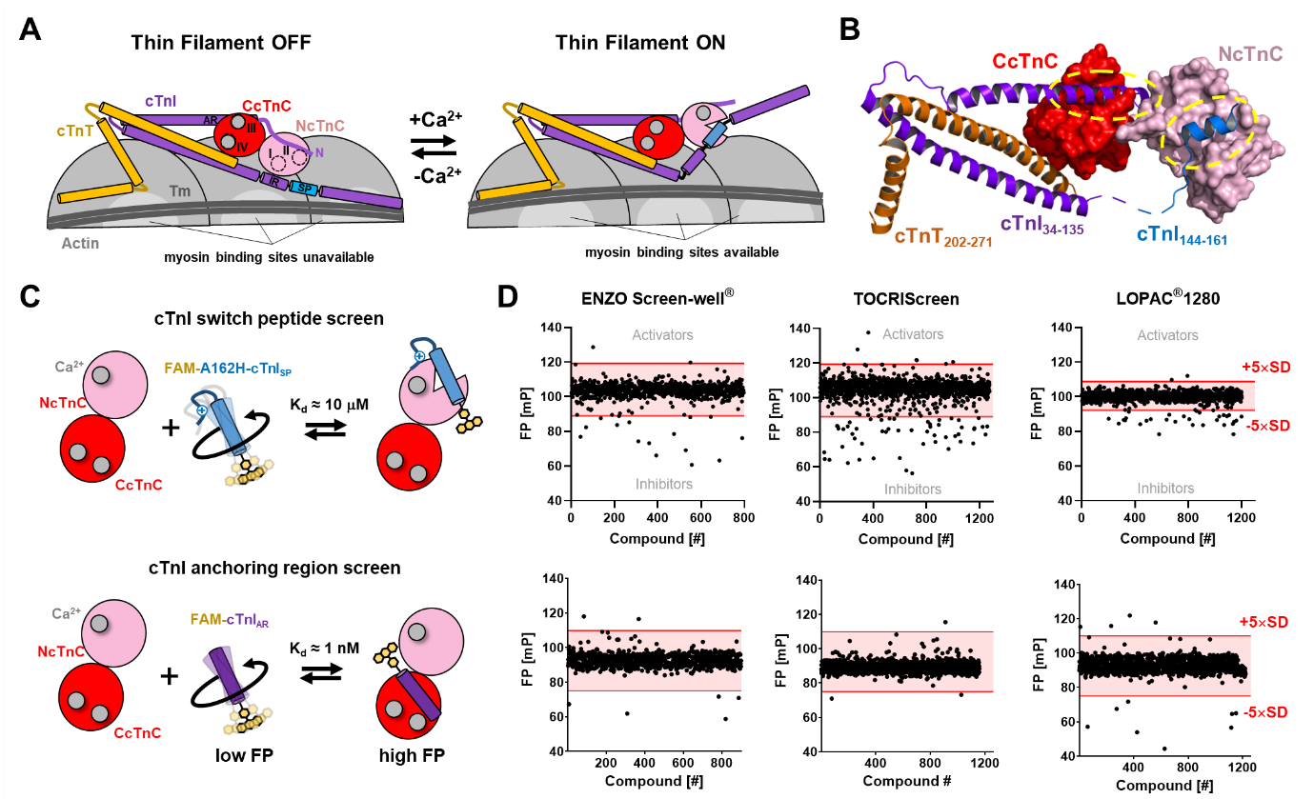

**Figure 1. High throughput screens for cardiac troponin modulators.** (A) Schematic illustration of the calcium-dependent thin filament activation pathway. In the thin filament OFF state (left), myosin binding sites on actin (light gray) are blocked by tropomyosin (Tm; dark gray). Ca2+ binding to troponin C (cTnC; red) allows switch peptide (SP; blue) interaction with the regulatory N-lobe of cTnC (NcTnC; pink). Removal of the C-terminal domain of cTnI (CTD) allows Tm to move azimuthally around the thin filament, exposing myosin binding sites on actin. The C-lobe cTnC (CCTnC; red) is constitutively bound to divalent cations and the anchoring region of cTnI (purple). (B) Atomic structure of the human cardiac troponin core complex (PDB 1J1D). The N- and C-lobe of cTnC are shown in surface representation in red and pink, respectively. Cardiac troponin I (cTnI) and troponin T (cTnT) are shown in purple and orange, respectively. The switch region of cTnI is shown in blue. Molecular interactions between cTnC and cTnI are highlighted by yellow dashed ovals. (C) Cartoon representation of the developed fluorescence polarization (FP)-based HTS that target cTnC-cTnI interactions. Top: FP-based screen targeting the interaction between NcTnC and the switch region of cTnI. Bottom: FP-based screen targeting the interaction between CcTnC and the anchoring region of cTnI. (D) HTS of three commercially available compound libraries targeting the interaction between cTnC and switch peptide (top) or the anchoring region of cTnI (bottom). Hits were defined by compounds that change the FP more than five times the standard deviation (5xSD) away from the average value (indicated by red lines).

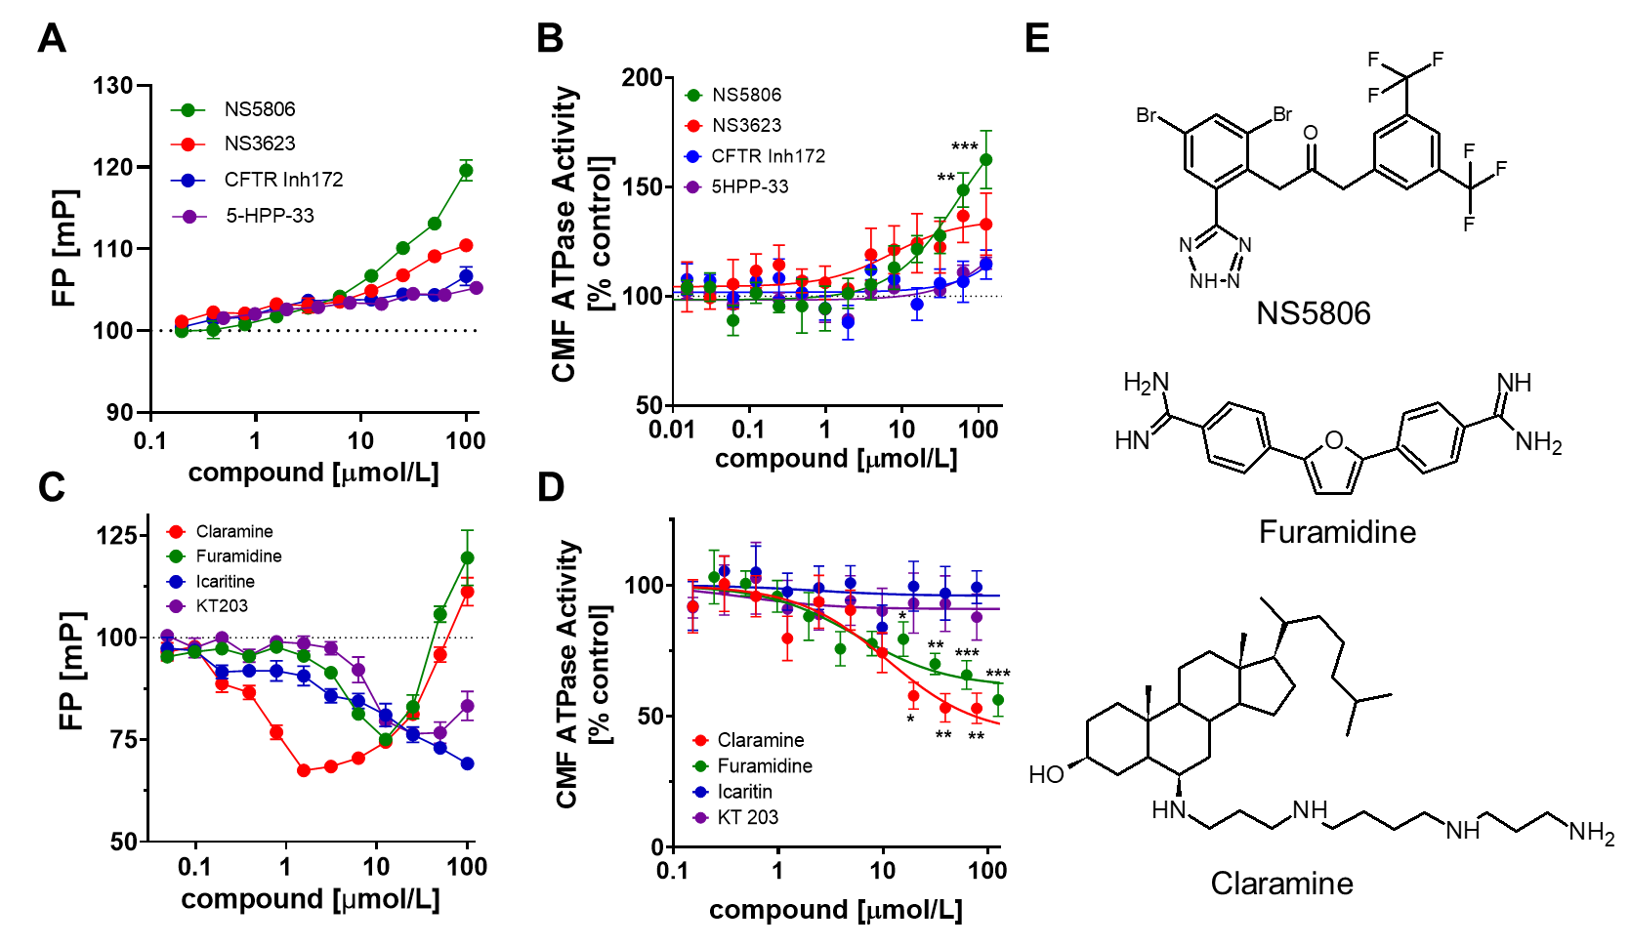

**Figure 2. Validation of hit compounds from high throughput screens.** (A) Dose-dependent effect of selected hit compounds on cTnC-cTnISP interactions monitored by fluorescence polarization. (B) Dose-dependent effect of hit compounds from the cTnC-cTnISP HTS on the ATPase activity of isolated bovine myofibrils at submaximal calcium activation (~30% of maximum activation). (C) Dose-response curves for selected hit compounds from the cTnC-cTnIAR HTS. (D) Dose-dependent effect of hit compounds from the cTnC-cTnIAR HTS on the ATPase activity of isolated bovine myofibrils at submaximal calcium activation (~70% of maximal activation). (E) Chemical structures of NS5806, Furamidine and Claramine. Means ± SEM, n=3-7. Statistical significance of values vs control were assessed with a one-way ANOVA followed by Tukey’s multiple comparison test: *p<0.05, **p<0.01, ***p<0.001.

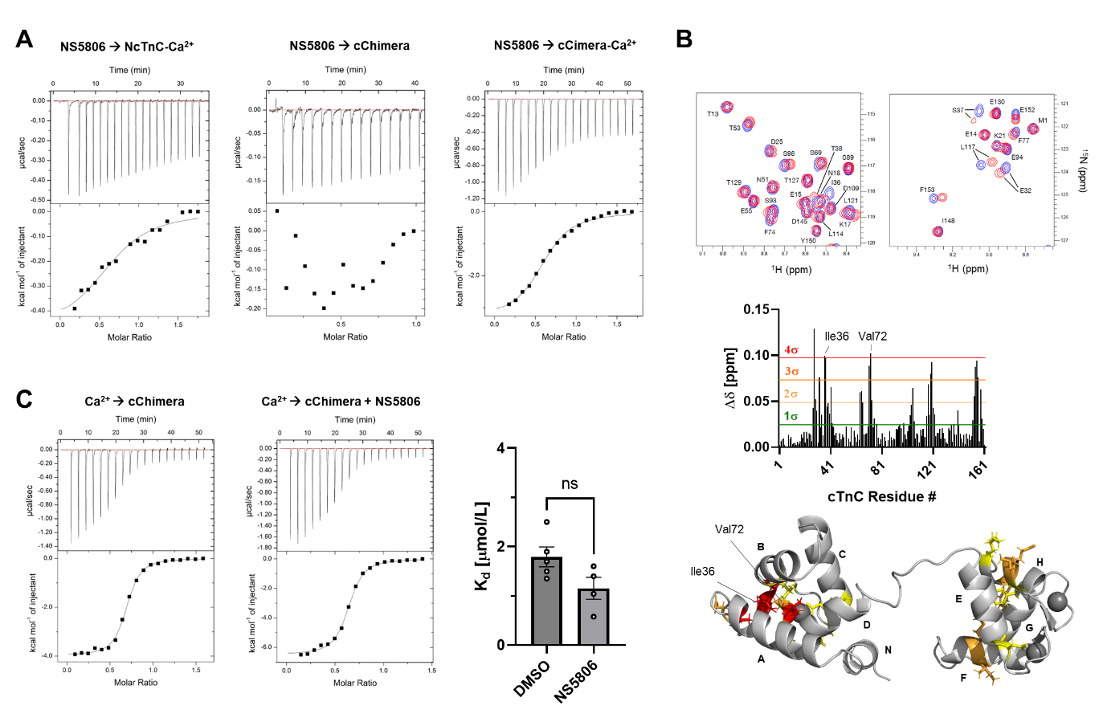

**Figure 3. Biophysical characterization of NS5806-cTnC interaction.** (A) NS5806 binding to Ca2+-bound NcTnC (left), Ca2+-free cChimera (middle) and Ca2+-bound cChimera monitored by isothermal titration calorimetry (ITC). (B) Top: Part of 2D-1H-15N HSQC spectrum of cTnC in the absence (blue) and in the presence (purple) of NS5806 at roughly 1:1 stoichiometry. Middle: Plot of chemical shift perturbations (Dd) of cTnC plotted against the amino acid sequence after addition of NS5806. Thresholds for different multiples of the standard deviation (SD) are shown in red. Bottom: Chemical shift perturbations mapped onto cTnC structure. Ile36 and Val72 are labelled accordingly. (C) ITC binding isotherm for Ca2+ titrated into cChimera in the absence (left) and in the presence (right) of NS5806. Means ± SEM, n=4-5. Statistical significance between control and drug treatment was assessed with an unpaired two-tailed student’s t-test: ns – not significant.

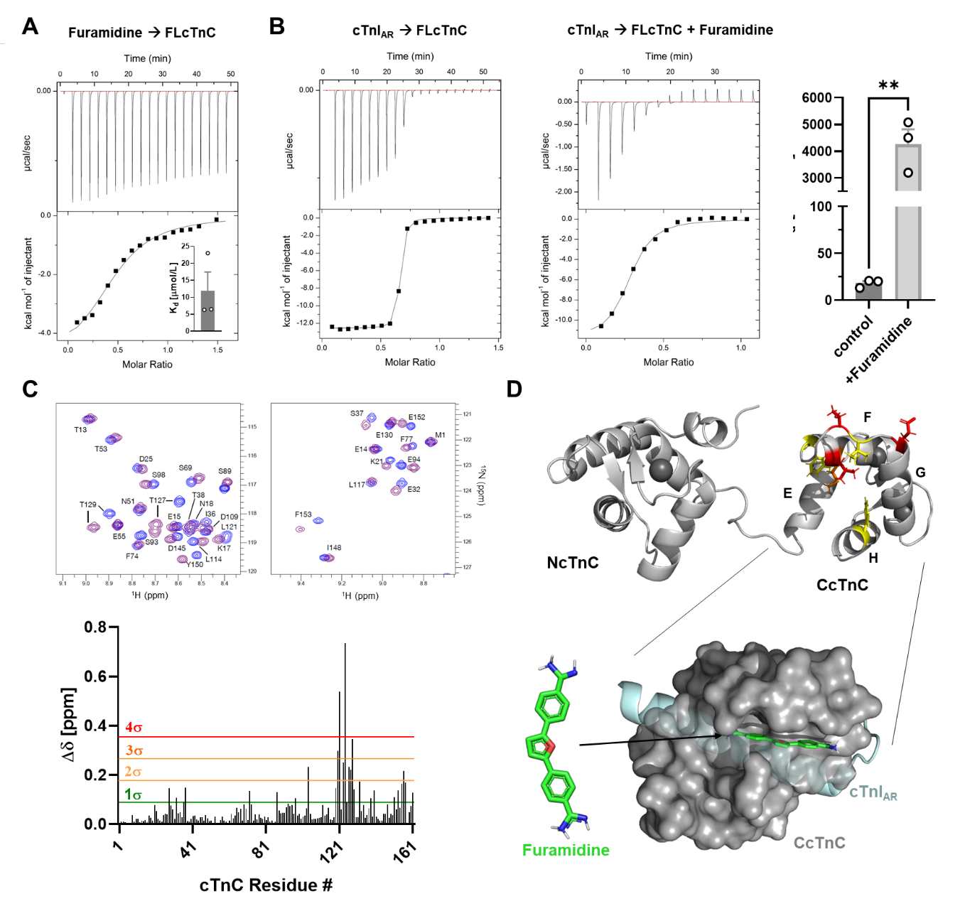

**Figure 4. Biophysical characterization of Furamidine-cTnC interaction.** (A) ITC for titration of Furamidine into cTnC. Insert: Measured steady-state dissociation constants. (B) ITC titration of unmodified cTnIAR into cTnC in the absence (left) and in the presence of Furamidine (middle). Measured steady-state dissociation constants are shown on the right. (C) Top: Part of 2D-1H-15N HSQC spectrum of cTnC in the absence (blue) and in the presence (purple) of Furamidine. Bottom: Plot of chemical shift perturbations (Dd) of cTnC after addition of excess Furamidine. (D) Top: Chemical shift perturbations mapped onto cTnC structure with the same colour coding as shown in (C). Bottom: Docking pose for Furamidine (green) binding to CcTnC (grey, surface representation) using flexible docking in AutoDock Vina. The position of cTnIAR (cyan) in the cardiac troponin complex (PDB 1J1D) was superimposed onto the structure.

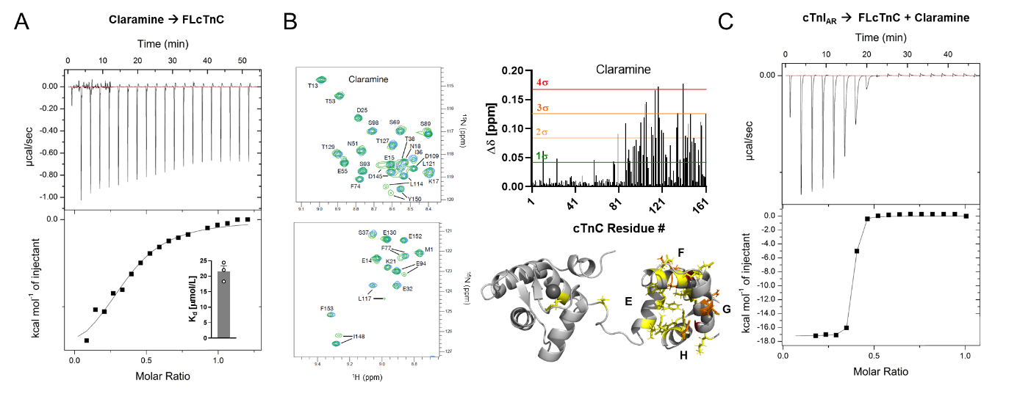

**Figure 5. Biophysical characterization of Claramine-cTnC interaction. (**A) ITC for titration of Claramine into cTnC. Insert: Measured steady-state dissociation constants. (B) Left: Part of 2D-1H-15N HSQC spectrum of cTnC in the absence (blue) and in the presence (purple) of Claramine. Right: Plot of chemical shift perturbations (Dd) of cTnC after addition of excess Furamidine. Chemical shift perturbations mapped onto cTnC structure. (C) ITC titration of unmodified cTnIAR into cTnC in the presence of Claramine (middle). Please note that Claramine had no effect on the cTnC-cTnIAR interaction.

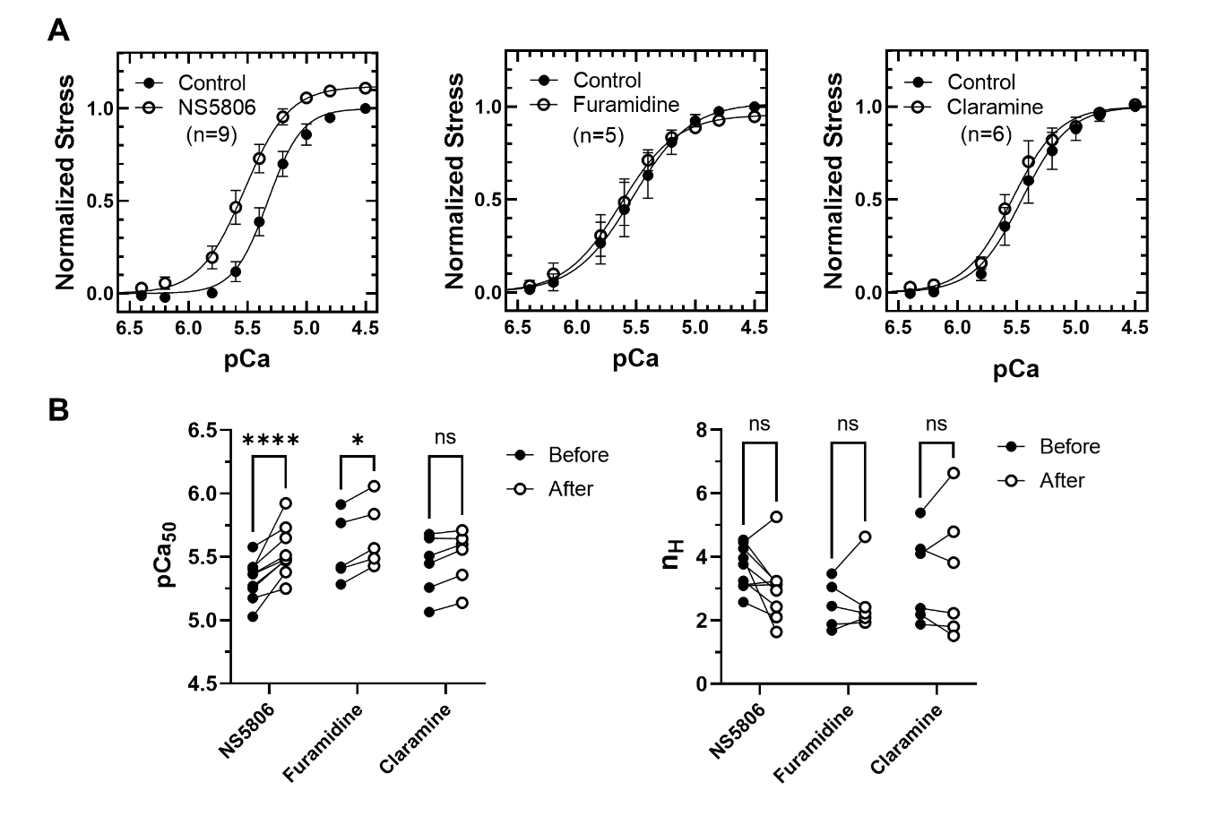

**Figure 6. Functional effects of hit compounds in demembranated human myocardium.** (A) Force-pCa relations of demembranated human myocardium in the absence and in the presence of 100 mmol/L NS5806 (left), Furamidine (middle) and Claramine (right). (B) Effects of hit compounds on calcium sensitivity (pCa50) and cooperativity (nH) of force development of demembranated human myocardium. Means ± SEM, n=5-9. Statistical significance of differences between before and after drug treatment were analyzed by a two-way ANOVA followed by Sidak’s multiple comparison test: *p<0.05, ****p<0.0001, ns – not significant.