Lab 11: The Field-Effect Transistor
This lab is an exploration of the operation of an NMOS FET, the ZVN4206. It is the first lab in which I have not shown you where to put the ammeters and voltmeters but left you to figure it out for yourselves. You might want to check your arrangement with me before making your measurements. NOTE you have two kinds of physically similar FET, the ZVN4206 and the ZVP2106. Make sure you use the right one!!!
Your first task is to measure the transfer characteristic of the ZVN4206. This should produce a figure that is similar to those in the chapter, though you will measure the curves over much more limited ranges than those in the book because you will be making static measurements and have a more up-to-date FET. When you make static measurements the FET will start to heat up as it dissipates power so your curves will not be as accurate as the manufacturer’s curves.

Building
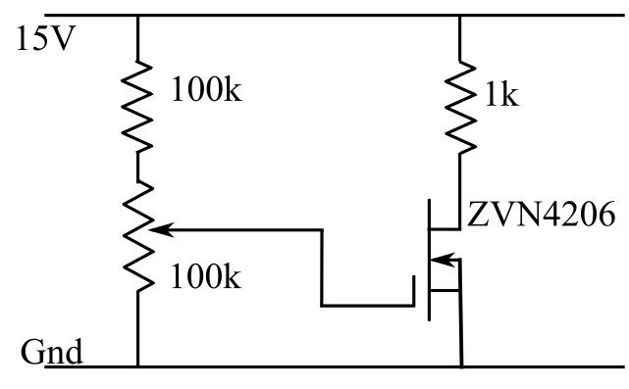
Start by building the circuit shown in the figure on the right.
The funny resistor with the arrow on the side is a Variable Resistor so you are looking for something with a knob and wires or pins or you might be able to use one of those built into you Designer.
The FETs come with their leads spaced too close together to plug into the breadboards. The sequence of figures below shows you how you should do this. On the left is the FET as it comes. Next shows one with the leads bent just enough to go into three adjacent holes in in the breadboard. The final figure shows how it should look when plugged in.
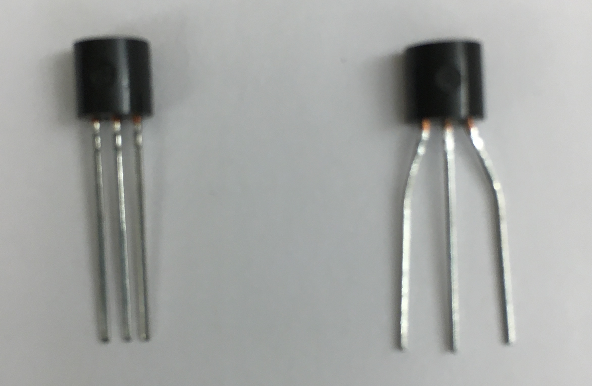
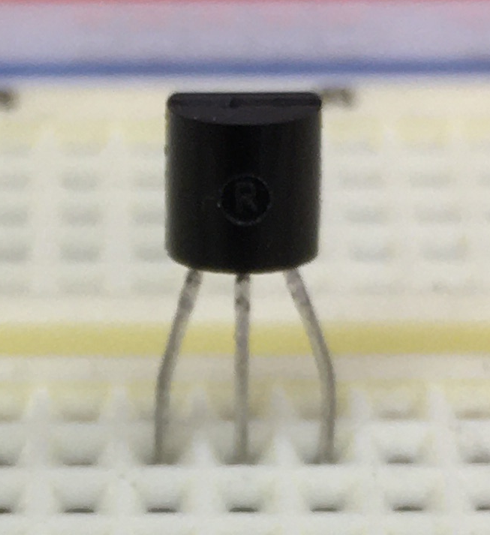

Part A: Transfer function
1) Start by measuring the Transconductance of the FET by plotting I_{DS} as a function of V_{GS}. You can vary the value of V_{GS} with the potentiometer (variable resistor). You can measure the current either by putting the meter in series with the 1k resistor or by monitoring the voltage across the 1k drain resistor
I suggest starting with measurements every volt from 0V to 5V and then going back and taking more data in the region where current is flowing so that you get a clear idea of the shape of the curve. Make sure you have good axes on your plot and paste it in the box below.
V mA
0.01 0.00
1.00 0.00
1.97 0.00
2.41 0.08
2.47 0.16
2.51 0.24
2.59 0.57
2.65 1.04
2.68 1.37
2.75 2.55
2.83 4.87
2.87 6.63
2.89 7.45
2.93 9.65
2.95 10.32
2.99 12.35
3.01 13.75

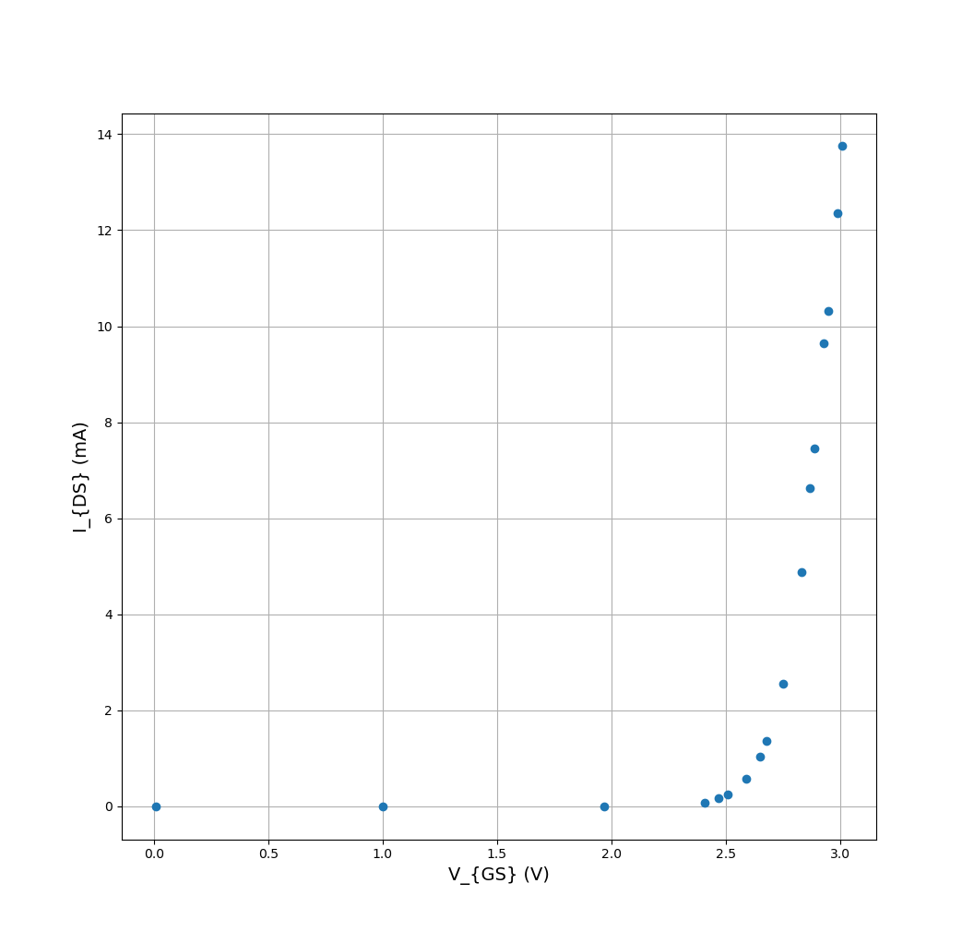

2) Compare your graph to the one in Figure 11-7. In particular, measure your threshold voltage (V_{GS} needed to give I_{DS}=1mA) and compare it to the value given in the data sheet (on Blackboard).
Threshold voltage: Between 2.59V and 2.65 V.
This agrees with the data sheet, which states that the threshold voltage is between 1.3V and 3V.
My graph matches Figure 11-7.

3) Compare your threshold value with some of your neighbors. How consistent is this value from device to device?
My neighbors found 2.5V and 2.53V as their threshold voltages.
This leads me to believe that the value is pretty consistent between devices, although you said that in the other section there was more variation.

Part B: A simple amplifier.
Replace the 1k resistor with a 10k resistor and add a 1µF capacitor to get the circuit shown on the right. The input voltage, Vin, should be a 0.1 V sine wave coming from the 50Ω output of your Instek signal generator. Vin and Vout should be shown on your oscilloscope.
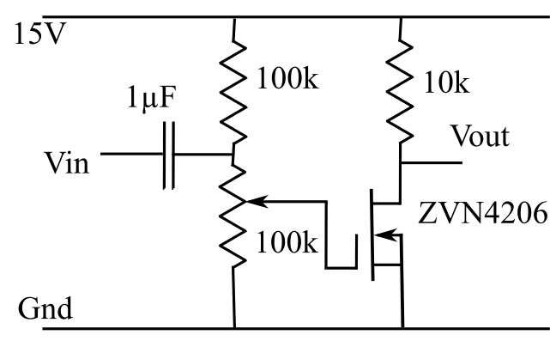
1) With the input disconnected adjust the variable resistor so that the output voltage is about 7-8V.
2) Connect the input and adjust you scope settings to show the input and output voltages clearly. Paste a picture of the scope screen below.
Variable Resistor: 8V
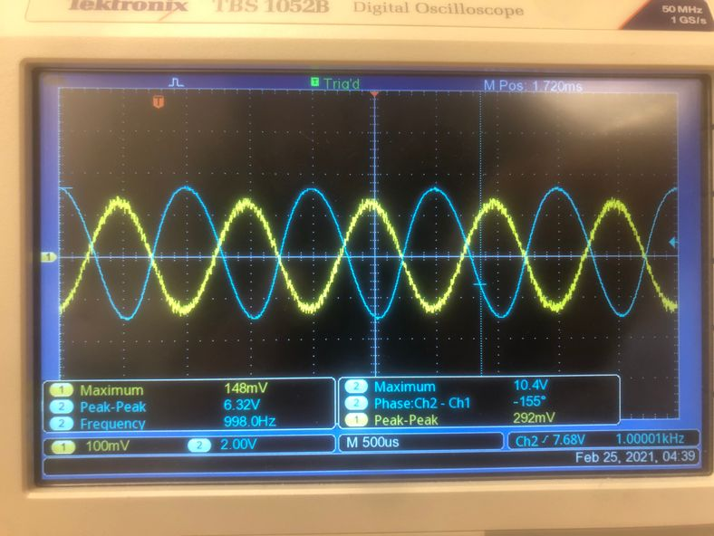

3) What can you say about the relationship between input and output?
Vout is 21.6 times greater peak-to-peak than Vin, and 180 degrees out of phase with Vin.
4) What is the Voltage Gain of your circuit. This is defined by
The voltage gain is 21.6.

5) Is this a good amplifier? That is, is the output signal a good copy of the input, enlarged without altering its shape?
Yes. The output is still a sine wave.

6) Roughly measure the frequency range over which the amplifier gain is constant (to within a factor of 2).
2Hz: 11.19
8.7kHz: 11.06
Thus, the amplifier gain is constant to within a factor of 2 between 2Hz and 8.7kHz.

7) Compare this with the audio frequency range (20Hz to 20,000Hz) and with the radio frequency range (0.1MHz to 4MHz).
This amplifier’s range range of constant gain covers the bottom 43% of the audio frequency range, and does not overlap with the RF range.

8) Would this make a good audio amplifier? Why?
This would make an audio amplifier sufficient for middle frequencies, but not for very high frequencies, because its gain is not constant at high frequencies.

9) What about an RF amplifier? Why?
This would make a terrible RF amplifier, since its gain is not constant in the RF range.
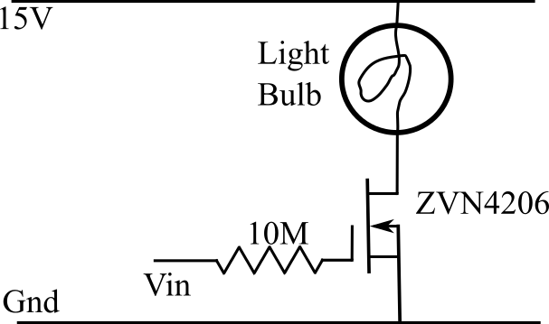
Figure 3

Part C: A Simple Switch
Build the simple switch in the circuit on the right. Use one of the 5-V toggle switches from the bottom row of your designer for the input.

1) What is Vin and what does the light bulb do when the switch is ON?
When the switch is on, Vin is 5.00V and the light bulb is on.

2) What is Vin and what does the light bulb do when the switch is OFF?
When the switch is off, Vin is 0.00V and the light bulb is off.

3) Explain the above results in the light of your measurements in the first part of the lab.
When Vin is 0V, the transistor will not conduct, as we observed earlier in the lab. When Vin is 5V, the transistor is well past its threshold, so it conducts, and the bulb turns on.

4) Set your switch so that the light is ON. Measure the voltage across the 10M resistor and so calculate the gate current.
There is 0V across the resistor. Thus, the gate current is 0A.

5) Measure the current in the light bulb.
82.2mA

6) Use your measurements to compute the current gain of the FET, that is Drain Current/Gate Current.
The FET has infinite current gain.

7) Why do your results indicate that the FET makes a good switch?
Hint: A good switch
a) Has a very low on resistance
b) Has a very high off resistance
c) Requires very little energy to change from on-to-off or off-to-on.
The FET is a good switch because it takes very little energy to toggle its state, and it takes no energy for it to maintain its state.

