Lab 10: Power Supplies 1
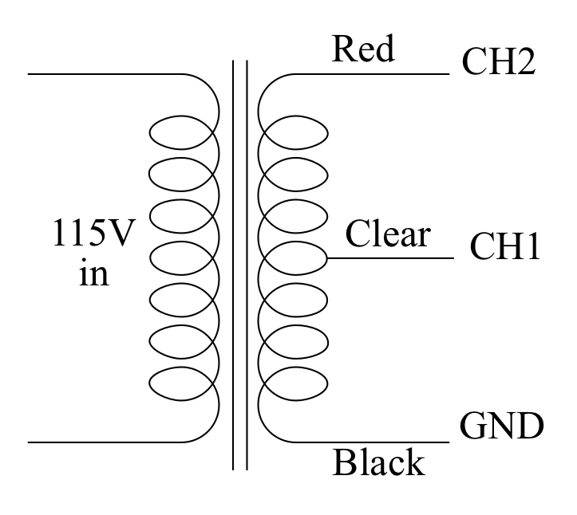Figure 1

The Transformer
I have provided you with a small power transformer attached to a mains lead. Be careful with it. You are unlikely to damage yourselves but you could get a mild shock if you are careless. Don’t touch the bare wires coming from the transformer when it is turned on and you will be quite safe. Connect up the red, white, and black wires from the transformer (or red-clear-black in some cases) to the inputs of your oscilloscope as shown in Figure 1 on the right.
Make sure that your screen shows 2-3 periods of the signal and fill as much of the screen as possible. Paste an image of your screen in the box below.

a) Explain what you see. I want to know the magnitude and frequency of the voltages and to know what is the relationship between the two traces.

b) Disconnect the oscilloscope and reconnect it as shown in Figure 2. Repeat the measurement and paste an image in the box below.
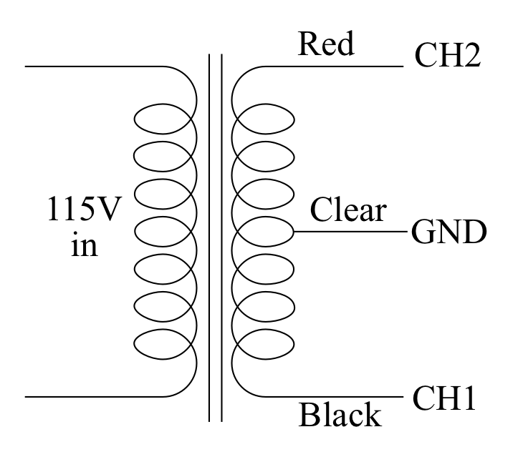Figure 2

b) Explain why the new image makes sense and explain how it makes sense that a single transformer could produce two such different images.

Full-wave Rectifier
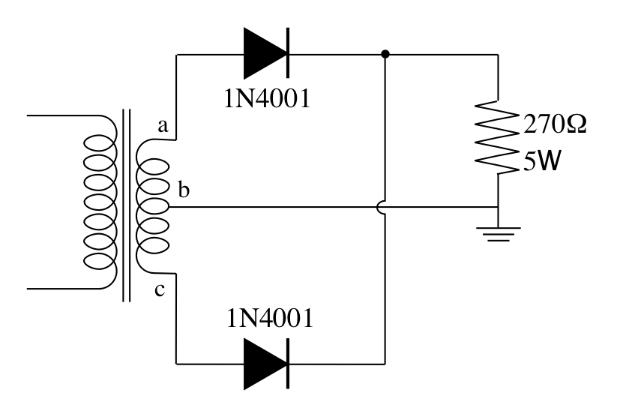Figure 3
Connect two diodes to the transformer to make a full-wave rectifier as shown in Figure 3. Connect one oscilloscope probe across the 270Ω 5W load resistor and the other to point a. DON’T plug the transformer in until I have checked your circuit!
Once your circuit is functioning adjust your scope to give a good view of the signals and paste a picture in the box below.

CH2 is across the resistor

c) Measure and account for the peak voltage that you observe at the output.

Now adjust the scales (and possibly the triggering) on your oscilloscope to show the detail of what happens in the region where the input voltage passes through 0. You want the total range to be about ±1 and 2-4 ms in duration. Paste the new image below.`

d) Discuss the shape of the output and account for the small flat region at 0V in as much detail as you can.

Smoothing
Return your oscilloscope to the settings for part c and then connect a 1000 µF capacitor in parallel with the 270 Ω load resistor. NOTE: The capacitor is polarized—it has a positive and a negative side. Please connect it up correctly because I don’t have many spares! Paste an image of the resulting screen in the box below.

e) Describe how the output voltage is now different and explain how the capacitor acts to cause this difference.

f) What is the average current through the 270Ω resistor?
Since we have a DC voltage of 9.60V, this is just V=IR.
Thus, I = 9.60/270 = .0356A.

Expand the vertical scale and paste and image of the ripple voltage in the box below.
Hint: you may want to experiment with the AC coupling setting on that channel your scope.

g) What is the peak-to-peak magnitude of the ripple voltage?

h) What is the frequency of the ripple?

i) Given that the line frequency is 60Hz explain why the ripple frequency has the value that you found.

j) Connect a second 270Ω load resistor in parallel with the first, re-measure the output voltage and the output ripple magnitude.

k) What is the average current drawn from the power supply now?
Remember that the average current comes from knowing the average voltage and not from knowing the ripple voltage!

l) For each of the cases compare the measured ripple voltage with the theoretical figure,
V_{ripple} =
Iout
120⋅C
where C is the value of the smoothing capacitor in Farads, and Iout is the average output current, in Amperes, delivered to the load.

m) Comment on the accuracy of this formula .

2) If time permits use your two different output voltages to compute the Thévenin equivalent of the power supply.

