Lab 4: Time Varying Voltages
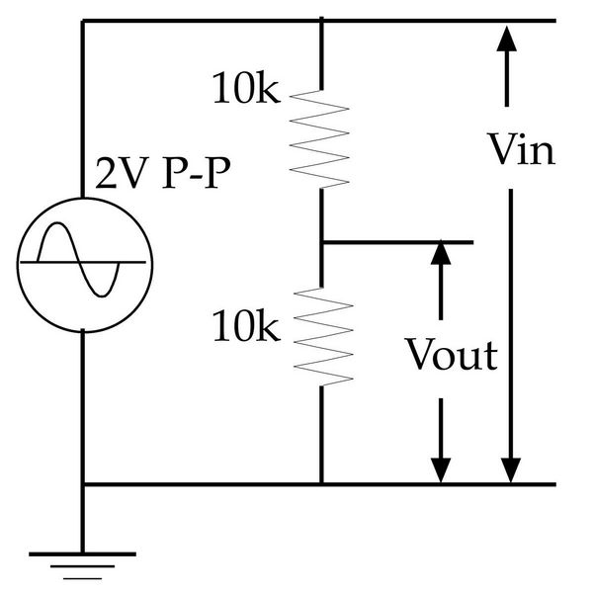Figure 1
In this lab you will begin your voyage away from the DC world and into the world of time varying voltages. Instead of the power supplies and meters of the earlier labs we concentrate on signal generators and oscilloscopes.

Part 1: The Voltage Divider at DC
Consider the voltage divider circuit on the right (Fig. 1). Note that this time I didn’t actually show any meters but just marked how I defined Vin and Vout. Get used to it. This is much more normal.
a) Compute the output voltage that you expect to find at the moment when the input voltage is +1V.
I expect to find .5V at Vout, since there should be a 50% voltage drop across the first resistor.

Use the Instek signal generator as your voltage source. Use the 50 Ω output plug not the TTL output of the signal generator.
Connect the points marked Vin to CH1 of your oscilloscope and those marked Vout to CH2. Make sure that your scope is set to display both channels.
Adjust the settings of the signal generator to produce an output of 2V P-P at 1kHz. Note that you can set the frequency either on the keypad or using the big knob and you can read out the frequency on the display. You can vary the size of the signal with the lower right knob marked AMPL but you do not get a readout of the size on the Instek. You will have to use your scope for that.
b) Measure the actual output voltage at the moment that Vin is 1V and discuss the relationship to your predicted answer.
I measured 500mV. This exactly matches the prediction.

c) Now use the cursors to pull data from your oscilloscope so that you can plot Vout as a function of Vin. You may need to turn off the menu. I want about 5-8 values of Vin between -1 V and +1 V. Paste your plot below.
Vin Vout
-1.00V -500mV
-800mV -400mV
-400mV -200mV
0.00V 0.00V
400mV 200mV
800mV 400mV
1.00V 500mV

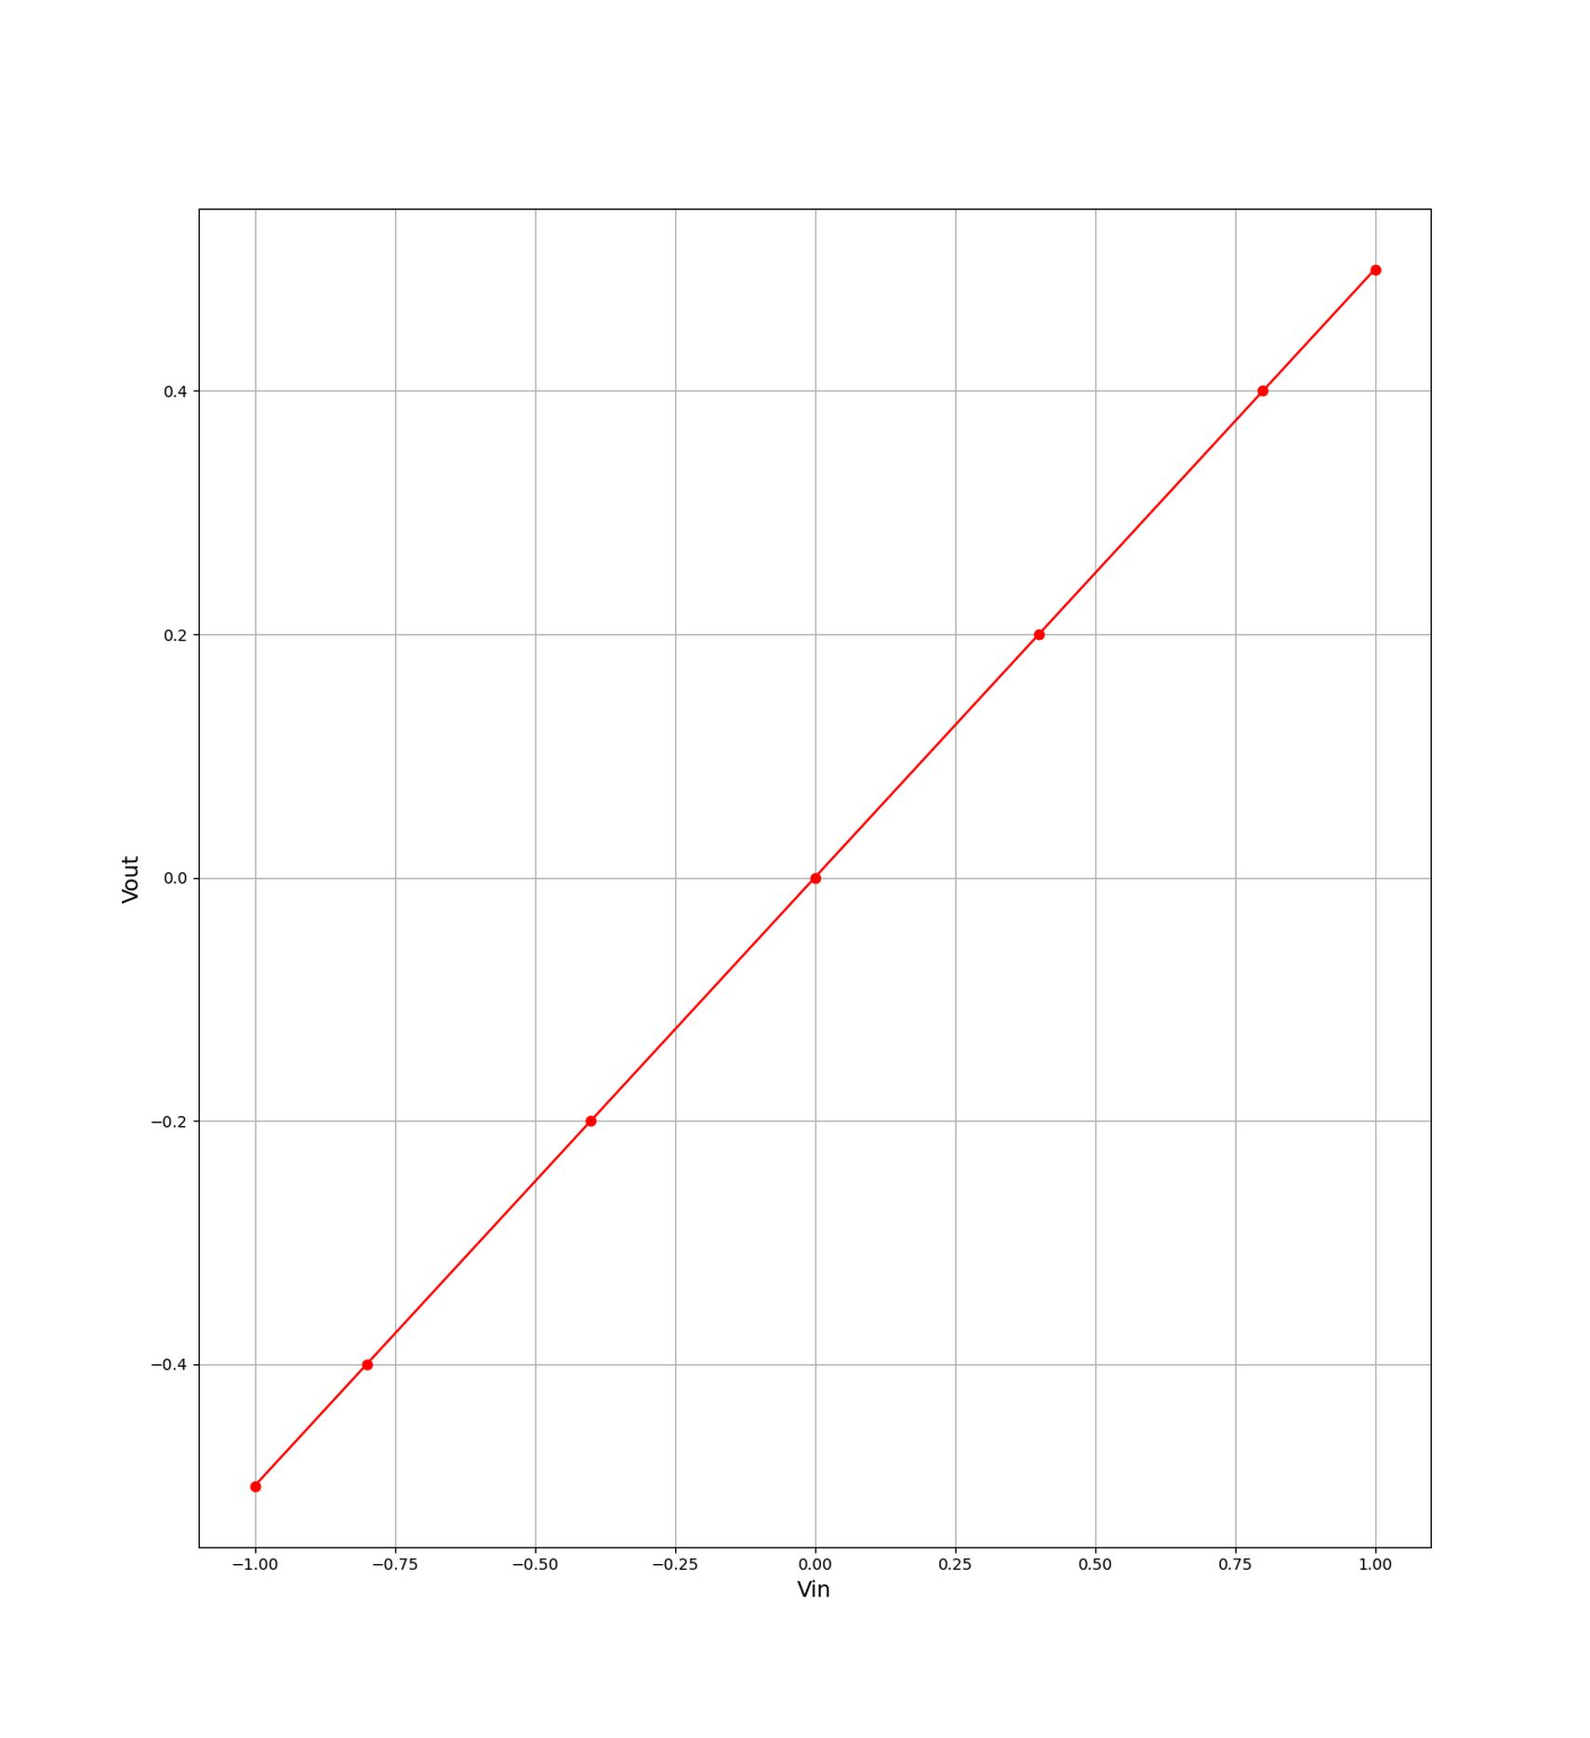

d) Discuss whether this is a linear circuit and how you reached that conclusion.
This is a linear circuit, since Vout = .5Vin.

Part 2: The Voltage Divider and Time-Dependent signals
a) Now paste in an image of your oscilloscope screen below. Make sure that the settings are well chosen so that the traces fill as much of the image as possible and make sure that the scales (Volts/div and Time/div) are shown on the screen or add them by hand.
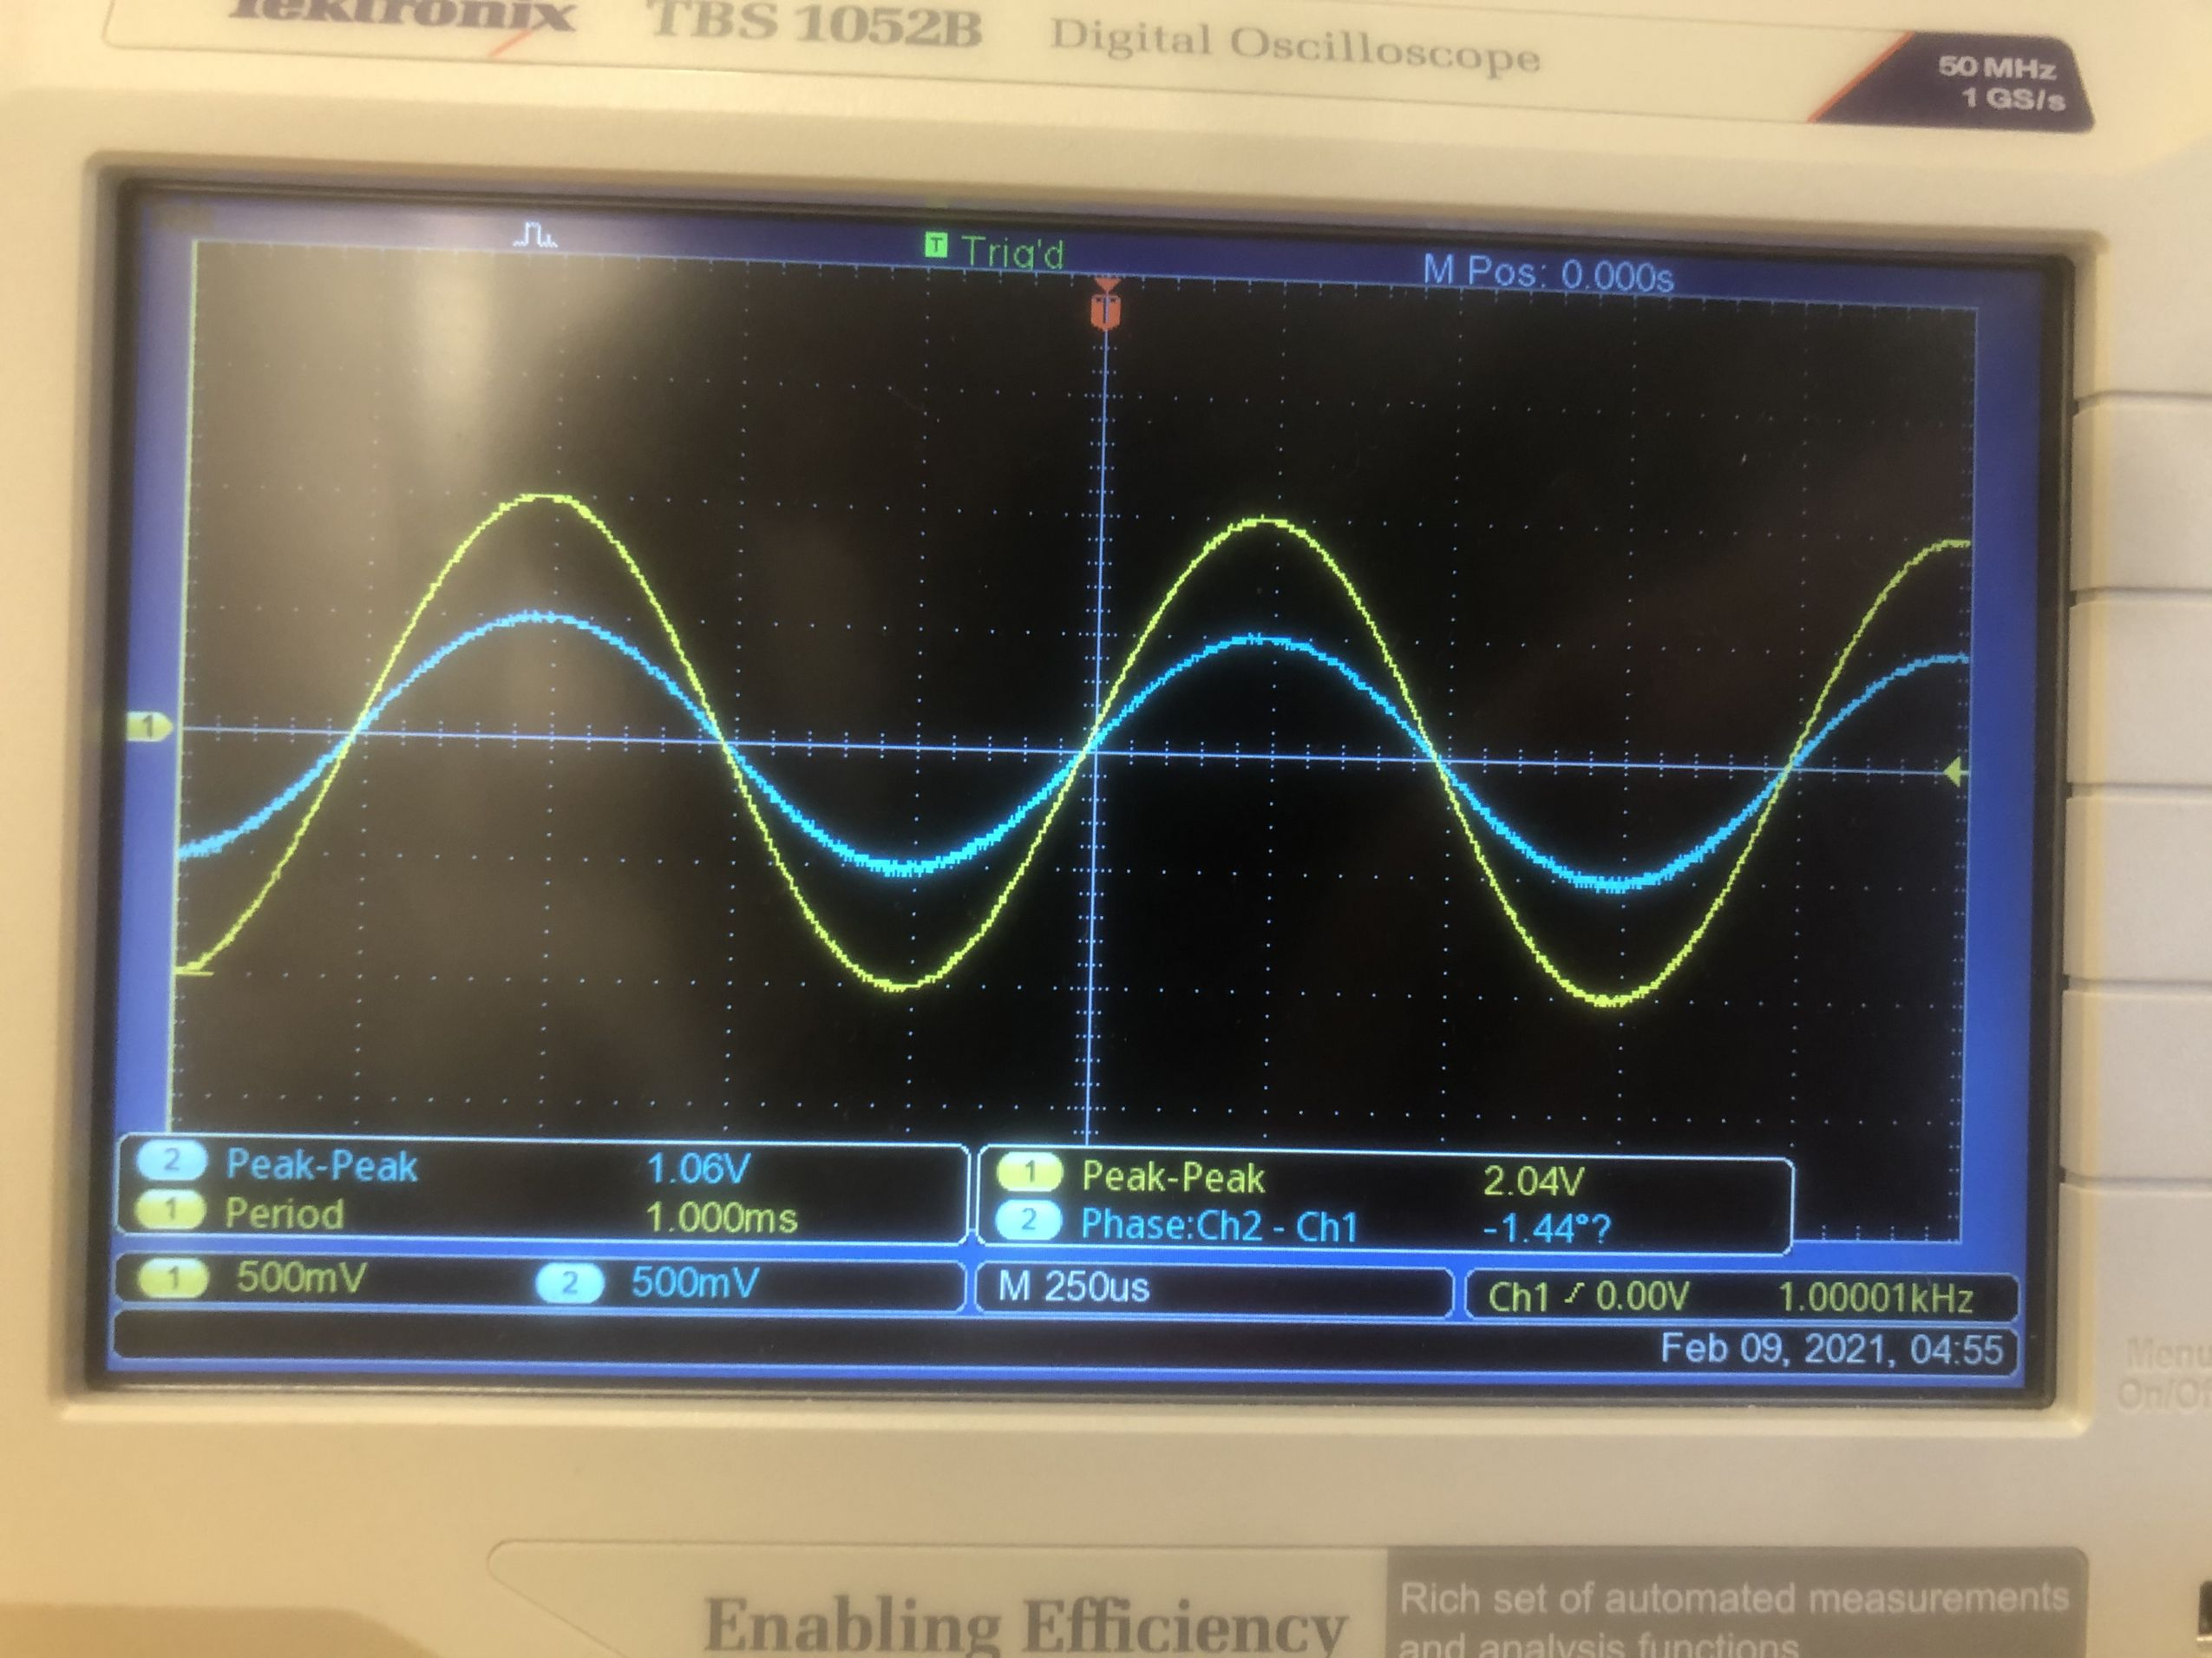
Answer the following questions in the boxes provided. In each case justify or explain your answer.
b) Are the input and output the same shape?
Yes.
c) Are they the same size?
No; Vout is 50% the size of Vin.
d) What is the phase difference?
0.
e) Use Ohm’s law to explain these findings.
Ohm’s law predicts that there would be a voltage drop of 50% across the first resistor. Thus, we expect the shape to remain constant, and the size of Vout to be 50% the size of Vin.

Part 3: Higher Frequency
a) Next, set the signal generator to produce a 2V P-P sine wave at 100kHz and repeat the measurement, pasting your new image into the box below.
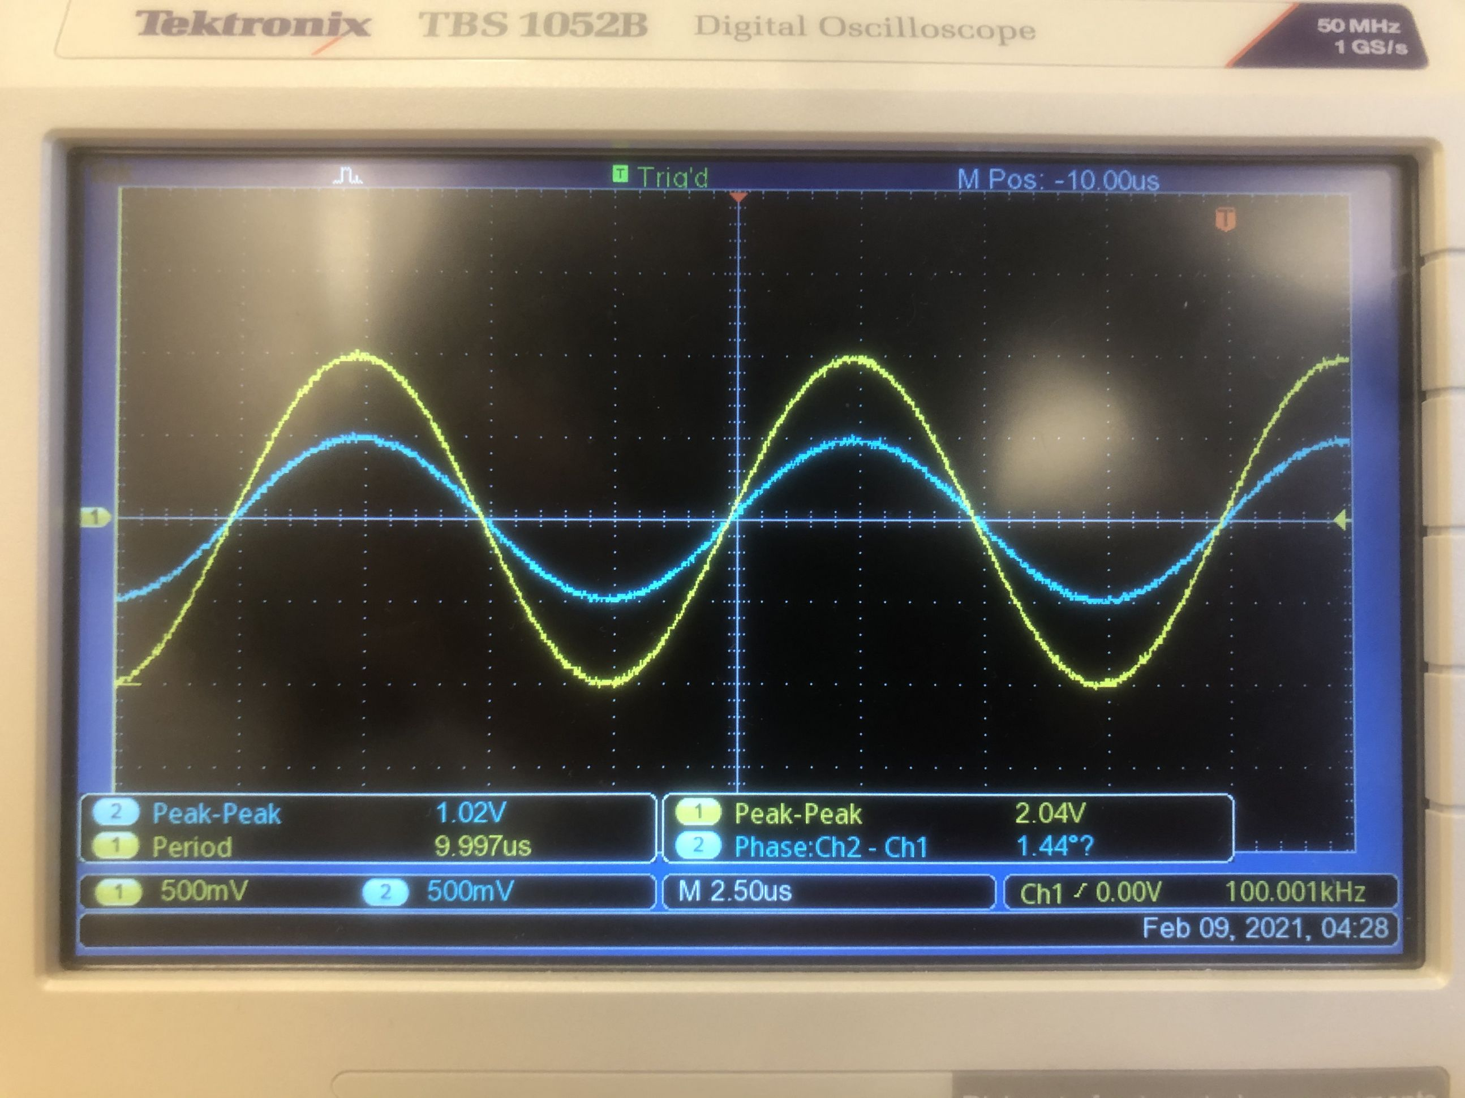

b) Do you find any effect on the size, shape, or phase from the change in frequency, i.e. is the relationship between Vin and Vout altered? (Obviously the period got shorter!)
There is no efrect on the size, shape, or phase from the change in frequency.

c) What does this tell you about the effect of frequency on Ohm’s law?
This tells me that frequency has no effect on Ohm’s law.

Part 4: Square Waves
a) Next set the signal generator to produce a 2V P-P square wave at 1kHz and repeat the measurement. (Remember to make sure the scales are clear!!)
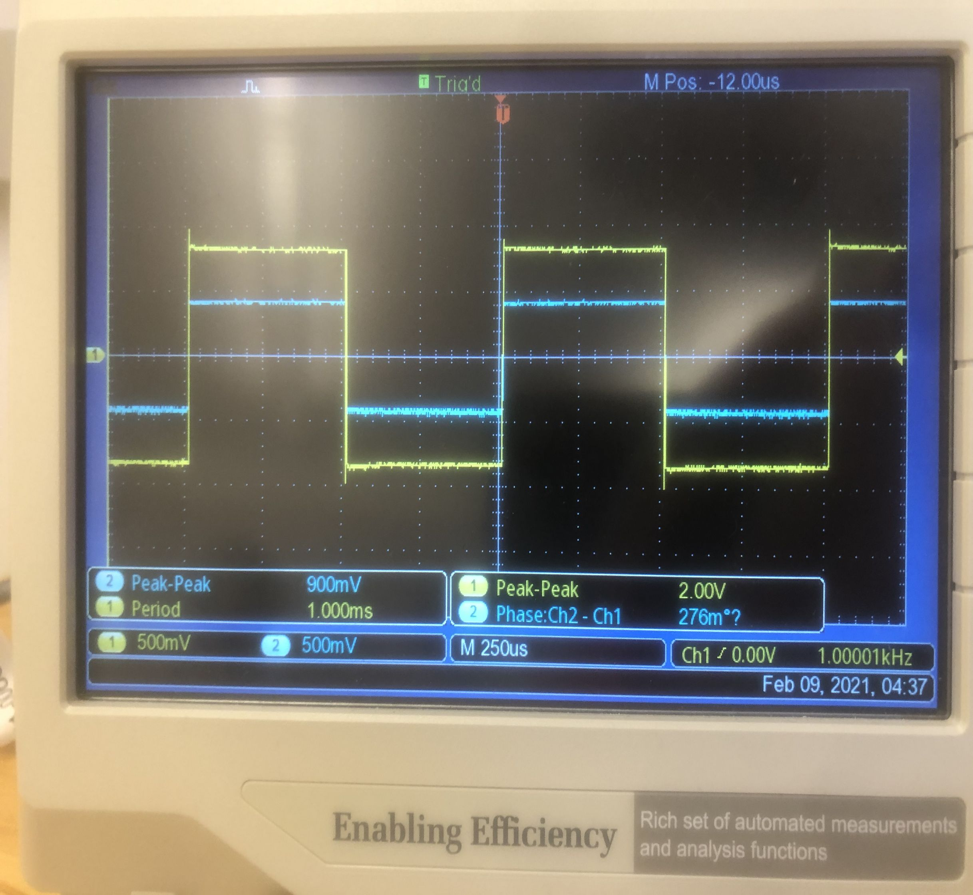

d) Does the square wave pass through without distortion?
Hint: Distortion means an alteration in the shape of the signal. Changes in the size, offset, or phase do not count.
There is no distortion visible.

e) Explain why this is what you would expect from a linear circuit.
I would expect this from a linear circuit because Vout and Vin have a linear relationship. Changing voltage should not change the fact that the voltage drop across the first resistor is 50% of the total voltage. Thus, we would expect the shape of Vout’s voltage curve to match Vin’s.

Part 5: But then?
a) Now return to sine waves but increase the frequency to 1MHz and repeat the measurement, pasting the image below.
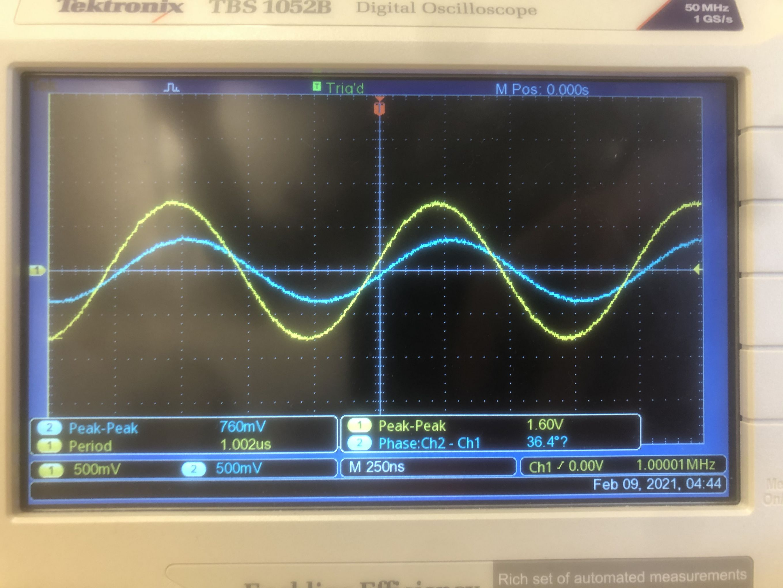

b) This time you should find a difference between the input and output. What has changed—the shape, the size, or the phase difference? Please measure the amplitude and phase carefully for this comparison.
There is now a small phase difference.

An ideal resistive circuit would not show this effect. Ohm’s law makes no mention of frequency. It predicts that the relationship between input and output should be the same at any frequency.

The problem is that our real system does not only consist of the resistors. There are a number of long wires and there are unknown things happening in the breadboard that holds the wires together. These wires both create and respond to electric fields in the air around them and this creates extra components called capacitors between the wires (see chapter 6 and lab 6). Because these capacitors are not distinct separate components that we have added, but are formed by the wires and other components, they are called Parasitic capacitances.
c) For your sine wave, do the parasitic capacitances affect the phase, amplitude (be precise), or shape?
Parasitic capacitances affect only the phase.

The parasitic capacitances affect high frequencies more than they affect low frequencies. When we consider a signal such as a square wave that is made up from many individual frequencies then the higher ones will be more altered than the lower. Thus the output signal may no longer look exactly like the input signal.

Part 6: Back to square
a) To see this, set your signal generator to produce 2V P-P square waves at 1Mhz and record input and output.
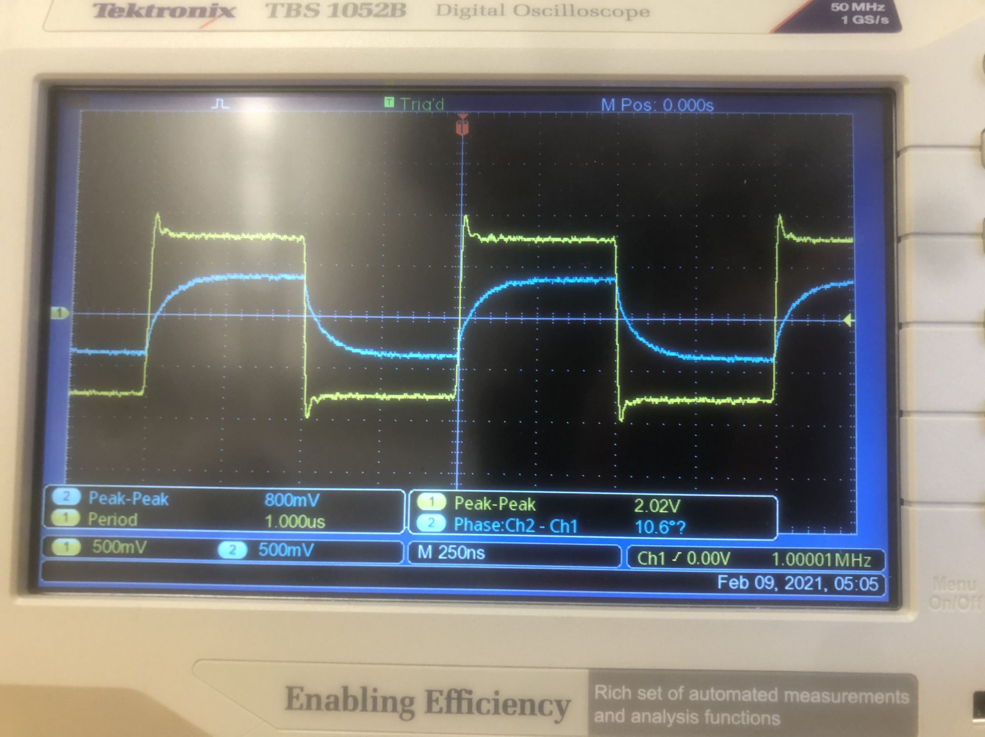

b) Describe the effect of the parasitic capacitances on the square wave.
There is no phase difference, but the shape of the square wave has been distorted into a shark tooth shape.
c) The parasitics have been there all the time and so they must have affected the square waves in the same way in the earlier tests. Discuss why you did not see their effects then.

I did see their effects, but only when I zoomed in on the square wave by adjusting the scale. The reason the effects became more obvious as frequency increased is that at higher frequencies, we have to adjust the scale to see the wave clearly, so the small amount of time it takes for the capacitor to charge becomes larger relative to the length of a period.

If you are careful you may be able to see that in fact the effects were there in the earlier tests. I am happy to help with this if you want.

