Lab 5: The Capacitor
It is time to add a new component to our toolbox. The capacitor, as you should have learned reading, acts as an infinite resistance to steady voltages (no DC current flows) but allows AC voltages to pass through. It has an effective resistance that gets smaller and smaller as the frequency gets higher and higher.

Part 1: R-C Circuits and square waves
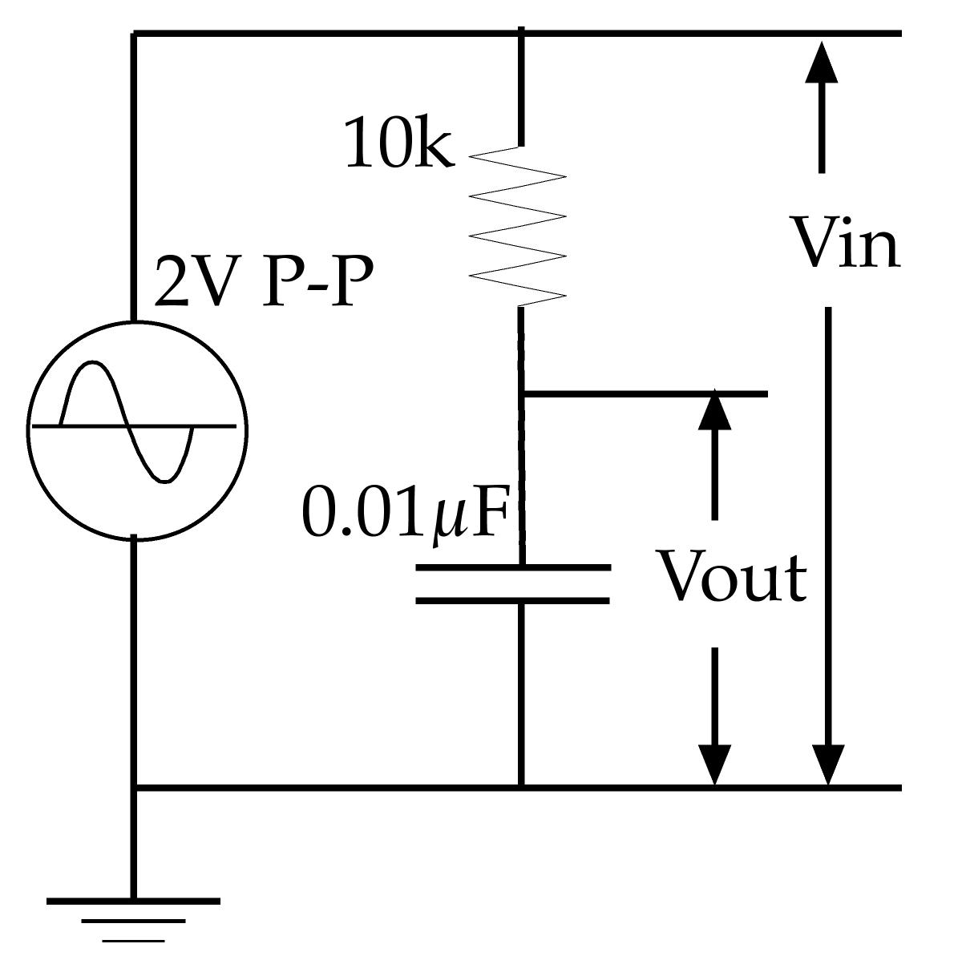Figure 1
Build a voltage divider using a 10k resistor and a 0.01µF capacitor, as shown on the right.
Adjust your Instek signal generator to produce 2V P-P square waves at 1kHz. Paste scope images to show Vout, Vin, and the current through the resistor in the boxes below (remembering to make the scales clear!).
You will have to think a little about the current through the resistor. It can be measured directly using the Math menu on your oscilloscope to compute Vin – Vout. You may need to ask for help using this.
a) Vout and Vin
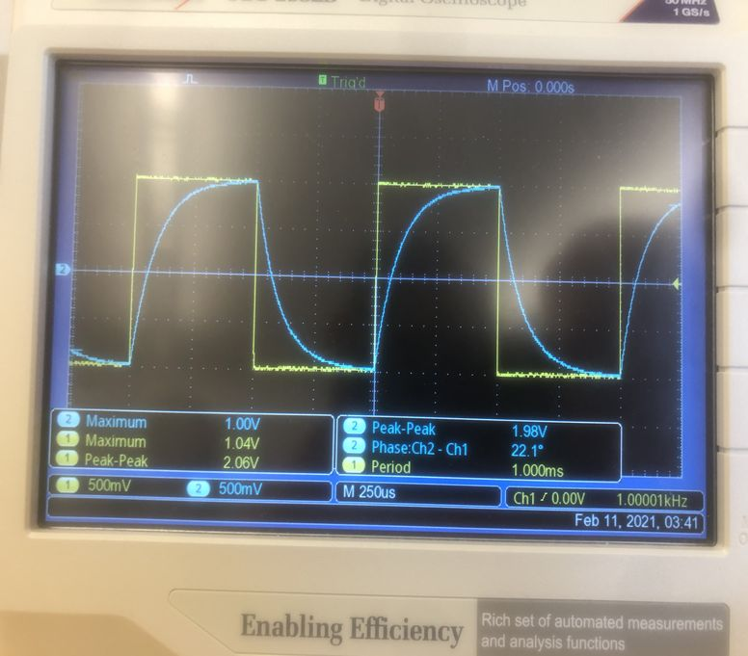

b) I_{R} and Vin
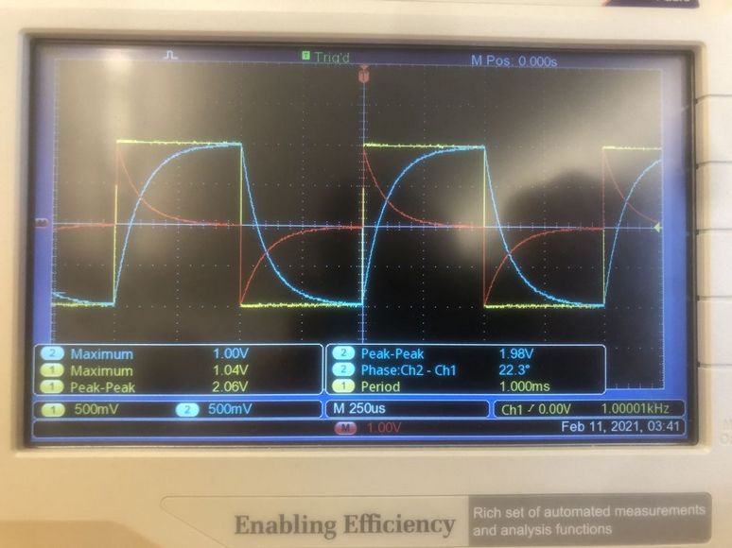

The red line, which indicates the difference between Vin and Vout, is proportional to the current through the resistor. Dividing its value by 10000 gives the current through the resistor.

c) Using the theory from §6.2, give a detailed explanation of these graphs. In particular, measure the time constant (the time that it takes the voltage to make 63% of its total change) during rising and falling edges and compare with the theoretical value. If measurement does not agree with theory then account for the difference.
These graphs almost exactly match the graphs in section 6.3.1 of the textbook. When Vin changes to the higher state, the capacitor charges, so the voltage drop across the capacitor increases. Thus, the voltage drop across the resistor decreases, so Vout rises. Consequently, the current through the resistor falls.
Calculated time constant: 10000 Ohms * .01 microfarads = 100 microseconds.
Measured time constant: 100 microseconds.
Thus, the measurement agrees exactly with the theory.

Part 2: Combining Capacitors
a) Put a second 0.01 µF capacitor in parallel with the first. Re-measure the time constant.
Measured time constant: 200 microseconds
Use the new time constant to compute the total capacitance of the two capacitors in parallel and compare with theory.
200 microseconds = 10000 Ohms * X Farads
2.00 * 10⁻⁸ Farads = X
Thus, the total capacitance is .02 uF.

This agrees with the theory, since capacitors in parallel add like resistors in series, so we would expect a total capacitance of .01 uF + .01 uF = .02 uF.
b) Repeat the above with the two capacitors in series instead of in parallel.
Measured time constant: 50 microseconds

50 microseconds = 10000 * X Farads
5.0 * 10⁻⁹ Farads = X
Thus, the total capacitance is 5 nF.

This agrees with the theory, since capacitors in series add like resistors in parallel, so we would expect a total capacitance of 1/(1/(.01 uF) + 1/(.01 uF)) = 10 nF.

Part 3: RC Circuits and Sine Waves
a) Now change the settings on your signal generator so that it is producing a 2kHz sine wave instead of a 1kHz square wave, and return to a single 0.01 uF capacitor. Paste your plot of the input and output voltages below.
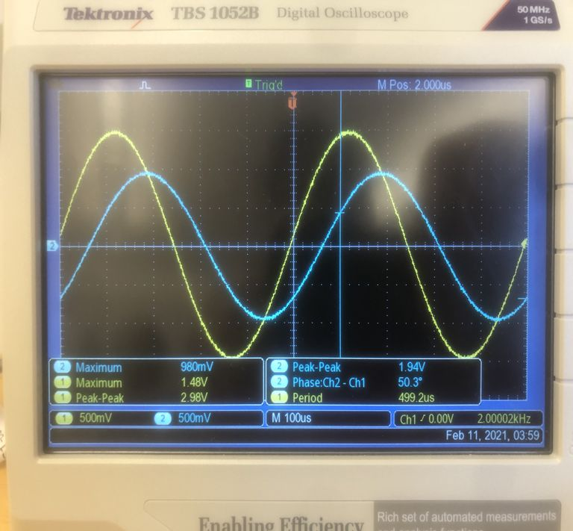

b) Describe the differences in amplitude and phase between the input and output voltages.
Vin has an amplitude of 3V peak-to-peak, and Vout has an amplitude of 2V peak-to-peak.
There is a phase difference of 50 degrees between the two signals.

c) Explain how the circuit acts to produce these differences.

Part 4: The Bode Plot
In §6.6 you read about the Bode plot. Now is your chance to construct such a beast.
Set your signal generator to produce sine waves at about 20V p-p and measure the information needed to produce a Bode plot for your RC filter.
NOTE: For amplitudes ONLY the ratio matters. You may alter the size of the input signal or the scales on the scope as needed to make the measurements accurate.
You will need to measure the ratio Vout/Vin and the phase shift between Vin and Vout over a range of frequencies. I have suggested a small set of frequencies to get you started. Collect data for these and plot them on graphs of dB vs. frequency (using a log scale for frequency) and phase vs. frequency (again use a logarithmic x axis).
Remember
dB = 20 log₁₀ (Vout/Vin)
a) The rough pattern should now be clear but you need to go back and add a few more measurements in areas where the curves are changing shape. Paste a table of your data and your plots in the box below.
Frequency | Vout/Vin | Phase Shift
10Hz 1 0°
100Hz 1 0°
250Hz 1 0°
500Hz 16.8/17.2 15.1°
750Hz 15.8/17.2 25.3°
1KHz 14.6/17.2 30.2°
2.5KHz 9.8/17.8 56.2°
5KHz 6.0/17.8 70.7°
7.5KHz 3.92/17.8 75.8°
10KHz 3.6/17.8 79.2°
25KHz 1.22/17.8 83.3°
50KHz .640/17.8 80.2°
75KHz .460/17.6 79.8°
100KHz .328/17.8 82.0°

b) Compare your Bode plot with the Bode plot in figure 6-30. Do your data agree qualitatively with the theory, i.e., are the curves the correct shape?

c) Calculate the cut-off frequency for this filter using the formula in the book.

d) Measure the cut-off frequency from your data and compare it to the theoretical frequency?

e) Would you describe this as a high-pass or as a low-pass filter? Why?

Part 5: Another Filter, Another Method
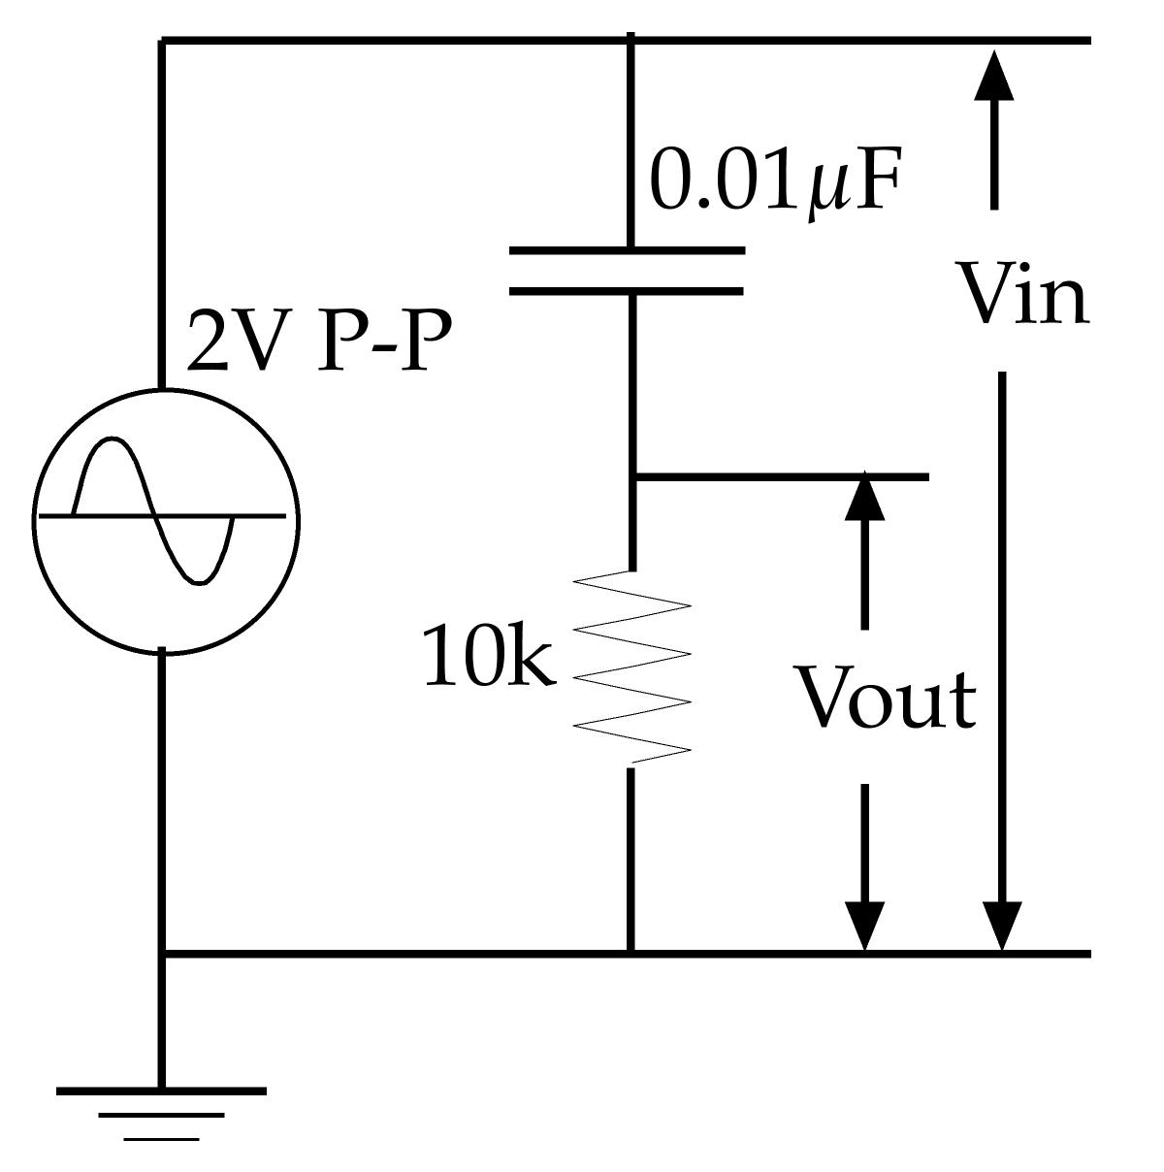Figure 2
Now, rather than repeat this process with the high-pass version of the filter, instead use Eagle to build a model of the high-pass filter (Figure 2) and use an AC Sweep simulation to generate the Bode plot for you. Pick your own values of R and C within a factor of 3 of the values shown. Sweep from 10 Hz to 10 MHz.
a) Paste below your schematic and Bode plot.

b) What is the theoretical cut-off frequency for the R and C values that you chose?

c) How well does this match your simulation?

d) Does this indeed produce a high-pass filter? How do you tell?

