Sequential Logic

Part 1: The flip-flop
a) The basis of all sequential logic is the bistable latch. Your first assignment here is to construct such a latch from two of the NAND gates in a 7400. You should first fill in both the NAND truth table and the truth/state table for a simple bistable latch.
A | B
0 | 0 | 1
0 | 1 | 1
1 | 0 | 1
1 | 1 | 0

A | B | Q |  | State Name
0 | 0 | 1 | 1 | U(nstable)
0 | 1 | 0 | 1 | Set
1 | 0 | 1 | 0 | Clear
1 | 1 | Q | !Q | Memory

b) Next you should cross-connect two of the NAND gates in a single 74HC00 into a bistable latch as shown below.
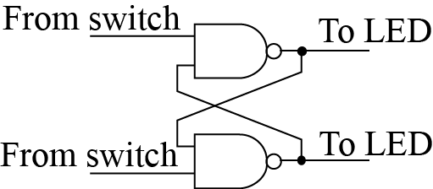
Verify that, when both inputs are at logic 1 the circuit can be in one of two stable states and that it remembers which of the two inputs was last at a logic 0. You can also check the non-stable input state 0,0 and show that its output is NOT remembered when you return the switches to 1,1. This is also called an SR flip-flop and it indicates the incredible power of the simple idea of feedback; of taking the output from the circuit and recycling it as an input.
c) Fill in a sequence of inputs and outputs to demonstrate the flip-flop behavior and label each state. NOTE that the sequence needs to demonstrate clearly the memory behavior, so annotate it to point out how you have shown this acts as a memory.
In1 | In2 | Out1 | Out2 | State name and Explanation
0 | 0 | 1 | 1 | Unstable. Memoryless state.
1 | 0 | 1 | 0 | Set. The output has been set to 1.
1 | 1 | 1 | 0 | Memory. The previous output remains.
0 | 1 | 0 | 1 | Clear. The output has been reset to 0.
0 | 0 | 1 | 1 | Unstable. Memoryless state; same as the start state.
0 | 1 | 0 | 1 | Clear. The output has been (re)set to 0.
1 | 1 | 0 | 1 | Memory. The previous output remains.
1 | 0 | 1 | 0 | Set. The output has been set to 1.
0 | 0 | 1 | 1 | Unstable. Memoryless state; same as the start state.

Part 2: The Transparent Latch
The transparent latch is the simplest kind of sequential logic that is found in common use. It has two inputs with very different natures—a clock input and a data input. When the clock input is a logic 1, the output (Q) follows the Data input (the latch is said to be transparent). When the clock goes from a 1 to a zero, the latch freezes and the Q stays at whatever value Data had when the clock went to zero. Thereafter, so long as the clock is at 0, the data input has no effect upon the output (the latch exhibits memory).
a) Build a transparent latch following the circuit below. You will need one gate from a 74HC04 in addition to the 4 NAND gates in your 74HC00.
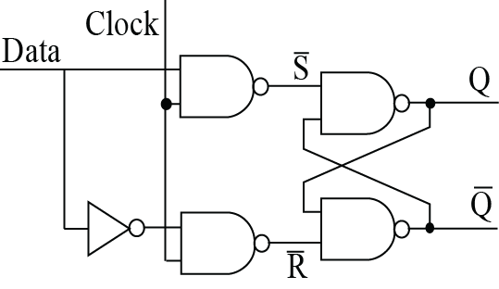
Clock | Data | Q |  | State Name
0 | 0 | Q | !Q | Hold0
0 | 1 | Q | !Q | Hold1
1 | 0 | 0 | 1 | Q0
1 | 1 | 1 | 0 | Q1

First show that it does indeed have the memory and transparency properties discussed above. You should connect both the Data input and the Clock input to switches on your Digi-Designer and show that the output follows the Data only when the clock is high.
Again, follow the behavior through a sequence of changes to show the state behavior and explain how this demonstrates memory.
In1 | In2 | Out1 | Out2 | State name & Explanation
1 | 1 | 1 | 0 | Q1. The clock input is high, so the output is set to match the data input.
0 | 1 | 1 | 0 | Hold1. When the clock is low, the prev. state stays
0 | 0 | 1 | 0 | Hold0. Same reasoning.
1 | 0 | 0 | 1 | Q0. The clock input is high, so the output is set to match the data input.
0 | 0 | 0 | 1 | Hold0. When the clock is low, the prev. state stays.
0 | 1 | 0 | 1 | Hold1. Same reasoning
1 | 1 | 1 | 0 | Q1. Same reasoning as starting state.

NOTE With only minor modification, this circuit is the basis of the kind of computer memory called “Static RAM”. This is the kind of memory used for the data memory in your Feather boards. There they are grouped into 8-bit bytes and then 196,608 of those form the RAM so there are about three quarters of a million gates used in the RAM alone.

Divide-by-2, First Attempt
In the next two sections we are going to develop a very useful kind of sequential circuit, a divide-by-two counter. This is a circuit with a single input called clock and a single output. When a square wave is fed into the clock the output should be a square wave at half the frequency. This will form the basis for all subsequent sequential circuits.
WARNING: Leave your transparent latch untouched. Build the next couple of sections somewhere else on the board.

Part 3: D-type flip-flop/latch
We can achieve this by adding more feedback. Wire up one of the two edge-triggered D-type latches in a 7474 and verify that behaves as described in its data sheet. NOTE you will have to tie the preset and clear inputs high! Describe and explain the behavior in your own words.

The outputs from the circuit match the data sheet.
This circuit behaves much like the transparent latch, except the output updates only when clock transitions from low to high.

a) Disconnect the switch from the Data input and instead connect the D input of the 7474 to the Q output of the same 7474.
b) Connect the clock input to the TTL Mode output of your Instek Function Generator and set it to run at 10kHz.
c) Use your oscilloscope to look simultaneously at the clock input and the Q output.
d) Paste an image of what you see on a scale that is slow enough to see several periods of the input wave.
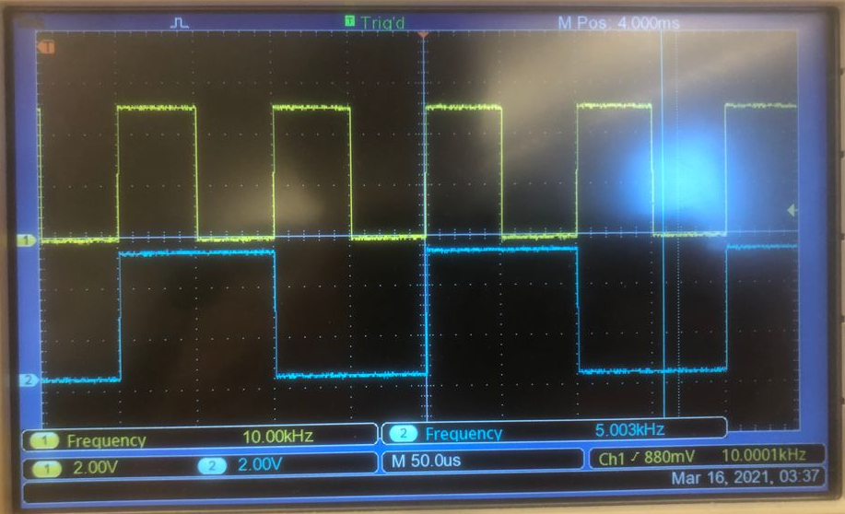

e) Describe what you see as best you can and discuss whether this is operating as a divide-by-two.
This is operating as a divide-by-two, since the output wave’s frequency of 5kHz is half the input wave’s frequency of 10kHz. This is happening because the flip-flop toggles when the clock transitions from 0 to 1. Since that happens once every period, the output signal changes state once for each period of the input signal, halving its frequnecy.

Part 4: Two-bit counter
If you look at the bit patterns on the input side of a 2-input truth table you will see that there is a very simple pattern. The leftmost column changes value every time the right hand column changes from a 1 to a zero, i.e. at half the rate of the rightmost column. Thus, we can build a simple counter using both of the D-type flip-flops in a 7474.
a) Go back to your 7474 circuit and extend it to match the circuit below. (Again, don’t forget to tie all the preset and clear inputs high.)
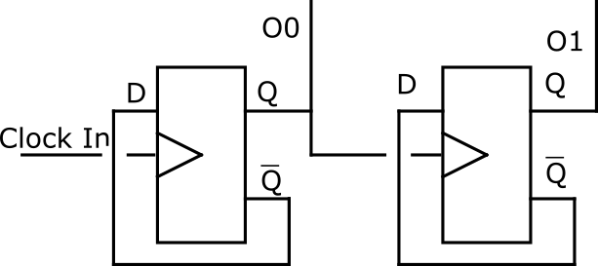
b) Arrange the traces so that O1 (the more significant bit) is on the top and O0 (the less significant bit) is on the bottom. Paste an image of the outputs on your scope in the box below.

c) Explain how your figure shows that this is a counting sequence.

d) Does your counter count up (0, 1, 2, 3, 0, 1, 2, 3, etc.) or down (0, 3, 2, 1, 0, 3, 2, 1, etc.)? Why?

e) What would need to be different about the flip-flops for the circuit to count the other way?

Part 5: Why did we switch to D-type Flip-flops?
Well, let's go back and try adding the same feedback to our transparent latch and see if it will make a divide-by-two. Go back to your transparent latch and:
i) Disconnect the clock input from its switch and connect it to the TTL Mode output of your Instek Function Generator set it to run at 10kHz.
ii) Disconnect the the Data input from its switch and instead connect the Data input of the transparent latch to the Q output of the transparent latch.
ii) Use your oscilloscope to look simultaneously at the clock input and the Q output.
d) Paste below an image of your scope on a scale scale slow enough to see several periods of the input wave.

e) Describe what you see as best you can and discuss whether this is operating as a divide-by-two.

f) Now zoom in to see a high-speed view of the interesting part of the signal, ideally showing the transition from a stationary period of the wave to an oscillating one. Paste an image below.

g) Explain this behavior by following bits through the logic diagram? Is the output a square wave at half the frequency of the input (as it should be for a divide-by-2)?

h) Explain how the edge-triggered nature of the ‘74 allowed the D-type latch to perform division safely.

