CircuitPython, Feather, and Mu

Introduction
While they may sound like the cast of a Saturday morning cartoon show, CircuitPython, Feather, and Mu are actually three parts of the toolkit that we will be using in this class to program micro-controllers in Python.
Feather, specifically the Feather M4 Express, is the hardware. It is a small board that allows us to plug a Microchip/Atmel SAMD51J19 micro-controller chip into a breadboard and access many of the pins. It looks like this.
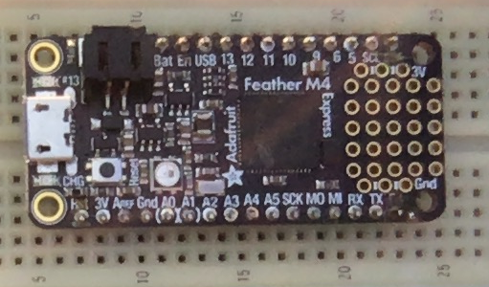
The SAMD51J19 is the big square black object surrounded by the text "Adafruit Feather M4 Express". The silver object on the far left is the micro-B USB port that powers the chip and allows to both program the chip and to communicate with it. Directly below the chip is a yellow LED that blinks when power is applied and the chip is functioning. Directly above the chip is a red LED that you will learn to control. The silvery circle to the left of the chip is a 3-color LED that is also available for you to program but is also used as a status LED for the computer to send you messages when something goes wrong. Along the top and bottom of the board are the pins that plug into the breadboard. A few are power pins (3V, GND, En, USB, and Bat) and a few others have rarely used special functions (RST and ARef) but the remaining 21 pins are there for us to play with.
Mu is the editor that we shall be using on our PCs to talk to the Feather. It was specifically written to support novice programmers working with Python and, in addition to working with the Python installation on the PC, has special support for three families of micro-controllers, the PyGame Zero, the BBC micro:bit, and various boards using CircuitPython, including the Feather.
CircuitPython is variant of the Python language that has been modified to work well on micro-controllers. There are some additions, mostly in the form of modules, to allow to talk directly to the hardware and there are some restrictions imposed by the very limited resources of a micro-controller. Chief among these are speed and memory capacity. The desktop PCs in the lab have multi-core CPUs that run at 2-3 GHz (depends on load, temperature, and number of other factors) that share 8 GB of main memory and 256 GB of disk space. The Feather M4 has a single core CPU that runs at 120 MHz. It has access to 512 kB of program storage memory and 192 kB of data memory. The Feather board adds a whole 2MB of external disk space in the tiny chip that is at the end of the word Express. These limitations mean that we can write only moderate sized programs and must avoid features (such as appending to arrays) that allocate memory.
Two more specialized terms that we shall need are host and target. The host computer is the PC that we use to talk to the target computer, the Feather board. We talk about uploading a program to the target and could download results from it.

Getting Started
The editor will be happiest if you plug the Feather into a USB port and wait for the status light to go green before you launch Mu. This should result in a new disk drive mounting in windows and showing up on the screen, like this. Note that the drive letter (F: in this case) may change but the drive will always be called CIRCUITPY.
You should see at least the lib folder and the boot_out.txt file and probably the code.py file. We shall use lib later to add new modules to the version of CircuitPython running on your board. The boot_out.txt file is re-written every time the computer resets. It is an ordinary text file and you can read it if you are interested. The file code.py is special. CircuitPython is set up so that every time this file is written Python will automagically run the file. All our programs will go into the code.py file.
Once your board is running, launch Mu and you should see something like the figure below, though the window be bigger and the contents will almost certainly be completely different. This one is only small because I shrank it to fit on the page better.
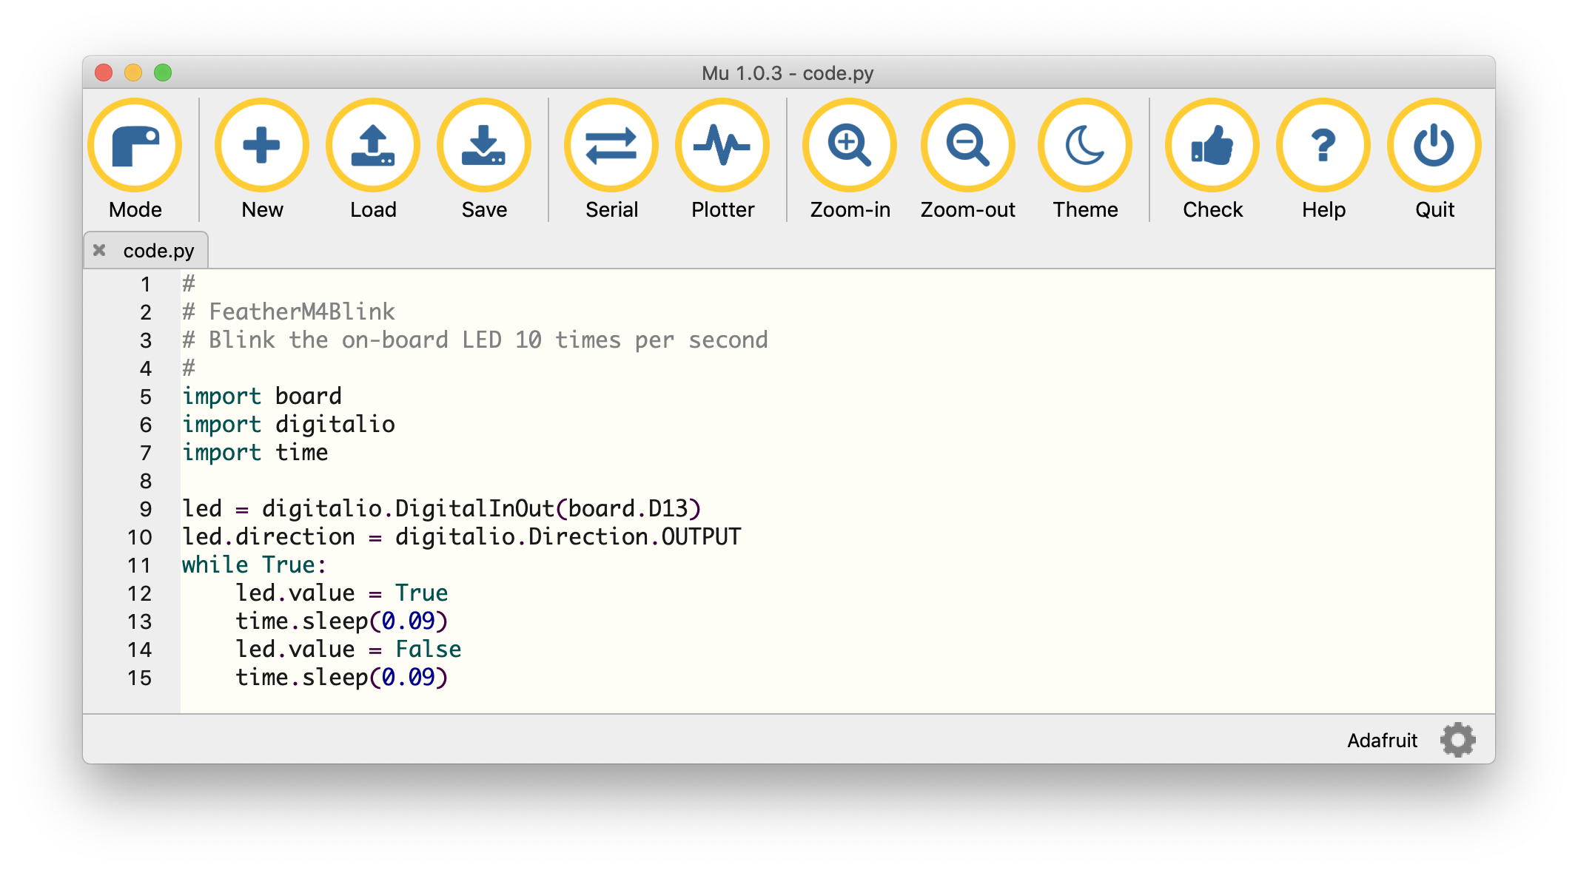
Rather than having menus, Mu is controlled by the big friendly buttons in the toolbar across the top of the window. The space below that is an editor in which you will write your code. This space is tabbed so that you can have multiple files open at once. Here we see a single tab open on the file 'code.py'. Later we shall explore the unexpected complications of working with more than one file. We shall primarily be concerned with four of the buttons, New, Load, Save, and Serial. As its name suggests, New creates a new, untitled editor pane. We use this when we want to create a new program. Load opens an existing program, and Save writes the current program out. When that program is the special 'code.py' program, this results in the program being sent to the Feather board and executed. For the special case of 'code.py', you could also think of this as the Run button.
As the separator bar suggests, Serial is quite different. It does not affect the current file, instead it opens a new pane below the editor pane in which it displays any output from your program. It can also provide access to the Python command line that work like the console window in Spyder. If you run a program that ends normally then you will drop into the the Python command line, also known as the REPL, and be able to type commands to Python interactively. Indeed, if you use Mu in the Native mode instead of the CircuitPython mode (with the Mode button) then you have full access to the PCs Python in exactly the same way as in Spyder. We shall play with this in a little while.

Task 1
Edit contents of your Mu editor pane to match those in the figure above. Save (Run) your file and record what you observe the on the Feather.
The red LED beneath the USB connected blinks rapidly.

Saving Your Work
At this point your program is saved only on the Feather board. As soon as you alter the program this one will be lost. We want to keep copies of all our (successful) programs. Although Mu has no Save As... tool button you can still access the function by double-clicking on the filename in the window tab, where it says code.py in the figure above. This will bring up a standard Save As dialog so that you can save the file with a new name. DON"T!
There is only very limited space on the CIRCUITPY drive so we want to save our backup copies on the PC's hard drive, which has nearly a million times more space. So, use the Documents icon in the side pane to navigate to the PC hard drive and save it there with a sensible name, such as Blink1.py.

More Blinkys!
Once your first program works, it is time for you to do something on your own. At the moment, the LED blinks at a single fixed rate. Over the rest of the lab you will alter the program so that the LED blinks in a different way.
Start a new program either by pressing the New button or by going to the File menu, selecting Save as..., and choosing a new name. Get your new program to look the same as your first one if it does not already do so.

Task 2
You next job is to make the LED flash in a more complex pattern. I would like the new program to Blink in a pattern of two long ONs followed by one short ON of about half the duration. The OFF times should all be the same, about as long as the short ON except that after the last short ON I want you to put in a significantly longer off. We are after something like this
OONN off OONN off ON o--------f OONN off OONN off ON o--------f OONN off OONN off ON o--------f
Start by modifying the header comment to reflect the new purpose and then modify the code. NOTE that copy and paste followed by a little judicious editing is a great thing.
Paste the working code in below and describe and explain what you did to make this happen.
To make this happen, I just changed the delays between the blinks to match the desired pattern.

# Author: Ben Kallus
# Blinks the D13 LED in the following repeating pattern: on (1s) off (.5s) on (1s) off (.5s) on (.5s) off (3s)

import board
import digitalio
import time

led = digitalio.DigitalInOut(board.D13)
led.direction = digitalio.Direction.OUTPUT
while True:
led.value = True
time.sleep(1)
led.value = False
time.sleep(.5)
led.value = True
time.sleep(1)
led.value = False
time.sleep(.5)
led.value = True
time.sleep(.5)
led.value = False
time.sleep(3)

Task 3
Now let’s add some new programming ideas! You have read about variables and the for loop in the text, now I want you to use a for loop to make a pattern with some built-in repetition.
Your task is to make your computer flash the red LED five times using a count loop, then wait 1 second and repeat forever. Past your commented code below.
# Author: Ben Kallus
# Blinks the D13 LED 5 times, then waits 1s and repeats.

import board
import digitalio
import time

led = digitalio.DigitalInOut(board.D13)
led.direction = digitalio.Direction.OUTPUT
while True:
for _ in range(5):
led.value = True
time.sleep(.2)
led.value = False
time.sleep(.2)
time.sleep(1)

Talking to Python
Although the Feather board has no built-in input hardware and only a single red LED for output, the PC has a full keyboard and display. Together CircuitPython and Mu will allow us to borrow the PC keyboard and display to talk to programs running on the Feather through the USB cable that links the two computers. CircuitPython uses the USB connection to support the built in print and input commands as described in Chapter 2 and Mu provides the Serial pane on the PC end.

Task 4
Make sure that you saved your previous program and then type the following program into code.py, but do not save it yet.
# Talk to Python
# Ask the user their name and compliment them
#
while True:
print('Please enter your name ')
name = input()
print('Thank you ', name, ', '. You are most kind.')

a) Before you Save/Run the program, press the Serial button to open the serial pane below the main editor pane. Once that is open, save your program and describe the resulting interaction.
The program asked me for my name, and upon entering it, it thanked me and told me I am kind.

b) What is wrong with the formatting of the output?
There’s an extra space on either side of my name, and an extra space before “You” (depending on who you ask. I don’t put two spaces after a period.)

c) By studying the Chapter 2 or otherwise, can you figure out how to correct the formatting problem? Paste your, properly commented, corrected code below.
I fixed the formatting problem by concatenating strings instead of giving `print` multiple arguments.

# Corrected by Ben Kallus
# Talk to Python
# Ask the user their name and compliment them

while True:
name = input("Please enter your name ")
print('Thank you, ' + name + '. You are most kind.')

Task 5
The chapter showed you how to write a program to average a set of numbers entered, one per line, into the serial pane or terminal. Write and demonstrate a program to print the maximum and minimum of a set of numbers entered that way.
# Author: Ben Kallus
# Talk to Python
# Computes the min and max of a sequence of user-provided numbers.

import math

maxx = None
minn = None
while True:
line = input("Enter a number: ").strip()
if line == "":
break
try:
line = int(line)
except ValueError:
try:
line = float(line)
except ValueError:
print("That is not a valid number. Try again.")
continue

if maxx is None:
maxx = minn = line

maxx = max(maxx, line)
minn = min(minn, line)

if maxx is None:
print("You didn't enter any numbers!")
else:
print("Maximum:", maxx)
print("Minimum:", minn)

A final challenge to put it all together. This one is "If time permits".

Task 6
Write and demonstrate a CircuitPython program that asks for and responds to single letter commands to turn the on-board LED on and off. You should at least support the commands 'n' and 'f' and are encouraged to add other commands, for example a command to blink the LED.
# Author: Ben Kallus
# Talk to Python
# Asks the user to enter single letter commands

import board
import digitalio
import time

led = digitalio.DigitalInOut(board.D13)
led.direction = digitalio.Direction.OUTPUT

def print_help():
print("Valid commands:")
print("h: Show this help message")
print("n: Turn the LED off")
print("f: Turn the LED on")
print("b <delay>: Blink the LED with specified delay in seconds")

data =[]
print_help()
while True:
line = input("Enter a command: ").strip().split()
if line == []:
continue
if len(line[0]) != 1 or line[0] not in ("hnfb"):
print_help()
continue

command = line[0]
if command == "h":
print_help()
elif command == "n":
led.value = True
elif command == "f":
led.value = False
elif command == "b":
if len(line) != 2:
print_help()
continue
try:
delay = float(line[1])
except:
print("Invalid delay specified.")
continue

led.value = True
time.sleep(delay)
led.value = False

