Lab 8: The Diode
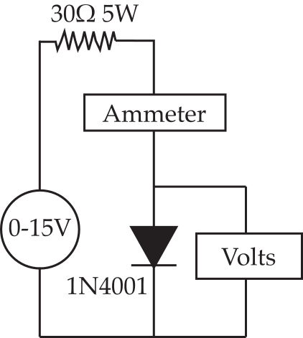
Figure 1
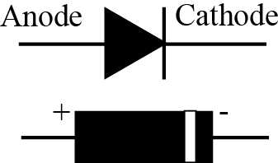
Figure 2
We turn to an exploration of the diode. We shall build some real circuits with diodes a little later but to start we shall explore the properties of the beastie.

Part 1: Forward DC I-V curve
Let’s start with the I-V curve. Using the circuit of figure 1, measure the forward current characteristic of the 1N4001 diode. First predict the forward turn-on voltage.
I expect it to be 0.6V.

Now explore the I-V curve. You will measure this in two current ranges because you can't see the details on one plot. Start with the higher current forward region. Use the 0-15 V power supply on your Designer and measure the voltage with a DMM. For the first part of the lab you will need to set the current DMM onto the 10 A scale and also to move the red probe from the regular input to the special 10 A input.
NOTE: Although the graph goes up to 1 V you will NOT be able to reach that voltage. Be careful not to exceed 0.5 A current or you may damage the power supply!
You will need to be careful about the orientation of the diode. The cathode end, the end with the bar, is usually indicated on a diode package with a white band as shown in Figure 2.
Measure the voltage across the diode as you set the diode current to 0mA, 10mA, 50mA, and then every 50mA to about 0.5A. Plot the current as a function of voltage and add any additional measurements to make a good curve. Paste your plot in the box and answer the questions.
mA V
0 0.00
10 0.67
50 0.77
100 0.80
150 0.81
200 0.82
250 0.83
300 0.83
350 0.84
400 0.84
450 0.84

- At what voltage does the diode seem to start conducting?

b) Is this consistent with your prediction? Explain.

Next, replace the 30Ω 5W resistor with your 270Ω 5W resistor and repeat the measurement using currents up to only 50mA. Essentially we are zooming in on the low current region. Again, paste in your graph and answer the questions based on both sets of data.
mA V
0 0.00
0.01 0.34
0.04 0.43
0.06 0.46
0.28 0.53
0.84 0.58
1.5 0.61
2.4 0.63
4.4 0.66
5.4 0.67
7.0 0.68
7.9 0.69
10.3 0.70
11.7 0.71
18.8 0.73
24.3 0.74
29.9 0.75
35.6 0.76
40.3 0.76
45.6 0.77
c) When the diode is conducting, what range of voltages can be found across its terminals?

d) Over what range of currents is the diode voltage in the range 0.55V-0.65V? )

e) What is a typical range of currents found a circuit containing resistors with values 1-10 kOhms driven by power supplies of 5-15 V?

f) Are your measurements consistent with the idea that the diode has about 0.6V across it whenever it is turned on in circuits powered by 5-15V and using resistors of a few kOhms? Explain. (Hint: what sort of current could be found under these conditions?)
Next, switch to the negative 15V power supply and measure the reverse leakage current.
NOTE: Remove the voltmeter before you measure the current, otherwise you just end up measuring the resistance of the voltmeter!
I measured 0.00 uA.

e) Do you see any signs of reverse breakdown?
No.

Part 2: AC Behavior
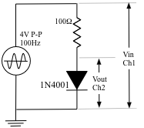
Figure 3
Next replace the DC power supply by a 4V P-P, 100Hz sinewave coming from the 50Ω output of your Instek signal generator, as shown in Figure 3 on the right.
Remove the ammeter and voltmeter and connect the oscilloscope probes as indicated. Adjust your scales to show about two full periods of the sine wave and so that the input is as large as possible. Paste an image of your screen in the box below.

f) Mark or describe clearly the regions where the diode is turned on and the regions where it is turned off and explain the details of the curve shape in each region using what you now know about the diode I-V curve.

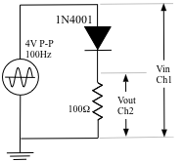
Figure 4

Part 3: Diode voltage divider/Half-wave Rectifier.
Build the circuit of Figure 4. The input and output should be connected to the channels of your oscilloscope as shown. Again, adjust your scales to show about two full periods of the sine wave and so that the input is as large as possible. Paste an image of your screen in the box below. Please use a common zero so that I can see the relationship between the traces.

g) Describe in detail the differences between the input and output signals. You should pay attention to the quantitative details and should account for the differences by referring to the I-V curves you just found.
NOTE: Make sure that you explain how and why this is different from the previous graph and in what way the two graphs are related.

