Lab 7: The Inductor
An inductor is usually just a coil of wire. In many ways it is the opposite of a capacitor. It has an effective resistance that gets smaller and smaller as the frequency gets higher and higher. It also has the unique ability to generate new voltages that are not simply related to the power supply voltages in the circuit. Inductors become more useful at high frequencies. In order to see significant effects as the low frequencies that we prefer I have provided you with a 0.01 Henry (10 mH) inductor that you will use in the following experiments.
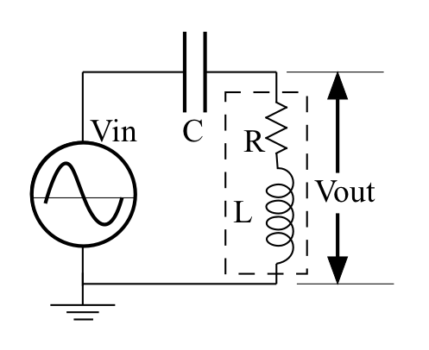Figure 1

Part 1: Resonance and the LCR filter
Start by building the LCR series circuit shown in the figure below right. Use a 0.01 µF capacitor and your 10 mH coil. Measure the response (Vout/Vin) of the circuit over the range from 1 kHz to 100 kHz, being careful to concentrate your data where the most rapid changes are occurring. Plot your data and paste a copy of your (properly labelled) graph in the box below.
(NOTE that the resistor shown in the dotted box is the DC resistance of the coil and NOT a separate component.)
f Vin Vout
1kHz 3.80 .0192
2.5kHz 3.88 .104
5kHz 3.92 .412
7.5kHz 3.88 1.01
10kHz 3.92 2.24
12kHz 3.84 4.40
12.5kHz 3.84 5.80
13kHz 3.84 6.56
13.5kHz 3.76 8.60
14kHz 3.68 10.5
14.5kHz 3.52 15.0
14.75kHz 3.36 18.0
15kHz 3.20 21.2
15.175kHz 2.88 24.0
15.25kHz 2.76 25.2
15.5kHz 2.48 27.6
15.75kHz 2.40 28.8
15.8kHz 2.40 28.8
15.9kHz 2.40 28.6
16kHz 2.48 28.4
16.25kHz 2.64 27.4
16.5kHz 2.88 26.2
16.75kHz 3.04 24.4
17kHz 3.20 23.0
18kHz 3.56 17.4
19kHz 3.72 13.8
20kHz 3.76 11.4
21kHz 3.84 10.0
25kHz 3.84 7.00
30kHz 3.84 5.80
40kHz 3.84 5.00
50kHz 3.92 4.60
60kHz 3.88 4.40
70kHz 3.92 4.40
80kHz 3.92 4.40
90kHz 3.92 4.20
100kHz 3.92 4.20
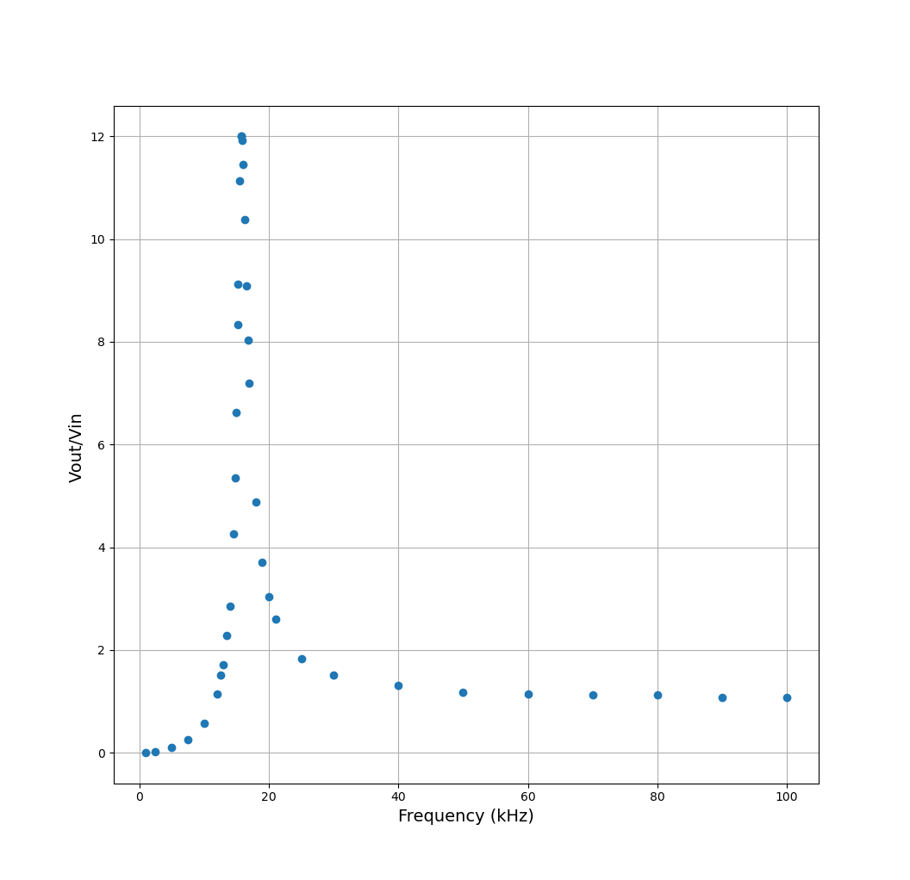

Compare your Bode plot with the appropriate Bode plot in chapter 8.
My bode plot matches the plot in chapter 8.

Do your data agree qualitatively with the theory, i.e., are the curves the correct shape?
The curve is the correct shape.

Calculate the resonant frequency for this filter using the formula in the book.
1/(2pi * sqrt(LC)) = 15915.49Hz.

Measure the resonant frequency from your data and compare it to the theoretical frequency?
The resonant frequency from my data is between 15.75kHz and 15.80kHz. This is just slightly lower than the calculated resonant frequency.

Measure the DC parasitic resistance of the coil (take the coil out and use your DMM) and so compute the expected Q of the circuit.
The parasitic resistance is 40.4 Ohms. Thus, Q = (15915.49 * .01 * 2pi)/40.4 = 12.38.

Compare your theoretical Q with the measured Q of the circuit and discuss.
The measured value for Q is 12.0, as shown in the Bode plot. This matches the calculated value.

Part 2: The R-L Circuit and square waves
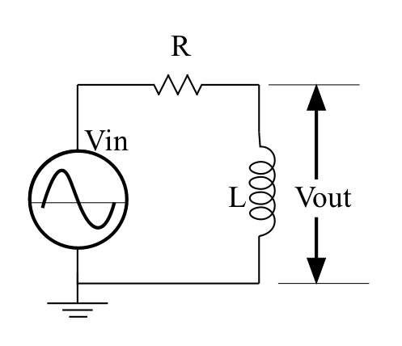Figure 2
Build a voltage divider using a 1k resistor for R and your 10 mH inductor, as shown on the right.
Adjust your Instek signal generator to produce 2V P-P square waves at 10 kHz. Just as you did for the capacitor, take pictures of your scope screen, one showing Vout and Vin as a function of time, and the second showing Vin and the current through the resistor as a function of time. Remember from last lab how to use the Math function on your oscilloscopes to display the current through the resistor. Paste the two images in the box below.
Remember to adjust the scale so this makes sense.

Measure the time constant (the time that it takes the voltage to make 63% of its total change) during rising and falling edges and compare with the theoretical value from the chapter. If measurement does not agree with theory then account for the difference.
It takes 10 microseconds for the voltage to drop from 1.9V to 700mV.
This is expected not to be in line with the theory, since there are other resistances in the circuit

Part 3: The RL Circuit and Sine Waves
Now change the settings on your signal generator so that it is producing a 10 kHz sine wave instead of a 10 kHz square wave. Paste a picture of your scope screen showing Vout and Vin as a function of time in the box below.

Describe the differences in amplitude and phase between the input and output voltages.

Explain briefly how the circuit acts to produce these differences.

Part 4: The Bode Plot
Chapter 8 tells us that this should be a high-pass filter. As you know, the way to characterize a filter is to create a Bode plot for it. As you should also have realized by now, this is a long slow job by hand so use Eagle to simulate the circuit and make a Bode plot. Paste your Bode plot below.

Compare your Bode plot with the Bode plot in Chapter 8. Do your data agree qualitatively with the theory, i.e., are the curves the correct shape?

Calculate the cut-off frequency for this filter using the formula in the book.

Measure the cut-off frequency from your data and compare it to the theoretical frequency?

Would you describe this as a high-pass or as a low-pass filter? Why?

