Lab 13:FET Switches

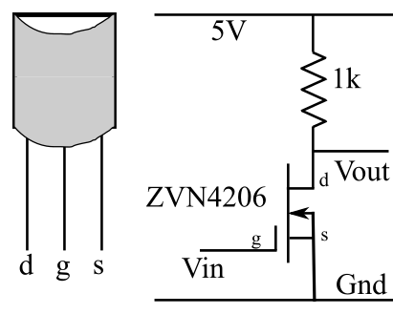
Part A: The NMOS Switch
Our first logic switch is the simple NMOS inverter shown to the left. Connect the TTL/CMOS output of your Instek signal generator to Vin of the NMOS gate and connect the Vout to one of the LEDs on your Designer and Vin to another LED.
1) Set the Instek signal generator to a frequency of 1Hz and describe the behavior of the LED’s.
If nothing happens press the Wave button a few times. Some of the settings don't turn on the TTL output but if you try several you will find one that does.

The LEDs blink once per second, with opposite states at all times.

2) Explain this behavior in terms of what you know about the operation of an FET. I need to know WHY the output LEDs behave as they do.
The LED connected to Vin is on when Vin is high and off when Vin is low.
The other LED is connected to the FET’s drain. When Vin is high, current flows through the FET with very low resistance, so most of the voltage drop will be across the 1k resistor, making Vout low. This explains why the two LEDS blink in opposite states.

3) Now unplug the LEDs and connect the oscilloscope to the input (CH1) and output (CH2) of the switch. Set the signal generator to produce a 1kHz output (the amplitude and wave-shape don’t matter because you are using the sync output).
Paste an image of the input and output and discuss whether this switch is acting as a good inverter. We are interested in the sharpness of the transitions and the values of the logic 0 and 1 voltages.
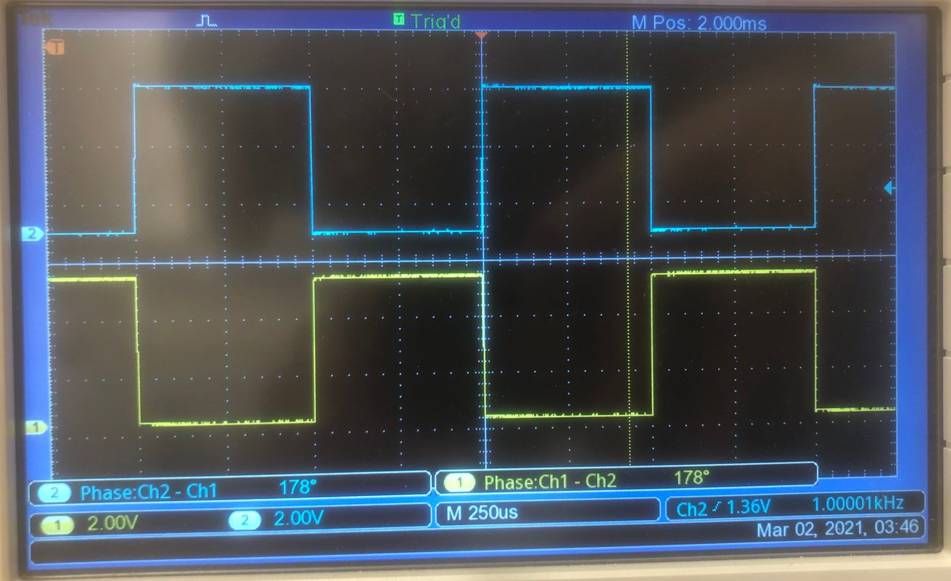
The switch is acting as a good inverter. The transitions are sharp, and the on/off voltages are consistent.

4) Now turn the frequency up to 1MHz and paste in the new image.
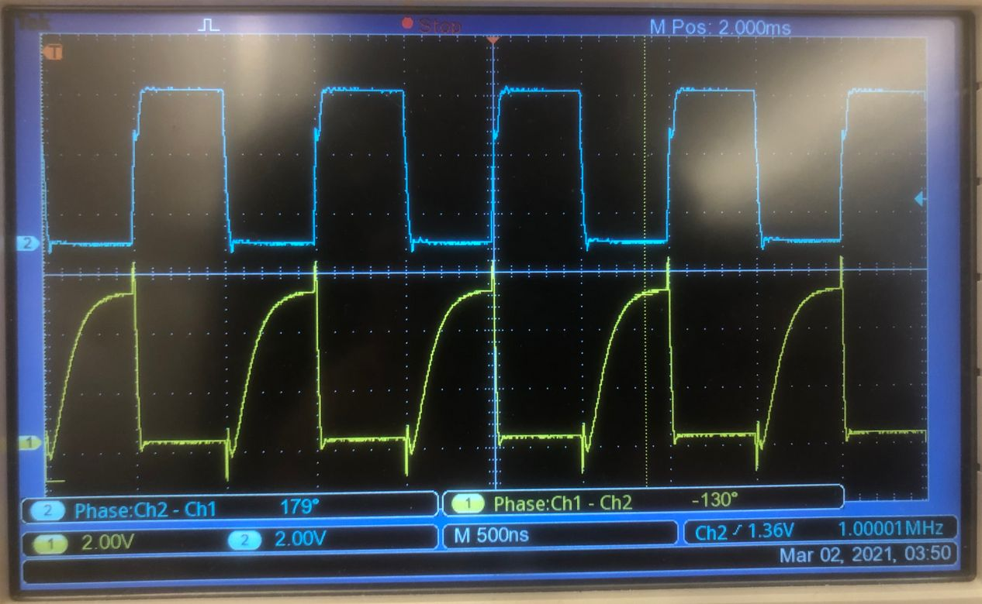

5) Is the output as good as it was? If not discuss what is wrong with it.
The output is not as good as it was. Since it takes ~90 nanoseconds for the FET to activate, we don’t see sharp transitions at this scale.

6) Refresh your memories of sections 12.4.1 and 12.4.2 in the Electronics book and then redraw the circuit showing the parasitic capacitances, paste an image in, and explain in detail how they cause the circuit to behave this way.
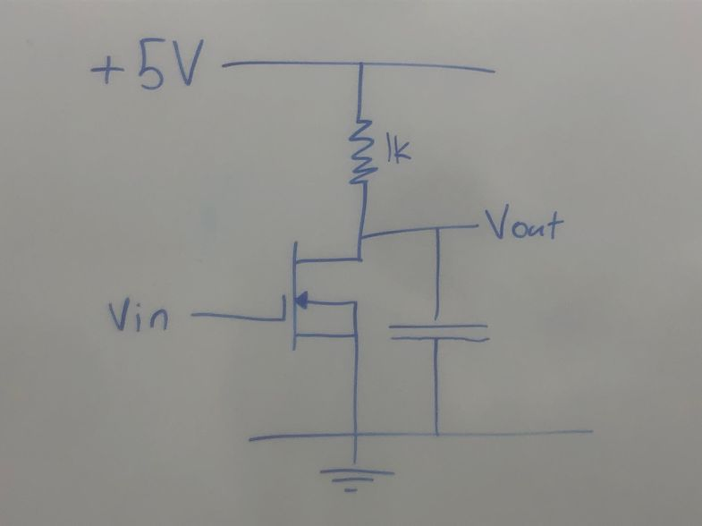
Current flows through an NFET when there is charge accumulated in the gate. Since it takes ~90 ns for an NFET gate to accumulate enough charge for current to flow, we are able to see the charging time when the FET activates at this timescale.

Part B: The PMOS switch
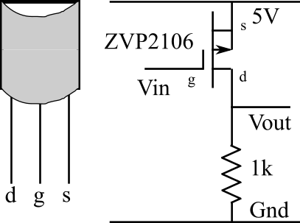
Maybe a PFET will do a better job. To find out, replace the NMOS circuit by the PMOS circuit on the left. Connect this one to the signal generator and the scope in the same way as the first one.
1) Again set the input to 1kHz, record the input and output waveforms, and paste the image in the frame below. (Don't forget to make sure that the scales are clear!)

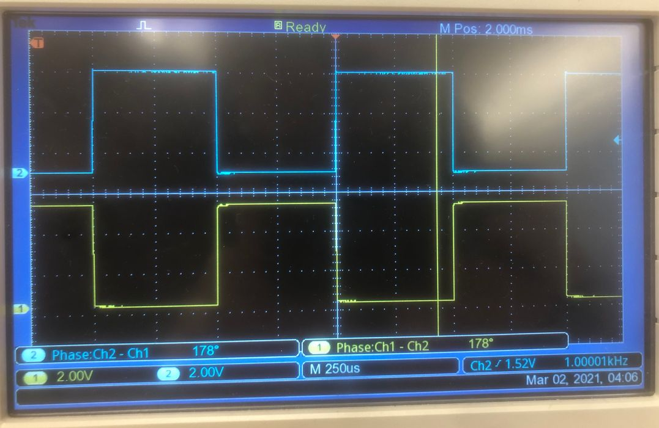

2) Discuss whether or not this is a good inverter.
This is also a good inverter. The transitions are sharp, and the high and low levels match.

3) Explain how this circuit works.
When Vin is high, current cannot flow through the FET, so Vout is low. When Vin is low, current flows through the FET with low resistance, so most of the voltage drop is across the resistor. Thus, we read high voltage at Vout.

4) Again, set the signal generator frequency to 1MHz and paste in the new image.
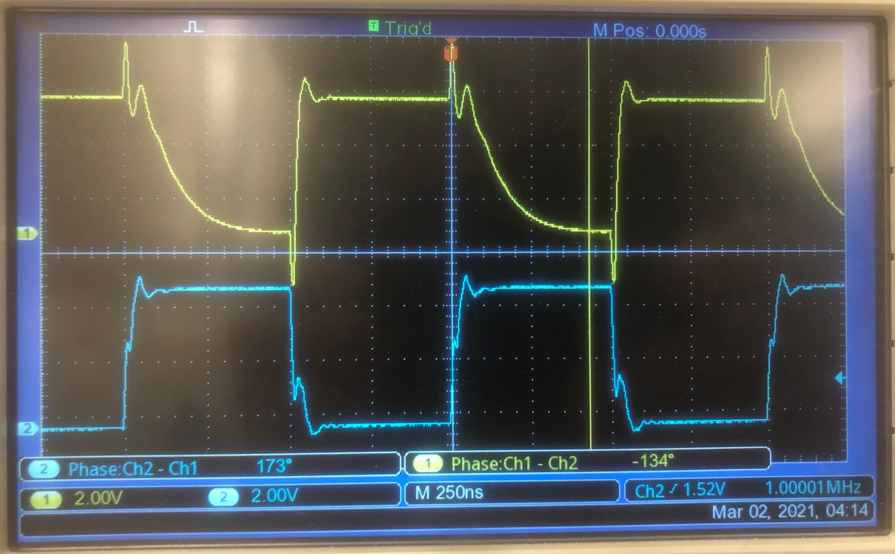

5) Is the output as good as it was? If not describe what is wrong with it.
The output is bad at this frequency. Instead of taking time to activate like the NFET, the PFET takes time to deactivate.

6) With a little help from section 12.4.3, explain, again with reference to parasitic capacitances, why this circuit behaves this way.
Current flows through a PFET when there is no charge accumulated in the gate. Since it takes ~90 ns for an PFET gate to accumulate enough charge for current to stop flowing, we are able to see the charging time when the PFET deactivates at this timescale.

Part C: The CMOS switch
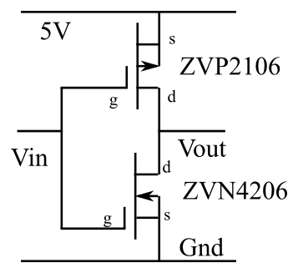
1) Each of those did one job well but another poorly. Here is a discrete CMOS switch circuit (left) that claims to manage the best of both previous circuits. Build this one, connect it up as before, and repeat the high frequency measurement on this improved circuit. (If that is fine then we can be pretty sure that the low frequency behavior will be fine.)

Paste your scope picture in the box below.

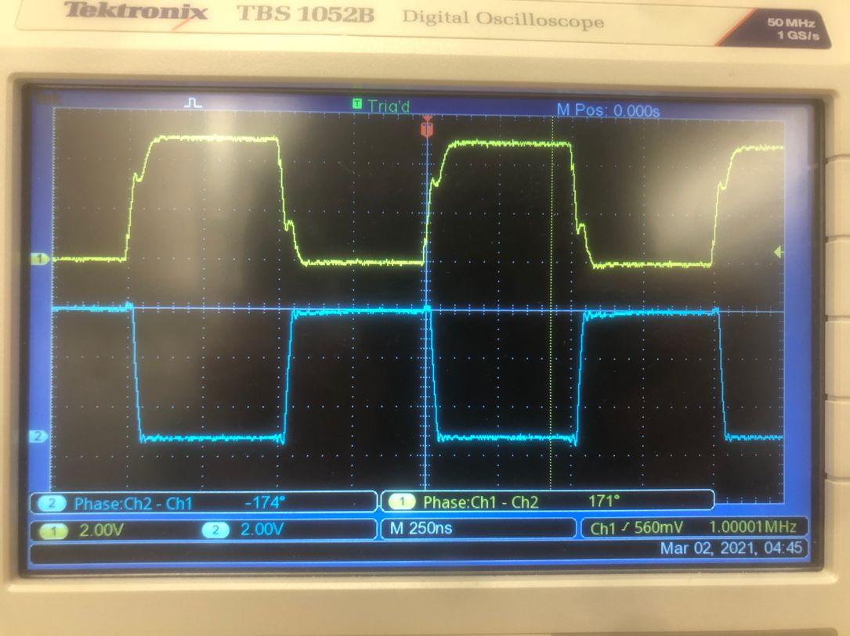

2) Is this any better than the previous circuits? If so, describe what is better about it.
This is better than both previous circuits. Even at 1MHz, both transitions are sharp.

3) With a little help from section 12.4.4, explain why this circuit operates differently from the others and discuss which of the three circuits is the best inverter.
This circuit is the best inverter, because both of its transitions are sharp. When Vin is high, current flows through the NFET, and not through the PFET. Thus, Vout is connected to ground through very little resistance, so it reads low. When Vin is low, current flows through the PFET, and not through the NFET. Thus, Vout reads high. When Vin transitions from high to low, the PFET transitions quickly, so we get a sharp transition. When Vin transitions from low to high, the NFET transitions quickly, so we get a sharp transition.

