Lab 3: Circuit Theory and Node Analysis
All of this lab is theory or simulation but I want to be there the first time you do one of these resistor problems to help as needed.

Part 1
Find all the unknown currents and voltages in the following circuit using Node Analysis.
You are required to show all your work. You are welcome to work on paper and paste photos into the lab.

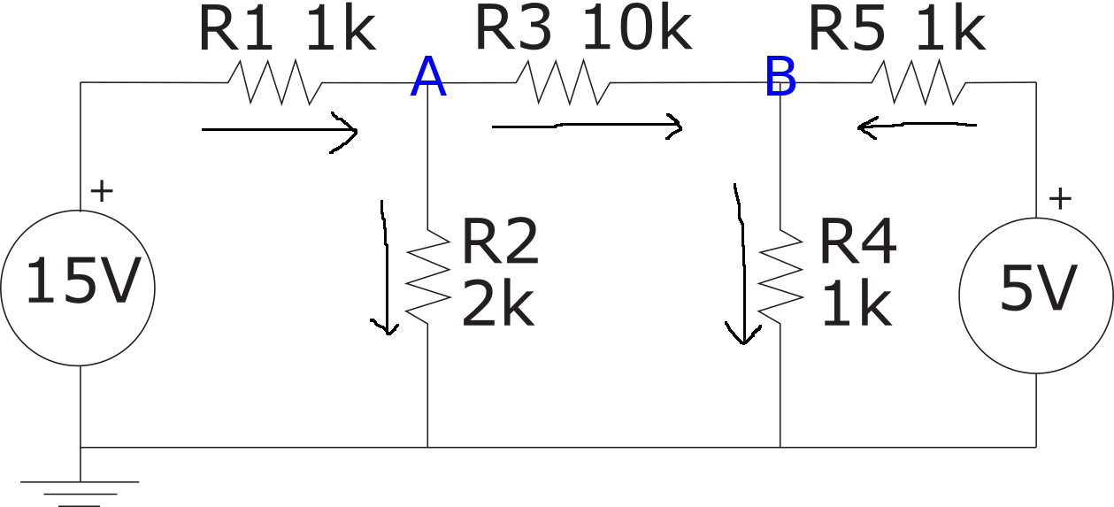
I1 = (15-A)/1k I2 = A/2k I3 = (A-B)/10k I4 = B/1k I5 = (5-B)/1k

I1 = I2 + I3 I5 + I3 = I4
(15-A)/1k = A/2k + (A-B)/10k (5-B)/1k + (A-B)/10k = B/1k
10(15-A) = 5A + A - B 10(5-B) + A-B = 10B
150 – 10A = 6A -B 50 – 11B + A = 10B
B = 16A – 150 A = 21B – 50
B = 16(21B – 50) – 150
B = 336B – 800-150
950 = 335B

B = 2.84V A = 9.55V

Part 2
Now build a model of the circuit in Eagle and run an Operating Point simulation to compute the two unknown voltages. Paste the simulated schematic below, with the voltages and currents shown.
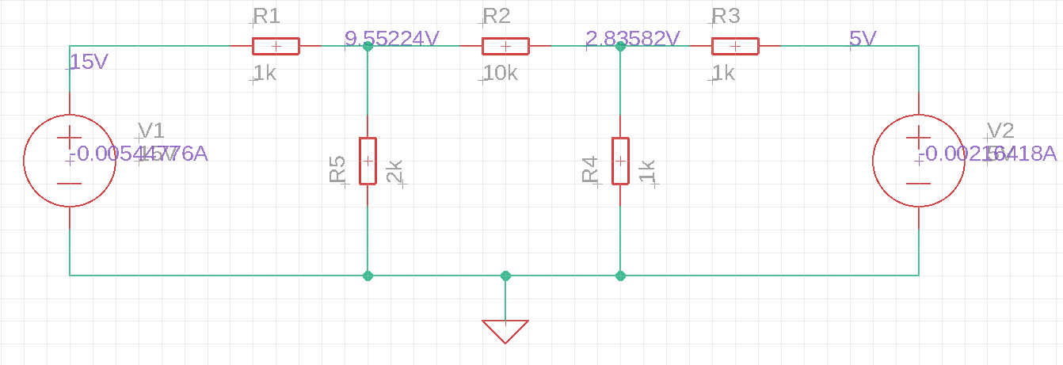

Compare the voltages computed by Eagle with your voltages from the first part of the lab.
They match exactly.

Discuss, in numeric detail, any differences that you might expect to encounter if you actually built the circuit in the lab with real components and real power supplies.
(Hint: What is the tolerance of your resistors and how accurate are your power supplies?)
If I were to build this circuit in the lab, I would expect the currents and voltages to differ from those predicted by the calculations because the resistors in the lab are rated for accuracy within 5%. Thus, a 1kΩ resistor in the lab could have a resistance as low as 950Ω or as high as 1.05Ω, which could result in reading higher or lower voltages and currents. Additionally, the voltage sources have small internal resistances that would increase the total resistance in the circuit.

