Stepper Motors
The brushed DC motor is the simplest of motors and one of the most efficient. If you want to make something move rapidly without too much control then a brushed DC motor is good choice. The stepper motor is far less efficient—you get significantly less torque for the same current—but in exchange they offer precise positioning. A stepper motor has a fixed number of stable positions (commonly 200) when current is flowing and can be shifted from one position to the next. This makes a stepper perfect when you want to position something. For example, stepper motors provide the precise motions that make 3-D printers possible. The cost for this positioning accuracy is some complexity in drive. In addition to the precision, a stepper motor has a longer working lifetime than a bushed DC motor because there is no commutator to wear out; the coils are fixed and the magnets are on the rotor. More information can be found at
https://wp.optics.arizona.edu/optomech/wp-content/uploads/sites/53/2016/10/Tutorial_Xinda-Hu.pdf
Stepper motors come in two basic kinds, unipolar motors, in which current only ever flows through the coils in a single direction, and bipolar motors, in which the current flows in both directions at different times. Unipolar motors are inherently less efficient since half the wire in the motor is unused at any one time. They used to be popular because they were easier to drive, needing only NFETs to pull the coil currents to ground. With the easy availability of H-bridge drivers the advantage switches to the bipolar motor and almost all modern steppers are bipolar.

The H-Bridge
An H-bridge switch is a 4-transistor system that can run current through a coil in either direction using only on a single positive power supply. The principle is illustrated in Figure 1, where the load is shown as a simple DC motor.
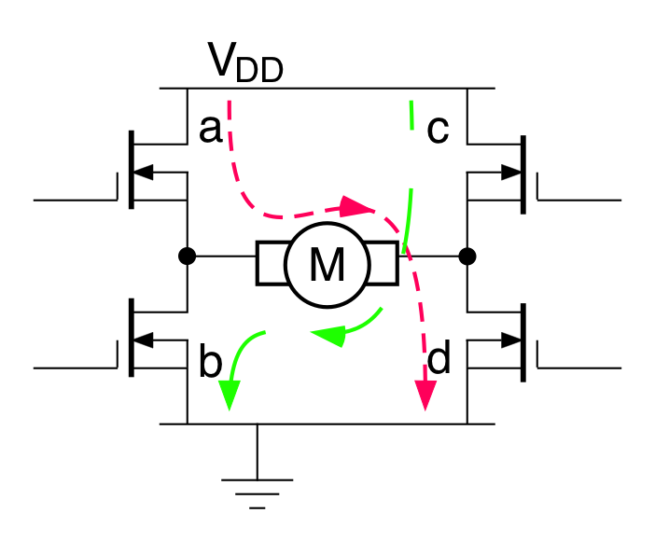Figure 1 H-Bridge
If we turn on transistors a & d but turn off b & c then current will follow the short-dashed red path from V_{DD} to ground. The current will flow from left-to-right through the motor and it will turn in the clockwise direction.
If we turn off a & d and then turn on b & c then current will follow the long-dashed green path. In this case current still flows from V_{DD} to ground but now it passes through the motor from right-to-left and the motor turns in the counter-clockwise direction.
If we turn a & c off and b & d on or vice versa then we place a short across the motor and it stops quickly. If we turn all the FETs off then the motor coasts to a stop and we had probably better have free-wheeling diode across all of the FETs to protect them. We must NEVER turn a & b or c & d on at the same time. If we do then all the current that the power supply can generate will flow through the two series FETs, almost certainly melting them and destroying them.
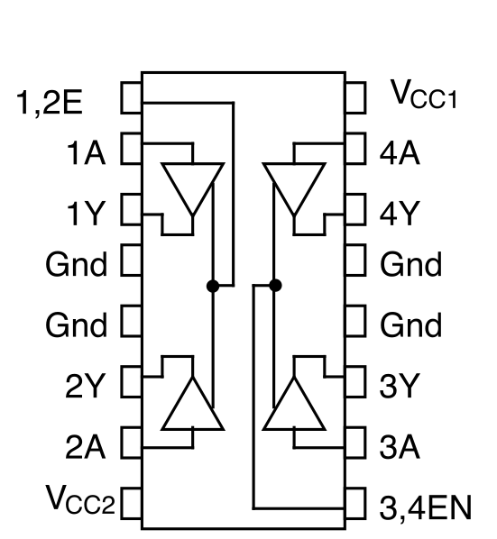
Figure 2 L293D

NOTE when used to switch an inductive load, like a motor coil, we have to add "free-wheeling" diodes to dump the inductive current spikes, generated when the coil current is interrupted, into the power and ground lines.
At the cost of four transistors we have built a circuit that drive current in either direction through the motor even though we only have one polarity of power supply. The problem is that it is now hard to turn on the upper two transistors, a & c. Their sources are not at ground and so they must either be PFETs or use special gate-driver circuits. Fortunately, there are a lot of complete H-bridge systems available in single chips with all of the gate drive circuits built in. Most such ICs also have circuitry to make it impossible to turn on the FETs in one of the forbidden modes.

The L293
One such common bridge chip is the L293D (Figure 2) made by Texas Instruments. This contains two full H-bridge circuits with free-wheeling diodes built-in. Each bridge can switch up to 1A at up to 36V with logic inputs as low as 0-3.3 V, though it will need significant heat-sinking for high power loads.
The four ground pins near the center of the chip not only carry the full motor current but also conduct heat out of the chip. For moderate loads they may provide enough heat-sinking for the whole chip. They work best when soldered into a printed circuit board.
There are two separate power supplies. V_{CC1} supplies the logic part of the chip and is usually connected to the 5V power from the computer. VCC2 is the power supply for the motor. It can be as large as 36V and must be able to supply the current for whatever loads we are switching. For this lab we can get away with the 5V power supply on our Digi-Designer.
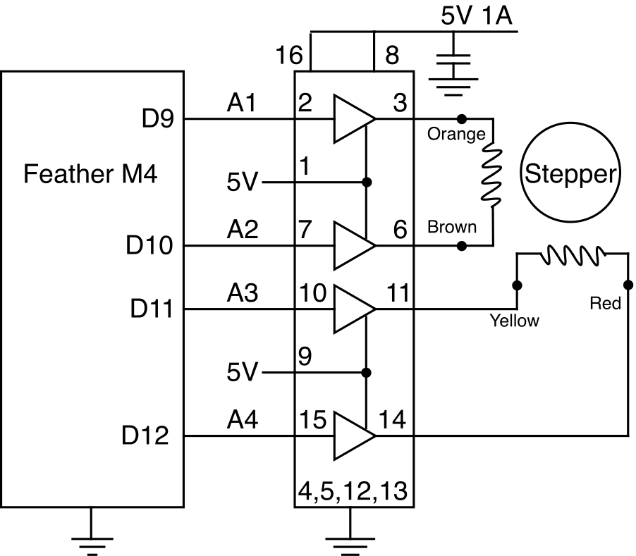Figure 3 Driving a Stepper with an L293D
A stepper motor has two coils that need to be turned on and off in sequence and in both directions. This means that we need two H-bridges to drive a single stepper motor so that a single L293D makes a good simple stepper driver so long as the stepper motor is well matched to the power supply, as there is no easy way to control the coil current.

Task 1
Build the circuit of Figure 3. Your stepper motor has a female connector but you will find that our regular wires will fit nicely into the sockets of the connector and allow you to connect the coils to the board.
NOTE: You need to make sure that you connect the four wires going to the stepper as shown, one coil to pins 3 & 6 and the other to pins 11 & 14. You can check the resistance with a multimeter to make sure you get it right.

Task 2
Step | Coil A | Coil B
1 | + | +
2 | + | -
3 | - | -
4 | - | +
1 | + | +
Table 1 Normal Stepper Sequence

There are several sequences of inputs that will drive the motor. The simplest turns one coil on at a time following the sequence of Table 1 on the left. You will need to put a short delay between each step. 10 ms is a good place to start.
Table 1 shows the normal stepping sequence. If you work through the rows from top to bottom the motor will turn in one direction. If work through the rows from bottom to top then it will turn in the opposite direction.
The entries in the Coil columns show the direction of current flow in each coil. You need to translate this into values of A1, A2, B1, & B3 to send to the motor.

a) Write a program to generate such a sequence and verify that you can drive the stepper motor in either direction. Demonstrate your motor to me and paste your commented program below.
# Author: Ben Kallus
# Spins a motor.

import board
from digitalio import DigitalInOut, Direction
from time import sleep

DELAY = .0025

def main():
A1 = DigitalInOut(board.D9)
A1.direction = Direction.OUTPUT
A2 = DigitalInOut(board.D10)
A2.direction = Direction.OUTPUT
A3 = DigitalInOut(board.D11)
A3.direction = Direction.OUTPUT
A4 = DigitalInOut(board.D12)
A4.direction = Direction.OUTPUT

A3.value = True
A4.value = False
while True:
A1.value = True
A2.value = False
sleep(DELAY)
A3.value = False
A4.value = True
sleep(DELAY)
A1.value = False
A2.value = True
sleep(DELAY)
A3.value = True
A4.value = False
sleep(DELAY)

main()

b) Experiment with the length of the delay to find the maximum speed at which your motor will turn. Give the maximum speed in rotations per second and describe how you measured that speed.
The smallest delay between states I can get to work is 1.6 ms. Any lower than that, and the motor just vibrates.
Thus, the motor is running at 1.6 * 200 = 320 ms / rotation = 3.125 rotations per second.

Task 3: A Better Way
A simple dual H-bridge like the L293D is a very versatile component but it is not the most convenient way to drive a stepper motor. First, there is no simple way to control the current in the motor so the power supply must be carefully matched to the motor. Second, a change in stepping pattern requires reprogramming the computer. The popularity of 3-D printers and small stepper-driven machine tools such as laser engravers has resulted in a flood of easy-to-use stepper drivers appearing on the market. These interface to the computer through two wires, Step and Direction, and incorporate current limiting for the motor as well as a choice of stepping pattern. In addition to the standard pattern these offer patterns that further divide each step into microsteps, as many as 32 microsteps per full-step being common.
Figure 4 shows the layout of the popular DRV8825 stepper-driver board, which is pin compatible with several other such driver boards. The actual driver chip is hidden under the silvery heat-sink visible in the bottom half of the board. With the heat-sink, the chip can drive more than 1A per coil from motor supply voltages as high as 48 V. If you add a cooling fan then the current can reach about twice that. Like the L293D, the DRV8825 operates with two separate power domains. The logic signals and the ground on the lower right lie in one domain that operates on 0-3.3 V or 2-5 V. The outputs, A1, A2, B1, & B2, (sorry; the two chips use the same names for different functions) and the top right Vmot and Gnd pins form the second domain that can use up to 48 V. As shown, the pin names are actually printed on the bottom of the chip, but that is not very much use when wiring the thing!
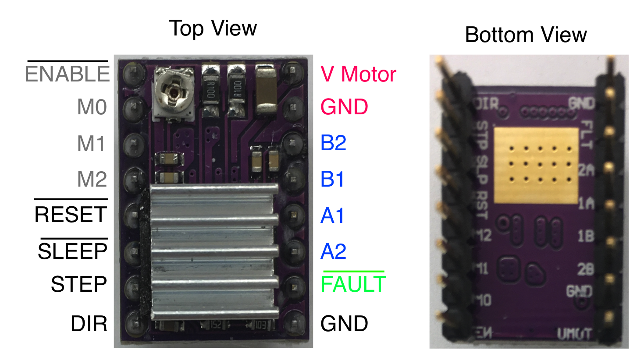Figure 4 DRV8825 Stepper-driver
The little silvery circular component just below the T of “Top View” is a variable resistor that sets the maximum current that will flow through the motor. The chip uses PWM to limit this current independently of the power supply voltage. This makes it much more flexible.
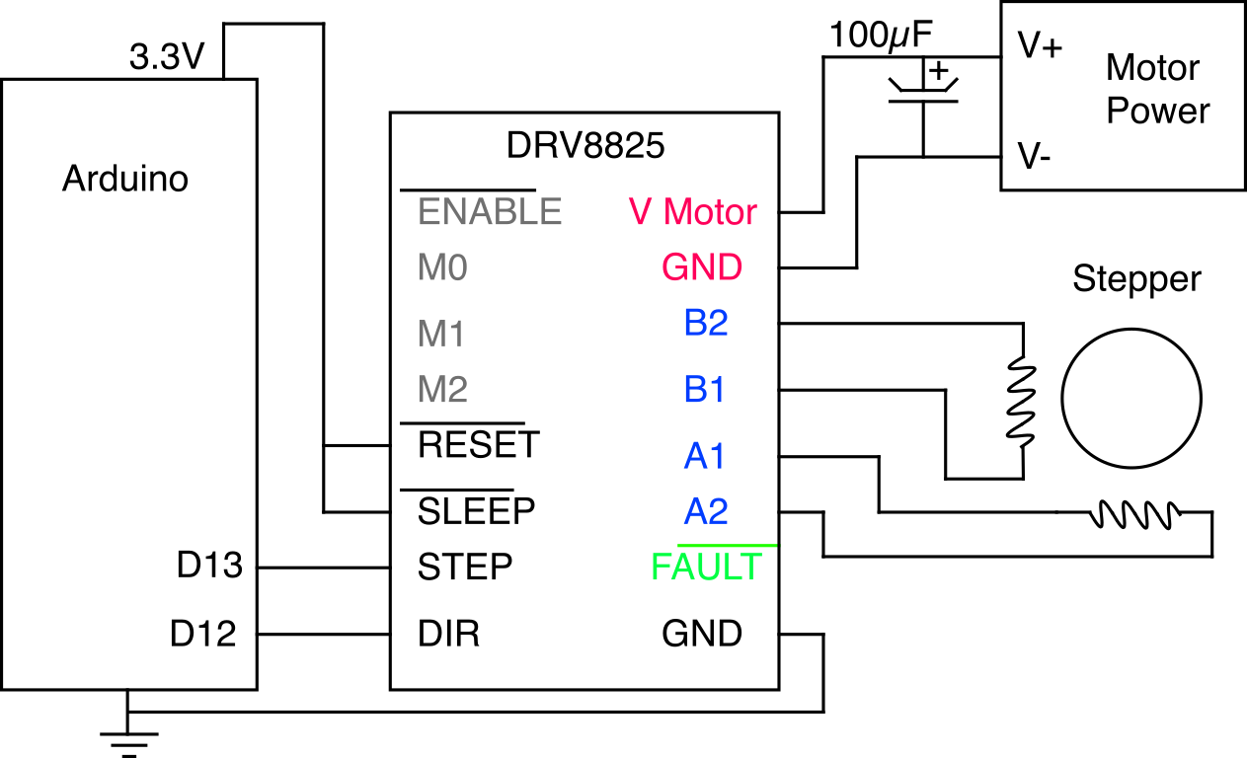Figure 5 Driving Stepper w/ DRV8825

a) Rebuild your stepper motor system using your DRV8830 driver following the circuit of Figure 5. We have to tie the RESET and SLEEP pins high to allow the chip to operate and we are going to ignore the FAULT output. The ENABLE pin can be left unconnected because it has a pull-down resistor on the board. This time you will want to pull the motor power from the +15 V supply on your Digi-Designer because the chip signals an error for motor supply voltages less than about 8.5 V. All the grounds get connected together.
b) Rewrite your program and verify that you can spin the motor in both directions. Paste the new, commented, program below.
# Author: Ben Kallus
# Spins a motor.

import board
from digitalio import DigitalInOut, Direction
from time import sleep

DELAY = .0006

def main():
STEP = DigitalInOut(board.D13)
STEP.direction = Direction.OUTPUT
DIR = DigitalInOut(board.D12)
DIR.direction = Direction.OUTPUT

DIR.value = True
while True:
STEP.value = not STEP.value
sleep(DELAY)

main()

c) Is the top speed still the same? If not discuss why this might have changed.
The new top speed is faster. This could be because the motor driver board is capable of changing states faster than the Feather’s digital pins.

Task 4
We have so far ignored the pins M0-M2. These control the stepping sequence used by the motor. Tape a small flag onto the output shaft of your stepper to monitor its position accurately. Demonstrate that it takes 200 steps to produce one 360° rotation of the shaft.
a) Now connect pin M0 to the 3.3V logic supply from the your Feather. How many steps does it now take to complete one 360° rotation?
It took 400 steps to complete a full rotation.

b) Explore the other possible settings for the three M inputs, which have pull-down resistors built in so that they are at logic 0 unless pulled high externally. Include a table describing your findings along with your description below.
M0 M1 M2 Steps/Rotation
0 0 0 200
1 0 0 400
0 1 0 800
0 0 1 3200
1 1 0 1600
1 0 1 6400
0 1 1 6400
1 1 1 6400

