It is about time you acquainted yourselves with real digital logic and so we will first get a feel for actual 74HCxx series logic chips and then try designing and building something.
Here are the design rules for 74HCxx chips:
1) The chips require +5V power and ground connections to operate at all. These connections are NOT normally shown on circuit diagrams!
2) The chips come in plastic DIP packages. DIP stands for Dual-In-Line Package and refers to the way the package has two sets of leads, one line down each side of the package. +5V Power is almost always applied to the highest numbered pin on the package and ground is always at the half-way point—diagonally opposite power. You can recognize pin 1 by the cut-out or dimple at end of the plastic package.
3) The inputs are MOSFET inputs and so draw no current (<1µA is the specification) except during switching. The outputs are saturated MOSFETs, connected either to ground or to 5V and can source or sink up to 25mA.
4) The normal output voltages are +4.9V for a high output and +0.1V for a low output (with 5V power supply).
5) Any voltage <1.35V will be recognized as a low level at the input. Any voltage above 3.7V will be recognized as a high level at an input. Voltages between those two levels will result in unpredictable outputs and will lead to excessive current draw as both n- and p- channel output FETs turn partially on. In practice, this simply means that you can connect outputs to inputs and be sure that they will work just fine.
6) All CMOS integrated circuits are at risk from static charges. Although 74HC series logic circuits incorporate protection circuitry, they require a little care in handling. Basically you store them in conductive containers, such as conductive black foam, and you don’t put them down on insulating surfaces. Always touch the foam before picking the device up and insert it straight into your breadboard. When you are done with a device put it back into the foam. Don’t leave it lying around on the bench top.

Part 1: Familiarization
We’ll start with a simple exercise to give you a feeling for working with the chips and to see the truth tables in action. Use the row of switches along the bottom of your breadboard to generate input signals and connect outputs to the row of LEDs in the top right.
a) First fill in what you expect to be the truth table of a NOR gate.
Prediction Table
A | B | Out
0 | 0 | 1
0 | 1 | 0
1 | 0 | 0
1 | 1 | 0
Now take a 74HC02 quad 2-input NOR gate and connect up one of the gates as shown on the left (remembering power and ground!).

b) By trying all the inputs and noting the output, fill in the table below.
Measured Table
A | B | A+B
0 | 0 | 1
0 | 1 | 0
1 | 0 | 0
1 | 1 | 0

c) Does your 74HC02 indeed implement the NOR function?
Yes.

NAND
Now let’s do the same thing for a NAND gate.
d) Again, start by filling in the truth table that you expect.
Predict
A | B | A&B
0 | 0 | 1
0 | 1 | 1
1 | 0 | 1
1 | 1 | 0

Take a 74HC00 quad 2-input NAND gate and connect up one of the gates, as you did for the 7402 in the previous section.
NOTE: The gate pin-outs are reversed from the previous chip. Each chip is different and you have to be careful! For the future, the pin-outs are on the table sheet with the resistor color code. Get used to looking them up.
e) By trying all the inputs and noting the output, fill in the truth table below.
A | B | A&B
0 | 0 | 1
0 | 1 | 1
1 | 0 | 1
1 | 1 | 0

f) Does this indeed implement the NAND function?
Yes.

Part 2: Combinatorial Logic

2-4 line demultiplexer
Wire up one half of a ‘139 dual 2-line to 4-line decoder (the pin diagram is in the datasheet and on the table sheet) and demonstrate its behavior.
Connect two of the switches on your breadboard to the A and B inputs of the ‘139 and ground the enable input (G) so that the device operates. Connect the outputs to four of the LEDs on your breadboard. Show that you can control which LED turns off by selecting its number on the switches.
a) Draw your circuit and describe its behavior. Draw it as a circuit diagram not a picture of the circuit and include all non-power connections. You should base your diagram on the little boxes representation of the decoder that is used in the data sheet. Arrange inputs on the left and outputs on the right and label each pin with its name and number. Think about how I drew the circuit for part 1a. There is nothing there about the shape of the chip, just the gate symbol, the pin numbers, and where things are connected. The symbol for the decoder is just a rectangle with 2 inputs on the left edge and 4 outputs on the right.

b) Fill in the truth table for the ‘139 as you have just observed it. (Yes, I know that you need 8 rows to handle 3 inputs fully but, as the data sheet shows, this is a special case that can be shortened with the use of the x marker that stands for any value of input.) Please be careful with the order of the inputs and outputs!!!
Inputs |  |  | Outputs
G | B | A | Y3 | Y2 | Y1 | Y0
1 | X | X | 1 | 1 | 1 | 1
0 | 0 | 0 | 1 | 1 | 1 | 0
0 | 0 | 1 | 1 | 1 | 0 | 1
0 | 1 | 0 | 1 | 0 | 1 | 1
0 | 1 | 1 | 0 | 1 | 1 | 1

Circuit Design
c) Use the product of sums technique to find a set of four separate logic equations that will implement that part of the truth table which has G = 0. You only need 2 inputs, A and B.
Y0 = A OR B
Y1 = (NOT A) OR B
Y2 = A OR (NOT B)
Y3 = (NOT A) OR (NOT B)

d) Use De Morgan's theorems to design and draw a circuit using only NAND, and NOT gates to implement those equations. Note that it should look little or nothing like the logic diagram given on the data sheet! Again, the figure from part 1a and the figures in the chapter are a guide to what we want.
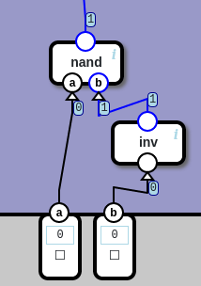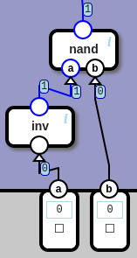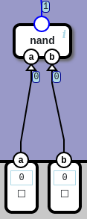Y0 Y1 Y2 Y3 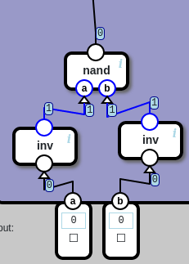

e) Build and test the circuit. Describe its operation and any problems you experience.
The circuit reads the binary number obtained by concatenating B with A, and turns off the corresponding LED.

Part 3: If Time Permits
With a little thought, or some reading, you should be able to use both sections of the ‘139 to construct a 3-line-to-8-line decoder. Build this circuit. (Hint. You will need to use 1 extra gate.) Test it by connecting its eight outputs to the 8 LEDs on your Designer.
a) Draw the circuit.

b) Describe in words what the circuit does and explain how the G input made it possible.

