Modeling Digital Circuits
Real-world digital circuits drove many of you to distraction with the complexity of their wiring. Circuit simulation provides us with some tidier ways of playing with digital circuits. We are going to explore two kinds of digital simulation during the second half of the semester. The first kind is based on drawing schematic diagrams of circuits, in exactly the same way as we have been simulation analog circuits. The second method, which is much more powerful, will involve learning a (small) new programming language called Verilog, which is one of a family of languages called Hardware Description Languages or HDLs. I hope that we will get chance to do a lab or two on that.

Digital Modeling and Eagle
Eagle, or rather the ngspice engine upon which Eagle’s simulation is based, treats the digital world as completely separate from the analog world. Digital models leave out such real-world necessities as power supplies and voltages that actually take on a range of values. It deals directly with gates and binary signals.
Eagle provides us with models for NOT and BUF (the digital buffer whose output is the same as its input), for 2-input AND, NAND, OR, NOR, and XOR (but not XNOR, if you want that you have to make it yourself) as well as some multi-input gates and both D-type and JK flip-flops. It also provides us with the model equivalent of switches for inputs and generators of clocks and more complex signals. Note that you CANNOT mix digital and analog signals without special converters, so you cannot set a digital input to 0 by wiring it to GND as you would do on a breadboard.
Start by watching Eagle Digital Tutorial #1, that will lead you through making a digital source and using it to test the built-in NOT gate.

Exercise 1
Build your own model that uses two single-bit digital inputs to demonstrate the behavior of an XOR gate. Hint: make one of your digital sources change at half the speed of the other.
a) Paste a screenshot of your model below.
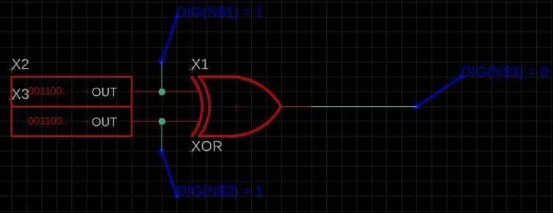

b) Then, paste a screenshot of the output below and write a short explanation of how the plot illustrates the XOR function.
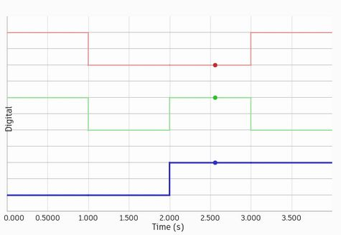
The plot illustrates XOR because the bottom line (indicating output) is high only when the input lines are in differing states.

Multi-bit Digital Sources
While single-bit digital sources remain extremely useful for generating clocks for sequential circuits, combinatorial circuits normally want several related inputs and so need multi-bit digital sources. Eagle gives us 4-bit and 8-bit sources so there are limits to the complexity of circuits that we can simulate this way. But that is not really a problem. You would not want to have to draw schematics for anything more complicated—such things are better left to Verilog.
Watch Eagle Digital Tutorial #2 to learn how to create the most common 4-bit digital source, a 4-bit counting sequence. You will see it used to test a 4-bit priority encoder following the design of Table 14.4 on page 14-7 of the Electronics book. You will use digital sources a lot in the rest of this lab and the next one.

Exercise 2
I want you to use the top 2-bits of such a source to test a 2-line to 4-line decoder based on your design from Lab 16. In particular, I want you to use the original product-of-sums form of the decoder equations to build your model using OR and NOT gates, not the converted form that you built during the lab with NAND and NOT gates.
a) Paste a screenshot of your schematic below.
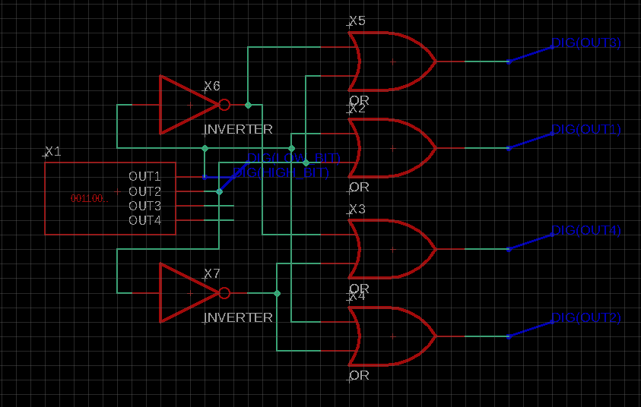
b) Then paste a screenshot of your simulation below and describe how it demonstrates the 2-line to 4-line behavior.

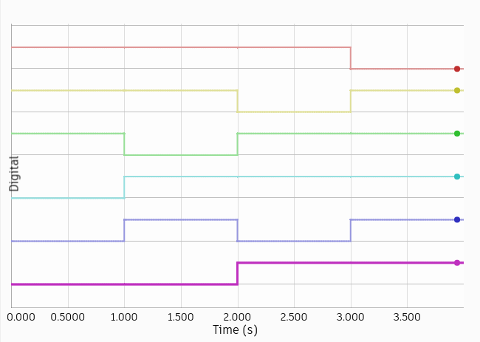
The circuit implements the following equations:
OUT1 = HIGH_BIT OR LOW_BIT (low only at 0 0)
OUT2 = HIGH_BIT OR (NOT LOW_BIT) (low only at 0 1)
OUT3 = (NOT HIGH_BIT) OR LOW_BIT (low only at 1 0)
OUT4 = (NOT HIGH_BIT) OR (NOT LOW_BIT) (low only at 1 1)
From the top down, the lines in the plot are OUT4, OUT3, OUT2, OUT1, LOW_BIT, HIGH_BIT

Arithmetic Circuits in Eagle
In Chapter 14 of the Electronics text you read about digital circuits to perform binary arithmetic. These were too complicated and needed too many different kinds of gate for us to explore in the real-life labs. However, they are very accessible to us in simulation. I want you to work your way up to testing the 2-bit adder that featured in problem 14.1.

Exercise 3
Make a copy of your XOR lab and convert it into a system to test a half-adder as described in Chapter 14.
a) Paste a screenshot of your circuit below.
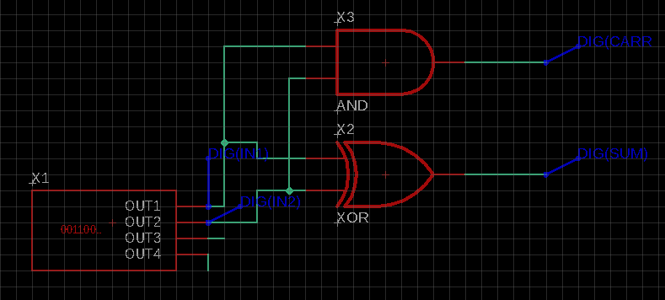

b) Paste a screenshot of the output of your simulation below and describe how the behavior is suitable for adding two single-bit binary numbers.

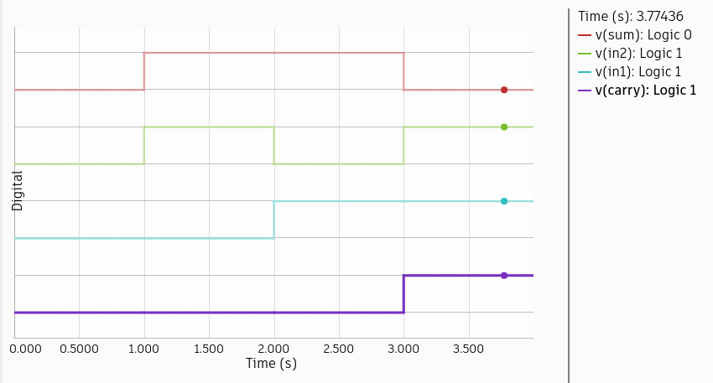
The output of the AND gate is high only when both inputs are high. Thus, this output is a suitable carry output, because we only need to carry when both inputs are 1.
The output of the XOR gate is high only when the inputs differ. Thus, this output is a suitable sum output, because we want the sum output to be high when exactly one input is high.

Exercise 4
Starting from a copy of your half-adder I now want you to build and test a full-adder, which you remember from Chapter 14 is made up from two half adders and an OR gate.
a) As usual, paste the screenshot of your completed full-adder circuit below.
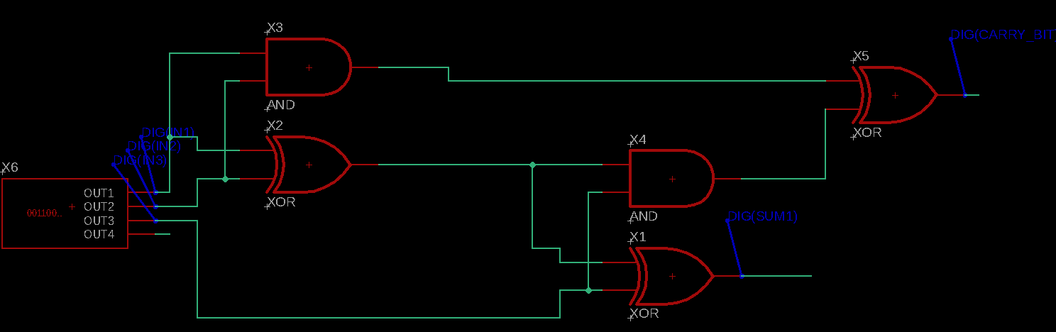

b) Paste below the output of a plot demonstrating that your full adder can correctly add three single-digit binary numbers (eight possible combinations).
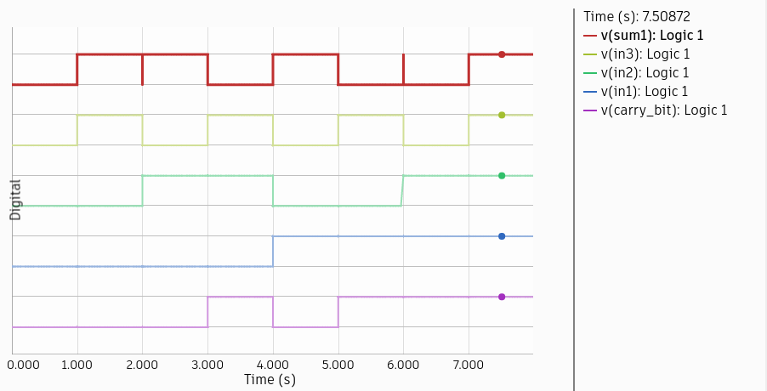

The full-adder is powerful and common enough to make available as a building-block. One does not come with Spice but I have provided a new library containing it and several other useful circuits that we will use in the next Eagle lab. Here’s how to install it.
- Close Eagle.
- Find the Eagle library folder. It should be inside the Eagle folder in your Documents folder unless you have told Eagle otherwise.
- Download the Phy245lib.lbr file and put it into the Eagle library folder.
- Launch Eagle and check that the library is visible.
It should show up like this
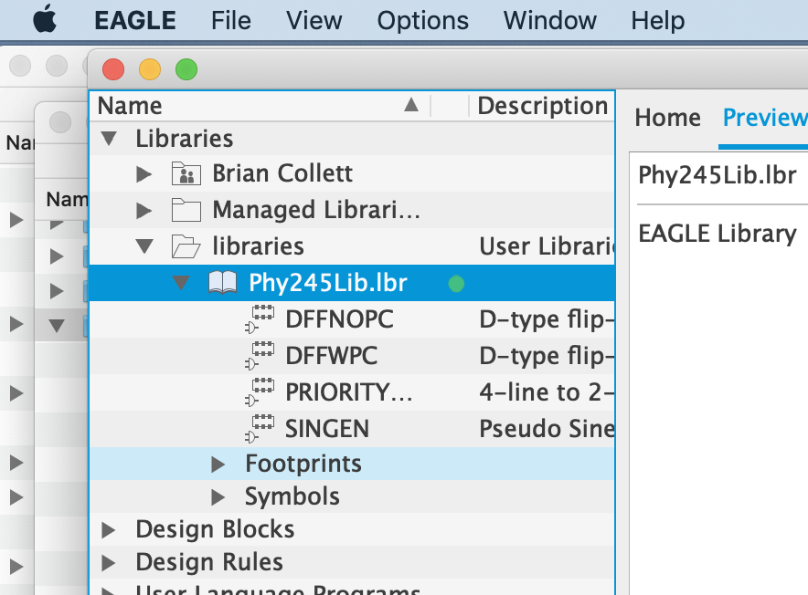

Exercise 5
I want you to use two full adders to construct and test a simulation of a 2-bit binary adder, just like the one you met in problem 14.1 and similar to the 4-bit adder in figure 14.4. I should warn you that, while getting it to work is not very difficult, showing that it does what you expect will be a little more challenging.
a) Paste a copy of your schematic below.
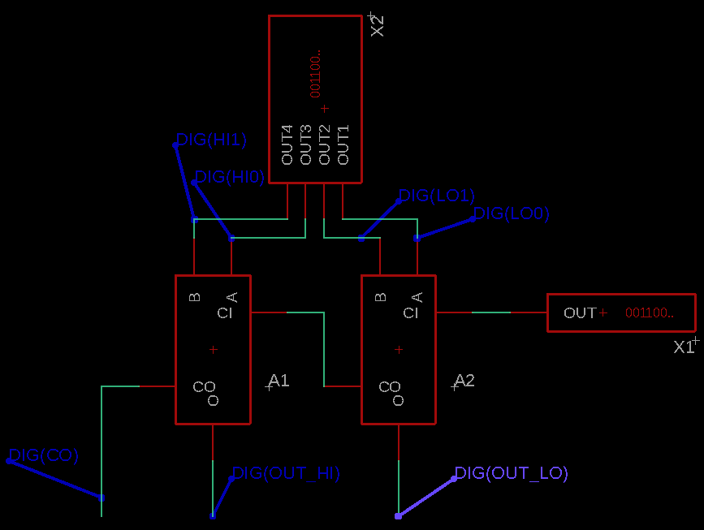

Test your circuit by feeding it all 16 possible combinations of two 2-bit input numbers and demonstrating that it outputs the correct sum.
b) Paste your simulation plot below and either annotate the plot (see below) to show the correct summations or explain the plot in sufficient detail to demonstrate the correct summations.
NOTE: because of the gate delays that are included in the simulation there will be short glitch states every time the input changes. During these few ns the outputs will be incorrect. You do not need to explain these glitches, just account for the steady states. You may find that you need to increase the number of points in the simulation. I usually set # Points to at least 1000 and Max # Points to 4000.

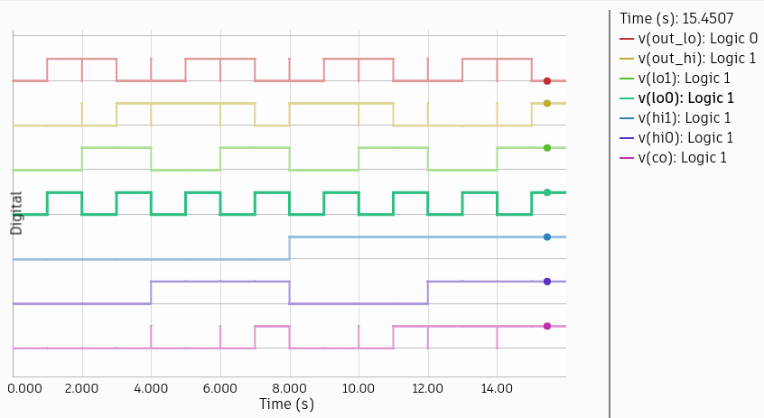When all inputs are 0 except for one of {lo0, lo1}, then out_lo=1, out_hi=0, and co=0.
When both lo0 and lo1 are 1, and all other inputs are 0, then out_lo=0, out_hi=1, and co=0.
When exactly one of {lo0, lo1} is 1, and exactly one of {hi0, hi1} is 1, and the rest of the inputs are 0, then out_lo=out_hi=1, and co=0.
When both hi0 and hi1 are 1, and all other inputs are 0, then out_lo=out_hi=0, and co=1.
When lo0, lo1, and exactly one of {hi0, hi1} are 1, and all other inputs are 0, then out_lo=out_hi=0 and co=1.
When hi0, hi1, and exactly one of {lo0, lo1} are 1, and all other inputs are 0, then out_lo=1, out_hi=0, and co=1.
When all inputs are 1, out_lo=0, and out_hi=co=1.

Thus, this 2-bit adder treats {lo0, lo1} as its least significant input bits, and {hi0, hi1} as its most significant input bits.

