Lab 21:Serial Communications
Earlier in the semester you used the print and input routines to communicate between the Serial console of Mu and your Feather board. It is now time to look into the details of how serial communication works.
As you read in the chapter, serial communication uses thee wires; ground and two signal wires. While the underlying SAM chip support serial I/O on several sets of pins, the Feather board comes with one pair marked for this use as Rx and Tx and CircuitPython supports them by default.
Because the signal levels that the computer chip uses are low voltage (0 and 3.3V) and can have problems with noise when carried over long wires, we connect our microcontrollers to the PC using the RS-232 communications standard. For us, this means connecting our Feather board to a small adapter board with a 9-pin socket (called a DB-9 socket) on it.
You need to connect the four lines on the DB-9 board to power and the UART pins on the LaunchPad. The 3.3V and Gnd are nicely labelled but the other two pins need to be connected E:0 to TX and E:1 to RX.

Part A: Testing
Our desktop PCs did not come with built-in serial ports so we have to use USB-Serial adapters. If you look on the back of your PC you should see a white USB-Serial cable coming from one of the USB parts and connected to a DB-9 cable. It will have connectors like those in the figure below. You will use the male connector to plug into your serial adapter.
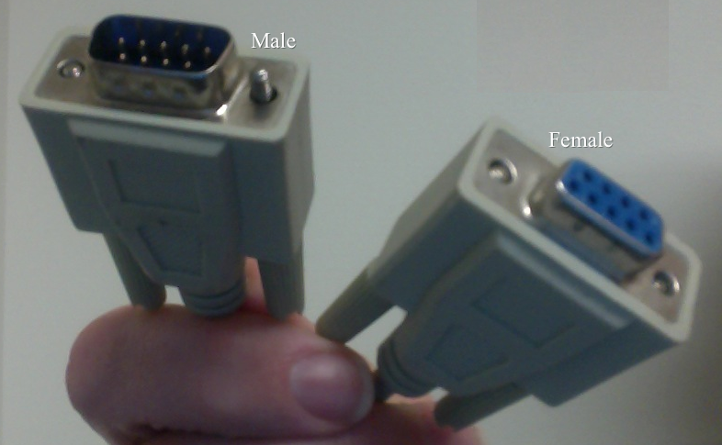
The problem with USB-Serial adapters is that we don't know what name Windows pick for them. The first time that you use a new Feather board with a computer you will have to run a test to find the name.
I suggest doing this with the Energia application that is left on your computers from last year.
- Start with the white USB plug removed.
- From the desktop or the Windows Start menu launch Energia.
- From the Tools menu select Port and memorize or write down the list of names that you find there. They will bf the form COM<n>, where <n> is a smallish number.
- Let the menu close.
- Plug in your white USB connector.
- Again use the Tools|Port to list the available ports. There should be a new one. If not contact me!
- The new port is the one that you want to use to talk to the Feather UART.
Alternatively, if you have Anaconda installed, then this will work
- Start with the white USB plug removed.
- In the Windows Start menu expand the Anaconda section by clicking on the down arrow and select Anaconda Prompt.
- In the resulting window type
python -m serial.tools.list_ports
- and you should get a short list of port names, each of the form COM<number>. Note which ones are present.
- Plug in the white cord. Wait for the bingle-bongle noise and then run the python command again. There should be a new entry. That is the name of your new serial port.
We cannot use Mu to talk to this port because it automagically connects to the Feather USB port. Instead we will use a program called Putty-Tel that you should find either on the desktop of your PC or in the Start menu. When you start the program you will get a dialog like this
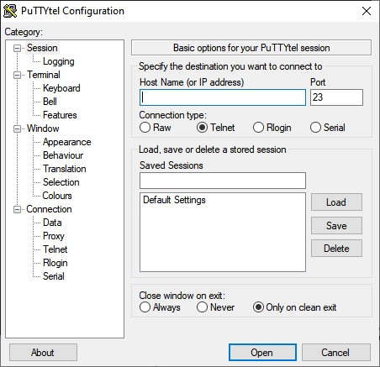
This program supports several kinds of communication so we need to click the Serial button to select the right kind. That will change the meaning of the boxes on the line above giving you the following dialog.
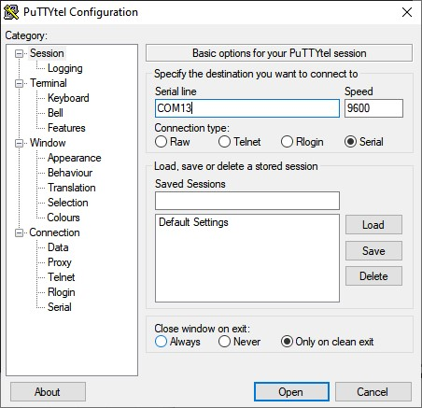
Edit the contents of the Serial line box to match the name that you found earlier. You can leave the Speed set to 9600 for now and should then click Open, which should bring up a blank window.
Once everything is connected you can open Mu, type in, and run the following very short program.
import board
import busio
ser = busio.UART(board.TX, board.RX) # Uses default 9600 Baud
while True:
ser.write(b'Success!')
You should see the Putty-Tel window fill up with Success lines. If you do not then seek help at once.
NOTE: I switched from using the default board.UART() function because you might want to use the timeout keyword argument later on.

Part B: Looking at the Signals
Now the DB-9 card is connected it is time to look at the signals on the DB-9. First unplug the cable to your computer. Then look very carefully at the surface of the plug and you will see that there are very small numbers moulded into the plastic. These are the pin numbers. The two data lines are pins 2 and 3. Probe these two pins with your oscilloscope and the special adapter pin that I have given you.
1) Which pin carries data into the Feather board and which carries it out.
Pin 2 carries data out of the feather, and pin 3 carries data into the feather.
2) How did you decide this?
I decided this by attaching the oscilloscope to pins 2 and 3, then sending a message over serial. Pins 2 went high when the message sent, and pin 3 did not change.

Part C: Looking at transmission
Now we want to look at the signals that travel over the serial line during communication. These signals are so fast that you will need your oscilloscope to watch them. However, in normal operation the signals change too rapidly and go away too fast for you to be able to see much. In order to give a nice stable oscilloscope display we need to have a signal that repeats continuously. You will need to write a program to produce this signal.
Now create a CircuitPython program that initializes the serial port and then sits in an infinite loop sending the characters ‘Z’ and ‘0’ (that is a numeral) one after another and then waiting 5mS before repeating. You will find it a good idea to insert a short delay, about 2mS, between the first character and the second. Here is a pseudo-code version.
- Initialize Serial at 9600 baud
- Send ‘Z’ to Serial7
- Wait 2mS
- Send ‘0’ to Serial7
- Wait 5mS
- Goto 2
I will remind you that the book points out that the serial methods take byte strings as arguments so that you will need to say b'Z' to generate a letter 'Z'.
- Run your program and look at the voltage on the data output line of the serial port with your oscilloscope. Paste an image below and then answer questions.
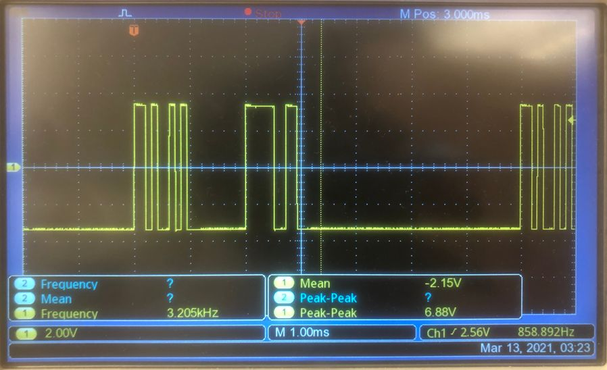
- What are the ASCII codes for ‘Z’ and ‘0’ (give them in binary)?
‘Z’ is 90 and ‘0’ is 48.
- What voltage corresponds to binary 1 and what to binary 0?
3.3V corresponds to 0 and -3.3V corresponds to 1.
- Does this agree with the RS-232 specification (justify by reference to the spec!)?
Yes, since the RS-232 spec specifies that 0 corresponds to 3V to 15V, and 1 corresponds to -3V to -15V.
- Draw a picture of the voltage pattern for the character 'Z', label it as follows, take a picture and paste that picture in the box below. Label your graph to show the start and stop bits. Put these labels below the line on the graph.Label your graph to show the individual bits that make up the character. Put these labels above the line.
This is going to mean importing your figure into e.g. Paint to add the labels.
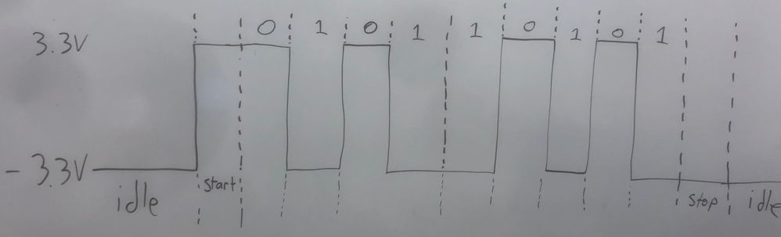
- Are the characters sent most significant bit first or least significant bit first? How did you decide?
The least significant bit is sent first. This is evident from the output for ‘0’, which is many 0s, a few 1s, and a few 0s. Since 0’s ASCII value is 90 = 00110000₂, we can tell that the bits are sent in reverse order.
- How many bits are sent per character (excluding the start and stop bits)?
8
- How long does each single bit last?
Each bit lasts 0.1ms.
- Explain whether this is consistent with the expected baud rate of 9600 Baud.
This is consistent with the expected baud rate, since 1/9600 is pretty close to 1/10000.

Part D: PC-to-Feather Link
Now it is time to do something with the serial link. Start by reconnecting the serial cable from your PC.
Our aim is to have a program that will allow you to command your Feather board to do various things from the PC running PuTTyTel. I am going to leave some of this to your imagination but I will get you started.
1) Make a program initialize Serial and just sit in a loop reading characters and echoing them back to the terminal. Paste your program below once it works.
You can read a single character with ser.read(1) but be aware that it will not wait for you to type characters but will return None if it does not find a character waiting. You can can either test for None or experiment with passing the timeout keyword argument to the UART() function.
# Author: Ben Kallus
# Reads from the UART, echos what it reads.
import board
from busio import UART
from time import sleep

ser = UART(board.TX, board.RX)
while True:
char = ser.read(1)
if char is not None:
print(chr(char[0]), end="")

2) Use conditional statements (if’s) to test the characters and give them meanings. For example, the following piece of code will make an ‘A’ turn the LED on (force the bit to a one) and an ‘a’ turn it off. Remember that you will need to make the LED pin into an output first!
if ch == b‘A’:
led.value = 1
elif ch == b'a':
led.value = 0
As the example suggests, remember that the serial read will return a byte string not a regular string, hence the use of e.g. b'A' in the comparison.
3) I would like you to be able to make the LED flash once under computer control. Choose a letter and add code to make that happen.
4) Add at least one other command of your design to the program and test the whole thing. Once it works, make sure that you have put your name and a really good header comment in and then paste the program below. NOTE that this is very similar to what you did in one of the first labs except that now the communication is going through the serial adapter.
# Author: Ben Kallus
# Flashes a neopixel based on input from serial.

import board
from digitalio import DigitalInOut, Direction
from busio import UART
from time import sleep
from neopixel import NeoPixel

red_led = DigitalInOut(board.D13)
red_led.direction = Direction.OUTPUT

pixel = NeoPixel(board.NEOPIXEL, 30)
pixel.show()

ser = UART(board.TX, board.RX)

def flash_neopixel(color):
pixel.fill(color)
sleep(1)
pixel.fill((0,0,0))

while True:
char = ser.read(1)
if char == b'f':
red_led.value = True
sleep(.2)
red_led.value = False
elif char == b'r':
flash_neopixel((255,0,0))
elif char == b'g':
flash_neopixel((0,255,0))
elif char == b'b':
flash_neopixel((0,0,255))
elif char == b'w':
flash_neopixel((255,255,255))

