# Ohm’s Law

This is a series of lab exercises. Note that your grade here depends at least as much on what you **write** as how good your results are! You **must** write clear, **detailed**, answers to **every** question in the lab. It is on those answers that I shall be grading you and assessing your understanding. The answers get pasted into the lab and submitted on Blackboard. The completed lab is always due at the start of the following lab, though many people finish during the lab and submit then.

### Part 1: Ohm’s Law

Connect up the circuit shown to the right. You should use the 0-15V positive variable power supply in your Designer as your voltage source, and your two DMMs as your voltmeter and ammeter. The resistor is one of the large white 5 Watt ones.

NOTE: While the voltmeter can be added to any circuit by connecting it between the points of interest the ammeter **must** go in series with the component whose current you wish to measure. **You must break the circuit and insert the ammeter**.

Measure the current at several voltages between 0V and 5V on the voltmeter and plot your results on an I-V curve (I suggest Excel but any tool you want is fine). **Paste** your graph below and answer the following questions in the boxes that follow.

5.01V: 51.4mA

4.05V: 41.4mA

2.99V: 30.6mA

1.99V: 20.4mA

1.00V: 10.1mA

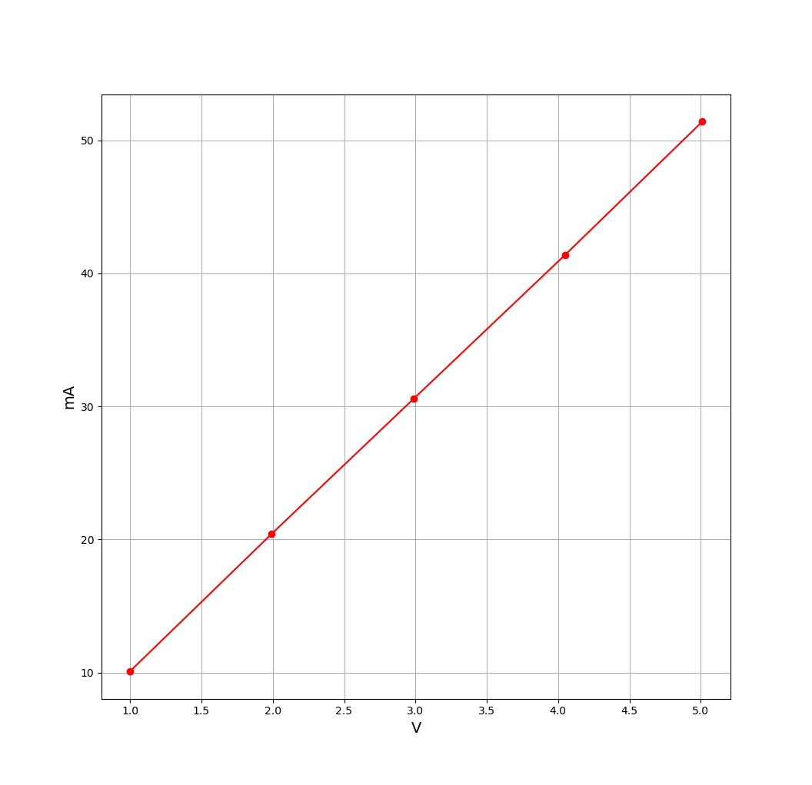

1. Do you get a **straight line**? If so, how straight (**rough** percentage error!)?

Linear regression gives y=-0.134101912+10.27729452x, with a correlation coefficient of 0.9999913434. That is a really straight line, with an error of **roughly** 0%.

b) How does your result in part a) **support or disagree with** Ohm’s law?

My result agrees with Ohm’s law, since it shows a linear relationship between current and voltage.

1. What is the **slope** of your line? (Careful with your units!)

The slope of my line is 10.27729452 mA/V.

1. According to that slope, what is the **value** of the resistor?

The value of the resistor is 0.0973018723998 V/mA = 97.3018723998Ω.

1. Measure the value of the resistor using the Ohms scale of your DMM and **compare** the value marked on the resistor to the slope resistance and to the DMM value with some discussion of the accuracy of each.

NOTE: You *must* remove the resistor from the circuit before connecting it to the DMM. The DMM works by sending a current through the resistor and measuring the voltage. This will be incorrect if the resistor is connected to a circuit.

The DMM reads 98.0Ω. This is .7Ω off from the slope resistance calculated earlier. The DMM’s reading is probably more accurate, since calculating the slope resistance requires using two DMMs, which introduces additional error.

f) Given that your DMM has an input resistance of 10 MΩ when used as a voltmeter and about 5Ω when used as an ammeter, **discuss** whether you will get a better measurement for the resistance from the circuit of figure 1 or from the circuit of figure 2 on the right.

The circuit in figure 1 will give the better measurement, since the current drawn by the voltmeter is negligible, but the voltage drop across the ammeter is 5/105 of the power source’s voltage, which is substantial.

g) **What does this tell you** about the input resistance of a good ammeter and that of a good voltmeter?

A good ammeter has low resistance, since it’s connected in series, and we want it to have as little effect on the circuit as possible. A good voltmeter has high resistance, since we connect it in parallel, so we want as little current as possible to be diverted to the voltmeter.

### Part 2: So much for Ohm’s law

Repeat the measurements using the small light bulb and the circuit on the right. This time I want you to take your measurements in a slightly different way. I want you to take measurements of the voltage across the lightbulb at currents of 0 mA, 5 mA, 10 mA, and so on until you can go no further.

Once again, plot I as a function of V (that is I must be on the y axis and V on the x axis to give an I-V curve). **Paste** your plot below. **Label** your plot to show roughly how bright the light is at various points.

0.01V: 0.2A; no light

0.09V: 5.1A; no light

0.20V: 9.8A; no light

0.60V: 16.1A; no light

1.11V: 20.4A; no light

1.78V: 25.6A; no light

2.48V: 30.4A; a little orange

3.21V: 35.0A; barely glowing orange

5.07V: 45.8A; glowing orange a little more

7.01V: 54.4A; glowing yellow-orange

8.97V: 62.3A; glowing yellow, not bright

10.99V: 69.8A; getting brighter yellow

13.01V: 76.8A; bright yellow

14.08V: 80.5A; bright yellow

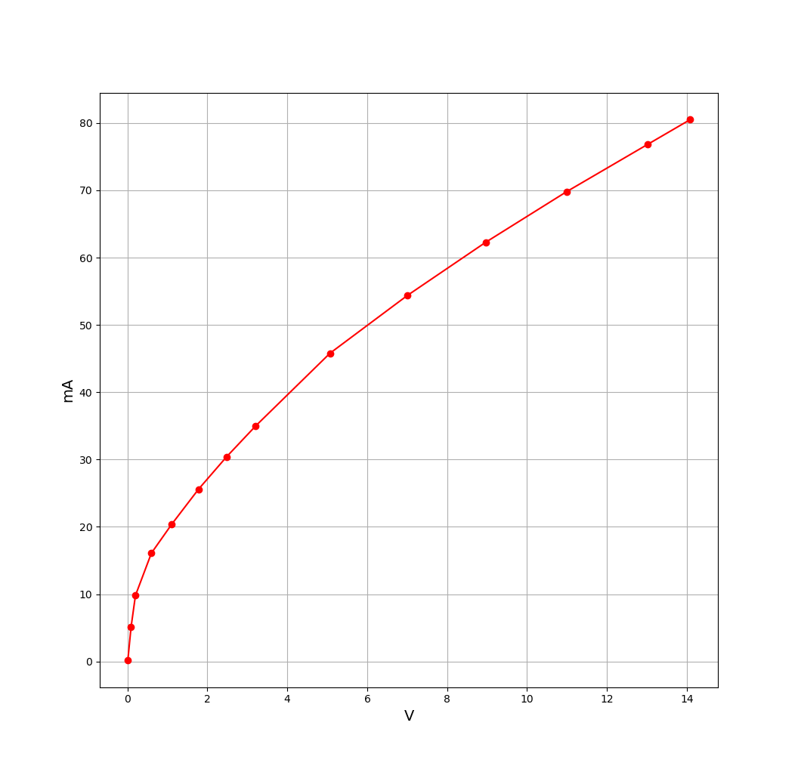

1. **Discuss** whether you get a straight line and what this tells you about the resistance of the light bulb. Does the light bulb have a **single, well-defined resistance**?

This is clearly not a straight line. Thus, the light bulb does not have a single, well-defined resistance.

1. If the bulb does not have a single resistance, **measure** the **slope** **resistance** at various voltages and **discuss** how the resistance of the lamp varies with temperature (NOTE, the brighter the bulb shines, the hotter the wire is).

Between .01V and .09V, the slope resistance of the light bulb is 16.3265Ω.

Between .20V and .60V, the slope resistance of the light bulb is 63.4921Ω.

Between 1.11V and 1.78V, the slope resistance of the light bulb is 128.846Ω.

Between 8.97V and 10.99V, the slope resistance of the light bulb is 269.333Ω.

Thus, as the light bulb’s temperature increases, its resistance increases.

1. **Why** did I make you take data this way?

Beyond 3V, the data appears to be linear, so you wanted us to take more measurements where the data is interesting.

d) Briefly **discuss** what it means for a circuit to be **linear** and **illustrate** your answer with examples from this lab and the last that show either linear or non-linear behavior.

In a linear circuit, there is a direct linear relationship between voltage and current. The first circuit in this lab is a linear circuit.

In a nonlinear circuit, there is a nonlinear relationship between voltage and current. The second circuit in this lab is a nonlinear circuit. This behavior is caused by the variable resistance of the light bulb; as it heats up, its resistance increases. Thus, Ohm’s law predicts that current would increase at a less than linear rate as voltage increases.