Pharmacy
Feature Overview
The Pharmacy Medication feature assists pharmacists in tracking & dispensing prescribed medications. It provides a detailed view of each medication's attributes and the prescribing physician's details. Pharmacists can provide specific instructions and document any discrepancies between the prescribed and dispensed quantities, all within the platform.
Pharmacist Workflow
To use the Pharmacy features, follow these steps:
- Ensure you have an active internet connection and log in to the SPICE platform app using your SPICE account credentials.
- Once logged in, navigate to the 'Dispense' option on the Home page.
- Click on the 'Dispense' option. You will be redirected to the 'Search Patient' page.
- Enter the National ID/Patient ID of the patient in the search bar and click 'Search'.
  - From the search results, select the patient card for the patient in question.
- On the patient's page, you will see parameters such as Program ID, National ID, Prescriber, and Prescriber Number, which are mapped from the medical review. The 'Last Refill Date' shows the last time the medication was refilled. The list of prescribed medications will be displayed in a tabular view. Each entry will show details such as Medication Name, Dosage, Form, Frequency, Prescribed Days, and Days Filled.
- Click on a specific medication to see additional details, such as the date the medication was prescribed and its dosage form. If there are specific instructions for taking the medicine, these will be recorded in the 'Instructions' text box.
- If the 'Days Filled' is less than the 'Prescribed Days', enter the 'Days Filled' value and click 'Done'. A pop-up will appear, asking for the reason for the quantity difference.
- Click on 'Reason' and select the appropriate reason for the quantity discrepancy. After selecting the reason, complete the process.
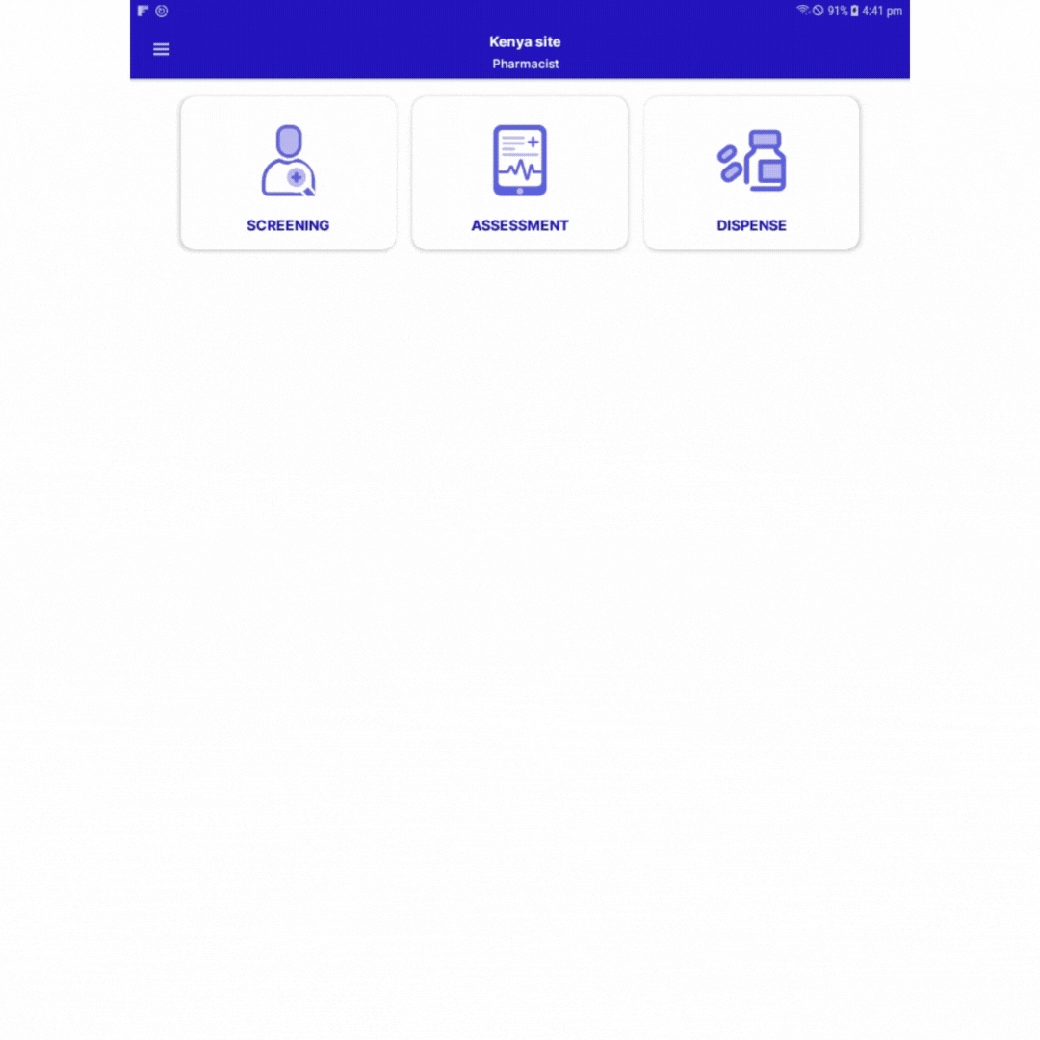
Dispense medication in SPICE

