Roadmap
Roadmap & Upcoming Releases
High-Level Product Roadmap
We build our product roadmap using the "Now, Next, Future" framework to drive our product focus and vision for the future. The below provides our high level roadmap and is no inclusive of all new product enhancements, bug fixes, and feature sets that we will introduce in the next versions. For information on our full product prioritization process, see our Prioritization Framework below.
Now
Next
Future
Ability to import the country geographic data
Automated the previously time-consuming process of loading district, county, and sub-county details into SPICE, enabling bulk uploads of geospatial data via the admin portal.
CHW Performance Monitoring
Peer supervisors can monitor community health workers' performance by viewing daily metrics, including the number of assessments, follow-up visits, and calls completed.
AI Model to predict patient retention
We are building a patient retention model to identify patients that are likely to be lost to follow-up and design interventions within SPICE to engage these patients before they churn.
Upcoming 2.0 Release - Coming September 2024
Our next major open source release will be SPICE 2.0. We are building SPICE 2.0 to be the next generation primary care platform; re-imagining primary care to be data-driven and outcomes focused.
The SPICE 2.0 release will support the following features:
- Algorithm-driven disease pathways for NCDs, TB, Malaria, HIV, ANC, PNC, child health, and immunization
- Closed loop, risk-based follow-up at community and facility levels
- Advanced admin portal features
- Customized dashboards for community & facility performance
- Real-time outcomes tracking by disease area
- FHIR Hybrid Architecture
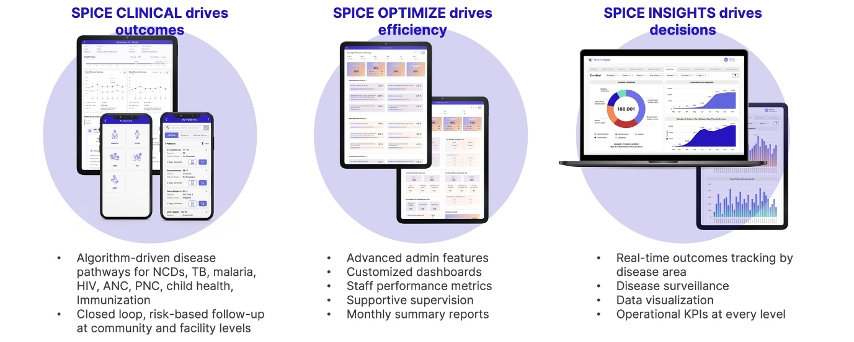
SPICE 2.0 Features
New Feature Requests & Prioritization
Submitting Feature Requests
To submit a new feature request, raise an issue in GitHub in the specific project (Android, Admin Web, Server, FHIR Adapter). To best prioritize the feature requests, we need to understand the why, what, and how of the requests coming from the end users.
Follow the steps below to submit a new feature request:
- Add a descriptive Title summarizing the feature
- Describe the feature with as much detail as possible in the Description field. Include the following details:
  - Problem Statement
  - Priority (Highest, High, Medium, Low)
  - Impacted Users
  - Impacted Workflows
- Tag the issue as a "enhancement" using the labels
- If possible, attach any images to further explain the feature request (screenshots are very helpful!)
Prioritization Process
Medtronic LABS will review all feature requests and issues submitted through the formal channel. In order to prioritize the issues and features, we follow the below process to prioritize new feature requests, enhancements, and bug fixes/issues.
Prioritizing Framework: MoSCoW: Must Have, Should Have, Could Have, Won't Have
Must Have Highest Priority
We genuinely cannot launch without this due to business needs, legal reasons and safety concerns—it would be a terrible idea to launch without this!
Should Have High Priority
It would be best to include these, but our product won’t be an absolute failure without them.
Could Have Medium Priority
Nice-to-haves if we have the resources and time. But not necessary for success. Think of how each requirement (or lack thereof) will affect customer experience.
Won't Have Low Priority
We’ve made an active decision that it’s not coming out with this launch.
Factors that influence the prioritization:
- Value Proposition
- Stakeholder Prioritizations
- Feedback from the end users
- Number of users Impacted
- Product Usage and Adoption metrics
- Patient Outcomes
- Patient Engagement
- Design, Development and Efforts
- Priority of the issue/defect.
We also look at the Value/Effort scale for feature requests.
- The objective is to identify features that will have the highest impact with the lowest effort.
- Build these first. Next, build high impact, high effort features. This will also differ based on the request from different region.
- Each feature is rated by a) effort to build the feature and b) potential impact on business value - Highest, High, Medium Priority items from the previous process.
- Deprioritizing low impact, low effort features, and do NOT build low impact, high effort features!
