4.3 System Design
4.3.1 System Flowchart
The system flowchart illustrates the complete operational workflow and decision-making logic of the Web-Based Student Clearance System with Role-Based Approval for Talibon Polytechnic College. It details the sequential transactions from student authentication and term-based request initiation to departmental compliance review, deficiency remark resolution, executive authorization, and automated digital receipt generation. Figure 6 presents the procedural flow governing the system.
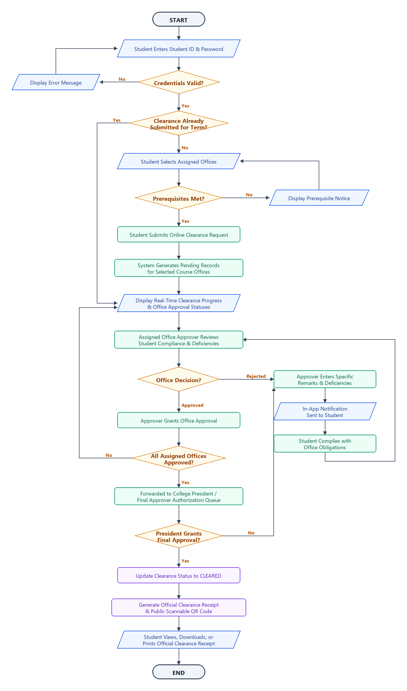
Figure 6. Student Clearance Process Flowchart
As depicted in Figure 6, the system execution is categorized into three major sequential phases:
1. Student Authentication and Request Initiation Phase. The workflow initiates when a student enters their unique Student ID and password. The system authenticates the credentials against verified accounts. If credentials do not match, an error notification is displayed, prompting re-entry. Upon authenticated access, the system checks whether the student has already submitted an active clearance request for the ongoing semester and academic year. If an existing application is detected, the student is redirected directly to the real-time tracking dashboard to monitor progress. If no request exists for the term, the student selects the designated clearance offices assigned to their curriculum. The system verifies whether any selected office requires prerequisite sign-offs; if prerequisite obligations exist, an advisory prompt informs the student. Once verified, the student submits the online clearance request, prompting the system to generate corresponding pending clearance approval records across the assigned offices.
2. Role-Based Departmental Review and Deficiency Resolution Phase. Assigned office approvers (e.g., Library, Guidance, Dean, Registrar, Cashier, and Student Affairs) access their respective role-based modules to inspect pending student clearance applications. Each approver assesses whether the student has satisfied all departmental accountabilities, returned borrowed resources, and settled institutional obligations. If deficiencies exist, the approver sets the status to 'Rejected' and inputs descriptive remarks specifying the non-compliance reason. The system promptly delivers an in-app notification to the student, allowing them to resolve the cited obligations with the respective office. Following resolution, the approver re-evaluates the clearance. Once all requirements are fulfilled, the approver grants departmental approval. The system continually evaluates whether every assigned office has recorded approval.
3. Executive Clearance Authorization and Receipt Generation Phase. When all prerequisite and assigned offices have completed their approvals, the student clearance application automatically advances to the authorization queue of the College President (or designated Final Approver). Upon executive review, the Final Approver grants final authorization, transitioning the overall clearance status to 'CLEARED'. The system instantly generates an official printable clearance receipt detailing student information, program, academic term, completion timestamps, and an official receipt number. Concurrently, the system produces a scannable Quick Response (QR) code embedded on the receipt, linking to a public, read-only verification page that allows authorized personnel and external parties to seamlessly confirm the authenticity of the clearance.

