4.3.2 Data Flow Diagrams (DFD)
The Data Flow Diagrams (DFD) visually illustrate the movement, transformation, and storage of clearance data within the Web-Based Student Clearance System with Role-Based Approval for Talibon Polytechnic College. The modeling is structured hierarchically, beginning with the high-level Context Diagram (Level 0 DFD), which defines the boundary of the system and its external user entities, followed by the decomposed Level 1 DFD, which details the internal functional sub-processes, data transactions, and relational data repositories.
4.3.2.1 Context Diagram (Level 0 DFD)
The Context Diagram establishes the global scope of the application by representing the entire clearance system as a single primary process (Process 0.0) interacting with five external entities: the Student, Office Staff / Approver, College President / Final Approver, Administrator / OSAS Director, and the Public / Verifier. Figure 7 illustrates the contextual information exchange across these primary stakeholders.
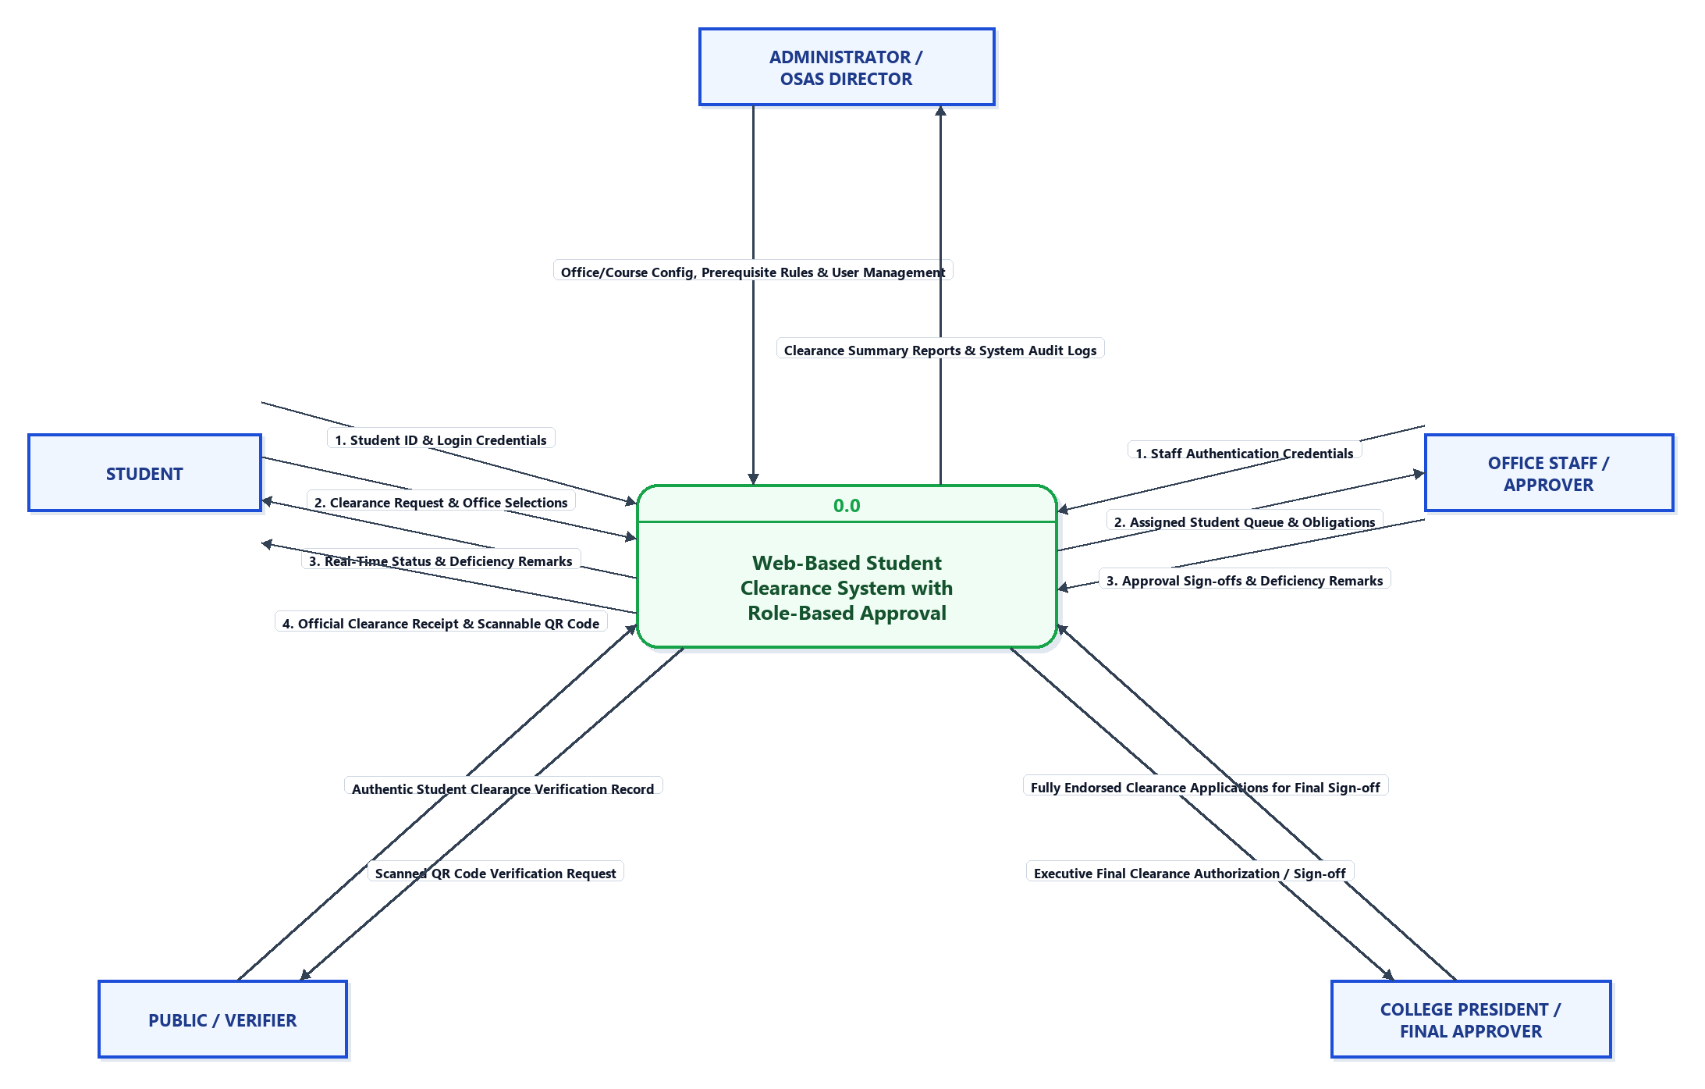
Figure 7. Context Diagram (Level 0 DFD) of the Proposed System
As illustrated in Figure 7, each external entity maintains distinct data input and output relationships with the system:
• Student Entity. The student inputs registration details, authentication credentials (Student ID and password), and clearance request submissions with selected course-assigned offices. In return, the system outputs session status, real-time clearance progress trackers, in-app deficiency notifications with remarks, and the downloadable official printable clearance receipt complete with a verification QR code.
• Office Staff / Approver Entity. Designated office personnel supply authentication credentials, approval sign-offs, and rejection actions accompanied by specific remarks for unmet student accountabilities. In return, the system provides a real-time list of pending student clearance applications and pertinent student academic information.
• College President / Final Approver Entity. The executive approver inputs final clearance authorizations or rejections. The system outputs comprehensive summaries of students who have secured all departmental office approvals and are ready for executive sign-off.
• Administrator / OSAS Director Entity. The administrator supplies system configuration inputs, including user account management, course curriculum definitions, office modules, and office prerequisite dependencies. The system outputs system audit logs, statistical clearance summaries, and institutional reports.
• Public / Verifier Entity. External stakeholders or institutional personnel initiate read-only verification requests by scanning the Quick Response (QR) code embedded on a student's clearance receipt. The system returns official, tamper-evident verification details confirming the authenticity and status of the student's cleared record.
4.3.2.2 Level 1 Data Flow Diagram (Level 1 DFD)
The Level 1 Data Flow Diagram provides an architectural decomposition of Process 0.0 into six core operational sub-processes. It explicitly traces the routing of information between the external entities, sub-processes, and the six fundamental data repositories of the system. Figure 8 delineates the comprehensive data flow structure.
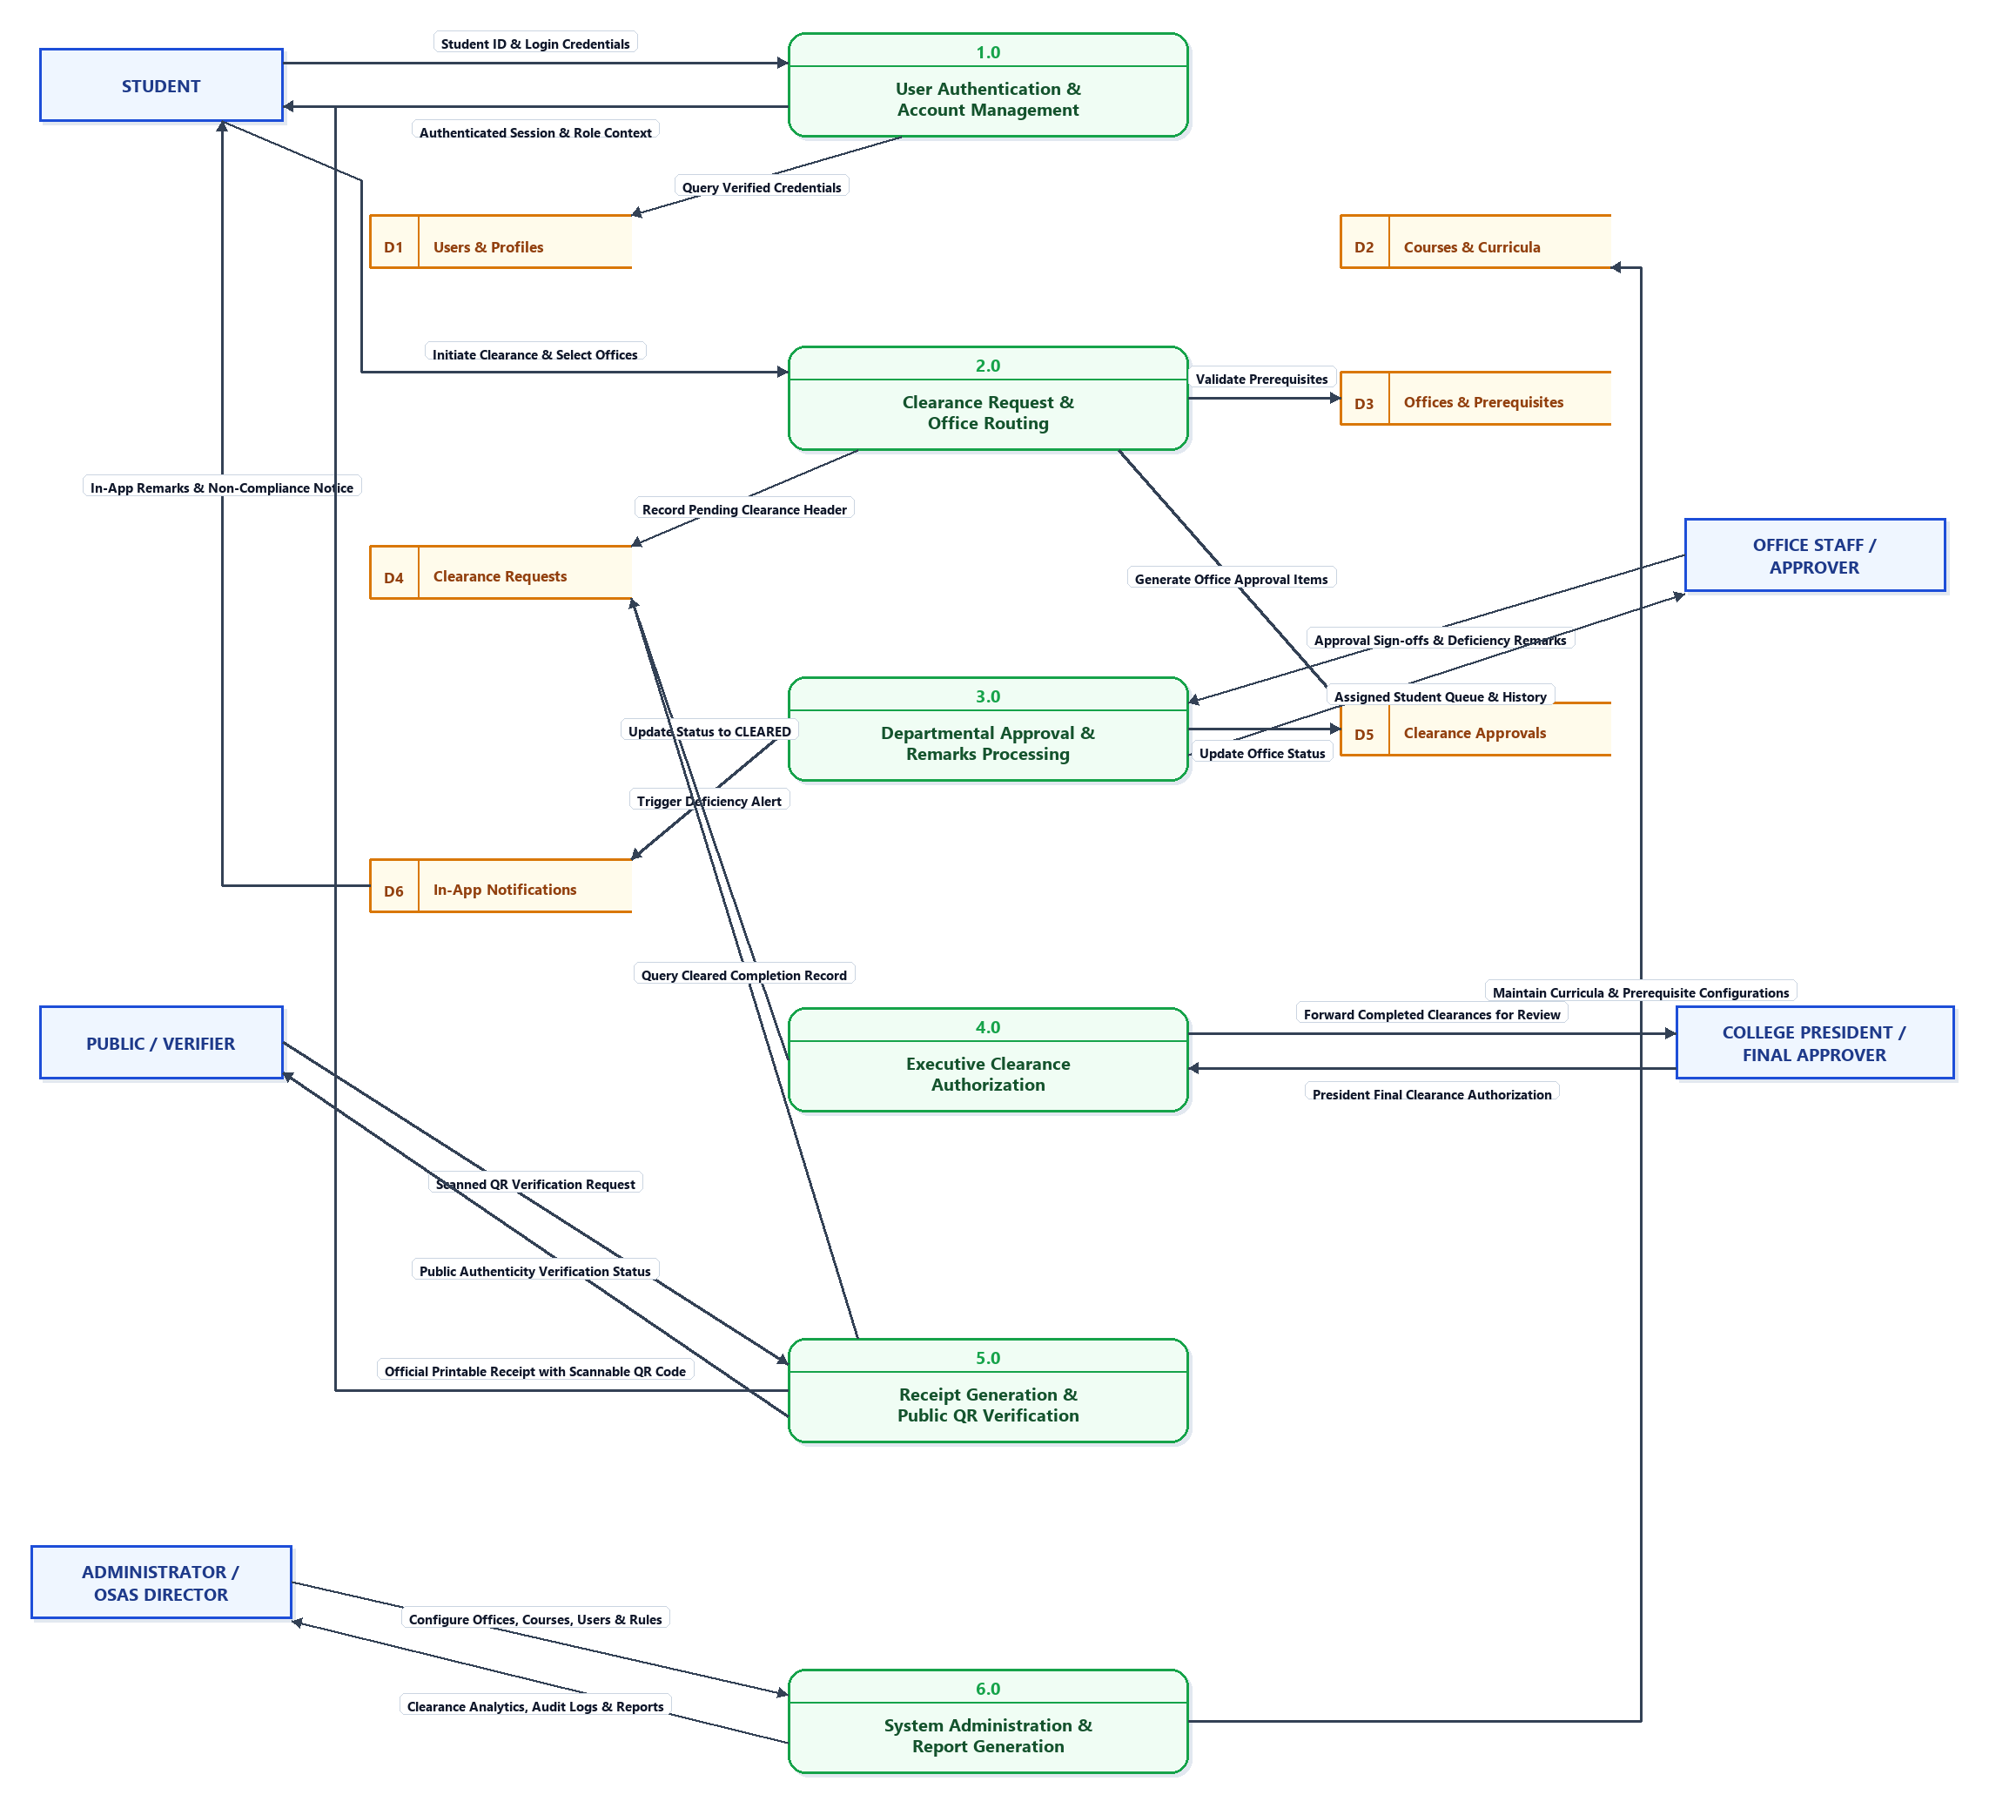
Figure 8. Level 1 Data Flow Diagram (Level 1 DFD)
The functional responsibilities and data repository interactions depicted in Figure 8 are detailed below:
• Process 1.0: User Authentication & Account Management. Accepts login credentials and registration inputs from students, staff, administrators, and the College President. It queries and verifies identity records stored in "D1: Users & Profiles" while associating enrolled students with academic programs defined in "D2: Courses & Curricula".
• Process 2.0: Clearance Request & Office Routing. Manages the digital initiation of student clearance requests for the active term. Upon submission, it evaluates prerequisite requirements defined in "D3: Offices & Prerequisites" to ensure sequencing compliance. It subsequently instantiates a pending clearance header in "D4: Clearance Requests" and initializes departmental approval items in "D5: Clearance Approvals".
• Process 3.0: Departmental Approval & Remarks Processing. Enables authorized office approvers to evaluate student compliance. When an approver submits an approval or rejection, the record in "D5: Clearance Approvals" is updated with timestamps, approver identity, and descriptive deficiency remarks. Any rejection automatically triggers an event that registers in "D6: In-App Notifications" to notify the affected student.
• Process 4.0: Executive Clearance Authorization. Monitors all departmental approval items in "D5: Clearance Approvals" for a given student request. Once every assigned office registers an approved state, the application is presented to the College President. Executive authorization transitions the request status in "D4: Clearance Requests" from "Pending" to "CLEARED".
• Process 5.0: Receipt Generation & Public QR Verification. Queries completed records from "D4: Clearance Requests" to produce an official printable clearance receipt containing a verifiable transaction number and an encoded Quick Response (QR) code. When scanned by a Public Verifier, the process decodes the token, queries the repository, and returns a public, read-only authentication screen verifying student clearance standing.
• Process 6.0: System Administration & Report Generation. Permits the Administrator / OSAS Director to maintain operational parameters, manage curriculum definitions in "D2: Courses & Curricula", establish office hierarchies and prerequisite chains in "D3: Offices & Prerequisites", and generate comprehensive institutional clearance reports and audit logs.

