4.3.3 Entity-Relationship Diagram (ERD)
The Entity-Relationship Diagram (ERD) establishes the logical data architecture and structural schema governing the Web-Based Student Clearance System with Role-Based Approval for Talibon Polytechnic College. It defines the concrete entity models, primary key identifiers, foreign key referential integrity constraints, and relational cardinalities (one-to-one, one-to-many, and many-to-many) that support multi-role clearance transactions, prerequisite office evaluation chains, deficiency remark logging, and tamper-proof QR verification. Figure 9 depicts the comprehensive entity-relationship model derived directly from the institutional database schema.
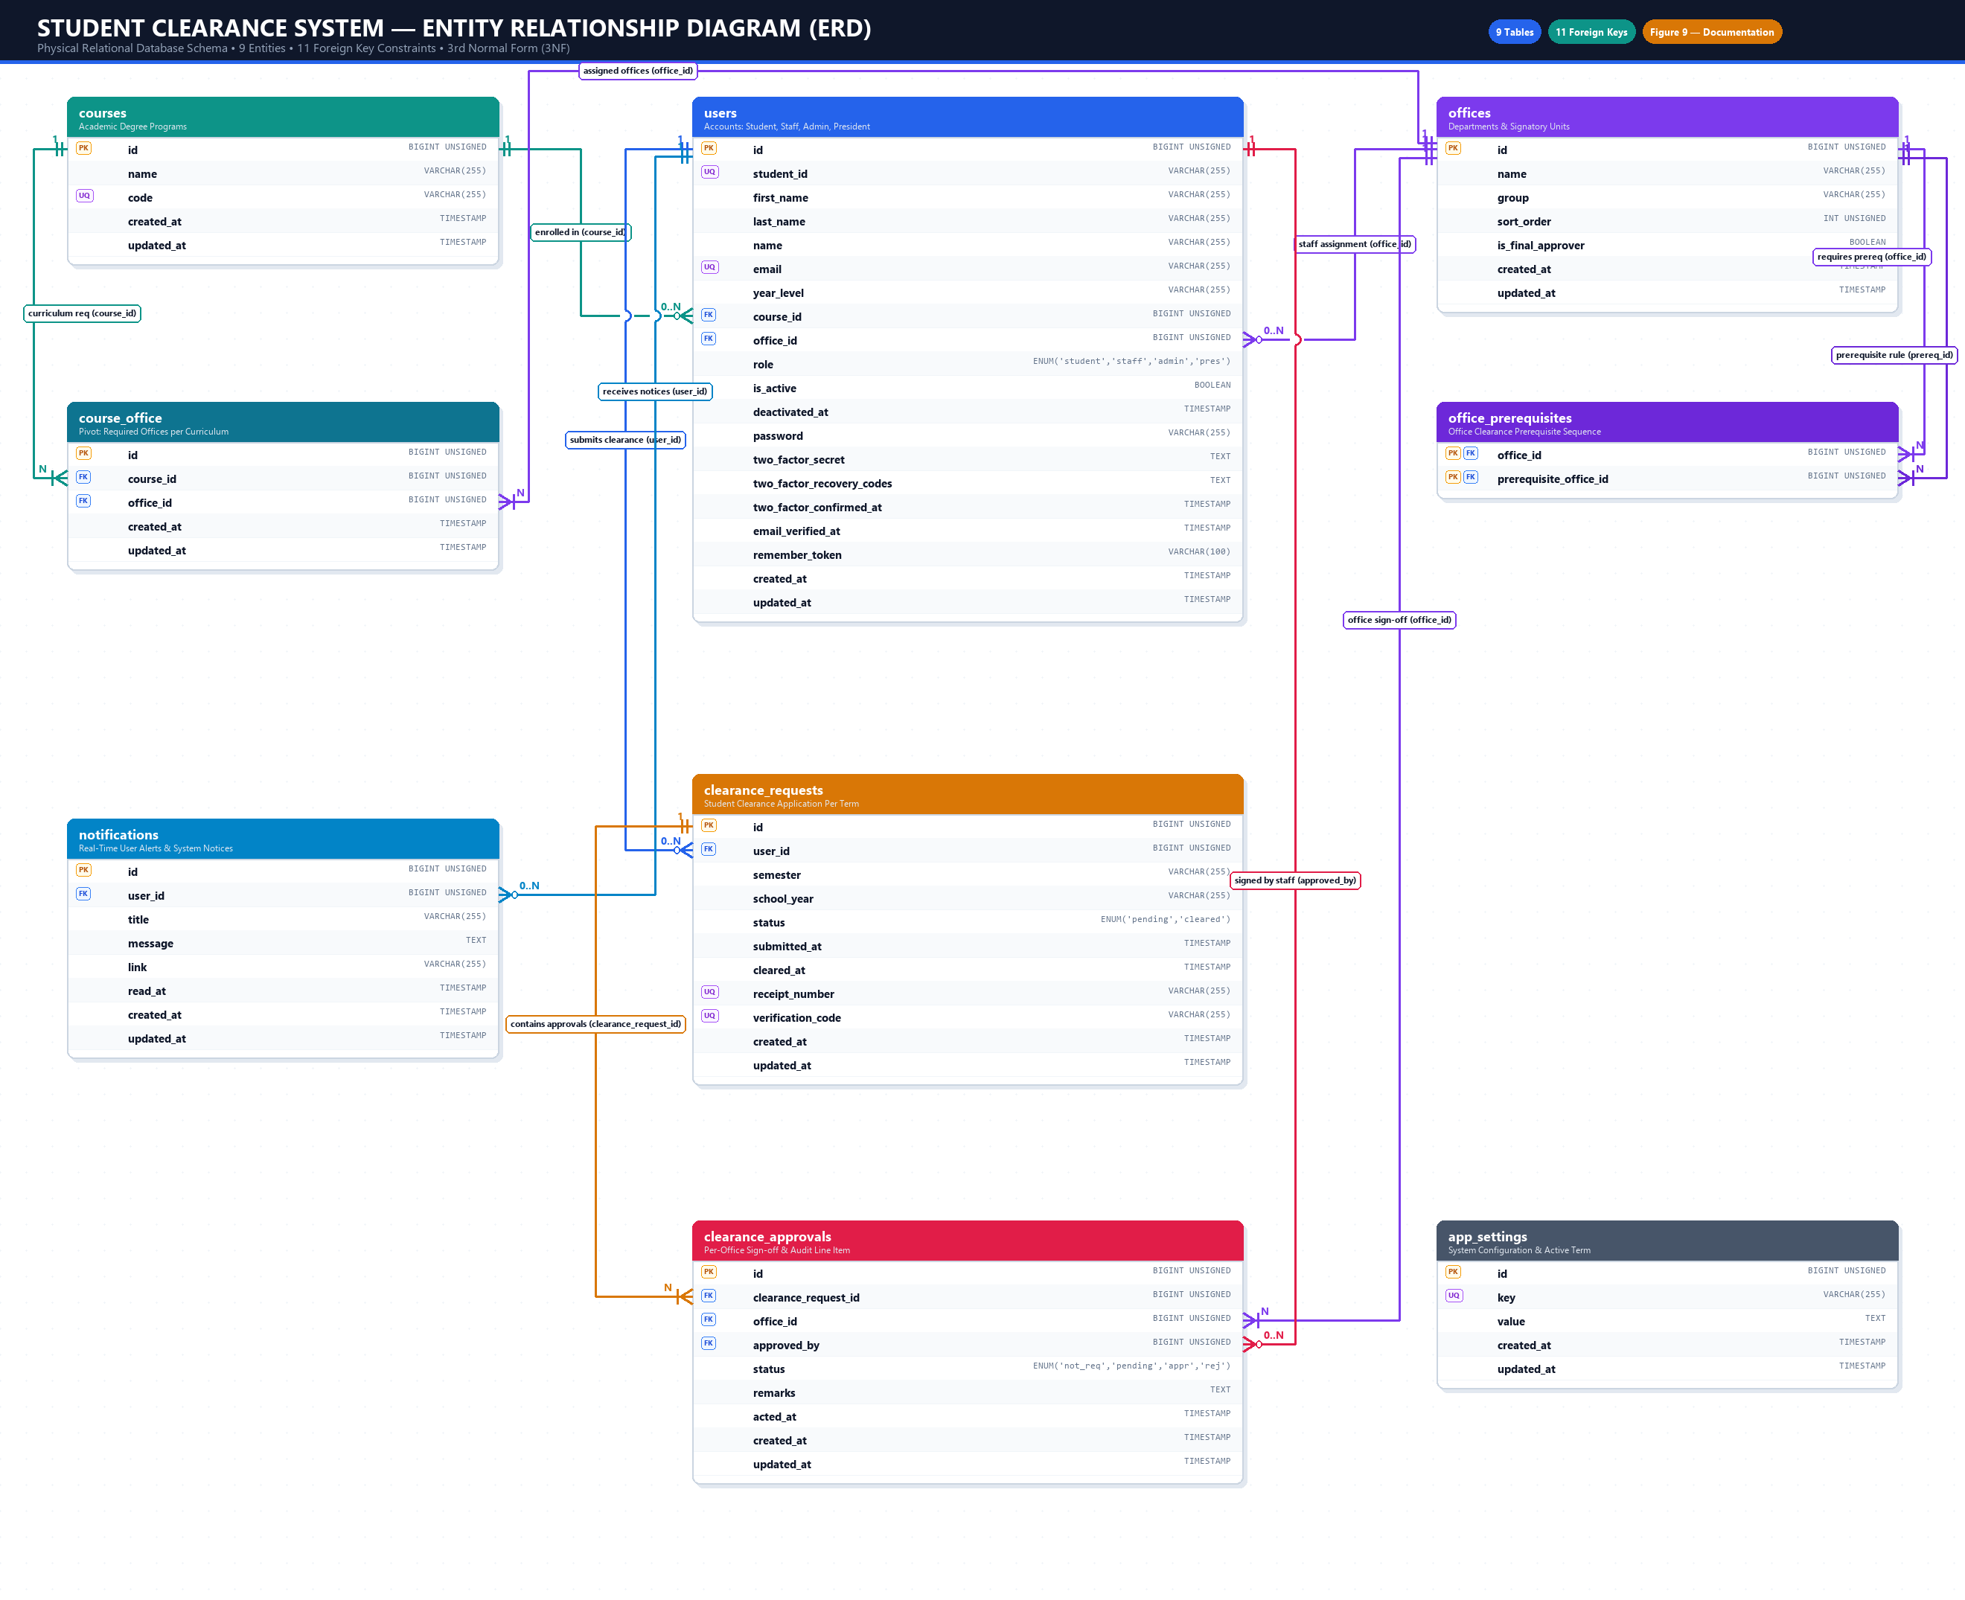
Figure 9. Entity-Relationship Diagram (ERD) of the Proposed System
As modeled in Figure 9, the relational schema consists of nine interrelated entities designed to manage academic, administrative, and audit data throughout the clearance lifecycle:
1. Users Entity (`users`). Maintains all authenticated system actors across the four defined user roles: students, office staff, system administrators, and the College President. Attributes include `id` (Primary Key), `student_id` (Unique student credential), `name`, `email` (Unique), `course_id` (Foreign Key referencing `courses`), `office_id` (Foreign Key referencing `offices` for assigned approvers), `role` (ENUM restricting authorization scope), `is_active`, and hashed `password`. It enforces a one-to-many relationship with clearance requests, clearance approvals, and system notifications.
2. Courses Entity (`courses`). Represents the academic programs offered by Talibon Polytechnic College (e.g., Bachelor of Science in Information Systems). Key fields include `id` (Primary Key), `name` (Program Title), and `code` (Unique Curriculum Code). It maintains a one-to-many relationship with enrolled students (`users`) and a many-to-many relationship with institutional clearance offices via `course_office`.
3. Offices Entity (`offices`). Stores the designated institutional clearance departments (such as Library, Registrar, Guidance, Dean, Cashier, and Student Affairs). Fields include `id` (Primary Key), `name`, `group`, `sort_order` (establishing evaluation sequence), and `is_final_approver` (Boolean flag). It maintains relationships with assigned staff accounts, course requirements, prerequisite dependency rules, and approval records.
4. Course-Office Junction Entity (`course_office`). Acts as a relational bridge resolving the many-to-many association between academic programs and clearance offices. Attributes include `id` (Primary Key), `course_id` (Foreign Key), and `office_id` (Foreign Key), with a composite unique constraint ensuring that a clearance office is associated with a specific curriculum only once.
5. Office Prerequisites Entity (`office_prerequisites`). Implements self-referential prerequisite dependencies among clearance offices to enforce compliance sequencing. It features a composite primary key comprising `office_id` (Foreign Key) and `prerequisite_office_id` (Foreign Key). This entity ensures that offices requiring prior clearance (e.g., Dean requiring Library clearance) cannot be cleared until the prerequisite office has granted approval.
6. Clearance Requests Entity (`clearance_requests`). Serves as the primary transaction header representing a student's clearance application for a specific academic semester and school year. Fields include `id` (Primary Key), `user_id` (Foreign Key referencing `users`), `semester`, `school_year`, `status` (ENUM: `'pending'`, `'cleared'`), `submitted_at`, `cleared_at`, `receipt_number` (Unique official receipt identifier), and `verification_code` (Unique token powering public QR validation). A composite unique constraint (`user_id`, `semester`, `school_year`) guarantees that a student can only submit one active clearance per term.
7. Clearance Approvals Entity (`clearance_approvals`). Represents granular departmental evaluation line items associated with each clearance request. Fields include `id` (Primary Key), `clearance_request_id` (Foreign Key), `office_id` (Foreign Key), `approved_by` (Foreign Key referencing the acting user), `status` (ENUM: `'not_requested'`, `'pending'`, `'approved'`, `'rejected'`), `remarks` (Text field documenting specific deficiencies), and `acted_at` (Timestamp). A composite unique key prevents duplicate office entries for a single request.
8. Notifications Entity (`notifications`). Facilitates real-time in-app communication between the clearance workflow and system users. Fields include `id` (Primary Key), `user_id` (Foreign Key), `title`, `message` (Detaling deficiency remarks or clearance status updates), `link`, and `read_at` timestamp. It ensures instant notification delivery when office staff flag obligations.
9. App Settings Entity (`app_settings`). Manages global institutional configuration parameters. Attributes include `id` (Primary Key), `key` (Unique setting identifier, such as `active_semester` and `active_school_year`), and `value` (Text data), enabling administrators to dynamically control clearance cycles.
Relational Cardinality and Data Integrity
The relational design enforces strict referential integrity across the database through foreign key cascade and nullification rules. Deleting a user or clearance request cascades to associated approval line items and notifications (`ON DELETE CASCADE`), preventing orphaned records. Conversely, if a course or office is disassociated from an assigned user, the foreign key is set to null (`ON DELETE SET NULL`) to maintain historical user logs. Unique composite indexes ensure strict data consistency, preventing duplicate term applications and redundant approval allocations.

