4.3.4 Use Case Diagram
The Use Case Diagram defines the functional scope and behavioral boundaries of the Web-Based Student Clearance System with Role-Based Approval for Talibon Polytechnic College. It visually maps the interactions between the five primary actors and the specific system use cases, illustrating how students, office staff, executive approvers, administrators, and external verifiers interface with the platform. This diagram directly operationalizes the Use Case Descriptions specified in Section 4.2 (Table 4.2.3). Figure 10 presents the clean, non-intersecting use case model.
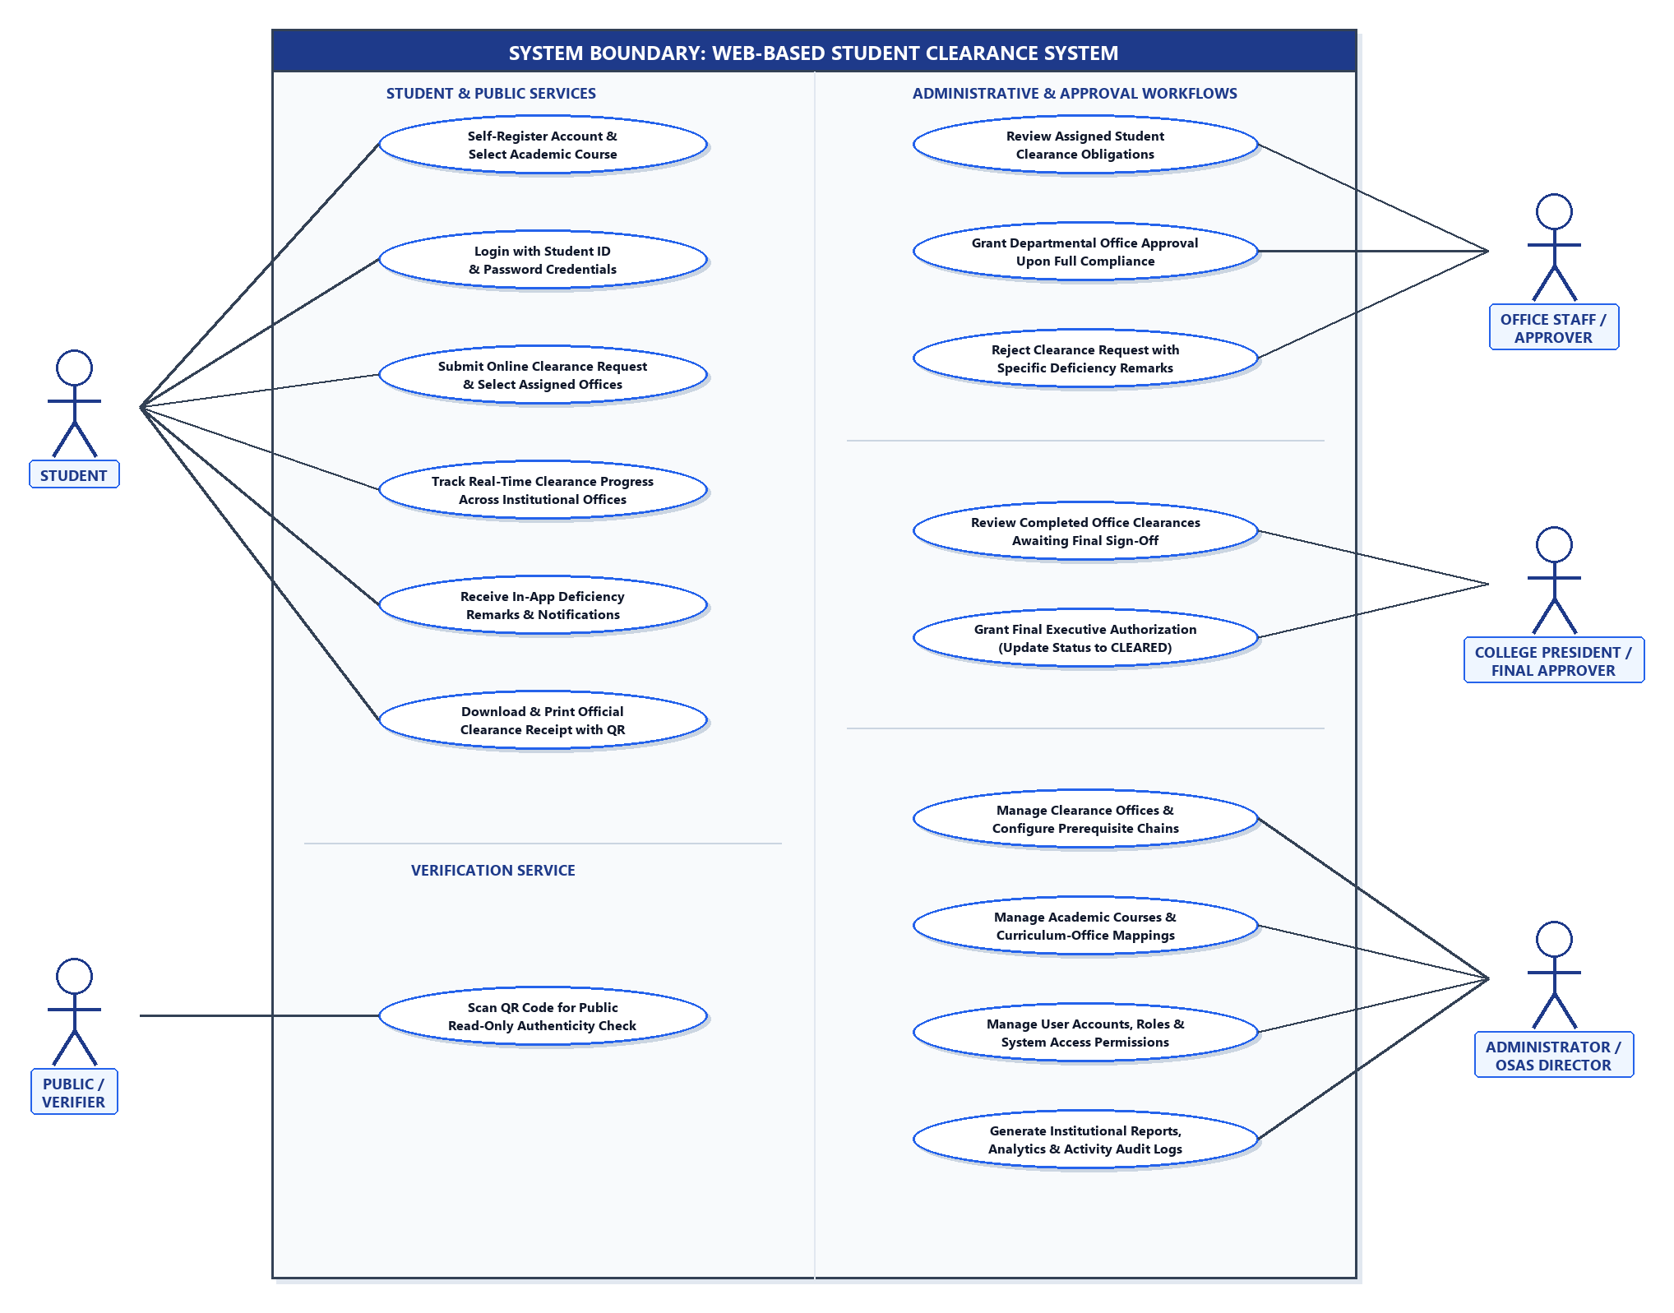
Figure 10. Use Case Diagram of the Proposed System
Identification of System Actors
1. Student. The primary user initiating clearance transactions. Students self-register, log in using their Student ID, submit clearance requests for the current term, monitor office approval progress in real time, view and comply with deficiency remarks, and download or print their official clearance receipt.
2. Public / Verifier. External stakeholders, employers, or institutional personnel who scan the scannable Quick Response (QR) code embedded on a student's clearance receipt to verify authenticity via a public, read-only verification portal.
3. Office Staff / Approver. Authorized personnel representing designated institutional departments (e.g., Library, Guidance, Dean, Registrar, Cashier, and Student Affairs). Approvers evaluate assigned student applications, grant approvals, or reject requests with descriptive deficiency remarks.
4. College President / Final Approver. The executive authority responsible for final authorization. The President reviews applications that have successfully secured all departmental sign-offs and grants executive clearance, updating the student's status to 'CLEARED'.
5. Administrator / OSAS Director. The administrative manager who oversees platform governance. The administrator manages user accounts, configures academic course curricula, defines clearance office hierarchies and prerequisite chains, monitors overall records, and generates institutional reports and audit logs.
Functional Grouping of Use Cases
• Student Services: Includes account self-registration with course selection, Student ID credential login, online clearance request submission across course-assigned offices, real-time multi-office progress tracking, receipt of in-app deficiency notifications, and official clearance receipt generation.
• Verification Service: Dedicated public service enabling external verifiers to scan the receipt QR code and view authentic, tamper-proof clearance status confirmation.
• Departmental Approvals: Empowers assigned office staff to review pending student obligations, record deficiency remarks citing specific compliance requirements, and grant departmental clearance approvals.
• Executive Authorization: Provides the College President with a dedicated queue to review fully endorsed clearance requests and grant executive authorization, transitioning the status to 'CLEARED'.
• Administrative Management: Permits the OSAS Director/Administrator to configure clearance departments, establish prerequisite chains, maintain academic courses, manage user accounts, and generate audit reports.

