4.3.5 Activity Diagram
The Activity Diagram models the dynamic operational behavior, procedural logic, and concurrency controls of the Web-Based Student Clearance System with Role-Based Approval for Talibon Polytechnic College. By organizing activities into distinct swimlanes (partitions), the diagram explicitly delineates the roles and responsibilities of the Student, the Clearance System, the Assigned Office Approvers, and the College President. Furthermore, it highlights concurrent departmental evaluations through UML synchronization fork and join mechanisms. Figure 11 presents the complete multi-role activity model.
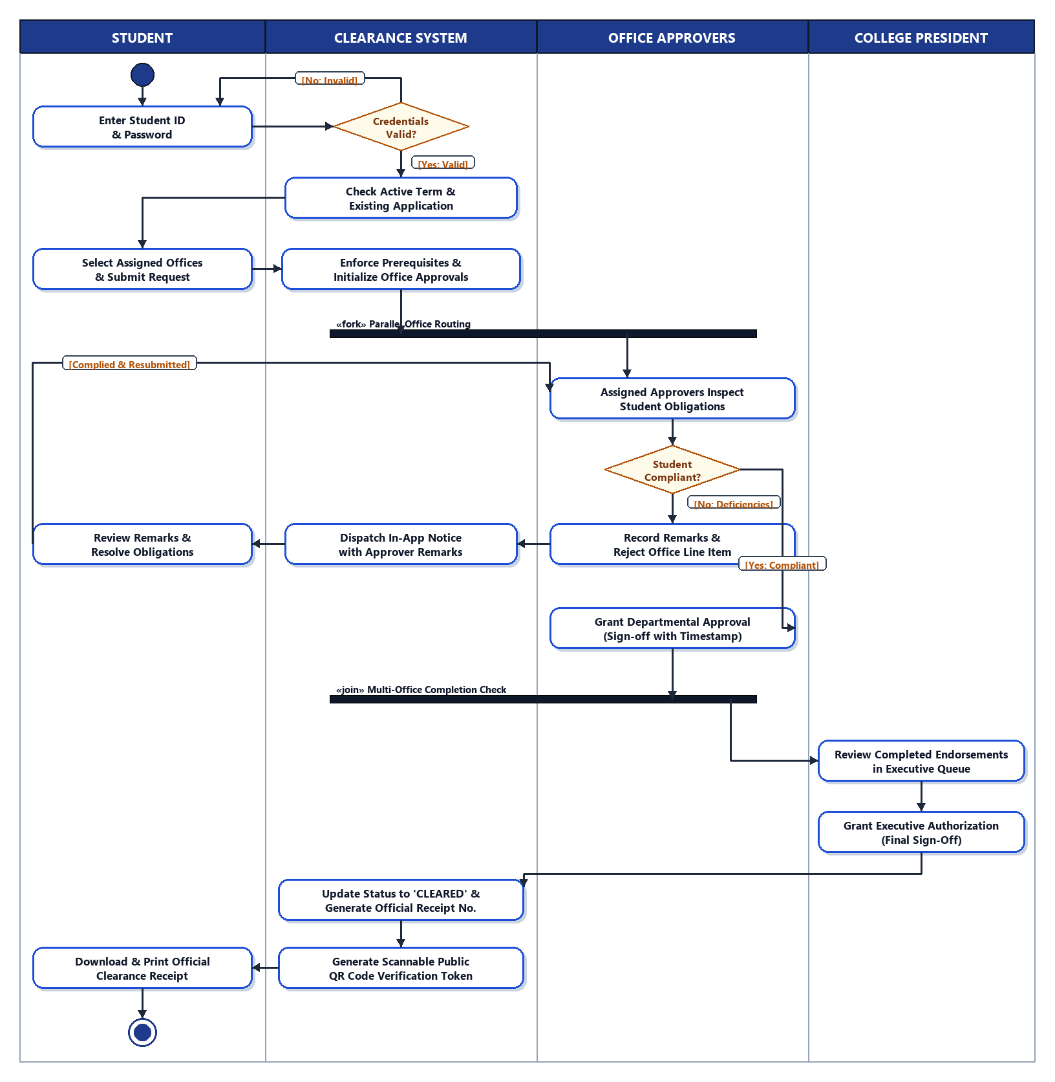
Figure 11. Activity Diagram (with Swimlanes) of the Clearance Approval Workflow
Swimlane Partition Analysis
1. Student Swimlane. Represents student actions throughout the clearance cycle. The flow initiates when the student submits authentication credentials. After credential verification, the student selects assigned clearance offices and submits an online application. In the event of a departmental rejection, the student reviews cited deficiency remarks and resolves obligations before re-evaluation. Once fully cleared, the student downloads and prints the official receipt.
2. Clearance System Swimlane. Performs background validation, transaction orchestration, and automated state transitions. It verifies login credentials, validates active semester parameters, enforces prerequisite office dependencies, orchestrates parallel routing via fork bars, delivers in-app deficiency notifications, monitors multi-office completion through join synchronization, updates overall status to 'CLEARED', and generates the official receipt number and scannable QR verification code.
3. Office Approvers Swimlane. Encompasses parallel evaluations conducted by designated signatories across institutional departments (Library, Guidance, Dean, Registrar, Cashier, and Student Affairs). Approvers inspect student obligations and make a binary determination: if obligations are unmet, they record deficiency remarks and reject the item; if obligations are satisfied, they record an official approval with a timestamp.
4. College President Swimlane. Embodies executive authorization. Once all required office approvals are synchronized at the join bar, the request enters the President's executive queue. The President reviews the completed departmental endorsements and grants final clearance authorization, finalizing the institutional clearance process.
Parallel Execution and Synchronization Semantics
A critical feature of the proposed system is the elimination of linear office queues through parallel processing. As depicted in Figure 11, the system utilizes a UML Fork bar («fork») upon request submission to route approval tasks simultaneously to all designated offices assigned to the student's curriculum. Offices can review, approve, or reject obligations concurrently without being blocked by unrelated departments. A corresponding UML Join bar («join») serves as a synchronization barrier, ensuring that the application advances to the College President's final authorization queue only after every assigned office records an approved state.

