4.3.6 Sequence Diagram
The Sequence Diagram models the dynamic, temporal interactions and message-passing mechanisms that occur between system entities during the core clearance evaluation and remarks handling process of the Web-Based Student Clearance System with Role-Based Approval for Talibon Polytechnic College. Whereas activity diagrams capture overall procedural flow and departmental concurrency, the sequence diagram emphasizes the precise chronological ordering of synchronous HTTP requests, internal controller validations, asynchronous service calls, and database transactions across the presentation, controller, domain model, service, and persistence tiers. Figure 12 illustrates the complete sequence execution for departmental evaluation, alternative approval/rejection branching, deficiency feedback capture, and audit timestamping.
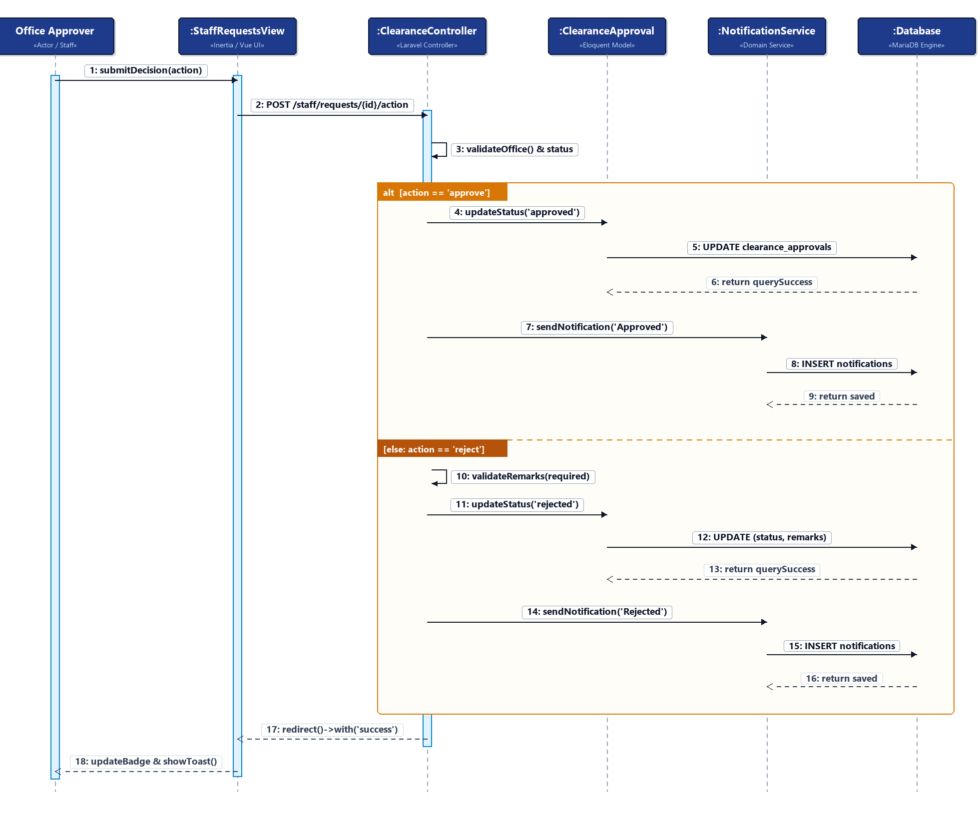
Figure 12. Sequence Diagram of the Clearance Evaluation and Approval Workflow
Lifeline and Participant Architectural Analysis
The sequence execution model engages six structural participants representing the full architectural stack of the clearance system:
1. Office Approver (Actor / Staff). Represents the authenticated departmental signatory (e.g., Registrar, Cashier, Dean, Library, Guidance, or Student Affairs staff) who inspects student clearance records and submits authoritative decisions.
2. :StaffRequestsView (Presentation Tier). Represents the client-side single-page interface built with Vue.js and Inertia.js. It renders the pending evaluation queue, handles action modals, captures deficiency explanations, and reactively re-renders table status badges upon transaction completion without full page reloads.
3. :ClearanceController (Application / Controller Tier). Represents the central Laravel application controller (PendingRequestController) managing request authentication, role authorization, office assignment validation, domain model invocation, and session flash dispatching.
4. :ClearanceApproval (Domain Model Tier). Represents the Eloquent Object-Relational Mapping (ORM) domain model mapped to the clearance_approvals database table. It encapsulates status state transitions ('pending', 'approved', 'rejected'), approver associations ('approved_by'), deficiency remarks, and evaluation timestamps ('acted_at').
5. :NotificationService (Service Layer). Represents the dedicated domain notification service (NotificationService) that decouples automated alert construction from evaluation logic, generating in-app deficiency or clearance notices for students.
6. :Database (Persistence Tier). Represents the relational MariaDB persistence engine that executes atomic SQL updates, enforces referential integrity constraints, and maintains immutable transaction histories.
Chronological Message Sequence Breakdown
The interaction flow proceeds through three sequential phases, incorporating a UML 2.0 Alternative Combined Fragment (alt) to handle conditional branching:
Phase 1: Request Initiation and Verification (Messages 1–3). The workflow begins when an approver selects a student record from their departmental queue and initiates an evaluation action via the modal dialog (Message 1: submitDecision(action)). The Inertia.js client serializes the payload and issues an asynchronous HTTP POST request to the server endpoint (Message 2: POST /staff/requests/{id}/action). The ClearanceController intercepts the request and executes authorization validations (Message 3: validateOffice() & status), confirming that the authenticated user belongs to the designated office and that the record is in an active pending state.
Phase 2: Conditional Evaluation via UML Alternative Fragment (alt). The diagram employs a UML Alternative Combined Fragment (alt) with two mutually exclusive operands to model the binary evaluation outcome:
• Operand 1: Approval Workflow [action == 'approve']. When the student has fulfilled all departmental obligations, the approver confirms approval. The controller commands the domain model to update state (Message 4: updateStatus('approved')). The model executes an atomic SQL UPDATE against the clearance_approvals table, updating status to 'approved', stamping the approver's user ID, clearing remarks, and recording the acted_at timestamp (Message 5). The database confirms row modification (Message 6). Subsequently, the controller triggers NotificationService (Message 7: sendNotification('Approved')), which writes an in-app notice to the notifications table (Message 8) and receives confirmation of persistence (Message 9).
• Operand 2: Rejection with Deficiency Feedback [else: action == 'reject']. When obligations remain unsettled, the approver selects rejection. The controller strictly enforces validation of required deficiency remarks (Message 10: validateRemarks(required)). The domain model is invoked (Message 11: updateStatus('rejected')) to execute an atomic SQL UPDATE recording status = 'rejected', the detailed deficiency explanation, the approver identifier, and current timestamp (Message 12). The database acknowledges the update (Message 13). The controller then dispatches NotificationService to create a detailed deficiency notification containing the specific office remarks (Message 14), which is persisted into the database (Message 15) and acknowledged (Message 16).
Phase 3: Response Dispatching and Client Reconciliation (Messages 17–18). Upon completing either branch, the controller returns an Inertia redirect response containing a success flash message (Message 17: redirect()->with('success')). The client-side Vue interface reactively receives the response, updates the departmental clearance badge to reflects the new status, and displays a toast notification confirming successful processing (Message 18: updateBadge & showToast()).
Auditability, Concurrency, and Deficiency Resolution Semantics
The sequence diagram highlights three essential design paradigms built into the system:
1. Accountability and Audit Trail. Every approval or rejection permanently records the evaluator's user ID (approved_by) and an exact timestamp (acted_at). This establishes institutional accountability, preventing signatory repudiation and providing administrative transparency.
2. Immediate Deficiency Resolution. Automated in-app notifications generated immediately upon rejection inform students of specific deficiencies without requiring in-person departmental inquiries. Students can promptly satisfy the requirement and request re-evaluation.
3. Stateless Concurrency and Multi-Office Independence. Because each evaluation targets an isolated record in clearance_approvals scoped by office_id, signatories across independent offices (e.g., Library, Dean, and Cashier) can review and update clearance applications simultaneously without blocking or database concurrency conflicts.

