4.3.7 Class Diagram
The Class Diagram captures the static object-oriented structure, domain entities, attribute definitions, operations, and relational multiplicities of the Web-Based Student Clearance System with Role-Based Approval for Talibon Polytechnic College. Designed in strict compliance with UML 2.0 specifications and directly reflecting the application's Laravel Eloquent Object-Relational Mapping (ORM) architecture and MariaDB schema, the diagram defines the contracts, associations, and structural constraints that govern the clearance domain. Figure 13 presents the complete structural class model.
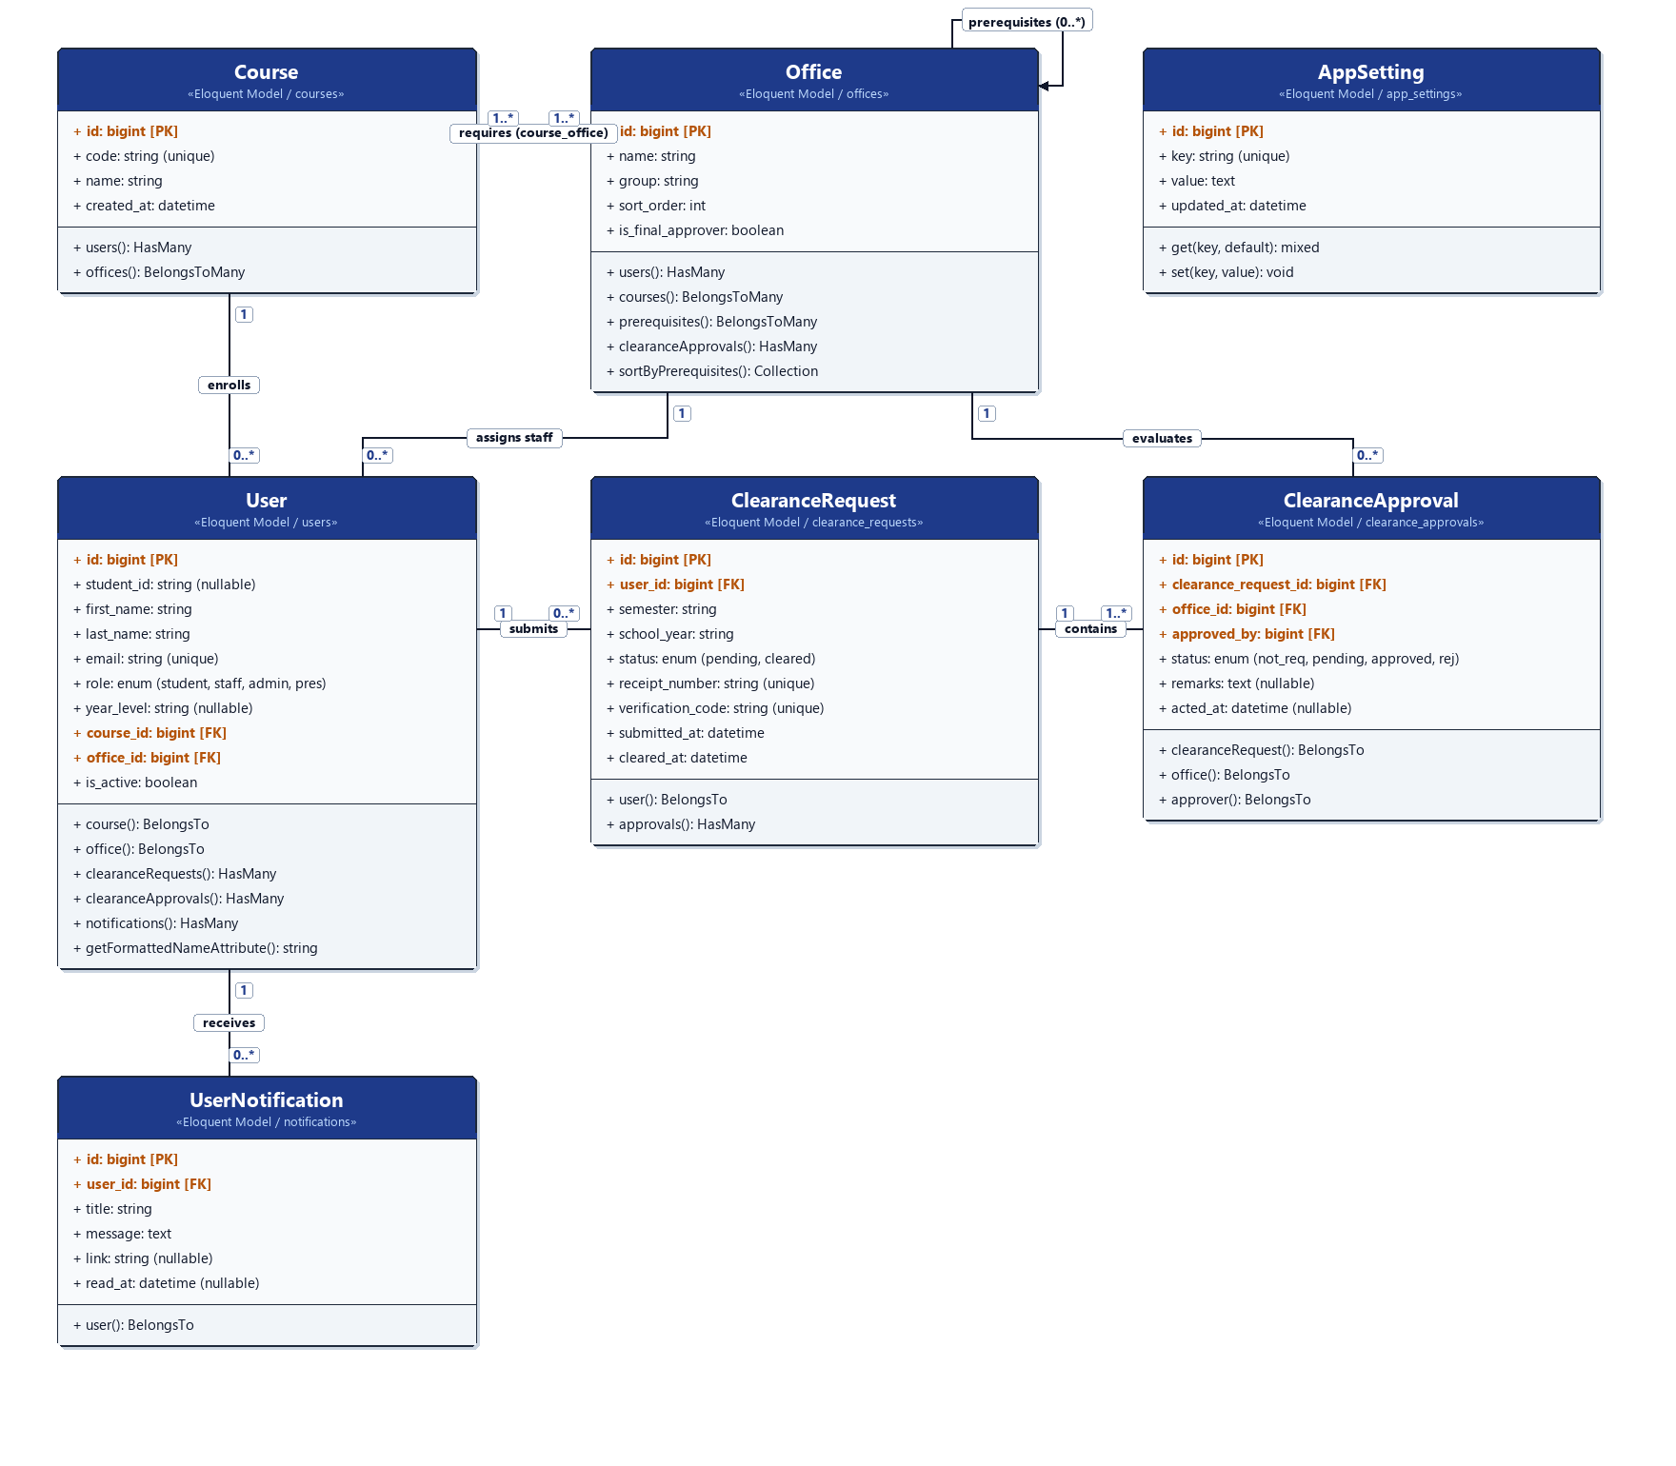
Figure 13. Class Diagram of the Student Clearance System
Domain Entity and Class Specifications
The structural architecture is decomposed into seven primary domain classes, each encapsulating specific data attributes, encapsulation scopes, and domain behaviors:
1. User Class (Mapped to users). Encapsulates all authenticated institutional users across four distinct operational roles ('student', 'staff', 'admin', and 'president'). For students, it stores their institutional student ID, year level, and curriculum linkage (course_id). For office staff, it records their designated departmental assignment (office_id). It provides navigational methods to access associated clearance requests, approval actions, and in-app notifications, along with domain helper methods such as getFormattedNameAttribute().
2. Course Class (Mapped to courses). Represents the degree programs offered by Talibon Polytechnic College (e.g., BS Information Systems, BS Criminology, Bachelor of Elementary Education). It manages academic curriculum configurations and links enrolled students to required clearance signatories through the course_office junction.
3. Office Class (Mapped to offices). Represents the institutional offices responsible for clearance evaluations (Registrar, Cashier, Dean, Library, Guidance, and Student Affairs). In addition to administrative attributes (group, sort_order, is_final_approver), it encapsulates the topological sorting method sortByPrerequisites(). This method dynamically resolves directed acyclic dependency graphs defined in office_prerequisites, ensuring that prerequisite offices are systematically cleared prior to dependent offices.
4. ClearanceRequest Class (Mapped to clearance_requests). Represents the central transactional aggregate root for a student's clearance filing within a specific academic semester and school year. It maintains the overall lifecycle state ('pending' or 'cleared'), audit timestamps (submitted_at, cleared_at), official receipt numbers, and cryptographic QR verification tokens for tamper-proof document authentication.
5. ClearanceApproval Class (Mapped to clearance_approvals). Models granular departmental clearance evaluations. Each clearance request instantiates multiple clearance approval line items corresponding to the offices assigned to the student's course. It tracks the evaluation state ('not_requested', 'pending', 'approved', 'rejected'), explicit deficiency remarks, the evaluator's user ID (approved_by), and the exact decision timestamp (acted_at).
6. UserNotification Class (Mapped to notifications). Represents the decoupled asynchronous notification model. It stores user-specific alerts containing titles, detailed messages (such as deficiency descriptions upon rejection), navigational action URLs, and read timestamps (read_at).
7. AppSetting Class (Mapped to app_settings). Serves as a centralized system configuration entity. It manages institutional global parameters (e.g., active_semester, active_school_year) with high-performance caching via get() and set() accessors, invalidating cached entries whenever administrative settings are modified.
Structural Relationships and Multiplicity Analysis
The class diagram establishes explicit cardinality constraints that preserve referential integrity across the system:
1. Course to Office Association (1..* to 1..*). Modeled through the course_office junction table, this many-to-many relationship defines the precise clearance obligations required for each academic degree program. A course must be associated with one or more offices (1..*), and an office can evaluate students across multiple programs (1..*).
2. Office Prerequisite Hierarchy (0..* to 0..*). Modeled via the office_prerequisites self-referencing pivot table, this recursive relationship enforces hierarchical office clearances. An office may require zero or more prerequisite offices to grant approval before its own evaluation queue unlocks.
3. Course/Office to User Association (1 to 0..*). A course enrolls zero or more students (0..*), while each enrolled student is linked to exactly one degree program (1). Similarly, an office employs zero or more staff signatories (0..*), while each staff member belongs to exactly one designated department (1).
4. User to ClearanceRequest Association (1 to 0..*). A student can submit multiple clearance filings across different academic periods over their academic tenure (0..*), but each clearance request belongs strictly to exactly one authenticated student (1).
5. ClearanceRequest to ClearanceApproval Composition (1 to 1..*). A clearance request is composed of one or more departmental approval items (1..*), with each approval item strictly referencing its parent request (1). When an office evaluates a student, it updates the corresponding approval record, ensuring that multi-office evaluations operate on isolated rows without concurrency locks.
6. User to UserNotification Association (1 to 0..*). A user receives zero or more automated notification records (0..*), while each notification record is strictly partitioned to exactly one recipient user (1), guaranteeing privacy and targeted feedback delivery.
Object-Relational Mapping (ORM) and Architectural Integrity
The structural classes diagrammed in Figure 13 map directly to Laravel Eloquent models backed by the MariaDB relational engine. Foreign key constraints (ON DELETE CASCADE where appropriate, and ON DELETE SET NULL on audit foreign keys) guarantee referential integrity. Furthermore, Eloquent relationship definitions (hasMany, belongsTo, belongsToMany) eliminate manual join queries, providing an expressive, secure, and type-safe abstraction tier for all controller and service interactions.

