4.3.9 Interface Design
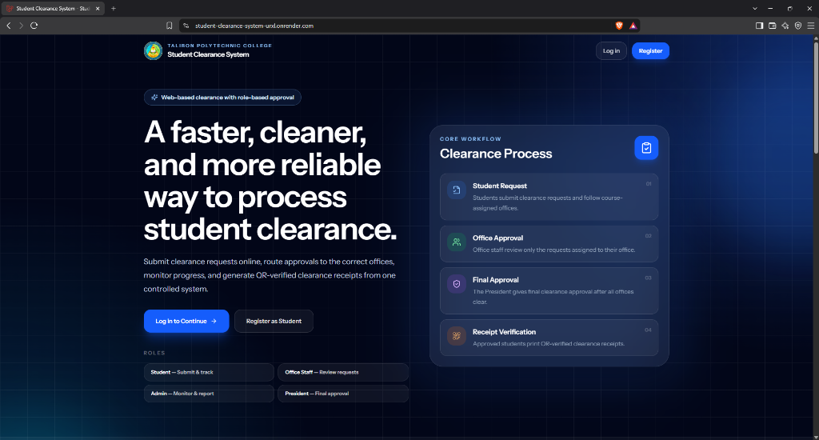
Figure 14. System Landing Page Interface
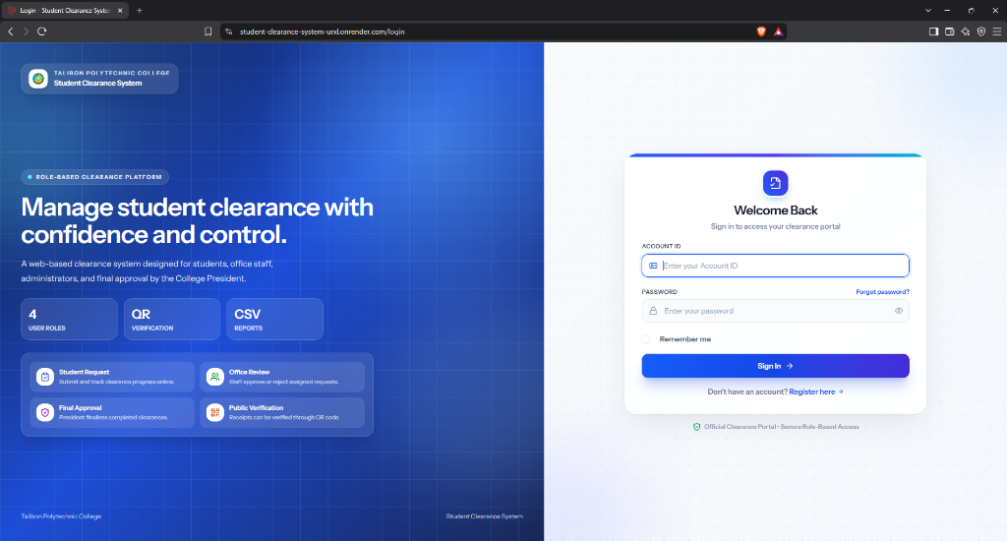
Figure 15. User Authentication (Login) Interface
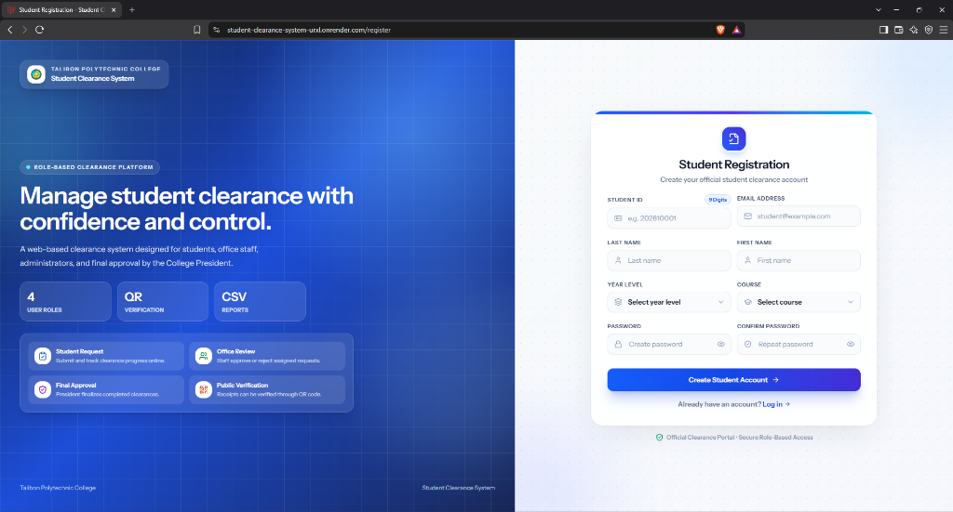
Figure 16. Student Account Registration Interface
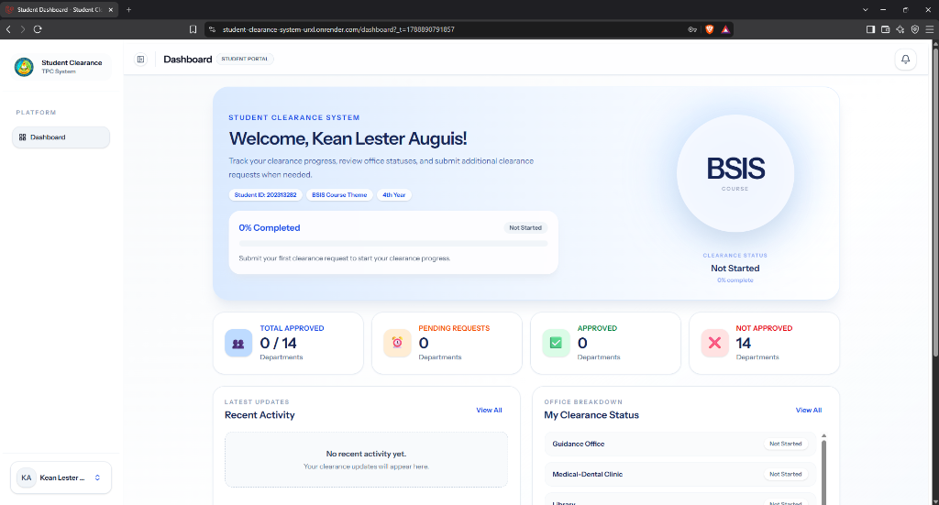
Figure 17. Student Clearance Dashboard Interface (Desktop / Web View)
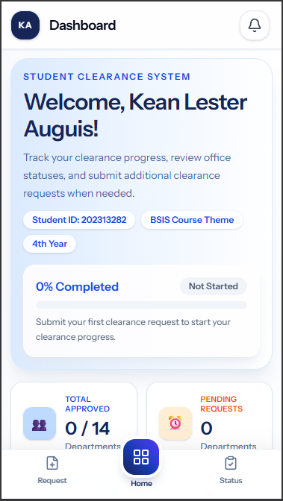
Figure 18. Student Clearance Dashboard Interface (Mobile Responsive View)
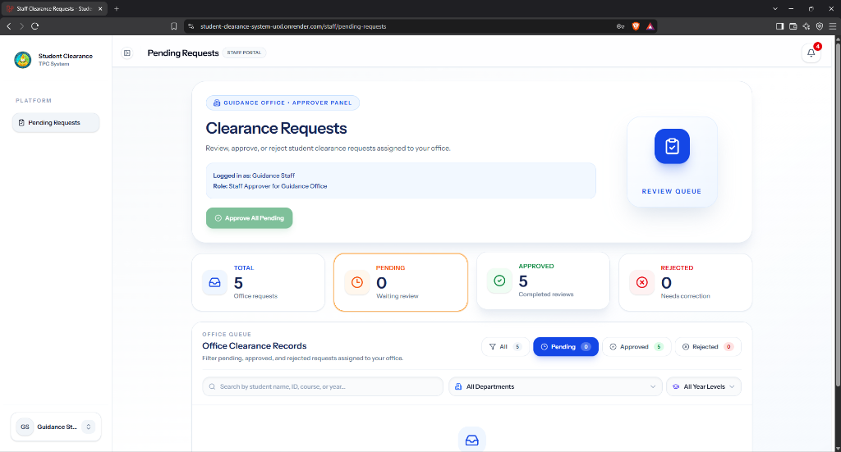
Figure 19. Office Staff Clearance Evaluation Queue Interface
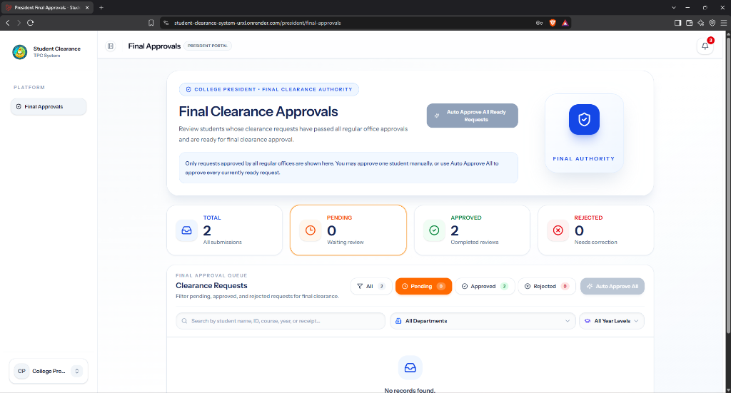
Figure 20. College President Final Clearance Authorization Queue Interface
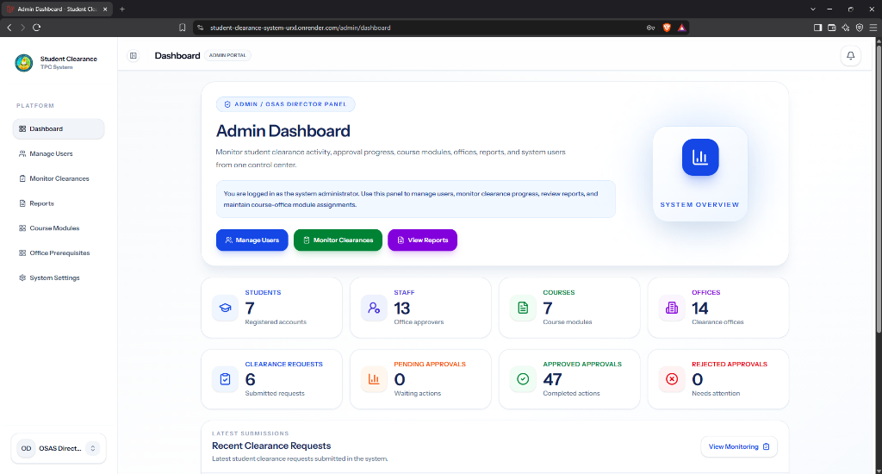
Figure 21. System Administrator Management Dashboard Interface
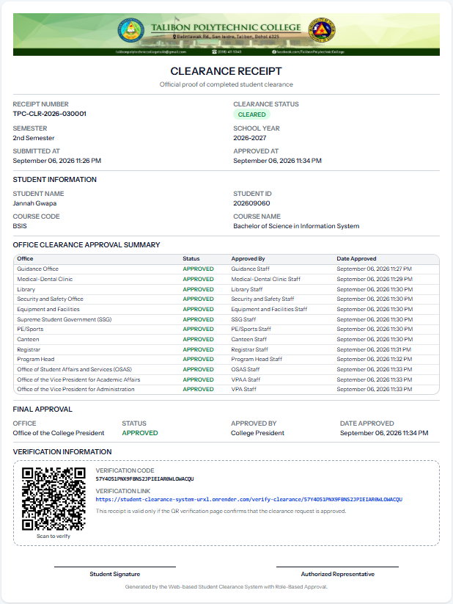
Figure 22. Official Electronic Clearance Receipt Interface
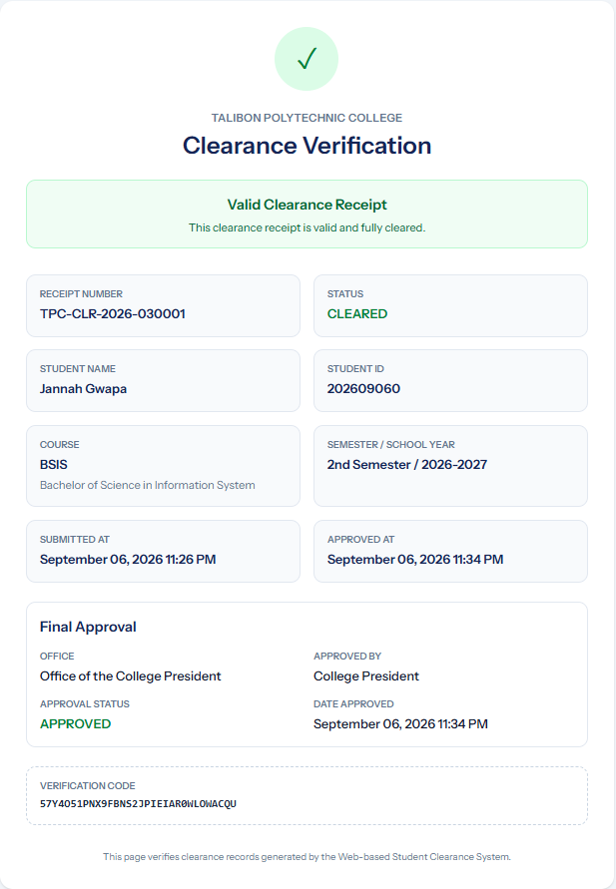
Figure 23. Public QR Code Clearance Verification Portal Interface

