WEB-BASED STUDENT CLEARANCE SYSTEM WITH ROLE-BASED APPROVAL FOR TALIBON POLYTECHNIC COLLEGE

________________

A Capstone Proposal Project
Presented to
The Faculty of the Department of Information Systems
TALIBON POLYTECHNIC COLLEGE
San Isidro, Talibon, Bohol
________________

In Partial Fulfillment
of the Requirements for the Degree of
BACHELOR OF SCIENCE IN INFORMATION SYSTEMS

________________
By

Kean Lester A. Auguis
Madel D. Romana
Sean Leo R. Añabieza

May 2026

APPROVAL SHEET

This Capstone Project with the title, “WEB-BASED STUDENT CLEARANCE SYSTEM WITH ROLE-BASED APPROVAL FOR TALIBON POLYTECHNIC COLLEGE” prepared and submitted by KEAN LESTER A. AUGUIS, MADEL D. ROMANA and SEAN LEO R. AÑABIEZA in partial fulfillment of the requirements for the degree in BACHELOR OF SCIENCE IN INFORMATION SYSTEMS has been examined and recommended for acceptance and approval for Oral Examination.

CAPSTONE PROJECT COMMITTEE

STANLEY CLARK M. DIPAY, Ph.D., RGC., CSASS
Chairman

JOSEPH JETT T. ABELA ASTRID P. VALMORIA, MAELT
Capstone Adviser English Critic

FLORDELIS A. TURTOGA, MAMT
Statistician

APPROVED by the Examining Panel during the Oral Examination held in May 2026 with the grade of ____.
-------------------------------------------------------------------------------------------------------

PANEL OF EXAMINERS

STANLEY CLARK M. DIPAY, Ph.D., RGC., CSASS
Chairman

DIOSCORO A. AVERGONZADO, Ph.D. GISELO B. CAJES, Ph.D.
Member Member

ACCEPTED and APPROVED as partial fulfillment of the requirements for the degree in Bachelor of Science in Information Systems.

May 2026 STANLEY CLARK M. DIPAY, Ph.D., RGC., CSASS.
Date of Oral Defense College President
ACKNOWLEDGEMENTS
The authors wish to express their heartfelt gratitude and sincere appreciation to their capstone adviser, Mr. Joseph Jett T. Abela, for his continuous guidance, patience, and valuable expertise throughout the development and completion of this capstone project. His constructive comments, meaningful suggestions, and constant support greatly helped the researchers improve the quality, accuracy, and overall presentation of the study.
The researchers also extend their sincere appreciation to Ms. Flordelis A. Turtoga, their Statistics and Subject Instructor, for her valuable instruction, guidance, and assistance in strengthening the statistical and academic aspects of this study. Her dedication to teaching and commitment to academic excellence served as a source of encouragement and inspiration to the researchers.
The authors also extend special thanks to Ms. Astrid P. Valmoria, the Grammarian, for her careful attention to detail and valuable assistance in improving the language, grammar, and overall clarity of this manuscript. Her effort in refining sentence structure, coherence, and correctness contributed significantly to the readability and professional quality of this study.
Sincere appreciation is likewise given to the School Administration of Talibon Polytechnic College (TPC) for their support, encouragement, and for providing an academic environment that promotes learning and research. Their cooperation and assistance contributed to the completion of this study, especially in supporting the development and implementation of the proposed system. The institution’s dedication to quality education and innovation inspired the researchers to complete this work with commitment and purpose.
The authors are also grateful to their peers, mentors, and colleagues for their technical assistance, helpful feedback, and professional guidance, which became valuable throughout the preparation of this manuscript.
Lastly, the authors extend their deepest gratitude to their friends and families for their constant support, patience, and understanding. This work stands as a reflection of their encouragement and shared belief in the importance of education and knowledge.

The Researchers

TABLE OF CONTENTS

TITLE PAGE ………………….…….…………….………… i

APPROVAL SHEET ……………………………………………….…... ii

ACKNOWLEDGEMENTS ……………………………………………….…… iii

TABLE OF CONTENTS ……………………………………………………. v

LIST OF FIGURES ...…………………………………………………………. vii

Chapter Page

Chapter 1 – INTRODUCTION AND PROJECT CONTEXT ………………. 1

Project Context …………………………………… 1

Purpose and Description …………………………………… 2

Objectives of the Study ……………………….…………… 3

Statement of the Problem ………………………….………… 5

Scope and Limitation ………………….………………… 7

Significance of the Study ………………….………………… 9

Research Methodology ………………….………………… 10

Research Design ………………….…….………………… 10

Research Environment ………………….………………… 12

Research Instrument ………………….………………… 12

Research Respondents ………………….………………… 13

Research Procedures ………………….………………… 15

Research Flow ………………….………………… 17

Chapter 2 – REVIEW OF RELATED LITERATURE/SYSTEMS…...….… 18

Related Literature …………………………………… 18

Related Studies ……………………….…………… 21

Conceptual Framework ……………………….…………… 24

DEFINITION OF TERMS ……………….……………………...…...……… 27

REFERENCES …………………………………………….……………… 29

CURRICULUM VITAE ………………………………….…………………. 31

LIST OF FIGURES

Figure Title Page
1 Location Map of the Study……………………………………………… 12
2 Research Flow of the Study ………………………….….…………… 17
3 Conceptual Framework of the Study..……………….………………… 26
4 Network Architecture of the Proposed System ……………….……… 32
5 Software Architecture of the Proposed System……………….……… 26

Chapter 1

INTRODUCTION AND PROJECT CONTEXT

Project Context

In today’s digital era, educational institutions are increasingly adopting information systems to improve administrative efficiency, data accuracy, and service delivery (Alenezi, 2023). One important administrative process in colleges is the student clearance system, which ensures that students have settled all required obligations before completing a semester or graduating (Olatunde and Faboya, 2025). Traditionally, the clearance process requires students to physically visit multiple offices to secure signatures or approvals from authorized personnel (Adamu, 2022).
However, this traditional method is often time-consuming and inconvenient. Students are required to line up early and move from one office to another during scheduled clearance periods, resulting in overcrowded hallways and offices that hinder smooth movement and cause delays. Furthermore, the unavailability of key personnel during students’ visit may further prolong the process. Therefore, the proposed digital student clearance system addresses the limitations of the traditional clearance process by providing a more organized and efficient way to manage student clearances.
Talibon Polytechnic College currently implements a manual, paper-based student clearance process that requires students to visit multiple offices to obtain approvals. This process involves physical forms, manual signatures, and in-person coordination among various departments such as Student Services Office and Administrative Offices. Consequently, the process becomes time-consuming, inefficient, and prone to delays, especially during peak periods such as enrollment and graduation. Moreover, based on preliminary observations and discussions with target users, the institution still relies on a manual clearance process, indicating the need for a digital solution suited to its clearance workflow.
Purpose and Description

The main purpose of this project is to design and develop a Web-based Student Clearance System with Role-Based Approval for Talibon Polytechnic College. The system aims to improve the existing manual clearance process by providing a centralized digital platform where clearance requests, office approvals, student status monitoring, and final clearance verification can be managed more efficiently.
The proposed system is intended for four main user roles: students, office staff or approvers, the administrator or OSAS director, and the College President or Final Approver. Students can register using their student ID, select their course, submit clearance requests, and monitor the status of their clearances in real time. Office staff can review submitted requests, approve or reject the requests, and provide remarks when requirements have not yet been completed. The administrator can manage user accounts, offices, course modules, clearance records, and reports. The college president serves as the final approver once all required office approvals have been completed.
The system also includes course-based classification, in-app notifications, approval status tracking, printable clearance receipts, and QR code verification. The QR code feature allows the authenticity of a cleared student’s final clearance record to be verified through a public verification page. Since the system is developed as a responsive web application, it can be accessed using web browsers on both desktop and mobile devices.
Through these features, the proposed system is expected to reduce delays, improve transparency, minimize manual handling of records, and provide a more organized clearance process for Talibon Polytechnic College.
Objectives of the Study
This study aims to design, develop, and evaluate a web-based student clearance system with role-based approval for Talibon Polytechnic College to improve the efficiency, accessibility, transparency, and overall organization of the student clearance process.
Specifically, this study aims to:
- identify the challenges encountered in the existing manual student clearance process in terms of time consumption, clearance status tracking, office coordination, and record management;
- design and develop a web-based student clearance system that supports student registration and course selection, student ID-based login, online clearance request submission, and course-based clearance processing;
- implement role-based access and approval for students, office staff or approvers, the Administrator or OSAS Director, and the College President or Final Approver;
- provide system features for the approval or rejection of clearance requests with remarks, clearance status monitoring, in-app notifications, final clearance status generation, printable clearance receipts, and QR code verification;
- evaluate the developed system as assessed by selected students, office staff or approvers, the Administrator or OSAS Director, and the College President or Final Approver in terms of usability, functionality, processing efficiency, transparency, accessibility, reliability, and user satisfaction; and
- develop an improved student clearance system based on the identified problems to improve the student clearance process at Talibon Polytechnic College.

THE PROBLEM

Statement of the Problem

This study aims to design, develop, and evaluate a web-based student clearance system with role-based approval for Talibon Polytechnic College to address the inefficiencies in the existing manual clearance process.
Specifically, this study seeks to answer the following questions:
1. What is the demographic profile of the respondents in terms of:
1.1 respondent group; and
1.2 sex?
2. What are the design and development requirements of the web-based student clearance system in terms of:
2.1. student registration and course selection;
2.2. student ID-based login-based login;
2.3. online clearance request submission; and
2.4. course-based clearance processing?
3. What role-based access and approval mechanisms can be implemented in the web-based student clearance system for:
3.1. students;
3.2. office staff or approvers;
3.3. the Administrator or OSAS Director; and
3.4. the College President or Final Approver?
4. What system features can be implemented to improve the student clearance process in terms of:
4.1. approval or rejection of clearance requests with remarks;
4.2. clearance status monitoring;
4.3. in-app notifications;
4.4. final clearance status generation;
4.5. printable clearance receipts; and
4.6. QR code verification?
5. How will the developed system be evaluated by selected students, office staff or approvers, the Administrator or OSAS Director, and the College President or Final Approver in terms of:
5.1. usability;
5.2. functionality;
5.3. performance efficiency;
5.4. accessibility;
5.5. reliability; and
5.6. user satisfaction?
6. Based on the findings of the study, what recommendations can be proposed to further improve the student clearance process at Talibon Polytechnic College?
SCOPE AND LIMITATIONS
Scope of the Study

This study focuses on the development of a web-based student clearance system with role-based approval for Talibon Polytechnic College. The system is designed to digitize the existing manual clearance process by providing a centralized platform that can be accessed through web browsers on desktop and mobile devices.
The system covers student self-registration, course selection, student ID-based login, online clearance request submission, and course-based clearance processing. It also includes a role-based approval workflow involving students, office staff or approvers, the administrator or OSAS director, and the college president or final approver. Through the system, students can submit clearance requests, monitor their clearance status, view remarks from offices, and access their final clearance status once all required approvals are completed.
Office staff or approvers can review assigned clearance requests, approve or reject requests, and provide remarks when requirements are not yet complied with. The college president serves as the final approver after all required office approvals have been completed. The administrator or OSAS director can manage user accounts, offices, course modules, clearance records, and reports. The system also includes in-app notifications, real-time status tracking, printable clearance receipt generation, QR code verification, and administrative monitoring and reporting features.
The study involves selected students, office staff or approvers, the administrator or OSAS director, and the college president or final approver of Talibon Polytechnic College as respondents who will evaluate the system in terms of usability, functionality, processing efficiency, transparency, accessibility, reliability, and user satisfaction.
Limitations of the Study
This study is limited to Talibon Polytechnic College and is not designed for use by multiple institutions. The student registration process relies on manually entered student information and does not integrate with an official school database for automatic validation. It provides only in-app notifications and does not support email, SMS, or push notifications. The system is web-based and responsive, but it does not include a native mobile application.
The system also requires an internet connection or network access for operation. The QR code feature is limited to public read-only verification of cleared students’ records and does not include advanced encryption-based authentication. The system does not support financial transactions, online payment processing, or academic subject-based clearance. It focuses only on office-based clearance approvals.
In addition, the system does not automatically verify physical requirements such as returned materials, submitted documents, unpaid obligations, or other office-specific compliance requirements. The actual checking of these requirements still depends on the assigned office staff before they approve or reject a clearance request. The system also does not currently support uploading documentary proof or attachments for office review.
Furthermore, the system does not integrate with other institutional databases such as library, registrar, accounting, clinic, or other office systems. Course and office assignments depend on the configuration managed by the administrator. Lastly, the evaluation of the system is limited to selected respondents and may not fully represent the perceptions of all possible users.
Significance of the Study
This study is significant because it aims to improve the student clearance process of Talibon Polytechnic College through a web-based system that supports online clearance requests, role-based approval, status tracking, and digital record management. The developed system is expected to benefit the following:
Students. The system provides students with a more convenient way to submit clearance requests, monitor their clearance status, view remarks, and access their final clearance record without repeatedly visiting different offices.
Office Staff. The system helps office staff manage clearance requests assigned to their respective offices. It allows them to approve or reject requests with remarks and organize office-based clearance records more efficiently.
Administrator. The system assists the administrator in managing user accounts, offices, course modules, clearance records, and reports. It also helps monitor the overall progress of student clearance requests.
Talibon Polytechnic College. The system supports the institution’s digital transformation by reducing manual paperwork, improving transparency, and providing a more organized clearance process.
Future Researchers. This study may serve as a reference for future studies related to web-based information systems, student clearance automation, role-based approval workflows, and digital administrative services.
RESEARCH METHODOLOGY
Research Design
This study will use an applied research approach employing a developmental method. The applied approach is appropriate because the study aims to address an existing institutional problem in the student clearance process. The developmental method is also suitable because the study focuses on designing, developing, testing, and evaluating a functional web-based student clearance system with role-based approval.
The proposed system will be developed based on the identified problems in the current clearance process, the required user roles, and the required clearance workflow of Talibon Polytechnic College. The development will focus on providing functions for student registration, course selection, student ID-based login, online clearance request submission, role-based approval, clearance status monitoring, in-app notifications, final approval, printable clearance receipts, and QR code verification.
The Agile methodology will be used as the system development methodology. This approach allows the researchers to develop the system through iterative phases of planning, designing, developing, testing, gathering feedback, and refinement. Through this approach, the researchers can gradually improve the system modules based on identified requirements and observed issues during development and testing.
The system evaluation will use a quantitative method utilizing a structured questionnaire. The questionnaire will measure the respondents’ assessment of the developed system in terms of usability, functionality, processing efficiency, transparency, accessibility, reliability, and user satisfaction.
Research Environment
The study will be conducted at Talibon Polytechnic College, located in San Isidro, Talibon, Bohol. The institution currently uses a manual, paper-based student clearance process that requires students to visit different offices to secure clearance approvals.
The proposed system will be developed and tested in a local web development environment. It will use Laravel for the backend, Vue.js for the frontend, Inertia.js for front-end and back-end integration, Tailwind CSS for interface design, and MySQL for database management. The system prototype will be tested using commonly used web browsers such as Google Chrome, Mozilla Firefox, and Microsoft Edge.
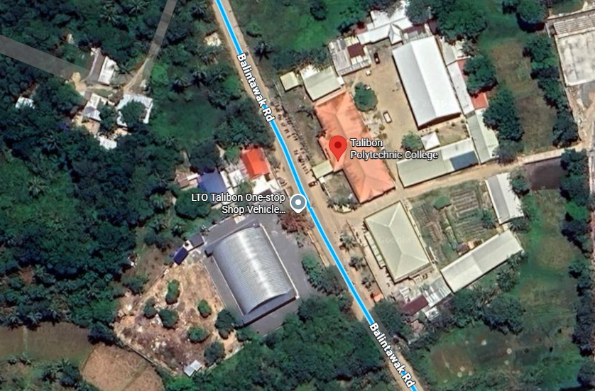
The system is intended for the main users involved in the student clearance process, including students, office staff or approvers, the Administrator or OSAS Director, and the College President or Final Approver of Talibon Polytechnic College.

Figure 1. Location Map of the Study
Research Instrument
This study will use a structured questionnaire as the main research instrument to evaluate the proposed web-based student clearance system with role-based approval. The questionnaire will be designed to gather the respondents’ assessment of the system in terms of usability, functionality, processing efficiency, transparency, accessibility, reliability, and user satisfaction.
The questionnaire will use a Likert scale to measure the level of agreement or satisfaction of the respondents regarding the system’s features, performance, and usefulness. The responses will be analyzed and interpreted based on the adopted rating scale of the research instrument.
The questionnaire will be administered to selected students, office staff or approvers, the administrator or OSAS director, and the college president or final approver after they have tested and interacted with the system prototype.
In addition to the questionnaire, system testing and observation will be conducted to determine whether the major system functions work as intended, including online clearance request submission, role-based approval, status tracking, notifications, printable clearance receipts, and QR code verification.
Research Respondents
The respondents of the study will be selected students, office staff or approvers, the Administrator or OSAS Director, and the College President or Final Approver of Talibon Polytechnic College. These respondents are chosen because they are the intended users of the proposed system and are directly involved in the existing manual clearance process.
The student respondents will consist of 35 students selected from the seven academic programs offered at Talibon Polytechnic College, with five students selected from each course. The student respondents are not meant to statistically represent the entire student population. Their primary purpose is to test and evaluate the proposed system by rating its usability, functionality, processing efficiency, transparency, accessibility, reliability, and user satisfaction through a structured questionnaire. The office staff or approvers will consist of the 13 personnel responsible for reviewing, approving, or rejecting clearance requests from their respective offices. The Administrator or OSAS Director will serve as the user responsible for managing accounts, monitoring clearance records, generating reports, and maintaining system configuration. The college president or final approver will represent the user responsible for the final approval of completed clearance requests.
The respondents were selected through purposive sampling by deliberately choosing five students from each of the seven courses to ensure diverse representation across all programs. It is also not feasible to have the entire student population test the system prototype, as respondents are required to first interact with the system before evaluating it. Therefore, a small yet diverse sample is sufficient and appropriate for a developmental study focused on system evaluation rather than statistical representation of the entire student population.
Research Procedures
The researchers will first identify the problems encountered in the existing manual student clearance process of Talibon Polytechnic College through observation and preliminary discussions with the intended users. The identified problems will be used to determine the system requirements, user roles, required clearance offices, and existing clearance workflow.
Next, the researchers will gather and analyze the requirements needed for the proposed system. This will include identifying the functions required by students, office staff or approvers, the administrator or OSAS director, and the college president or final approver.
After the requirements analysis, the researchers will design the proposed system. This will include preparing the database structure, user roles and permissions, clearance request workflow, approval and rejection processes, notification flow, user interface layouts, printable clearance receipts, and QR code verification process.
The researchers will then develop the system prototype. The development will focus on implementing student registration, course selection, student ID-based login, online clearance request submission, role-based approval, status monitoring, in-app notifications, final approval, receipt generation, and QR code verification.
After the prototype is developed, the researchers will conduct system testing to determine whether the major functions work as intended. The testing will cover student registration, login, clearance request submission, office-based approval, rejection with remarks, notification display, final clearance approval, receipt generation, and QR code verification.
The researchers will then allow selected respondents to test and interact with the developed system prototype. After using the system, the respondents will answer a structured questionnaire to evaluate the system in terms of usability, functionality, processing efficiency, transparency, accessibility, reliability, and user satisfaction.
Finally, the researchers will tabulate and analyze the gathered evaluation data. The results will be used to determine the effectiveness, acceptability, and perceived improvements brought by the developed system. The researchers will then finalize the system documentation based on the findings of the study.

Research Flow
Problem Identification

Requirements Gathering and Analysis

System Design


System Development

System Testing

User Evaluation



Data Analysis and Documentation

Figure 2. Research Flow of the Study

Chapter 2

REVIEW AND RELATED LITERATURE/SYSTEMS

Related Literature

Student clearance is an important administrative process in educational institutions because it determines whether students have completed the necessary academic, administrative, and office-related requirements required by the school. Traditionally, this process is performed using paper-based forms, manual signatures, and personal visits to different offices. Adamu (2022) noted that manual clearance procedures usually require students to move from one office to another to secure approval, making the process time-consuming and inconvenient. Similarly, Eweoya, Agbeyangi, and Lukose (2025) and Adegoke and Olalekan (2026) emphasized that manual clearance procedures may cause delays, poor monitoring, and difficulty in coordinating clearance activities across departments.
The manual clearance process can affect both students and office personnel. Students may need to spend additional time moving from one office to another, while office staff may need to manually check, sign, and organize clearance records. Awofolaju, Bada, Alawode, and Orotosho (2023) explained that manual clearance operations may lead to excessive paperwork, document loss, document forgery, and the need for physical presence during processing. These issues show the need for a more efficient and organized system that can reduce manual handling of records and improve the monitoring of clearance transactions.
Digital clearance systems provide a possible solution to the limitations of manual clearance processing. Essel et al. (2023) developed an online students clearance system clearance signing for higher education institutions and emphasized that manual clearance procedures can be difficult for both students and clearing officers. Their study showed that a digital clearance platform can support a more organized and efficient clearance process. Similarly, Mangubat et al. (2023) developed an online student clearance management system that allowed clearance signing to be processed online, enabled students to view their clearance status, and used QR code technology for final clearance verification.
Web-based clearance systems also improve accessibility and coordination among users involved in the clearance process. Through a centralized online platform, students may submit clearance requests, office staff may review and approve records, and users may monitor the progress of clearance requests. Eweoya, Agbeyangi, and Lukose (2025) stated that web-based clearance systems can centralize clearance activities across departments, allow students to monitor their clearance status in real time, and improve administrative efficiency. This supports the need for a web-based system that can reduce delays and improve transparency in student clearance processing.
Role-based access is also important in a student clearance system because different users perform different functions. Students need access to their own clearance records, office staff need access to requests assigned to their respective offices, administrators need access to system management and monitoring features, and the final approver needs access to requests that have undergone the required office approvals. Adegoke and Olalekan (2026) included role-based access control in their workflow-driven online student clearance system to support multi-departmental clearance processing. This indicates that role-based access can help organize user responsibilities and prevent unauthorized actions within a clearance workflow.
Status tracking and notification features also support the efficiency of digital clearance systems. Real-time status tracking allows students to monitor whether their clearance requests are pending, approved, rejected, or completed. Notifications can inform users about updates, remarks, and required actions. Eweoya, Agbeyangi, and Lukose (2025) noted that the lack of real-time communication between departments is one of the problems in manual clearance processes. Therefore, status tracking and notifications are important features in improving communication and transparency among students and clearance offices.
QR code verification can also strengthen the validation of final clearance records. Mangubat et al. (2023) used QR code technology as a mechanism for finalizing clearance approval and reducing dependence on signed paper forms. Adegoke and Olalekan (2026) also included QR code-enabled clearance certificate verification in their workflow-driven clearance system. These studies show that QR code verification can help validate final clearance records and provide a faster method of confirming whether a student has completed the required clearance process.
The related literature shows that digital systems can improve manual administrative processes by providing centralized records, role-based access, status monitoring, notifications, and verification features. These concepts support the development of the proposed Web-based Student Clearance System with Role-Based Approval for Talibon Polytechnic College.
Related Studies
Several studies have been conducted on the development of online and automated clearance systems in educational institutions. These studies focused on improving manual clearance procedures through digital platforms, role-based access, status monitoring, office approval workflows, and verification features. The following related studies support the development of the proposed web-based student clearance system with role-based approval for Talibon Polytechnic College.
Essel et al. (2023), in their study entitled “Digitalising the Clearance Processes of Higher Education Institutions through the Design and Implementation of an Online Clearance System,” developed an online student clearance system for higher education institutions. The study used the Agile methodology in the development process. The system was developed using ASP.NET MVC 5, MSSQL 2014, JavaScript, HTML, and CSS. The findings showed that the developed system provided an effective and efficient web-based platform that addressed the challenges of manual paper-based clearance procedures. The study supports the present project by showing that a web-based clearance system can improve the efficiency, accessibility, and organization of clearance processing.
Similarly, Mangubat et al. (2023) conducted a study entitled “Online Student Clearance Management System,” which aimed to address the manual process of student clearance signing in an academic institution in Pagadian City, Zamboanga del Sur. The study used the Waterfall Model, which included requirements specification, planning, design, development, implementation, testing, deployment, and maintenance. The system allowed clearance signing to be processed online, enabled students to view their clearance status, allowed office heads or representatives to approve or reject student clearances, and used QR code technology for final clearance verification. Its connection to the proposed system can be seen in the use of online clearance processing, status monitoring, office approval, and QR code verification to reduce dependence on manual clearance forms.
In the same manner, Awofolaju, Bada, Alawode, and Orotosho (2023), in their study entitled “Design and Implementation of an Automated Departmental Clearance System,” developed an automated departmental clearance system for graduating students. The study used the Waterfall Model and developed the system using Python for back-end processing, HTML, CSS, and JavaScript for the user interface, and MySQL for database management. The findings showed that the system improved efficiency by reducing paperwork, processing time, document loss, document forgery, and the need for students to be physically present during clearance processing. These findings are useful to the current study because they emphasize the need to automate clearance procedures and maintain organized digital records for student clearance transactions.
Moreover, Eweoya, Agbeyangi, and Lukose (2025), in their study entitled “Streamlining Student Clearance in Higher Education: A Web-based Solution,” developed and tested a web-based student clearance system intended to improve administrative efficiency, transparency, and user experience in higher education institutions. The system was developed using ExpressJS for the backend, ReactJS for the frontend, and MongoDB for data storage. It included functions such as real-time status tracking, role-based access control, automated notifications, and departmental clearance monitoring. The findings showed that the system reduced clearance processing time, minimized human errors, and improved administrative efficiency. This supports the proposed systems’ inclusion of real-time tracking, notifications, and role-based clearance processing.
Furthermore, Adegoke and Olalekan (2026) conducted a study entitled “Design and Development of a Workflow-Driven Online Student Clearance System for Seamless Multi-Departmental Integration.” The study focused on automating student clearance workflows across multiple departments in higher education institutions. The system was developed using the Django framework and MySQL database. It included role-based access control, department-wise document submission, automated email notifications, real-time clearance tracking, and QR code-enabled clearance certificate verification. The findings showed that a workflow-driven system can improve coordination among departments, reduce delays, improve data consistency, and strengthen transparency in clearance processing. The study strengthens the basis of the present project by highlighting the importance of a centralized role-based workflow for office approvals, final clearance processing, and QR code verification.
Collectively, the reviewed studies show that online and automated clearance systems can improve the efficiency, transparency, accessibility, and organization of clearance processes in educational institutions. These studies provide a basis for the proposed web-based student clearance system with role-based approval for Talibon Polytechnic College, particularly in the areas of online request submission, role-based approval, status tracking, notifications, final approval, printable clearance records, and QR code verification.
Conceptual Framework
This study is guided by the Input-Process-Output (IPO) model. The input represents the existing problems in the manual clearance process, the needs of the target users, the necessary offices, and the system requirements needed for the proposed Web-Based Student Clearance System with Role-Based Approval. These inputs will serve as the basis for designing and developing the proposed system.
The process represents the activities involved in the development of the system. This includes system design, database design, student registration, course selection, student ID-based login, clearance request submission, role-based office approval, approval or rejection with remarks, status tracking, in-app notifications, final approval, printable clearance receipt generation, and QR code verification.
The output represents the proposed Web-based Student Clearance System with Role-Based Approval for Talibon Polytechnic College. The expected output of the study is a system that can provide a more organized clearance process, real-time clearance monitoring, role-based approval, printable clearance records, and QR code-based verification of cleared students.

INPUT

- Problems in the existing manual clearance process
- Needs of students, office staff, administrator, and final approver
- Required clearance offices
- User roles and permissions
- Clearance workflow requirements
- System feature requirements

- System design and database design
- Student registration and course selection
- Student ID-based login
- Online clearance request submission
- Role-based office approval
- Approval or rejection with remarks
- Status tracking and in-app notifications
- Final approval process
- Printable clearance receipt generation
- QR code verification
PROCESS

OUTPUT

- Web-based Student Clearance System with Role-Based Approval for Talibon Polytechnic College
- More organized student clearance processing
- Real-time clearance status monitoring
- Role-based clearance approval workflow
- Printable clearance receipt
- QR-based clearance verification

Figure 3. Conceptual Framework of the Study
CHAPTER 3
TECHNICAL BACKGROUND
The proposed Web-Based Student Clearance System with Role-Based Approval for Talibon Polytechnic College is designed to improve the existing manual clearance process by providing a centralized platform for managing student clearance transactions. Through the system, students can submit clearance requests online, monitor their clearance status, receive notifications, and obtain printable clearance receipts. Likewise, office staff or approvers, the Administrator or OSAS Director, and the College President or Final Approver can perform their designated responsibilities through a role-based approval workflow.
To support these functionalities, the proposed system will utilize various software technologies, development tools, database technologies, and architectural components. The system will be developed using Laravel, Vue.js, Inertia.js, Tailwind CSS, and MySQL within a web-based environment that supports accessibility across different devices and web browsers. These technologies will enable the system to provide efficient clearance processing, real-time status monitoring, approval management, and QR code verification.
This chapter presents the technical background of the proposed system, including the software requirements, hardware requirements, programming languages, development tools, database technologies, network architecture, software architecture, security features, and system architecture that will be used in the development and implementation of the project.
3.1 Software Requirements
These consist of the applications and technologies that will be used in the development and operation of the proposed system. These software technologies support the system’s functionality, user interface, database management, and accessibility.
Table 3.1. Software Requirements
Software | Description
Laravel | Backend framework used to manage application logic, routing, authentication, and database transactions.
Vue.js | Frontend framework used for interactive and responsive user interfaces.
Inertia.js | Integrates the Laravel backend and Vue.js frontend.
Tailwind CSS | Used for interface design and responsive layouts.
MySQL | Database management system for storing system records.
Google Chrome | Supported browser for accessing the system.
Mozilla Firefox | Supported browser for accessing the system.
Microsoft Edge | Supported browser for accessing the system.

3.2 Hardware Requirements
The proposed system is designed as a web-based application that can be accessed through desktop computers, laptops, and mobile devices. These devices will enable users to access the system and perform their assigned functions within the clearance process.
Table 3.2. Hardware Requirements
Hardware | Description
Desktop Computer or Laptop | Used by students, staff or approvers, the Administrator or OSAS Director, and the College President or Final Approver to access the proposed system and perform their respective functions.
Mobile Device | Used to access the proposed system through supported web browsers. The system is designed as a responsive web application that can be accessed across different devices.
Internet Connection | Required to access the web-based student clearance system.

3.3 Programming Languages
The proposed system will utilize programming languages that support backend development, frontend interaction, and database management. These programming languages will be used to implement the functionalities, user interfaces, and data processing requirements of the proposed system.
Table 3.3. Programming Languages
Programming Language | Description
PHP | Used as the primary server-side programming language through the Laravel framework. It will process user requests, implement system functionalities, and communicate with the database.
JavaScript | This will be utilized through Vue.js and Inertia.js to provide interactive and responsive functionalities within the system. It will support user interactions and dynamic content updates.
SQL | Structured Query Language (SQL) will be used for storing, retrieving, updating, and managing records within the MySQL database.

3.4 Development Tools
The development of the proposed Web-Based Student Clearance System with Role-Based Approval will utilize various tools that support backend development, frontend development, system integration, and user interface design. These tools will be used throughout the development process to ensure that the system functions efficiently and provides a responsive and user-friendly environment for its users
The development tools that will be utilized in the study include Laravel, Vue.js, Inertia.js, and Tailwind CSS. Laravel will support the development of the backend functionalities of the system, while Vue.js will be used to create interactive user interfaces. Inertia.js will facilitate the integration of frontend and backend components, and Tailwind CSS will be utilized for interface design and responsiveness.
3.5 Database Technologies
Table 3.4. Database Technology
Database Technology | Description
MySQL | This will store and manage student records, clearance requests, approval records, notifications, clearance status, printable clearance receipts, and QR verification information to support the system’s operations.
3.6 Network Architecture

Client Tier
Administrator /
OSAS Director

Web browser
(PC/laptop/mobile)
Office staff /
Approver

Web browser
(PC/laptop/mobile)
Student

Web browser
(PC/laptop/mobile)
President /
Final Approver

Web browser
(PC/laptop/mobile)

Network Tier

TPC Campus Network

Wi-Fi / LAN, with internet access for off-campus users

Queries / Results
Web / Application Server

Laravel, Vue.js, Inertia.js,
Tailwind CSS
Database Server

MySQL
Student, clearance, and
Approval records

Server Tier

Figure 4. Network Architecture of the Proposed System

3.7 Software Architecture
Figure 5. Software Architecture of the Proposed System
Database Server

- MySQL
- Student records
- Clearance records
- Approval records
Web / Application Server

- Laravel
- Vue.js
- Inertia.js
- Tailwind CSS
TPC Campus Network

Wi-Fi / LAN, with internet access for off-campus users
President / Final Approver

Web Browser
(PC/Laptop/Mobile)

Student

Web Browser
(PC/Laptop/Mobile)
Administrator / OSAS Director

Web Browser
(PC/Laptop/Mobile)

Office Staff / Approver

Web Browser
(PC/Laptop/Mobile)
3.8 Security Features
The proposed Web-Based Student Clearance System implements several built-in and framework-level security mechanisms to ensure data privacy, prevent unauthorized access, and protect institutional records.
Table 3.5. Security Features of the Proposed System

Security Features | Description
Role-Based Access | Restricts system functions based on the assigned user role, ensuring students, office staff, the Administrator, and the College President only access their designated workflows.
User Authentication | Secures system entry through a student ID-based login process to ensure that only registered users can access clearance records and submit requests.
Public QR Code Verification Control | Restricts the QR code verification feature strictly to public, read-only verification of a cleared student’s final record, as it does not include advanced encryption-based authentication.

3.9 System Features

Table 3.6. System Features of the Proposed System

System Features | Description
Student Registration & Course Selection | Allows students to self-register by providing their student ID and selecting their respective academic course program.
Student ID-Based Login | Secures access to the system using the student's unique ID number to authenticate their clearance profile.
Online Clearance Request Submission | Enables students to digitally initiate and submit clearance requests for a specific semester or school year.
Course-Based Clearance Processing | Organizes and classifies clearance records and requests according to the student's academic program.
Role-Based Clearance Approval & Rejection with Remarks | Allows designated office staff/approvers to evaluate requests, grant approvals, or reject requests with descriptive remarks when obligations are unmet.
Real-Time Clearance Status Monitoring | Enables students and approvers to track clearance progress in real time (e.g., pending, approved, rejected, or cleared) across multiple offices.
In-App Notifications | Delivers system-generated messages to inform users of updates, approvals, rejections, remarks, or required compliance actions.
Final Approval Process | Routes completed office clearances to the College President / Final Approver for final clearance authorization and status generation.
Printable Clearance Receipts | Generates an official printable receipt/record confirming that a student has completed all required clearance requirements.
QR Code Verification | Provides a scannable QR code on clearance records directing to a public, read-only verification page to validate the authenticity of a cleared student.
Administrative & Record Management | Allows the Administrator / OSAS Director to manage user accounts, offices, course modules, monitor overall clearance records, and generate administrative reports.
Responsive Web Access | Adjusts layouts dynamically to allow desktop, laptop, and mobile device access via supported browsers without requiring a native app installation.

CHAPTER 4
METHODOLOGY, RESULTS, AND DISCUSSION
4.1 Requirement Analysis
This involves identifying, analyzing, and documenting the specific functional and non-functional capabilities that the Web-Based Student Clearance System with Role-Based Approval must possess to meet the needs of Talibon Polytechnic College.
Functional Requirements
Table 4.1.1. Functional Requirements
Feature | Description | Target User
Registration & Course Selection | The system must allow students to self-register using their student ID and select their academic course program. | Student
User Authentication | The system must secure access through a student ID-based login process. | All Users
Clearance Request Submission | The system must enable students to digitally initiate and submit clearance requests for a specific semester or school year. | Student
Course-Based Classification | The system must organize and classify clearance records and requests according to the student's academic program. | System
Role-Based Access Control | The system must implement role-based access for students, office staff, the Administrator, and the College President. | System
Office Approval & Remarks | The system must allow designated office staff to evaluate requests, grant approvals, or reject them with descriptive remarks. | Office Staff / Approver
Status Monitoring | The system must allow users to monitor clearance progress (pending, approved, rejected, cleared) in real time. | Student, Approver, Admin
In-App Notifications | The system must deliver notifications to inform users of updates, approvals, rejections, or required actions. | All Users
Final Clearance Authorization | The system must route completed office clearances to the College President for final approval and status generation. | College President
Printable Clearance Receipt | The system must generate an official printable receipt confirming a student has completed all requirements. | Student
QR Code Verification | The system must generate a scannable QR code directing to a public, read-only verification page to validate authenticity. | Admin
Administrative Management | The system must allow the Administrator to manage accounts, offices, course modules, and generate reports. | Administrator

Non-functional Requirements
Table 4.1.2. Non-functional Requirements
Feature | Description
Accessibility | The system must be a responsive web application that dynamically adjusts its layout for desktop, laptop, and mobile devices.
Platform Compatibility | The system must be accessible via supported web browsers, specifically Google Chrome, Mozilla Firefox, and Microsoft Edge, without requiring a native mobile app installation.
Network Dependency | The system requires an active internet connection or TPC Campus Network access (Wi-Fi/LAN) to operate.
Security & Authentication | The system must implement role-based access restrictions and require user authentication through a student ID-based login process.
Verification Limitation | The QR code verification feature must be restricted to a public, read-only verification page without advanced encryption-based authentication.
Integration Boundaries | The system must function independently without processing online payments or integrating with other institutional databases such as the library or registrar.

4.2 Requirements Documentation
User Requirements
The following table outlines the specific needs and expected system interactions for each of the four main user roles involved in the clearance process of Talibon Polytechnic College.
Table 4.2.1. User Requirements
User Role | Requirements Description
Students | Require a digital platform to self-register using their student ID, select their course, submit clearance requests, monitor status in real time, view remarks from offices, and access a printable clearance receipt.
Office Staff or Approvers | Require the ability to review clearance requests assigned to their respective offices, approve or reject the requests, and provide remarks when requirements have not yet been completed.
Administrator or OSAS Director | Require administrative functionalities to manage user accounts, offices, course modules, clearance records, and reports.
College President or Final Approver | Require access to review requests that have completed all required office approvals to serve as the final approver.

System Requirements
This table details the hardware and software components necessary for the users to access the system and for the server to successfully host the web-based clearance application.
Table 4.2.2. System Requirements
Requirement Type | Description
Hardware | The system requires users to have a desktop computer, laptop, or mobile device connected to the internet or the TPC Campus Network.
Software | The system requires a web browser (such as Google Chrome, Mozilla Firefox, or Microsoft Edge) for access. The server environment requires PHP (Laravel framework) for the backend, JavaScript (Vue.js and Inertia.js) for the frontend, Tailwind CSS for design, and a MySQL database to manage system records.

Use Case Descriptions
The table below identifies the major interactions between the primary actors and the system to accomplish specific tasks within the clearance workflow.
Table 4.2.3. Use Case Descriptions
Use Case Name | Primary Actor | Description
Register Account | Student | The student self-registers by providing their student ID and selecting their academic course program.
Submit Clearance Request | Student | The student digitally initiates and submits a clearance request for processing.
Evaluate Clearance | Office Staff or Approver | The office staff reviews a submitted request assigned to their office and approves or rejects it with remarks.
Finalize Clearance | College President or Final Approver | The final approver reviews the request after all required office approvals have been completed and grants final approval.
Manage System | Administrator or OSAS Director | The administrator manages user accounts, offices, course modules, clearance records, and system reports.
Verify Clearance | Admin | A user scans the QR code to verify the authenticity of a cleared student's final record through a public verification page.

4.3 System Design
System Flowchart
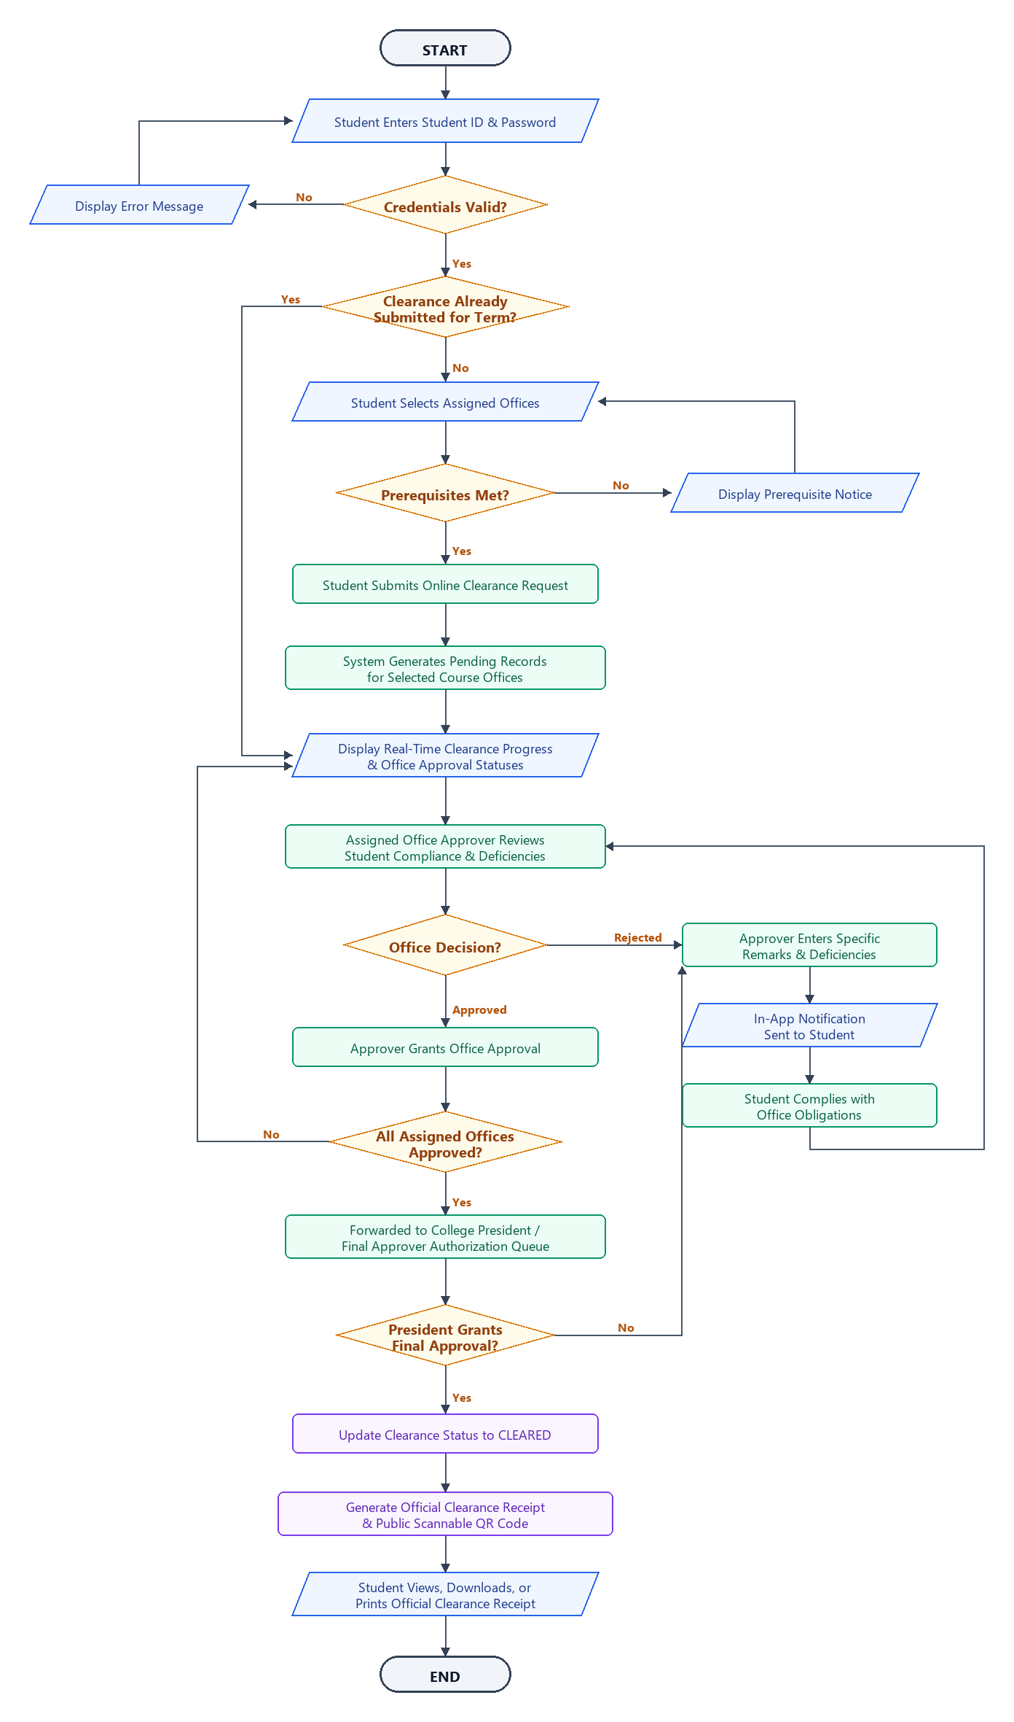
The system flowchart illustrates the complete operational workflow and decision-making logic of the Web-Based Student Clearance System with Role-Based Approval for Talibon Polytechnic College.

Figure 6. System Flowchart of the Study
Data Flow Diagrams
Context Diagram (Level 1 Data Flow Diagram)
The Context Diagram establishes the global scope of the application by representing the entire clearance system as a single primary process (Process 0.0) interacting with five external entities: the Student, Office Staff / Approver, College President / Final Approver, Administrator / OSAS Director, and the Public / Verifier. Figure 7 illustrates the contextual information exchange across these primary stakeholders.
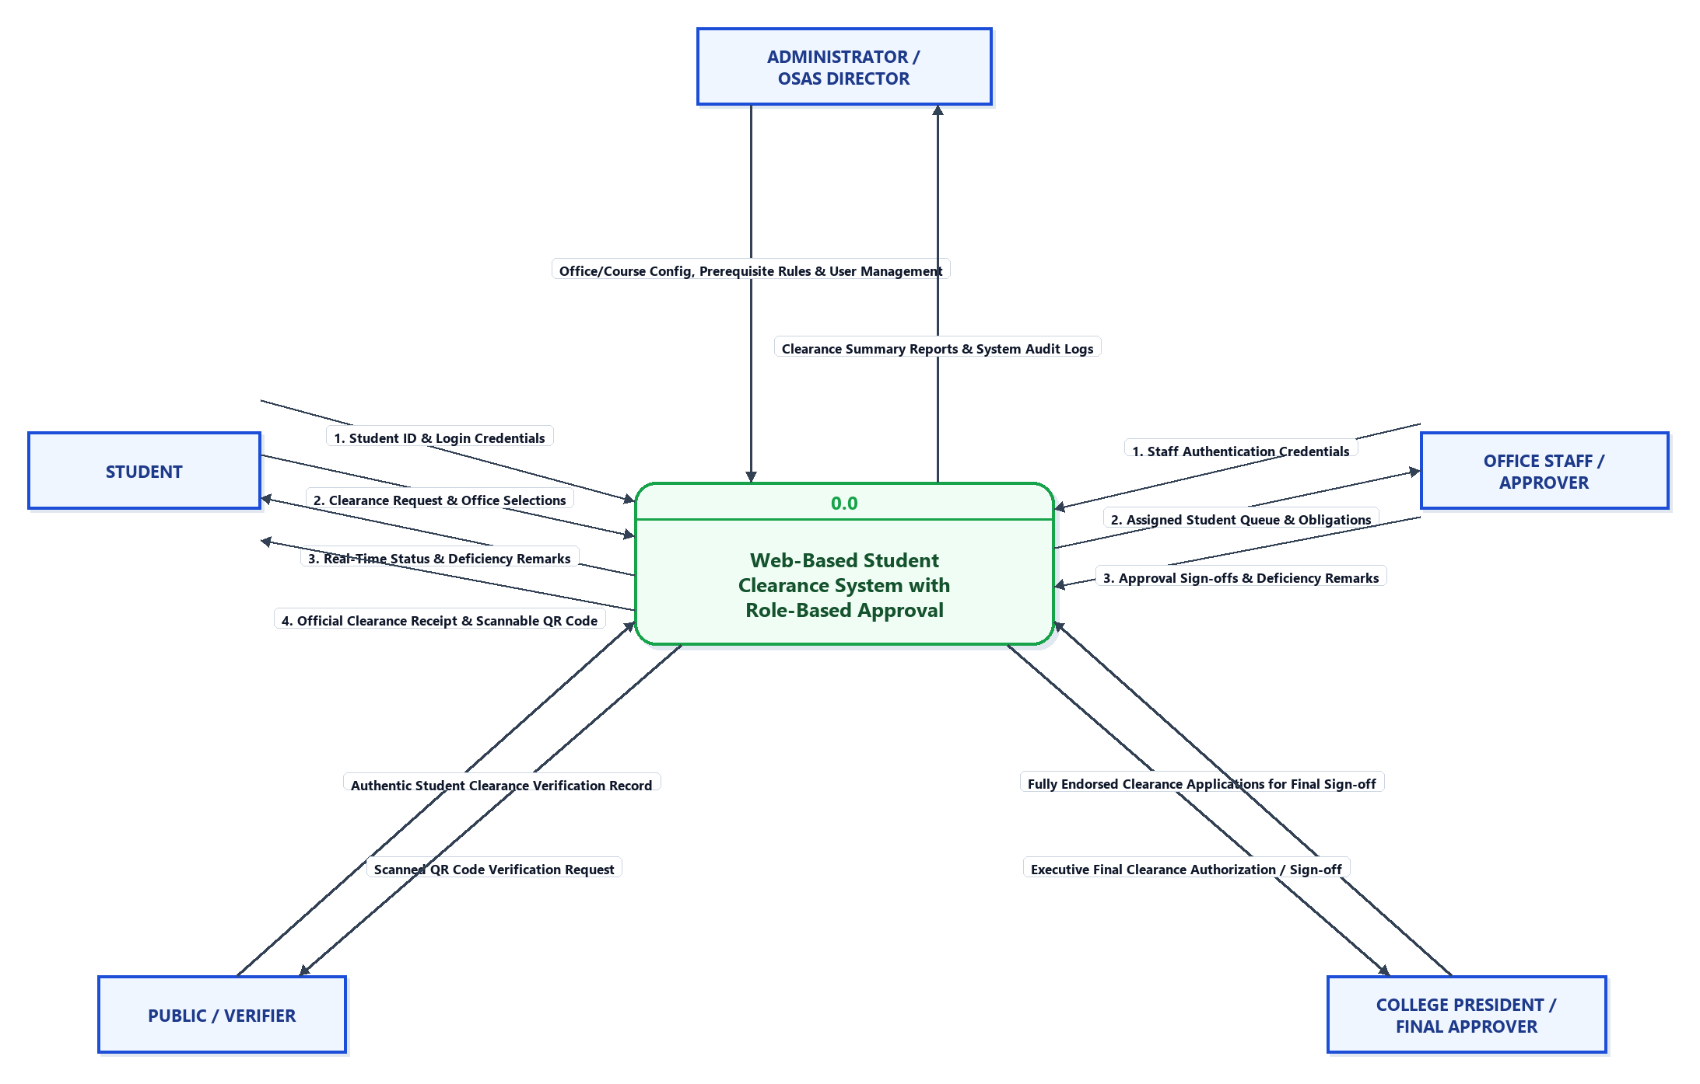

Figure 7. Context Diagram (Level 0 DFD) of the Study

Level 1 Data Flow Diagram
The Level 1 Data Flow Diagram provides an architectural decomposition of Process 0.0 into six core operational sub-processes. It explicitly traces the routing of information between the external entities, sub-processes, and the six fundamental data repositories of the system. Figure 8 delineates the comprehensive data flow structure.
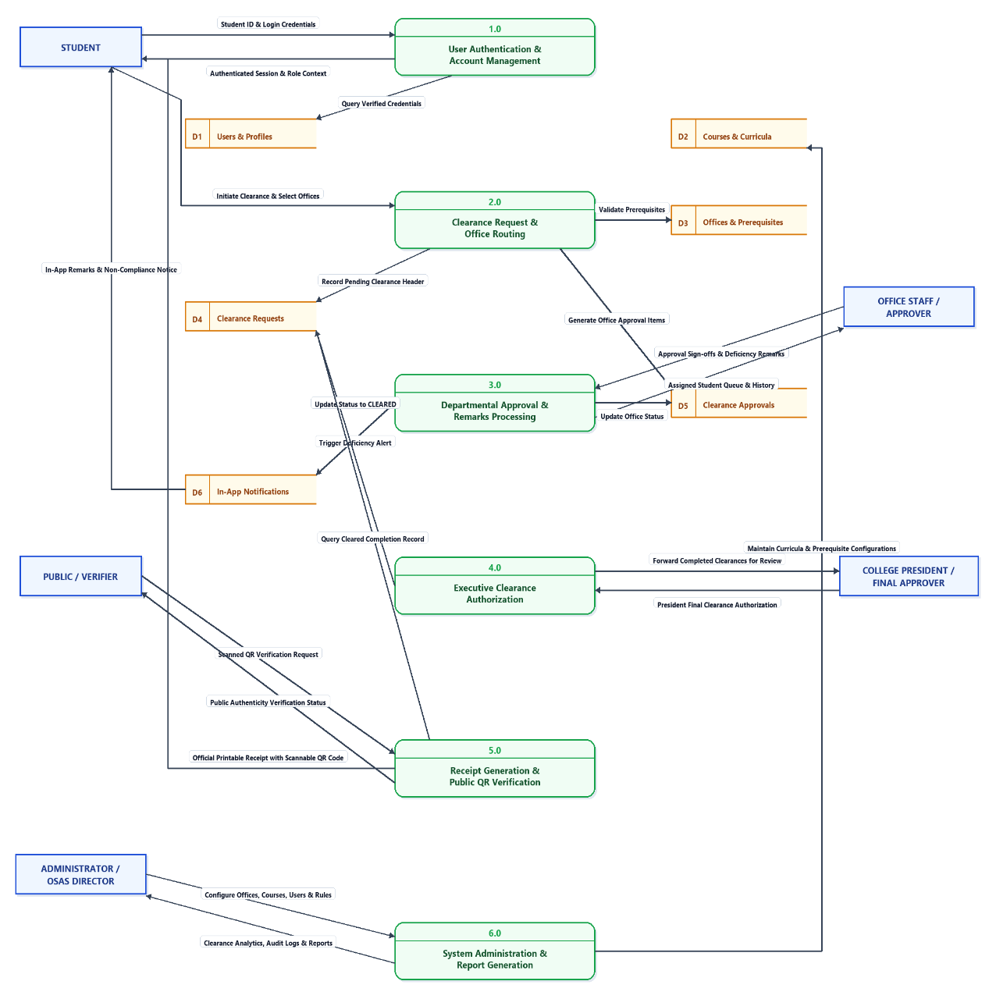

Figure 8. Level 1 Data Flow Diagram
Entity-Relationship Diagram
The Entity-Relationship Diagram (ERD) establishes the logical data architecture and structural schema governing the Web-Based Student Clearance System with Role-Based Approval for Talibon Polytechnic College.
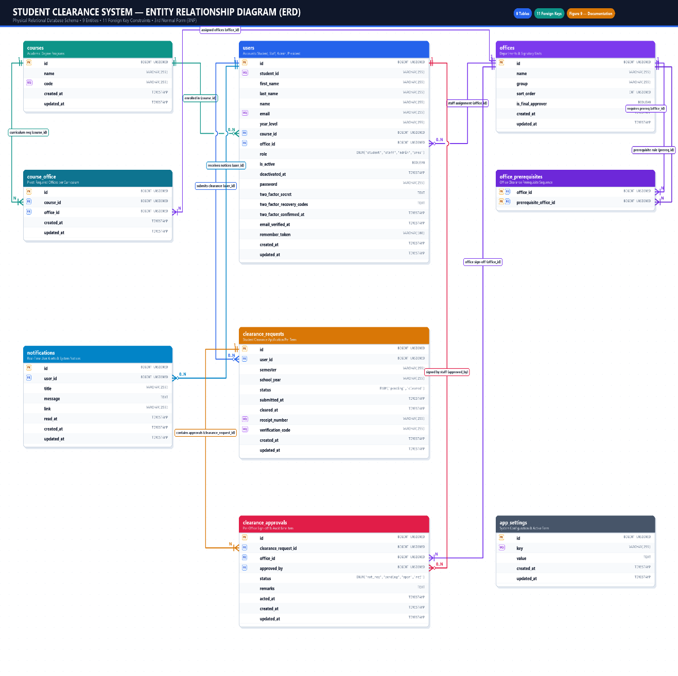

Figure 9. Entity-Relationship Diagram (ERD) of the Study
Use Case Diagram
The Use Case Diagram defines the functional scope and behavioral boundaries of the Web-Based Student Clearance System with Role-Based Approval for Talibon Polytechnic College. It visually maps the interactions between the five primary actors and the specific system use cases, illustrating how students, office staff, executive approvers, administrators, and external verifiers interface with the platform.
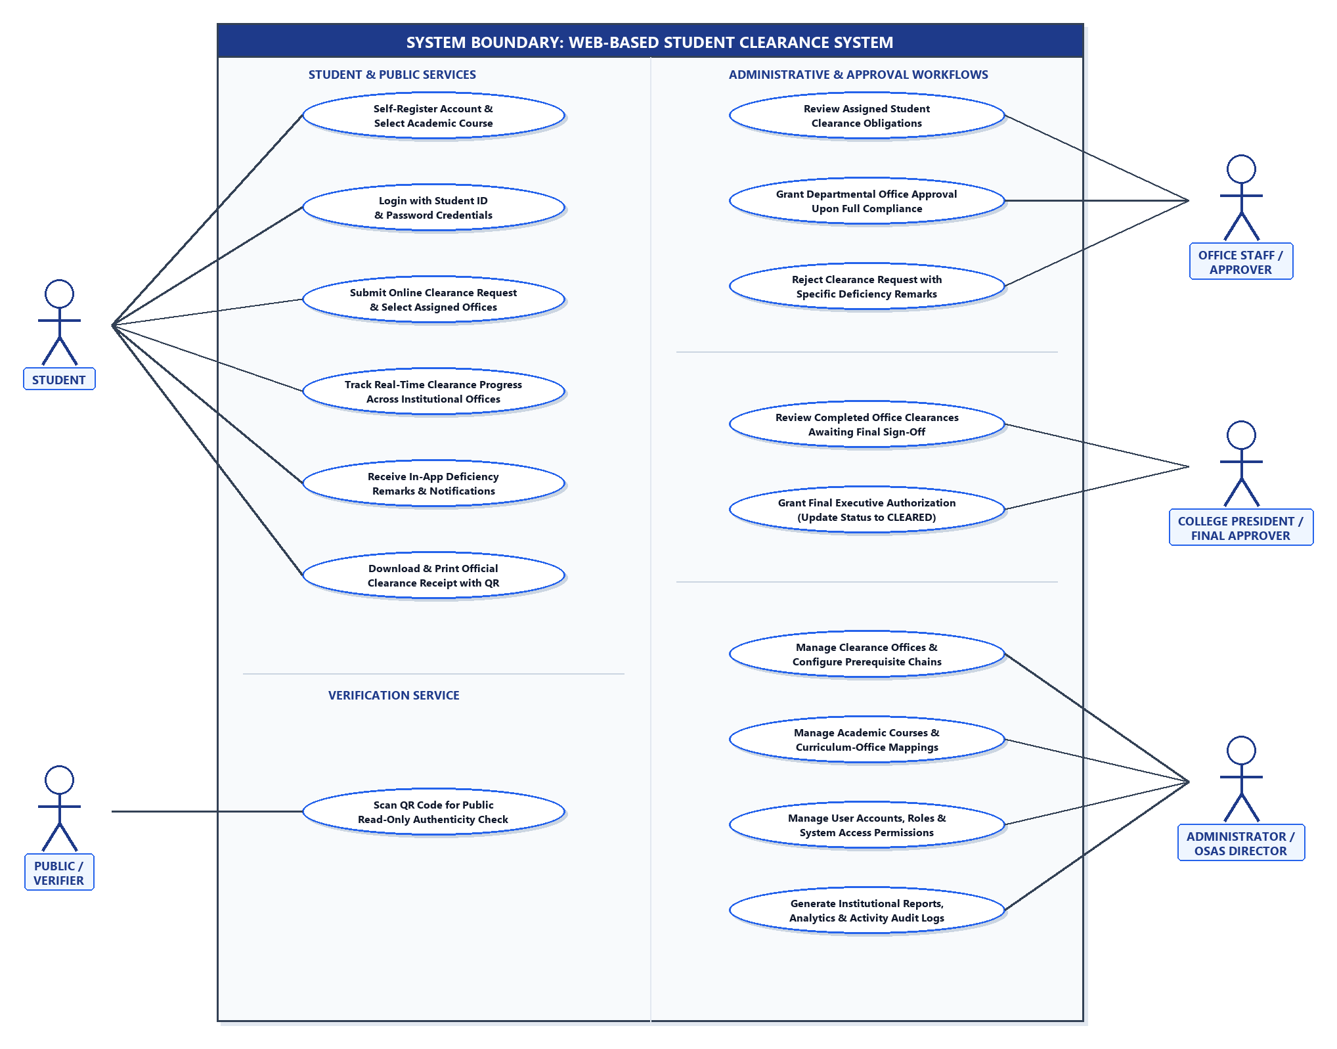

Figure 10. Use Case Diagram of the Study

Activity Diagram
The Activity Diagram models the dynamic operational behavior, procedural logic, and concurrency controls of the Web-Based Student Clearance System with Role-Based Approval for Talibon Polytechnic College.
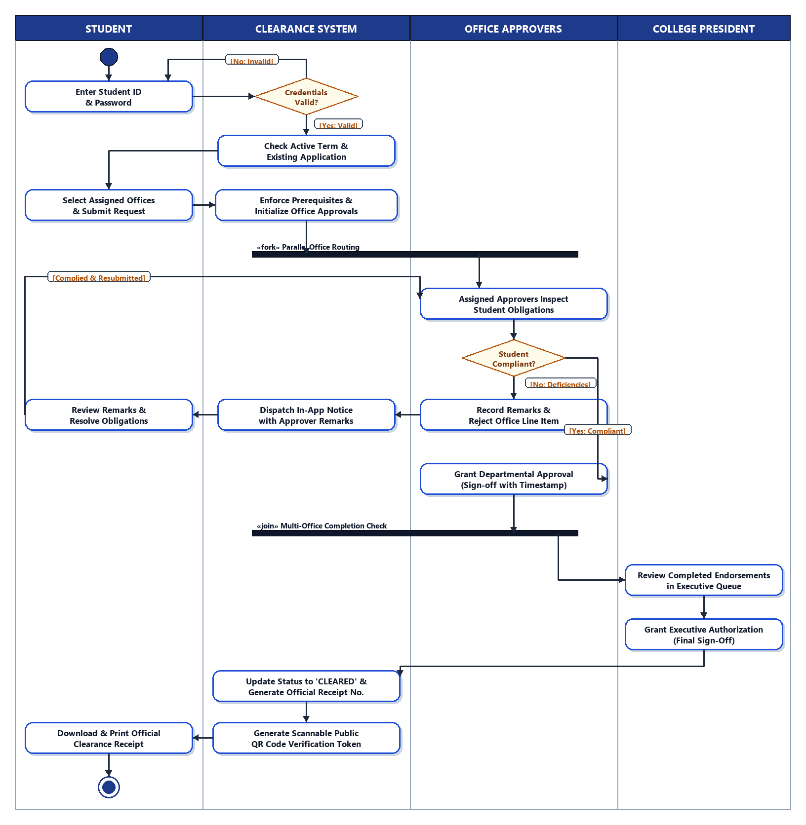

Figure 11. Activity Diagram of the Clearance Approval Workflow
Sequence Diagram
The Sequence Diagram models the dynamic, temporal interactions and message-passing mechanisms that occur between system entities during the core clearance evaluation and remarks handling process of the Web-Based Student Clearance System with Role-Based Approval for Talibon Polytechnic College.

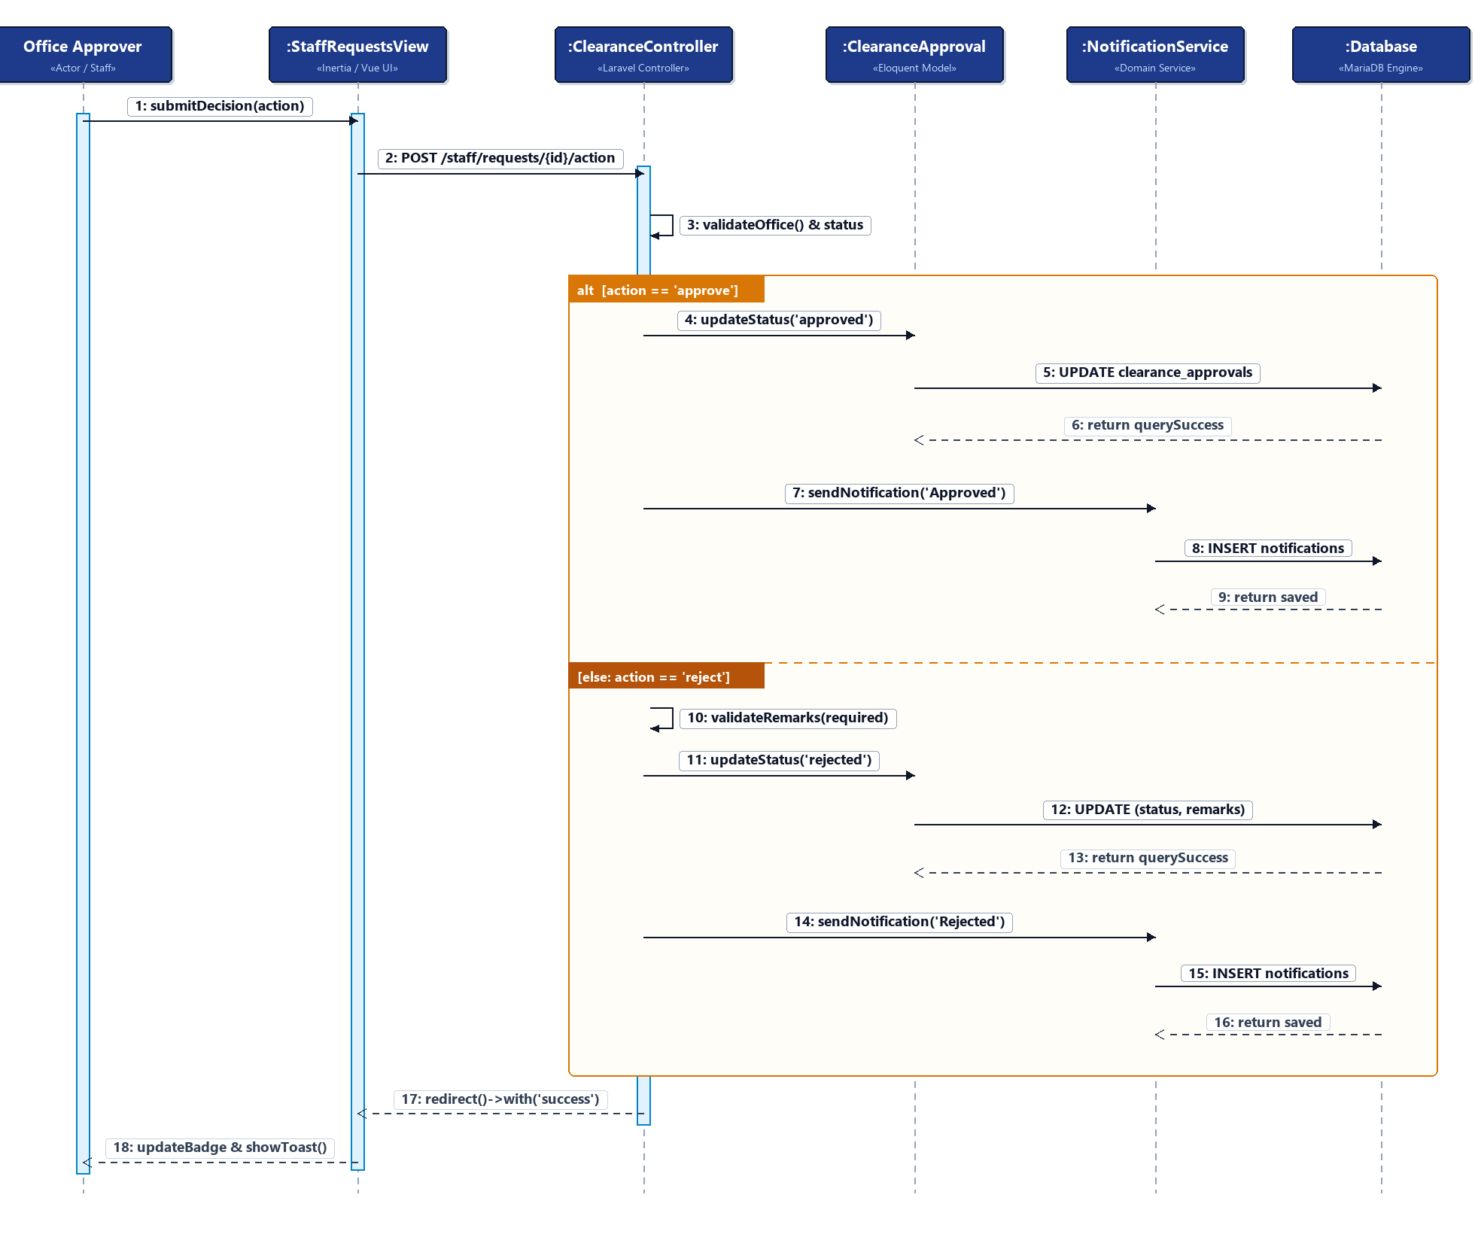

Figure 12. Sequence Diagram of the Clearance Evaluation and Approval Workflow
Class Diagram
The Class Diagram captures the static object-oriented structure, domain entities, attribute definitions, operations, and relational multiplicities of the Web-Based Student Clearance System with Role-Based Approval for Talibon Polytechnic College. Designed in strict compliance with UML 2.0 specifications and directly reflecting the application's Laravel Eloquent Object-Relational Mapping (ORM) architecture and MariaDB schema, the diagram defines the contracts, associations, and structural constraints that govern the clearance domain.
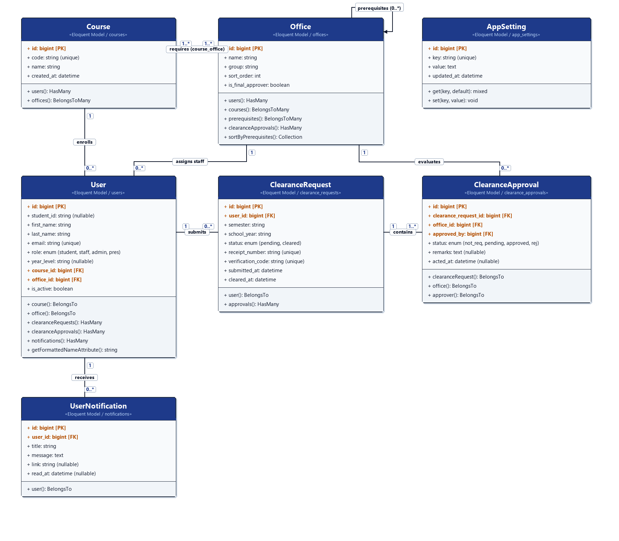

Figure 13. Class Diagram of the Student Clearance System

Database Design
Database Design defines the physical relational tables, column structures, data types, integrity constraints, and referential mappings that persist institutional records for the Web-Based Student Clearance System with Role-Based Approval for Talibon Polytechnic College.
Table 4.3.8.1. Users Table Data Dictionary (users)
Field Name | Data Type | Null | Key / Constraint | Description
id | BIGINT(20) UNSIGNED | NO | PRIMARY KEY, AUTO_INC | Unique surrogate identifier for each institutional user account.
student_id | VARCHAR(255) | YES | UNIQUE KEY | Official institutional student ID number (e.g., TPC-2024-0012). Null for non-student roles.
name | VARCHAR(255) | NO | None | Full legal name of the user or account display name.
email | VARCHAR(255) | YES | UNIQUE KEY | Official institutional or personal email address used for system login and alerts.
course_id | BIGINT(20) UNSIGNED | YES | FOREIGN KEY -> courses(id) | Foreign key referencing the student's enrolled academic program. Null for administrative staff.
office_id | BIGINT(20) UNSIGNED | YES | FOREIGN KEY -> offices(id) | Foreign key referencing the staff member's assigned clearance office. Null for students.
role | ENUM('student', 'staff', 'admin', 'president') | NO | DEFAULT 'student' | Role-Based Access Control (RBAC) role defining system privileges and navigation.
is_active | TINYINT(1) | NO | DEFAULT 1 | Boolean status flag indicating account activation (1 = Active, 0 = Deactivated).
deactivated_at | TIMESTAMP | YES | None | Timestamp recording when the user account was deactivated by the system administrator.
email_verified_at | TIMESTAMP | YES | None | Timestamp indicating when the user verified their email address.
password | VARCHAR(255) | NO | None | Bcrypt-hashed password string for secure authentication.
remember_token | VARCHAR(100) | YES | None | Cryptographic token for persistent browser session authentication.
created_at | TIMESTAMP | YES | None | Record creation audit timestamp managed by Eloquent ORM.
updated_at | TIMESTAMP | YES | None | Record modification audit timestamp managed by Eloquent ORM.

Table 4.3.8.2. Courses Table Data Dictionary (courses)
Field Name | Data Type | Null | Key / Constraint | Description
id | BIGINT(20) UNSIGNED | NO | PRIMARY KEY, AUTO_INC | Unique identifier for the academic degree program.
name | VARCHAR(255) | NO | None | Official title of the academic program (e.g., Bachelor of Science in Information Systems).
code | VARCHAR(255) | NO | UNIQUE KEY | Standard institutional program code abbreviation (e.g., BSIS, CRIMS, BEED).
created_at | TIMESTAMP | YES | None | Record creation timestamp.
updated_at | TIMESTAMP | YES | None | Record modification timestamp.

Table 4.3.8.3. Offices Table Data Dictionary (offices)
Field Name | Data Type | Null | Key / Constraint | Description
id | BIGINT(20) UNSIGNED | NO | PRIMARY KEY, AUTO_INC | Unique identifier for the institutional clearance department.
name | VARCHAR(255) | NO | None | Official departmental office name (e.g., Library, Cashier, Dean, Registrar, Guidance, Student Affairs).
group | VARCHAR(255) | YES | None | Administrative grouping or category designation for the office.
sort_order | INT(10) UNSIGNED | NO | DEFAULT 0 | Numerical priority index controlling display sequencing and topological queue order.
is_final_approver | TINYINT(1) | NO | DEFAULT 0 | Boolean flag designating the office as the executive final gatekeeper (1 = College President, 0 = Standard Department).
created_at | TIMESTAMP | YES | None | Record creation timestamp.
updated_at | TIMESTAMP | YES | None | Record modification timestamp.

Table 4.3.8.4. Course-Office Junction Table Data Dictionary (course_office)
Field Name | Data Type | Null | Key / Constraint | Description
id | BIGINT(20) UNSIGNED | NO | PRIMARY KEY, AUTO_INC | Unique surrogate identifier for the curriculum-office mapping entry.
course_id | BIGINT(20) UNSIGNED | NO | FK -> courses(id), UNIQUE(1) | Foreign key referencing the academic course. Part of composite unique key (course_id, office_id).
office_id | BIGINT(20) UNSIGNED | NO | FK -> offices(id), UNIQUE(2) | Foreign key referencing the mandatory clearance office for the linked course. Cascades on delete.
created_at | TIMESTAMP | YES | None | Record creation timestamp.
updated_at | TIMESTAMP | YES | None | Record modification timestamp.

Table 4.3.8.5. Office Prerequisites Junction Table Data Dictionary (office_prerequisites)
Field Name | Data Type | Null | Key / Constraint | Description
office_id | BIGINT(20) UNSIGNED | NO | PK(1), FK -> offices(id) | Foreign key referencing the target clearance office requiring a prerequisite. Cascades on delete.
prerequisite_office_id | BIGINT(20) UNSIGNED | NO | PK(2), FK -> offices(id) | Foreign key referencing the prerequisite office that must be cleared prior to the target office.

Table 4.3.8.6. Clearance Requests Table Data Dictionary (clearance_requests)
Field Name | Data Type | Null | Key / Constraint | Description
id | BIGINT(20) UNSIGNED | NO | PRIMARY KEY, AUTO_INC | Unique surrogate identifier for the student clearance application filing.
user_id | BIGINT(20) UNSIGNED | NO | FK -> users(id), UNIQUE(1) | Foreign key referencing the applying student in the users table. Cascades on delete.
semester | VARCHAR(255) | NO | INDEX(1), UNIQUE(2) | Academic semester term of application (e.g., '1st Semester', '2nd Semester', 'Summer').
school_year | VARCHAR(255) | NO | INDEX(2), UNIQUE(3) | Academic school year of application (e.g., '2026-2027'). Prevents duplicate semester filings.
status | ENUM('pending', 'cleared') | NO | DEFAULT 'pending' | Overall master state of the clearance filing. Transitions to 'cleared' once all obligations are fulfilled.
submitted_at | TIMESTAMP | YES | None | Exact date and time the student formally submitted the online clearance application.
cleared_at | TIMESTAMP | YES | None | Exact date and time when final executive approval was recorded, granting overall clearance.
receipt_number | VARCHAR(255) | YES | UNIQUE KEY | Official alphanumeric receipt serial number generated automatically upon full clearance completion.
verification_code | VARCHAR(255) | YES | UNIQUE KEY | Cryptographic alphanumeric verification token embedded into the scannable QR certificate code.
created_at | TIMESTAMP | YES | None | Record creation timestamp.
updated_at | TIMESTAMP | YES | None | Record modification timestamp.

Table 4.3.8.7. Clearance Approvals Table Data Dictionary (clearance_approvals)
Field Name | Data Type | Null | Key / Constraint | Description
id | BIGINT(20) UNSIGNED | NO | PRIMARY KEY, AUTO_INC | Unique surrogate identifier for the departmental clearance evaluation line item.
clearance_request_id | BIGINT(20) UNSIGNED | NO | FK -> clearance_requests(id), UNIQUE(1) | Foreign key referencing the parent clearance request. Cascades on delete.
office_id | BIGINT(20) UNSIGNED | NO | FK -> offices(id), UNIQUE(2), INDEX(1) | Foreign key referencing the evaluating department. Scopes staff pending queues.
approved_by | BIGINT(20) UNSIGNED | YES | FOREIGN KEY -> users(id) | Foreign key referencing the authenticated staff member who acted on the obligation. Sets NULL on delete.
status | ENUM('not_requested', 'pending', 'approved', 'rejected') | NO | DEFAULT 'not_requested', INDEX(2) | Granular departmental evaluation state indicating obligation compliance status.
remarks | TEXT | YES | None | Explicit deficiency descriptions, monetary obligations, or settlement instructions provided upon rejection.
acted_at | TIMESTAMP | YES | None | Exact timestamp when the staff signatory approved or rejected the departmental requirement.
created_at | TIMESTAMP | YES | None | Record creation timestamp.
updated_at | TIMESTAMP | YES | None | Record modification timestamp.

Table 4.3.8.8. Notifications Table Data Dictionary (notifications)
Field Name | Data Type | Null | Key / Constraint | Description
id | BIGINT(20) UNSIGNED | NO | PRIMARY KEY, AUTO_INC | Unique surrogate identifier for the in-app notification record.
user_id | BIGINT(20) UNSIGNED | NO | FOREIGN KEY -> users(id) | Foreign key referencing the recipient user account. Cascades on user deletion.
title | VARCHAR(255) | NO | None | Brief summary headline of the alert (e.g., 'Clearance request rejected', 'Clearance marked as complied').
message | TEXT | NO | None | Detailed notification body containing specific departmental feedback and cited deficiency remarks.
link | VARCHAR(255) | YES | None | Internal application route directing the recipient to relevant dashboard views (e.g., '/dashboard').
read_at | TIMESTAMP | YES | None | Timestamp recording when the user opened or read the notification (null indicates unread).
created_at | TIMESTAMP | YES | None | Record creation timestamp.
updated_at | TIMESTAMP | YES | None | Record modification timestamp.

Table 4.3.8.9. Application Settings Table Data Dictionary (app_settings)
Field Name | Data Type | Null | Key / Constraint | Description
id | BIGINT(20) UNSIGNED | NO | PRIMARY KEY, AUTO_INC | Unique surrogate identifier for the system configuration setting.
key | VARCHAR(255) | NO | UNIQUE KEY | Unique configuration key identifier (e.g., 'active_semester', 'active_school_year').
value | TEXT | YES | None | Global setting value stored as text and cached via Laravel Cache facade for fast runtime retrieval.
created_at | TIMESTAMP | YES | None | Record creation timestamp.
updated_at | TIMESTAMP | YES | None | Record modification timestamp.

Interface Design
This section presents the graphical user interfaces of the Web-Based Student Clearance System with Role-Based Approval for Talibon Polytechnic College. It illustrates the primary screens utilized by students, departmental office approvers, the College President, and administrators, as well as the generated clearance receipt and public QR verification page.
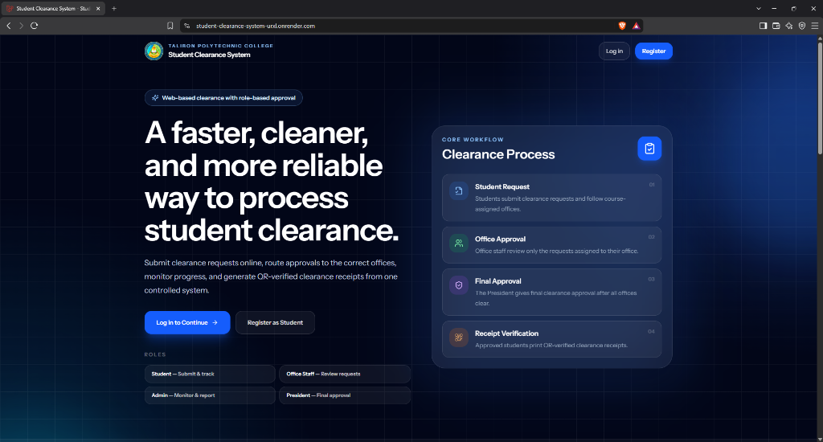
Figure 14. System Landing Page Interface
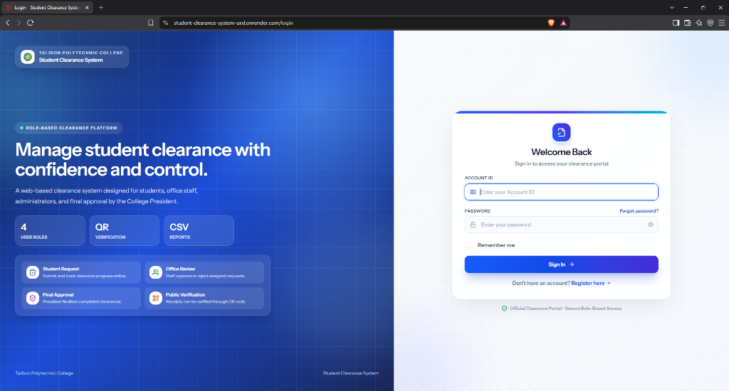
Figure 15. User Authentication (Login) Interface
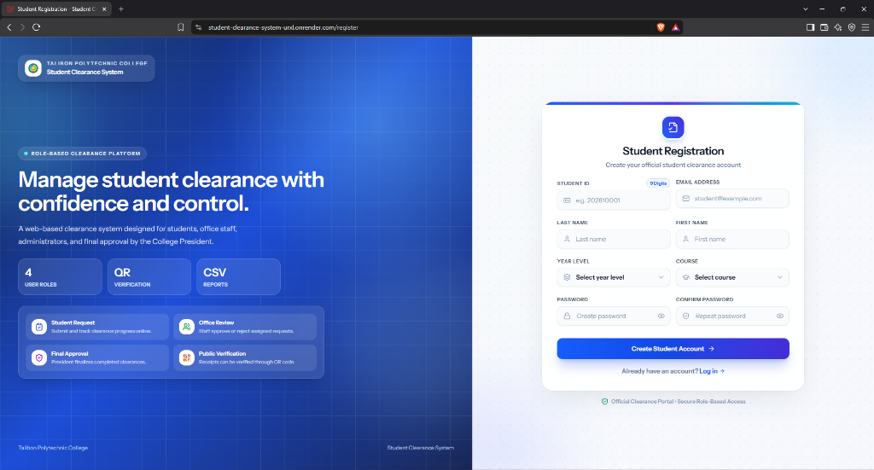
Figure 16. Student Account Registration Interface
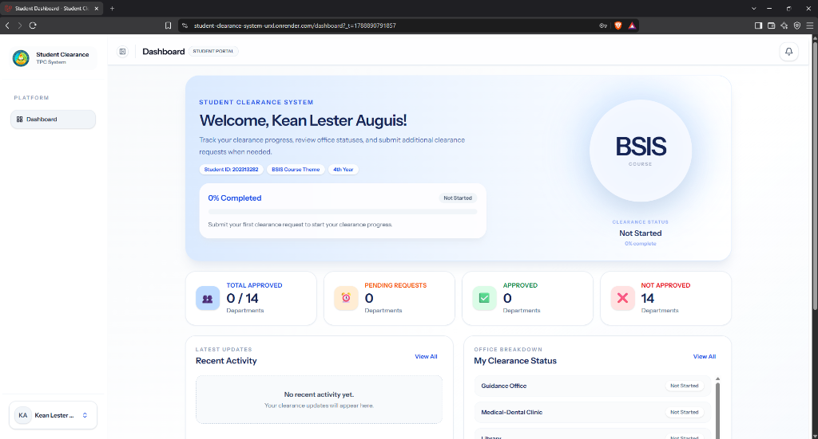
Figure 17. Student Clearance Dashboard Interface (Desktop / Web View)
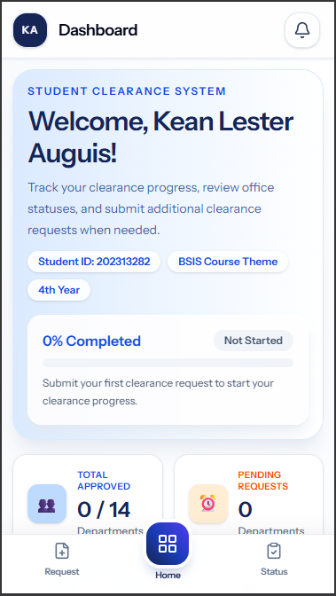
Figure 18. Student Clearance Dashboard Interface (Mobile Responsive View)
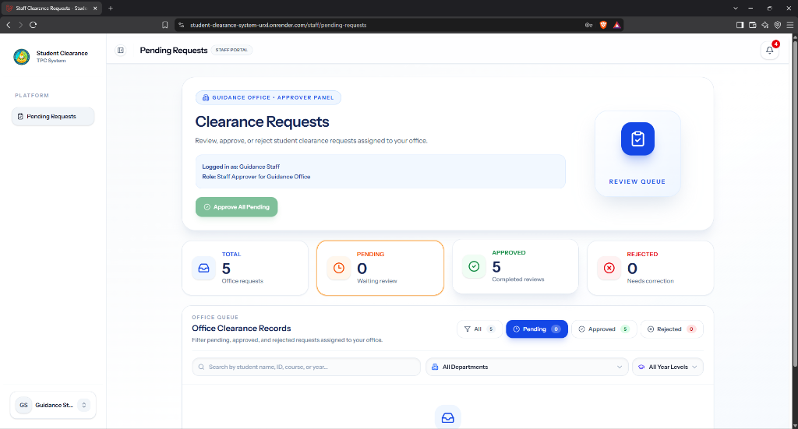
Figure 19. Office Staff Clearance Evaluation Queue Interface

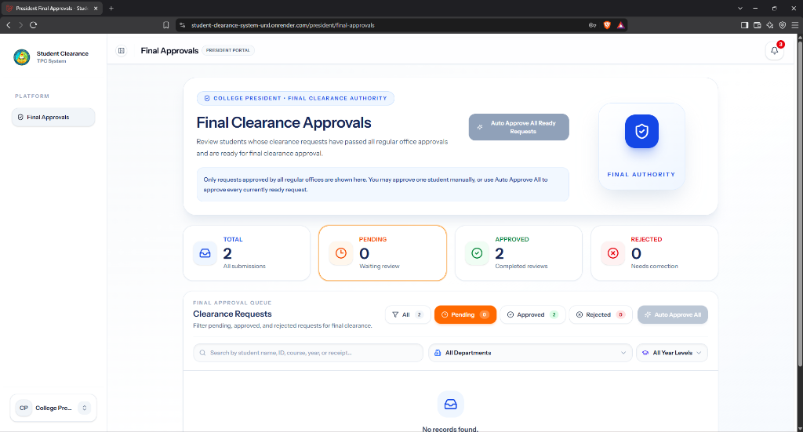
Figure 20. College President Final Clearance Authorization Queue Interface
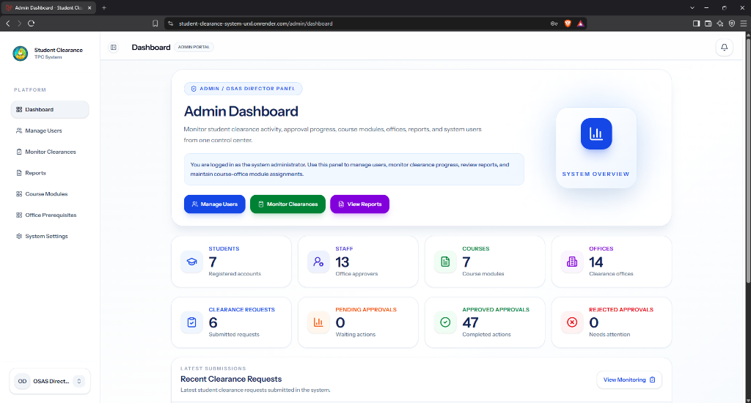
Figure 21. System Administrator Management Dashboard Interface
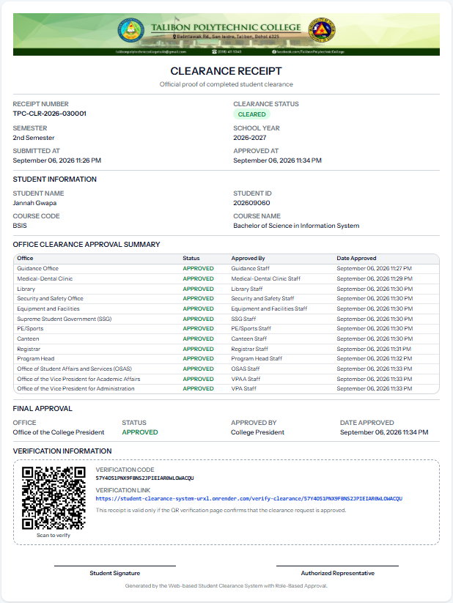
Figure 22. Official Electronic Clearance Receipt Interface
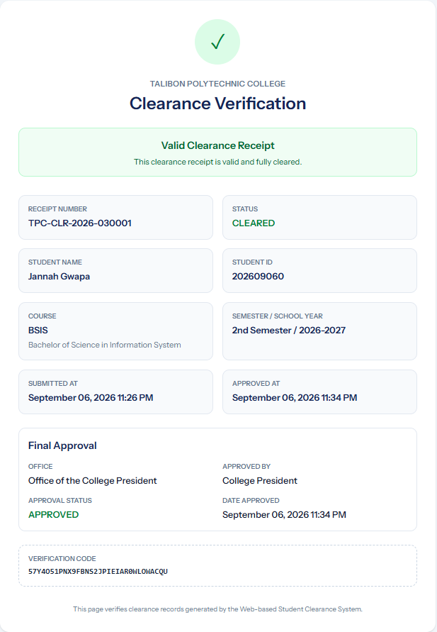
Figure 23. Public QR Code Clearance Verification Portal Interface

DEFINITION OF TERMS
To ensure a common understanding, the following terms are defined as they are used in this study:
Administrator refers to the authorized system user who will manage user accounts, offices, course modules, clearance records, and reports.
Approval is the action performed by authorized office staff or the final approver to confirm that a student has complied with the required clearance requirements.
Clearance Request refers to the online request that will be submitted by a student to begin the clearance process for a specific semester or school year.
Clearance Status is the current progress of a student’s clearance request, such as pending, approved, rejected, or cleared.
Course-Based Classification refers to the organization of student clearance records according to the academic program selected by the student during registration.
In-App Notification is a system-generated message that will inform users about updates, approvals, rejections, remarks, or required actions within the system.
Office Staff or Approver refers to authorized personnel assigned to specific offices who will review, approve, or reject student clearance requests.
Printable Clearance Receipt is the document that will be generated after a student has completed all required clearance requirements.
QR Code Verification is the feature that will allow the verification of a cleared student’s final clearance record through a scannable QR code.
Remarks refer to comments or notes provided by office staff when a clearance request is rejected or requires further action from the student.
Responsive Web Application is a web-based system designed to adjust its layout and functions across different devices, including desktop and mobile devices.
Role-Based Access refers to the restriction of system functions based on the assigned user role, such as student, office staff, administrator, or college president.
Student Clearance System refers to the proposed web-based system that will manage student clearance requests, office approvals, status tracking, final approval, receipt generation, and QR code verification.
Student ID is the unique identification number that will be used by students to register and log in to the proposed system.
Web-Based System refers to an application that can be accessed through a web browser and does not require installation as a native desktop or mobile application.
REFERENCES
Adamu, A. (2022). Online clearance system. FUDMA Journal of Sciences, 6(2), 283–291. https://doi.org/10.33003/fjs-2022-0602-1756
Adegoke, T. B., & Olalekan, A. A. (2026). Design and development of a workflow-driven online student clearance system for seamless multi-departmental integration. ISA Journal of Engineering and Technology, 3(1), 62–74. https://doi.org/10.5281/zenodo.18506360
Alenezi, M. (2023). Digital learning and digital institution in higher education. Education Sciences, 13(1), Article 88. https://doi.org/10.3390/educsci13010088
Awofolaju, T. T., Bada, O. M., Alawode, K. O., & Orotosho, S. P. (2023). Design and implementation of an automated departmental clearance system. Adeleke University Journal of Science, 2(1), 149–157. https://aujs.adelekeuniversity.edu.ng/index.php/aujs/article/view/132
Essel, D. D., Techie-Menson, H., Oppong, S. O., & Alakuu, A. (2023). Digitalising the clearance processes of higher education institutions through the design and implementation of an online clearance system. International Journal of Scientific Research and Management, 11(7), 42–58. https://doi.org/10.18535/ijsrm/v11i07.as01

Eweoya, I. O., Agbeyangi, A. O., & Lukose, J. M. (2025). Streamlining student clearance in higher education: A web-based solution. Information Impact: Journal of Information and Knowledge Management, 16(1), 47–62. https://doi.org/10.4314/iijikm.v16i1.5
Mangubat, J. M. L., Reubal, K. V. P., Caluya, J. F. M., Pepito, J. K. B., Catungal, M. L. P., & Encarnacion, P. C. (2023). Online student clearance management system. International Journal of Science and Applied Information Technology, 12(5), 38–43. https://doi.org/10.30534/ijsait/2023/011252023
Olatunde, T., & Faboya, O. T. (2025). Automated final year online clearance system: A case study of a university. IRE Journals, 9(3), 318–326. https://www.irejournals.com/formatedpaper/1710410.pdf

CURRICULUM VITAE


KEAN LESTER AUTENTICO AUGUIS
Purok 7, San Isidro, Talibon, Bohol
6325 Philippines
Cellphone Number: 0991 291 6663
Email Address: keanlesterauguis@gmail.com

Personal Data
Age : 22
Birthdate : July 10, 2003
Civil Status : Single
Religion : Roman Catholic
Father’s Name : San Ryan Fariolen Auguis
Mother’s Name : Analyn Autentico Auguis

Educational Attainment
Tertiary : Bachelor of Science in Information System
Talibon Polytechnic College
San Isidro, Talibon, Bohol

Secondary : San Jose National High School
San Jose, Talibon, Bohol

Elementary : San Isidro Elementary School
San Isidro Talibon School

CURRICULUM VITAE

SEAN LEO RAMOS AÑABIEZA
Purok 1, San Jose, Talibon, Bohol
6325 Philippines
Cellphone Number: 0954 440 9565
Email Address: seanleoanabieza911@gmail.com

Personal Data
Age : 20
Birthdate : June 1, 2005
Civil Status : Single
Religion : Roman Catholic
Father’s Name : Leonido Ombing Añabieza
Mother’s Name : Hazel Mae Ramos Añabieza

Educational Attainment
Tertiary : Bachelor of Science in Information System
Talibon Polytechnic College
San Isidro, Talibon, Bohol

Secondary : San Jose National High School
San Jose, Talibon, Bohol

Elementary : Balintawak Elementary School
Balintawak, Talibon Bohol
CURRICULUM VITAE


MADEL DEHILLO ROMANA
Purok 4, Mahayag, San Miguel, Bohol
6323 Philippines
Cellphone Number: 0953 778 2765
Email Address: romanamadel9@gmail.com

Personal Data
Age : 24
Birthdate : October 14, 2001
Civil Status : Single
Religion : Baptist
Father’s Name : Mario Ludevese Romana
Mother’s Name : Delia Dehillo Romana

Educational Attainment
Tertiary : Bachelor of Science in Information System
Talibon Polytechnic College
San Isidro, Talibon, Bohol

Secondary : Mahayag National High School
Mahayag, San Miguel, Bohol

Elementary : Mahayag Elementary School
Mahayag, San Miguel, Bohol

