Calculating 1D DCT basis

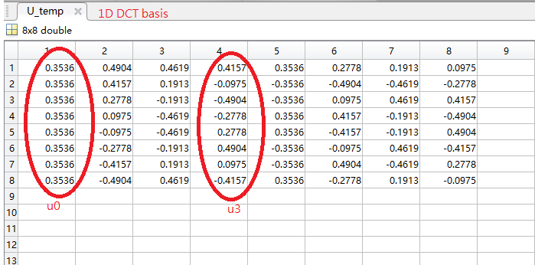

|  |  |  |  |
| --- | --- | --- | --- |
| cat1.png | n=2 | n=4 | n=8 |
| build-in psnr() | 2.729439e+01 | 3.564602e+01 | 6.820546e+01 |
| psnr_imple() | 2.729439e+01 | 3.564602e+01 | 6.820546e+01 |
| cat2_gray.png | **n=2** | **n=4** | **n=8** |
| build-in psnr() | 2.547226e+01 | 2.922452e+01 | 4.878895e+01 |
| psnr_imple() | 2.547226e+01 | 2.922452e+01 | 4.878895e+01 |
| cat3_LR.png | **n=2** | **n=4** | **n=8** |
| build-in psnr() | 2.088408e+01 | 2.242330e+01 | 3.941740e+01 |
| psnr_imple() | 2.088408e+01 | 2.242330e+01 | 3.941740e+01 |

with YIQ

|  |  |  |  |
| --- | --- | --- | --- |
| cat1.png | n=2 | n=4 | n=8 |
| build-in psnr() | 2.729439e+01 | 3.564602e+01 | 6.820546e+01 |
| psnr_imple() | 2.729439e+01 | 3.564602e+01 | 6.820546e+01 |
| cat2_gray.png | **n=2** | **n=4** | **n=8** |
| build-in psnr() | 2.547226e+01 | 2.922452e+01 | 4.878895e+01 |
| psnr_imple() | 2.547226e+01 | 2.922452e+01 | 4.878895e+01 |
| cat3_LR.png | **n=2** | **n=4** | **n=8** |
| build-in psnr() | 2.088408e+01 | 2.242330e+01 | 3.941740e+01 |
| psnr_imple() | 2.088408e+01 | 2.242330e+01 | 3.941740e+01 |

Q3 Image Convolution

|  |  |  |  |
| --- | --- | --- | --- |
| cat1.png | 3X3 | 5X5 | 7X7 |
| build-in psnr() | 3.386060e+01 | 3.162394e+01 | 3.139908e+01 |
| psnr_imple() | 8.200245e+01 | 7.976093e+01 | 7.953552e+01 |
| cat2_gray.png | **3X3** | **5X5** | **7X7** |
| build-in psnr() | 2.933215e+01 | 2.816989e+01 | 2.805983e+01 |
| psnr_imple() | 7.746296e+01 | 7.630070e+01 | 7.619063e+01 |
| cat3_LR.png | **3X3** | **5X5** | **7X7** |
| build-in psnr() | 2.303717e+01 | 2.242027e+01 | 2.237251e+01 |
| psnr_imple() | 7.119235e+01 | 7.057400e+01 | 7.052610e+01 |

|  |  |  |  |
| --- | --- | --- | --- |
| cat1.png | 1 | 5 | 10 |
| build-in psnr() | 3.162394e+01 | 2.771111e+01 | 2.760863e+01 |
| psnr_imple() | 7.976093e+01 | 7.584507e+01 | 7.574252e+01 |
| cat2_gray.png | **1** | **5** | **10** |
| build-in psnr() | 2.816989e+01 | 2.561451e+01 | 2.554654e+01 |
| psnr_imple() | 7.630070e+01 | 7.374531e+01 | 7.367735e+01 |
| cat3_LR.png | **1** | **5** | **10** |
| build-in psnr() | 2.242027e+01 | 2.092954e+01 | 2.089550e+01 |
| psnr_imple() | 7.057400e+01 | 6.908091e+01 | 6.904680e+01 |