low-pass

N=1999

cutoff=350

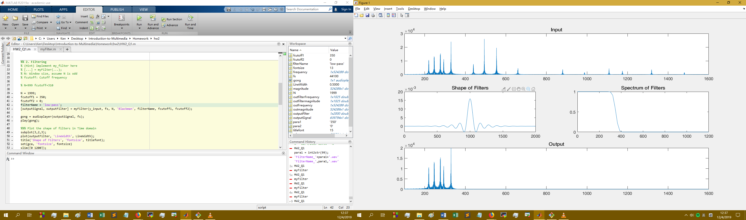

high-pass

N=1999

cutoff=800

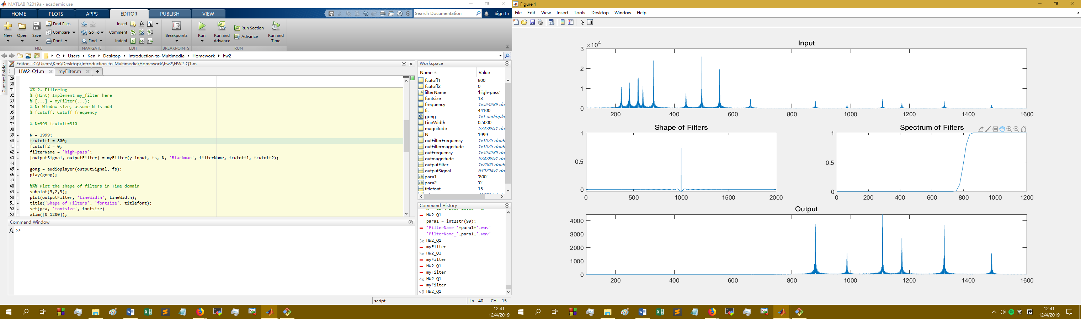

bandpass

N=1999

cutoff=400, 700

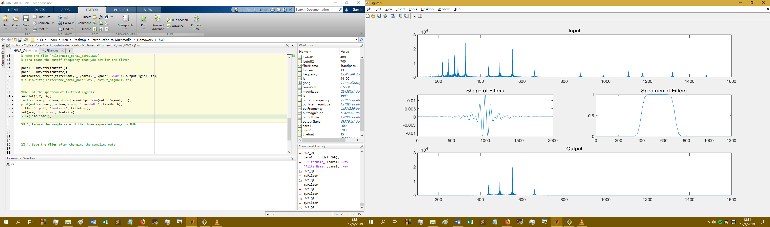

2kHz music should play with Windows Media Player, Matlab audioplayer(), player() and iTunes(Windows)

https://www.mathworks.com/matlabcentral/answers/404777-everytime-i-use-the-audiowrite-and-audioread-function-it-adds-some-noise-to-my-original-signal-doe

Echo

<http://mirlab.org/jang/books/audiosignalProcessing/filterApplication_chinese.asp?title=11-1%20Filter%20Applications%20(%C2o%AAi%BE%B9%C0%B3%A5%CE)>

Q2

% Get input data wihtout normatization

% Great for bit reduction

[input, fs] = audioread('Tempest.wav', 'native');