

Institut für Informationssysteme und Softwaretechnik

Implementation of dynamically generated graphical assessment collections

June 27th. 2005

Responsible: Kenneth Rohde Christiansen (kenneth.christiansen@gmail.com)

Institut für Informationssysteme und Softwaretechnik (IFIS)
Universität Passau
94030 Passau

Tel. 0851 / 509-3131
Fax 0851 / 509-3182
http://www.ifis-passau.de
info@ifis.uni-passau.de

© IFIS 2005

This document will include the considerations leading to the current design of the Assessment.Suite extension. The considerations are mentioned concise to serve as help when changes are to be made in the future.

Table of Content

Use-case scenarios: 3
Required user-interfaces: 3
Considerations: 4
Administration: 4
Editing: 5
Available collections and exercise selection: 6
Major issues: 8
Positioning: 8
Text on map: 8
Adding assessments to a collection 9
Technical questions: 11
Open questions: 11
Rejected ideas: 13
Class design (Main classes, mostly related to the database) 14
Testing plan 15
Used libraries (non-standard at IFIS) 17

The idea is to add support for graphically assessment collections to the IFIS Assessment.Suite. These graphically collections will from the beginning consist of country maps with associated exercises.

The system will be used by Russisch Online to make a tour though Russia where the students can find exercises associated with different regions in Russia.

Since not all students follow the same courses, the maps that will be shown to the user will have to be generated dynamically.

The system has a few additional use cases:

Use-case scenarios:

- Country maps
- Map of human body: Questions related to different parts of the body
- Mind maps

Note: Though Point markers might be sufficient for most use-cases, rectangles (tinted areas) might be more suited for the last 2 use-cases.

Required user-interfaces:

User interface for

- Viewing the collections dynamically (markers are added dynamically) and selecting the publications.

User interface for

- Uploading new collections / removing collections
- Selecting collections (if we allow multiple) to add exercises to
- Adding/removing exercises to the collections (positioning)

Considerations:

The final user-interface consists of four pages:

Administration:

Here new collections can be uploaded and a list will show the current collections in the system. The list will contain two buttons for removing and editing the collections. Since the collections might require a lot of work making, a confirmations system will be added for deletion.

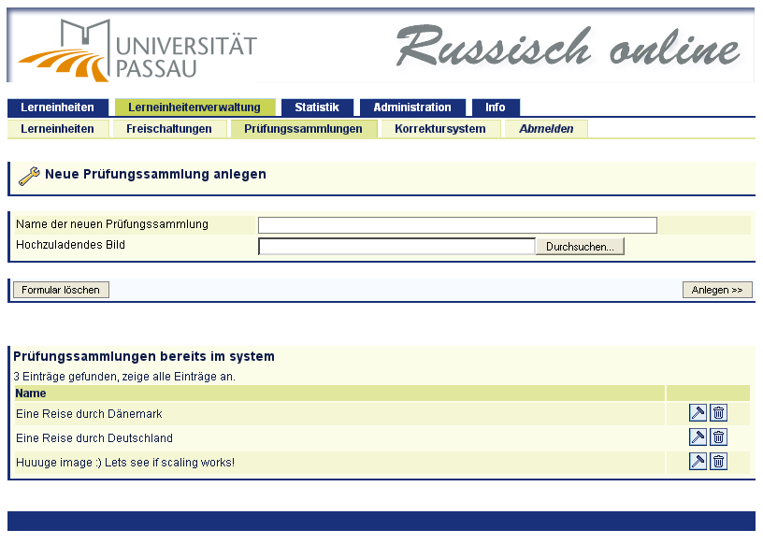
Editing:

The edition page will show the current collections along with it properties (name, image etc). It will show a list of assessments not yet added to the collections as well as a list of assessments added to the collections. This makes it easy to remove and add assessments to the collections. By the use of JavaScript it is possible to click on the image where after a point will be shown.

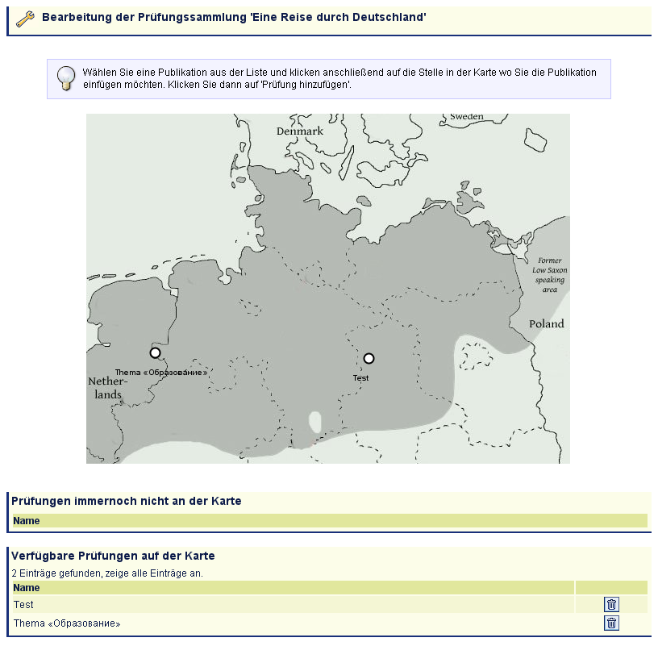

Available collections and exercise selection:

The student will be presented with a menu item showing a list of collections which contain exercises for him to perform. The list will contain thumbnails of the collection images.

Clicking on a collection link will open a new window (maybe popup) showing the current collections with the exercises mapped on the image to those exercises that are accessible to the student.

There have been some considerations:

- What do we do if an assessment specification is published for a user more than once?

It has been decided that AssessSpecs are added to a collections and not AssessPublications. Please check the section ‘AssessPublication vs. AssessSpec’ for the reasoning.

Showing multiply points does not seem to make sense as they would redirect to the same test. Adding additional points and thus moving the original point is error prone and too much work for a corner issue that will seldom occur.

Instead we have decided to list all the assess publications in a list below the collections image (also those published more than once) as well as on the image (except those that are published more than once). This way all publications will always be available.

Considerations for which publication to show on the collection image:

The different publications have different properties: valid date, percentage for passing and the number of times you can do the test.

The date does not affect which publications to show as when the date is no longer valid one of the other publications will be shown instead.

The number of times you can do the test is also not that interesting as when one test runs out of tries, another one will be shown instead.

Percentage: We probably want to make the test as hard as possible since one of the courses (groups) requires it. This means that we want to show the publications with the highest percentage.

- Do we always want to show the collection images, or just link to collections?

One of the original ideas was to show a list of all collections (incl. image) but have all images hidden (folded up and made unfoldable as shown on the following screenshots)

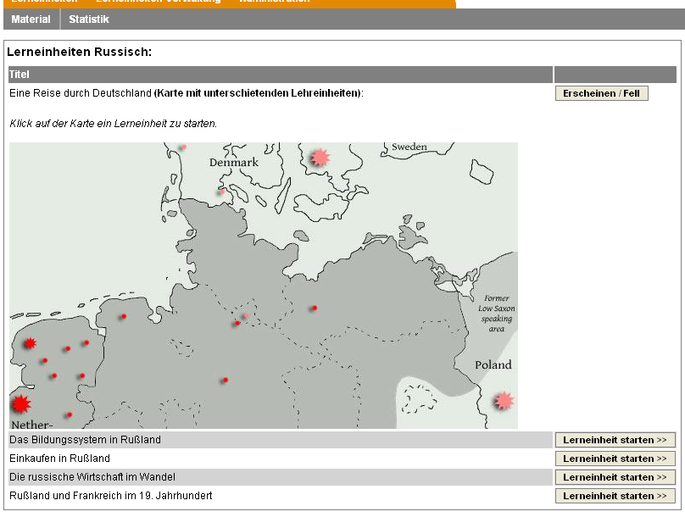

The above (unfolding/folding also knows as show/hide) is in the above prototype implemented with the help of JavaScript.

The idea has been rejected as it might clutter the user-interface and since we do not know which collection to unfold by default.

Major issues:

Positioning:

- Scaling required relative positioning – is that reliable?

Since html embedded images are fixed in size absolute positioning is sufficient

- Relocation when possible

This is not easy to implement with JavaScript (please consult the section, Adding assessments to a collection), and will thus not be implemented. Instead emphasis will be put on making it easy to remove a marker and re-add it at a different position.

- Removing publications from a map requires selecting a marker

Since we do not support selecting a marker on the map we will provide a list with the markers currently added to the map/collection. This will make it possible to easily remove a particular marker.

- We only want one position per exercise (the position does not depend on the user)

Solution could be not to support scaling of the maps and always scale the supplied maps to a given width and use pixel coordinates.

This is a reasonable solution as the browser doesn’t scale the image when it is being a part of a webpage (embedded in an html page for instance). When zooming is uses the web browser also scales the image map coordinates.

Text on map:

- Support of different charsets (UTF-8 required).
- Overlapping text
- Scaling (of text)
- Font support (server side)
- Where to show text: below, beside, centred, etc.
  - This is an even harder question if we use – for instance – rectangles, where the user might want to decide the placement of the text independent of the rectangle. This is not recommendable and it would be better to find an automatically solution, but finding such one is not obvious.
- Too long text or the marker is placed so that the text is not in the image

Solution could be to use tooltips instead and thus not show the title, or show the title and provide a tooltip system as well.

Using standard tooltips have the disadvantage that the tooltip size is a bit too small to be easily recognizable and the delay before the tooltip is shows is too large which means that they user will often have moved the mouse away from the marker before the tooltip is shown. These properties cannot be changes, but tooltips can be implemented with JavaScript and DHTML.

JavaScript, DHTML Tooltips is a JavaScript Cross Browser Library written by Walter Zorn. The library is LGPL and is available at http://www.walterzorn.com/tooltip/tooltip_e.htm. The tooltip works on most browsers and has been tested with the newest versions of Opera, Internet Explorer and Mozilla Firefox. The tooltip system supports many properties and supports displaying images, which might be usable for our purpose (at least we have the possibility if our customers demand it)

We have found the system well working. The tooltip have been made to appear immediately (delay = 0) and with a nice size and background that make them easily readable for the user.

Since the tooltip are made with JavaScript and DHTML it uses the standard fonts supplied with the web browser and it supports UTF-8 as well, though converting to escaped hex is required, but can be done by the Java backend.

Example:

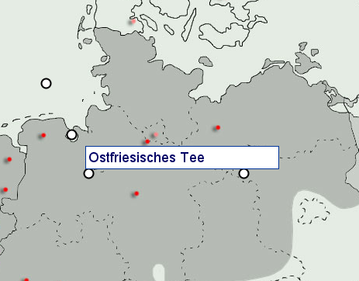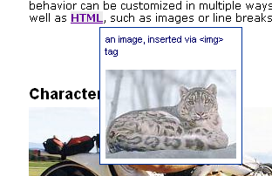

Adding assessments to a collection

Adding publications to a map can be done is various ways. The two most obvious ones being:

- Using a Java applet
- Using JavaScript

Using a Java applet

Advantages:
- Easy to build user interface (drag and drop, moving points, using the Java2D drawing API)

Disadvantages:
- Feels like an external application, doesn’t integrate so well.
- More heavy weight

Using JavaScript

Advantages:
- Integrates well with the rest of the webpage

Disadvantages:
- Harder to make cross platform
- Harder to build a user interface

A prototype user-interface has been build to see what was possible and whether it covered our goals. The JavaScript interface fulfils our needs, is very lightweight and integrates well in the system.

Proto example:

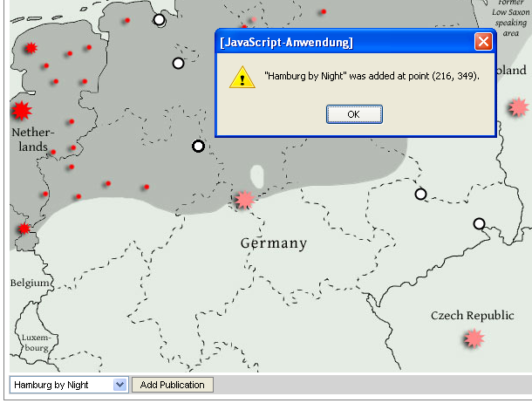

So far it can be concluded that it is possible to add a marker to a map in real time and store the coordinate. Selecting a publication from a drop down box and clicking Add Publication will add the publication at the stored coordinate set. If no coordinate have been selected, a dialog box will ask the user to do so.

Technical questions:

- Do we support multiple maps?

Yes.

- What image formats do we support?

Answer JPEG, PNG (and all images that the Java2D API can read)
Elaboration: Internally convert to PNG (using a known format like JPEG could decrease quality).

Open questions:

- Should AssessPublication or AssessSpec be added to the collections?

One of the design questions regards whether adding AssessPublications or AssessSpecs to the graphical maps. It is mostly a usability question as adding assess publications might require a bit more work.

Publications are published assess specs which are mostly short living, where as the specs might live for years (though of course being changed through the years).

A teacher of Russian might want to use the same test for different courses. If the specs are used the teacher only needs to add the spec once and then publish the test for each course. The advantage of this is less work and that the test will be situated at the exact same coordinates.

Since the graphical maps are long living, and a sort of specification it seems logical to add the specs to them and not the short-living publications.

The disadvantage of this is that there might be more than one publication of the same spec for a given user. The question is how to visualize this; do we show multiple points or do we just show one of them, and in that case which one. Further discussion can be found in the user-interface section.

- Should the collections be grouped?

An organization might be an institution as for instance Uni-Passau, but there can also exist sub-organizations and for instance the Institute for Russian at Uni-Passau.

Groups are mostly a way of organizing students, so that it is easier to add people to publications. Publications can thus be grouped by group.

Limiting the maps to only be viewable by certain groups seems not to be a good idea for a couple of reasons:

Reviewers:

There might be reviewers, reviewing the tests. These will probably be members of the organization (lets say Institute for Russian, Uni-Passau) but most-likely not be member of the individual classes. It is possible to make a group for reviewers, but we cannot guaranty that the users will come up with that idea.

Foreign students:

Foreign students might have to do some extra tests even though they don’t have to follow the course where the test is assigned to. This means that they are not members of the group but it should still be possible for them to see the test if it is made accessible to them.

My suggestion is simply to show maps for the users when they contain publications that are accessible to the user, and thus not show all maps available for a given organization. This way the access system of the publications will be used.

The disadvantage of this is that a user, let us say student at Russisch, might be confused why he has no maps with tests when other students at Russisch (an organization) have.

The advantage is that you won’t be bothered with many irrelevant maps.

- Is there any limitation on map size?

Answer: Yes, as we do not want the user to wait too long to download the map. It can be realized by only allowing upload up maps up to a given size. Resizing is also a possibility, plus conversion (harder jpeg compression?). Minimum resolution is also required in order to ensure proper quality of the shown map.

- Do we only support marking points on the maps or do we support convex polygons (collections of points, with start and end point connected and inner area tinted?)

Cons:
- Hard to come up with nice user interface
- Users might get confused because only polygons without intersecting lines are supported
- Users might choose to use many points to mark areas nicely which might have side effects on performance and scaling (points does not fit precisely when scaled)
- Maybe supporting SVG would be a better option
- The same can be accomplished by drawing a nice map and marking areas on the map with different colours and then adding one marker (cross, point etc) within each area.

Alternative:

Support rectangles or circles (or both).
- Only two clicks required.
- Objects are always convex.
- Not too complicated user-interface.
- The marker type can be abstract so the alternatives can be added later.

Use of technology

- Scaling map
- Drawing crosses (etc) and text (dynamically read from the AssessSpec) on the map
- Checking size of image etc, scaling etc.
- Internationalization (Support for multiple languages)

Rejected ideas:

- Support of the SVG format

Pros: Great format, able to select areas
Cons: Not supported by current browsers, not many maps available as SVG, nor many SVG editors on the market

Answer: We do not support. Can be added later if we support different collection

- The support of “zooming” where a click on one part of the map will show you another map (required a way to get back)

Answer: Too complicated and not necessary for our current users.

Class design (Main classes, mostly related to the database)

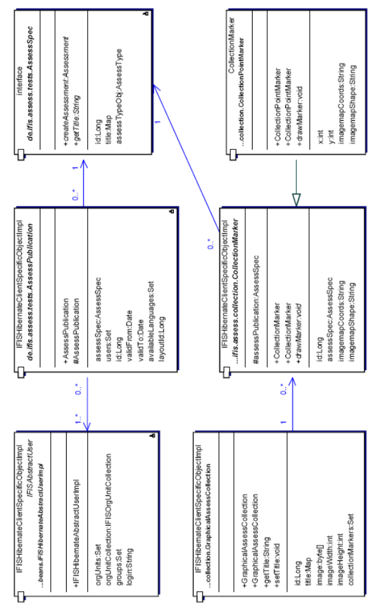

Testing plan

Menus

Manage Collections:

- Add collection: diff. file formats, different sizes
- Remove collections: with confirmation, cancel
- Edit collection, right collection?

Edit Collection

Shows right map, scaled correctly,
Is the point added the right place (Opera, IE, and Mozilla)?
Is a warning given if I forget selecting a place to add the point?

- Add point: added to right collection? Can I re-add the same point twice? (post parameters? refresh)
- Remove point: the right point removed? (post parameters? refresh)

In order to test the user side we have two users; user1 and user2, as well as three collections, coll1, coll2 and coll3. We have 4 assessment specifications and two of them are added to the first two collections and two are not. Coll3 is just used to test List Collections.

Specification
Coll1: 1, 2, 3
Coll2: 1, 4, 3
Coll3: 2

User1: Published 1, 2, 4
Coll1: 1, 2, x
Coll2: 1, 4, x
Coll3: 2

User2: Published 1, 1, 4, 3
Coll1: 1, x, 3
Coll2: 1, 4, 3

List Collections

- The right collections are shown

Show Collection

- Points disappear when they are started and only allowed to be started once
- Tests can be started (from map and from list)
- List shows duplicated published assessments but the map does not
- Only the published assessments are shown for the user.
- Tooltip work with non-ASCII text (Russian)

Used libraries (non-standard at IFIS)

JavaScript/DHTML Tooltips
http://www.walterzorn.com/tooltip/tooltip_e.htm
License: LGPL

High-Performance JavaScript Vector Graphics Library.
http://www.walterzorn.com/jsgraphics/jsgraphics_e.htm
License: LGPL

Light ball icon from GTK+ (The Gimp Toolkit)
http://www.gtk.org
License: LGPL

