Name: Jiacheng Sun

Course: Math/Cmpsc455

Instructor: Keller Justin

Project1: Natural Cubic Spline

Procedure:

First, I roughly read the entire project and all the materials that I have and decide to work on my own. Second, I try to implement the spline.m file to make sure I have the algorithm written and applicable before doing the experiment. When I implemented the spline.m, the basic algorithm was not a problem because the lecture notes declared it clearly. The main problem was the matrix defining. I need to make sure the “a, b, c, d” all have the length n-1 so I use y instead of a when I need to use the length of n of a. I use for loops to construct the matrix. The “for statement” went wrong because I did not use the double equal mark. Third, I began to do the experiment after finish implementing the spline.m file. I set the interval from 0-10, the tolerance 1e-3 and the function f = sin(x). I begin with 50 nodes, it went out of the range. Then I use 55 nodes, it was in the range. To make it close to the range, I use 53 nodes. It was very close to and in the range. Then I use 52 nodes, and it went out of the range. The error increased sharply closed to 10. Then I use 0-3pi instead of 0-10, and I found the sharp increase disappear, and it only need 14 nodes to keep the error in the range.

Conclusion:

The sharp increase because the end of the range “10” is not on the periodic point of sin function. It needs 53 nodes to keep the error within 1e-3 in the interval 0-10.

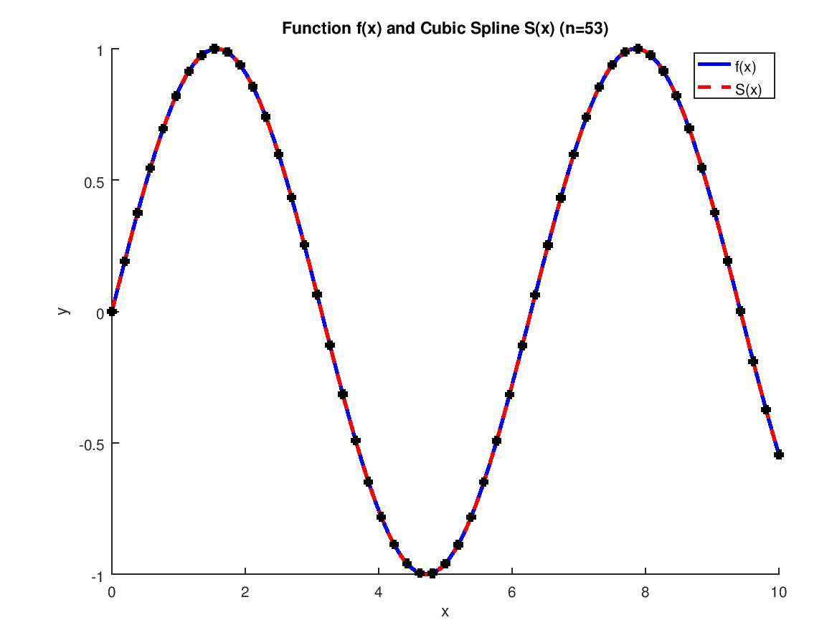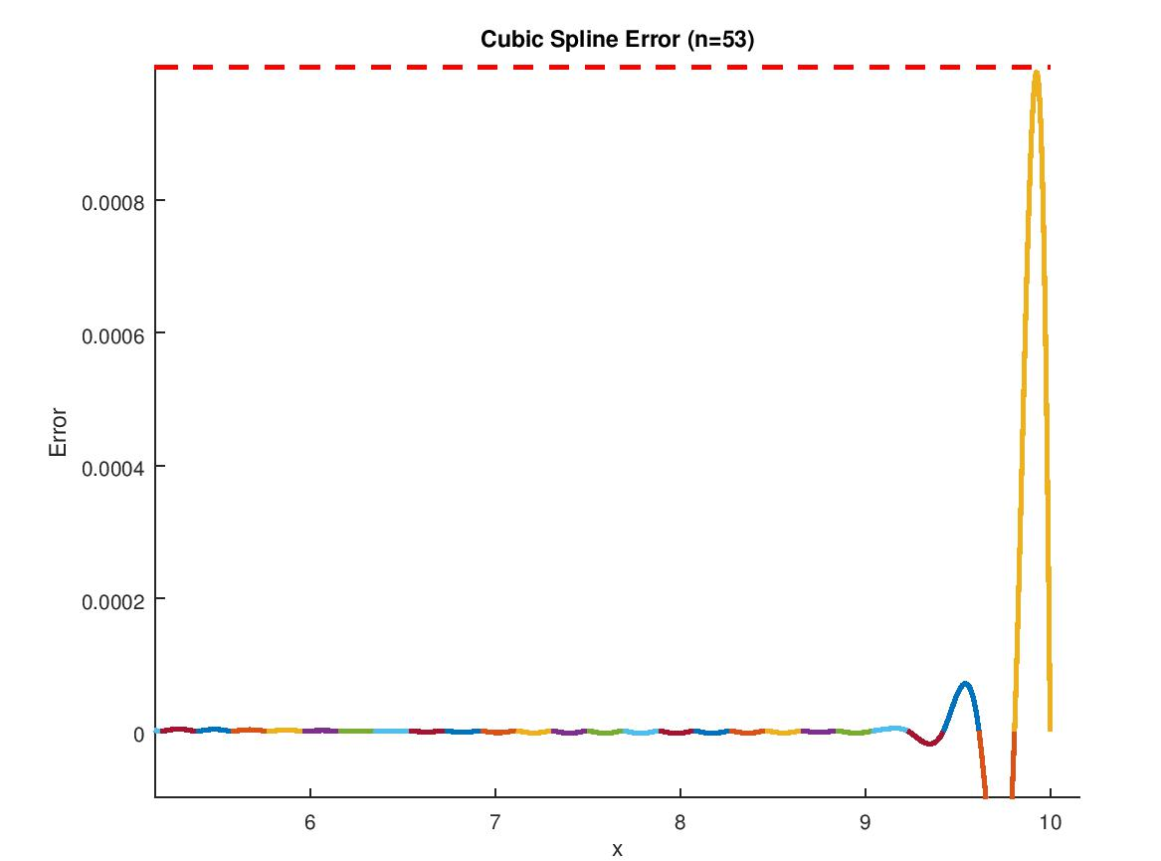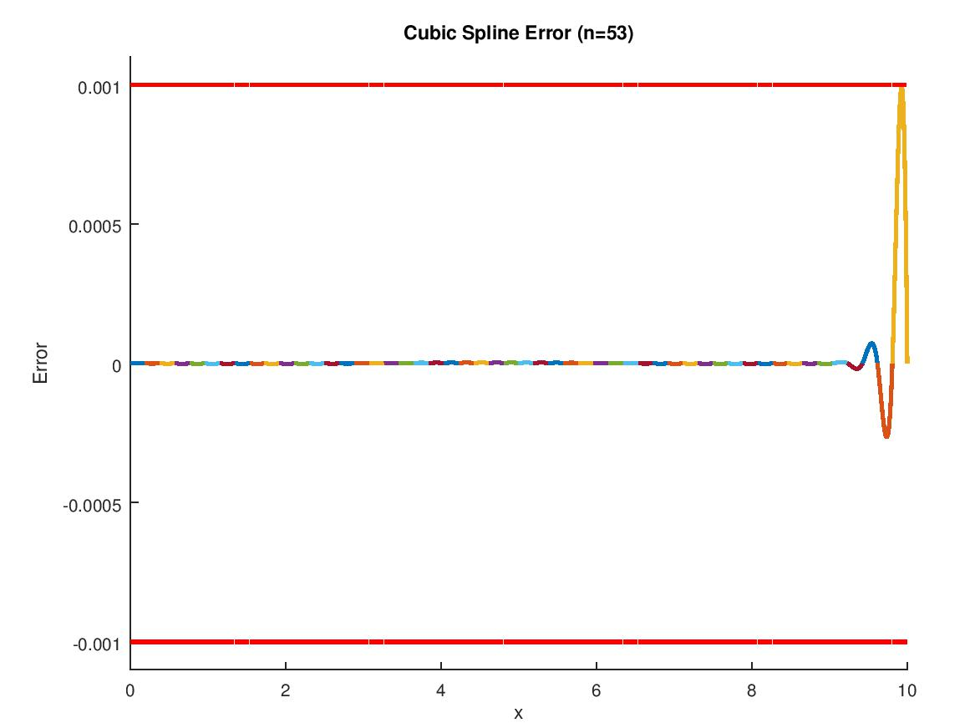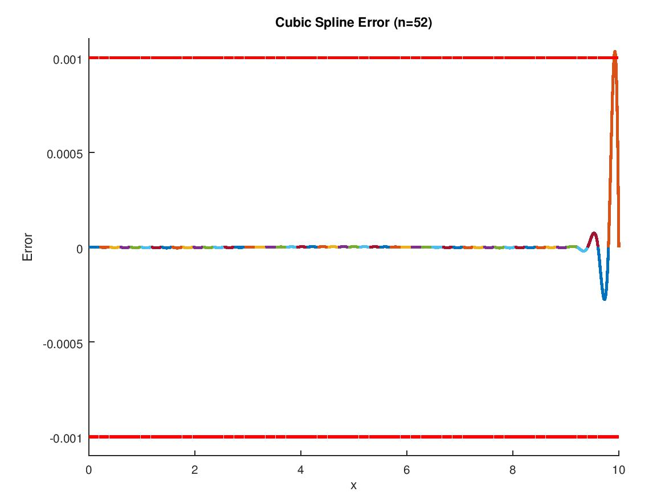(node of 52, go out of range)

It needs 14 nodes to keep the error within 1e-3 in the interval 0 – 3\*pi.

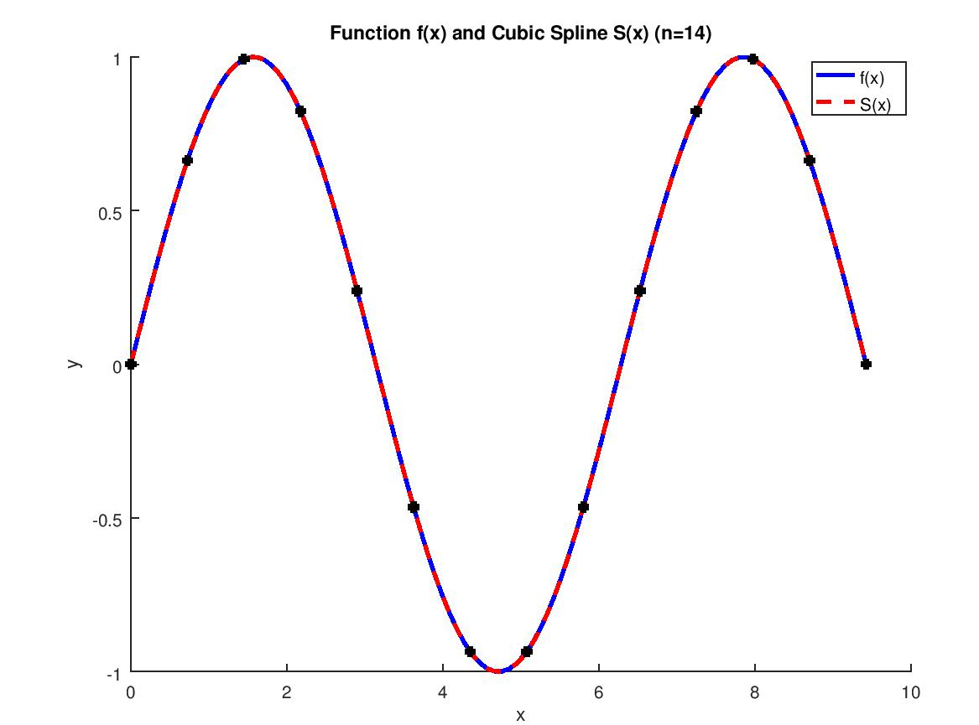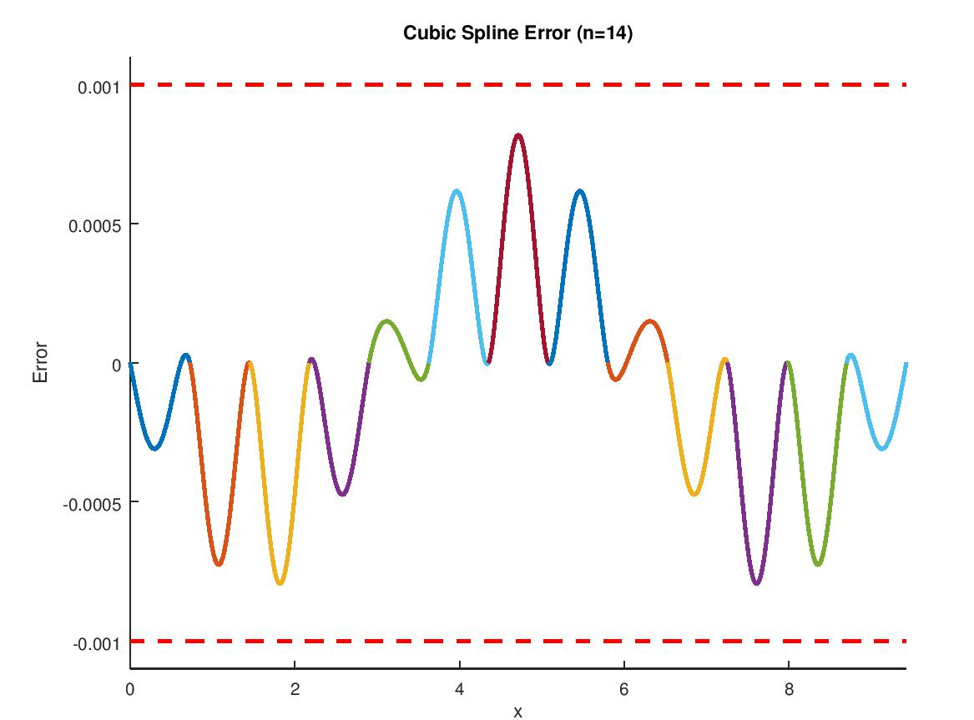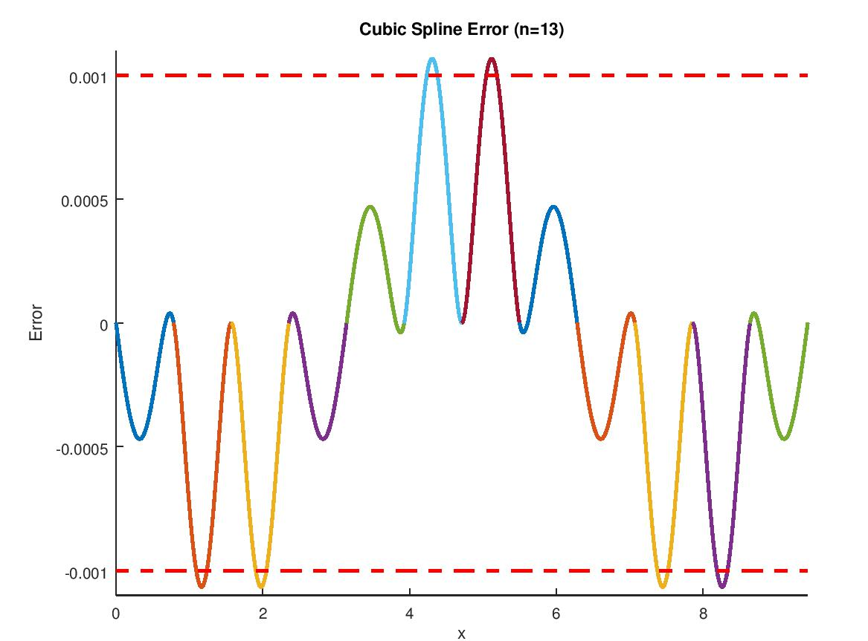(13 nodes, go out of range)