Rating Company Date

**SELL Airbnb, Inc. (ABNB)** 26 July 2024

Industry Analyst Basic Information

Travel and Hospitality Hongjia CUI Target Price: 110.23 (-21.3%)

**Business Overview**

Airbnb, Inc. engages in the management and operation of an online marketplace. Its marketplace model connects hosts and guests online or through mobile devices to book spaces.

The business reflects typical travel behavior patterns over the course of the calendar year. First three quarters typically have higher **Nights and Experiences Booked** than the fourth quarter, and the third quarter for North America and EMEA is the peak travel quarter in general.

**Gross Booking Value** will reach highest in the first two quarter with comparatively lower check-ins. In Q3, revenue and EBITDA will reach the highest due to the most check-ins of the year.

After the pandemic, the war in Ukraine, and macroeconomic headwinds, such as high inflation both happened in the U.S. and Europe, Airbnb still can generate an increase on revenue growth in terms of year-on-year level, and it is still growing.

Airbnb has segmented its market into four key regions since the 2020 fiscal report: North America, EMEA (Europe, Middle East, and Africa), Latin America, and Asia Pacific. Nearly a half revenue generated from North American segment, however, recently EMEA market is growing pretty faster, approximately is going to achieve 40% of total revenue. The rest two equally separates the rest. Additionally, the revenue projection in the North America seems soften, and it will be continuously strong in the Europe segment because of the Olympic Games launching in France, and events like European Cup will boost the volume of travel continuously. Airbnb is focusing more on expanding potential market in the Latin America, actually they performed well in Brazil and Mexico last year, so they have confidence in the future market expansion. Asia Pacific is lagged due to the slow recovering, and they took out the China supply, but maintained the outbound business.

**Industry Overview**

The travel and hospitality is a high competitive industry. Despite the traditional OTAs (online travel agencies), such as Booking Holdings, Expedia Group, Airbnb is still facing intensive competition directly from traditional hotel chains, such as Marriott, Hilton. Even those listing and regional internet search engines, such as Google and Baidu, are also potential competitors, which present travel search results and promotions of its own travel meta-search services.

Airbnb reached nearly 11% of total market share in 2023, and it seems flat due to intensive competition.

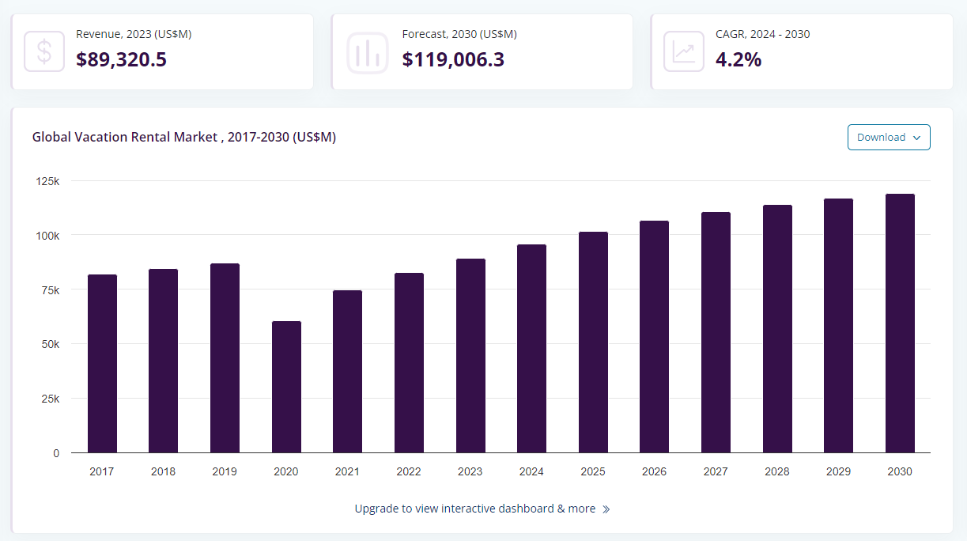As we approach the end of this year, having endured first two years of pandemic-induced disruptions and lockdowns, the global vacation rental market, which faced a significant decline in 2020, is finally stabilizing. The volatility that characterized leisure travel over the past three years is giving way to a new era of stability in 2024. And the global vacation rental market is growing as 4.2% CAGR from 2024 to 2030. This year is shaping up to be the first truly normal year since the pandemic, with consistent levels of leisure travel contrasting sharply with the uncertainty and fluctuations seen in previous years.

**Key driver #1: Robust supply of listings will drive revenue up**

In 2024, Airbnb is poised to capitalize on a resurgence in the global vacation rental market, demonstrating robust growth and resilience post-pandemic. With hosting becoming increasingly mainstream, Airbnb has focused on enhancing the quality of its listings. Excluding the impact of removals, **active accommodation listings have grown by 17% year-over-year**, with **supply and demand growth rates remaining aligned.** This **double-digit supply growth across all regions** underscores Airbnb's ability to scale its platform effectively, meeting the renewed demand for travel and positioning itself as a strong investment opportunity in the leisure travel sector.

**Key driver #2: Optimization of core business**

Honestly speaking, Airbnb focus on its core business every year to provide a better user experience, they have launched a lot of new features, such as Guest favorite, which can simulate the rebooking rates; total price display; AI-filter; comparable price tool.

The optimization led U.S. app downloads increase from 49% of bookings to 54% of bookings, **grown 60% from last year**, notably, the conversion rate on Airbnb's native application is significantly higher than on its mobile website. This surge is attributed to the natural growth after COVID-19 and people start to do the revenge travel.

**Key driver #3: Potential market expansion**

Five core regions, U.S., Canada, Australia, France and U.K., have driven the majority of Airbnb's revenue, generating figures that are an order of magnitude higher than those from other markets. In contrast, market penetration in regions like Latin America and other countries in EMEA remains significantly lower. It would be a chance if they find out another fast-growing market which is comparably undervalued before.

**Risk #1: Any decline or disruption or economic downturn could materially adversely affect the business**

Any decline or disruption in the travel and hospitality industries, such as an economic downturn influenced by inflation or other macroeconomic pressures in the U.S. and global economy, could significantly and adversely impact Airbnb's business, operational results, and financial condition. These factors could lead to reduced consumer spending on travel, lower booking rates, and increased operational costs, ultimately affecting the company's revenue and profitability.

**Risk #2: Airbnb are subject to laws, regulations and rules, especially to taxation**

On December 13, 2023, without admitting any liability, Airbnb Ireland signed an agreement with the Italian Revenue Agency in settlement of the 2017-2021 audit periods for an aggregate payment of $621 million.

**Valuation**

