Rating Company Date

**HOLD Chipotle Mexican Grill, Inc. (CMG)** 19 June 2024

Industry Analyst Basic Information

Fast Food Hongjia CUI Target Price - $51.82

**Business Overview**

Chipotle Mexican Grill, Inc. specializes in developing and operating restaurants that offer a menu featuring burritos, burrito bowls, quesadillas, tacos, and salads made with fresh, high-quality ingredients. Committed to its "Food with Integrity" philosophy, Chipotle serves meats branded as "Responsibly Raised®," sourced in alignment with their sustainability and animal welfare criteria, without non-therapeutic antibiotics or added growth hormones. With 26 distribution centers, the company continues to expand its network of ingredient suppliers. **Digital sales**, primarily for customer pick-up orders, **constituted 37.4%** of their food and beverage revenue in 2023. Chipotle also emphasizes internal growth, achieving over **24,000 internal promotions** in 2023, including significant percentages of senior leadership roles.

Chipotle Mexican Grill, Inc. is committed to "Cultivating a Better World" by implementing five key strategies. These include fostering world-class leadership through the development and retention of diverse talent, running successful restaurants with a culture of accountability and providing excellent food and service both in-restaurant and digitally. The company aims to enhance brand visibility and guest engagement, leverage technology and innovation to boost growth and productivity, and expand access and convenience by accelerating new restaurant openings in North America and internationally.

Chipotle operates over 3,600 locations across North America until Q1 2024, with an additional 66 international stores. During the COVID-19 pandemic, the company leveraged its unique CRM system and efficient service to achieve significant financial growth. From 2019 to 2023, Chipotle's total revenue increased from $5.5 billion to $9.8 billion, reflecting a compound annual growth rate (CAGR) of 12%. The operating margin improved from 8% to 15.7%, while the net margin rose from 6.2% to 12.4%. Additionally, the average unit volume (AUV) grew from $2.1 million at the end of 2019 to $3 million in the first quarter of 2024.

**Industry Overview**

The fast-casual, quick-service, and casual dining segments of the restaurant industry are highly competitive. Chipotle’s competition spans locally-owned restaurants as well as national and regional chains. The main competitors published are Starbucks, Wendy’s, Yum Brands, McDonald, Restaurant Brands International, Domino's and Darden. In 2023, Chipotle is capable of capturing 9.5% of total market share. Additionally, Chipotle's penetration rate in the overall fast food market is 4.39%

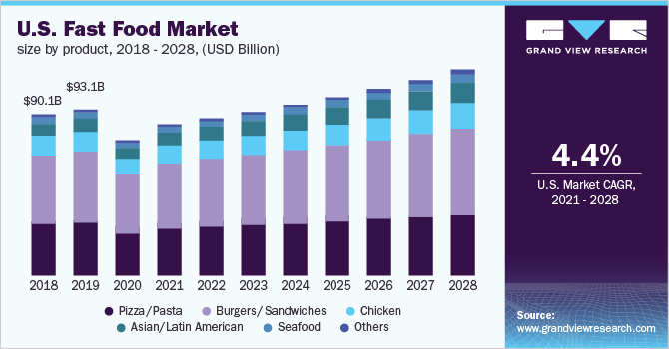As market data estimated, in 2028, the U.S. Fast Food Total Addressed Market is going to reach $121.8 billion dollar, with 4.4% CAGR for 8 years; also based on Chipotle’s growth rate of market share, it will achieve around 11% of total market. Therefore, in rational thinking, Chipotle will achieve 13.4 billion total sales in 2028. Optimistically, based on our estimation, Chipotle can achieve this goal by the end of 2026, because Chipotle's 14% YOY growth is way faster than the average market growth.

**Investment Thesis #1: Domestic new openings in untapped locations can bring considerable revenue**

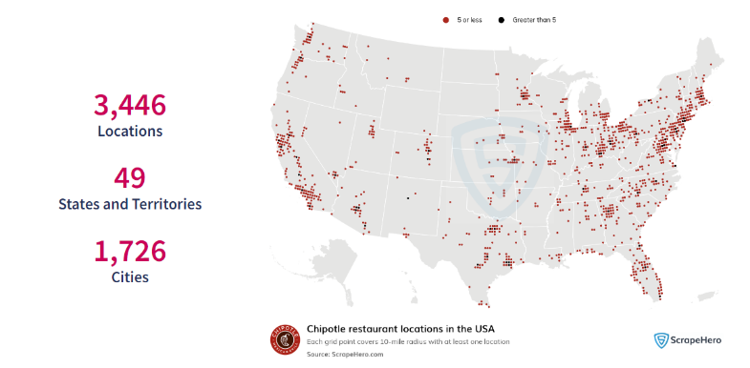Chipotle continues to achieve impressive growth in new restaurant openings, maintaining a YOY increase of 7%-8%. This expansion is complemented by a remarkable 6% rise in average unit volumes, underscoring the company’s ability to effectively scale its operations while driving higher sales per location. This consistent growth in both new openings and AUVs highlights the strength and resilience of Chipotle's business model, making it an attractive investment opportunity.

Chipotle's main competitors each operate over 6,000 locations, indicating a significant market presence. Considering Chipotle's current pace of opening new stores, there is substantial potential for growth and profitability. Currently, most of Chipotle's locations are concentrated in the western U.S., particularly California, and the northeastern U.S., including New York and Pennsylvania. Expanding into the southern regions offers a promising opportunity for further development and market penetration.

**Investment Thesis #2: Unique CRM initiatives has effectively enhanced customer engagement and loyalty**

Fantastic CRM initiatives, such as Chipotle Rewards and gift cards, play a crucial role in attracting and retaining customers. The Chipotle Rewards program offers personalized promotions and incentives, encouraging frequent visits and higher spending. Gift cards provide a convenient and attractive option for customers, helping to bring in new patrons who might not have otherwise chosen Chipotle. These initiatives convert floating customers into loyal patrons, driving consistent revenue growth and enhancing the overall customer experience. By leveraging these CRM strategies, Chipotle can continue to build a strong, loyal customer base and sustain its competitive edge in the fast food market.

**Risk #1: Food Safety & Menu Price**

Their commitment to using fresh, unprocessed produce and traditional cooking methods inherently increase our exposure to food safety incidents compared to some of our competitors. This heightened risk is further compounded by their extensive handling of raw chicken in our restaurants, a process that demands meticulous hygiene practices to prevent contamination. Additionally, their deliberate choice to avoid added preservatives and frozen ingredients, which can serve as safeguards against foodborne pathogens, further elevates this risk. While these practices ensure the superior quality and taste of menu items, they also result in higher ingredient costs. This price premium, driven by the reliance on fresh, high-quality inputs, positions their offerings at a higher price point relative to competitors who may utilize more processed and preserved ingredients.

**Risk #2: Significantly elevated P/E ratio & it may take longer to ramp up**

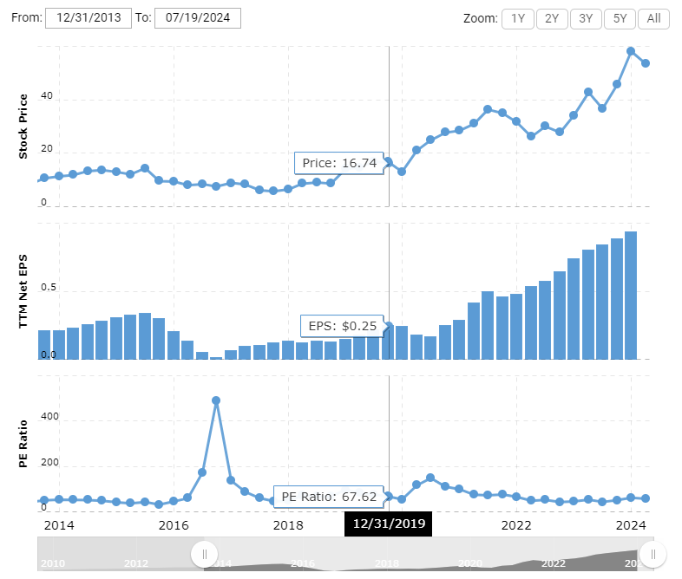The company currently exhibits a super high P/E ratio compared to industry peers, which may raise concerns among investors. Since 2019, the P/E ratio has consistently hovered around 50x, significantly higher than the average in the sector. This elevated P/E ratio reflects strong investor expectations for future growth and profitability; however, it also implies a greater degree of risk. Investors may worry that the stock is overvalued, especially if there are challenges in meeting these high growth expectations. Such concerns could lead to increased market volatility and potential sell-offs if performance does not align with investor expectations. Additionally, the average time required for new openings to achieve profitability is estimated to be 36 months, it may lead to other uncertain risks.

**Catalysts**

Earnings Season: Given the robust EPS growth over the past three years, it is likely that Chipotle's stock price will experience a significant increase in the upcoming earnings season. This consistent earnings per share (EPS) growth reflects the company's strong financial health and effective management strategies, which have been pivotal in driving investor confidence.

**Valuation**

