Section 1:
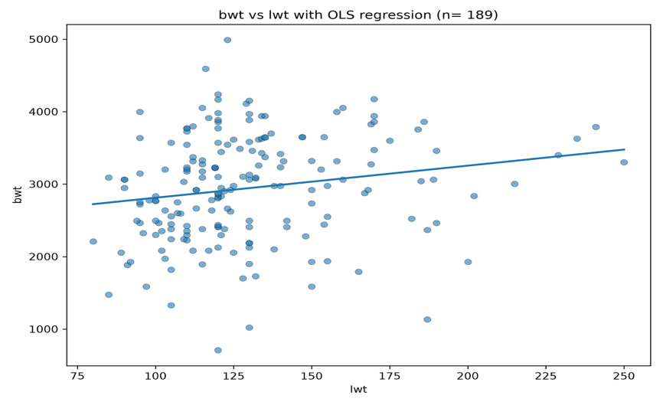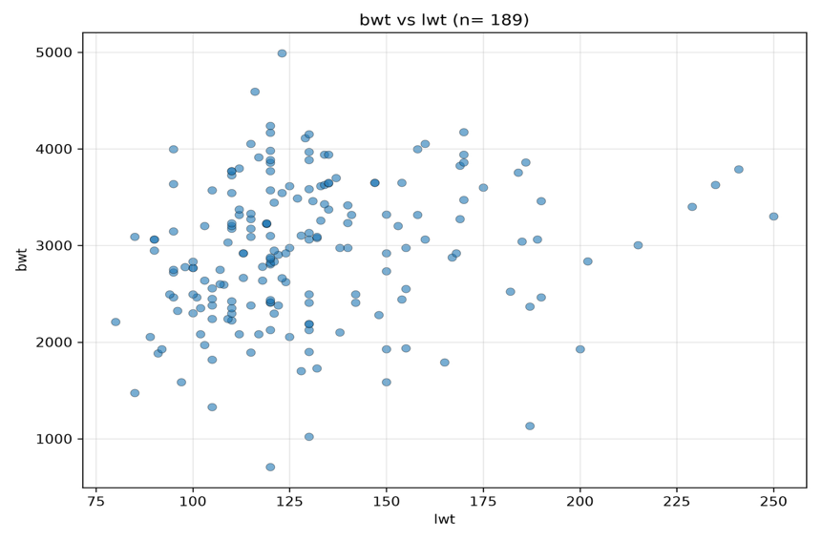
R²: 0.0345
β₀: 2369.6235
β₁: 4.4291
Description: There is a weak positive relationship between the mother’s weight and the baby’s birthweight. As the mother’s weight increases the baby’s birthweight also increases. The R² value of 0.0345 means a percentage of 3.45% explains the reasoning of the mother’s weight and the changes in birthweight.

Section 2:
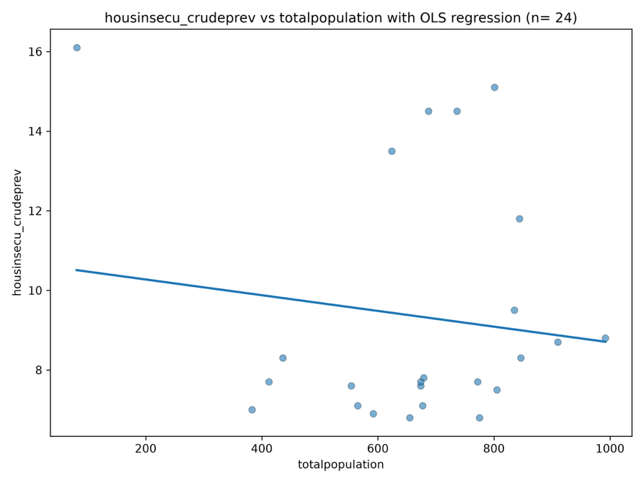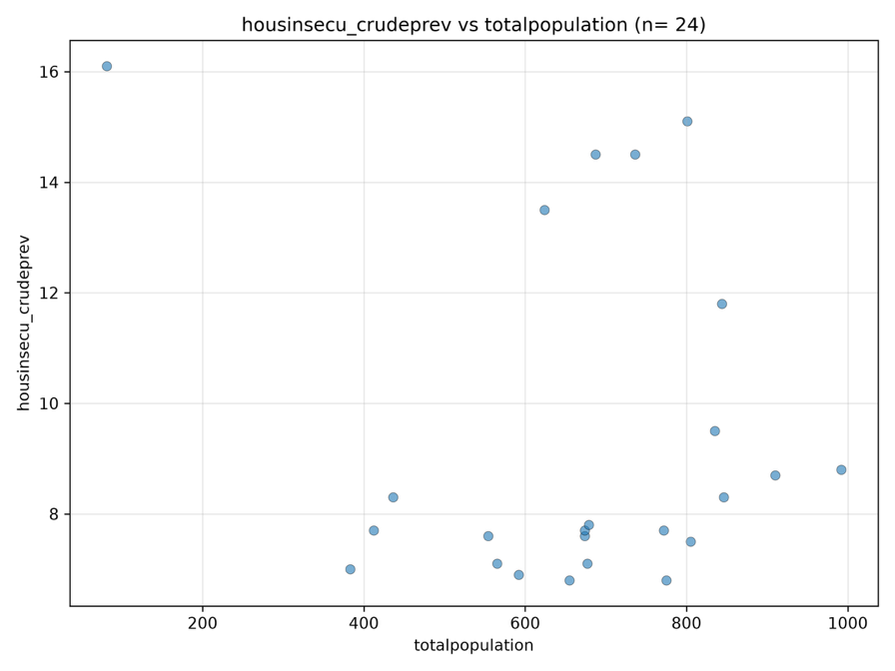
R²: 0.0164
β₀: 10.6677
β₁: -0.00198
Description: There is a weak negative relationship between the total population and housing insecurity. As the total population increases the housing insecurity slowly decreases. The R² value of 0.0164 means that there is a 1.64% change of housing insecurity.

section 3:
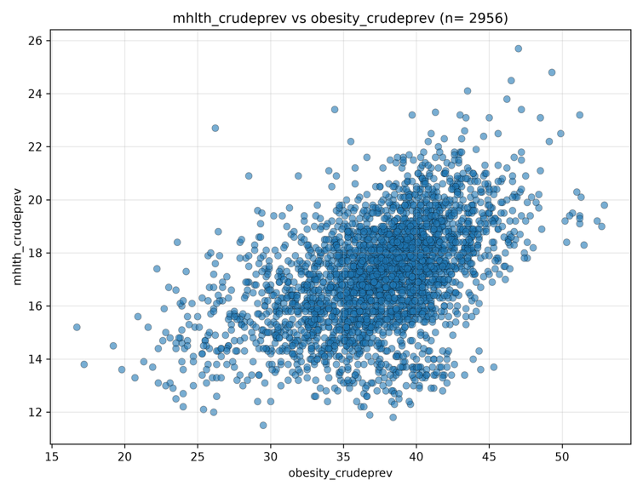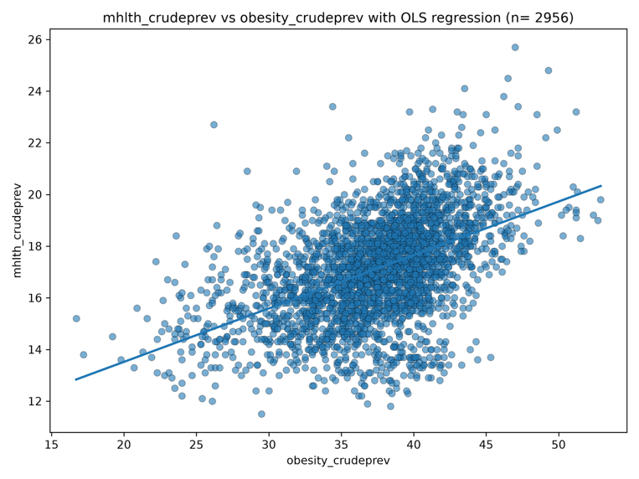
R²: 0.2418
β₀: 9.3830
β₁: 0.2069
Description: There is a positive relationship between obesity and mental health disorders. As the obesity prevalence increases so does the mental health disorder prevalence. The R² value of 0.2418 means obesity explains about 24.18 of the changes in mental health disorder prevalence.

