|  |
| --- |
| Eorzea Solutions |
| CRM Proposal for MJ Logistics Gaming Company |
| Holistic Customer Relationship Management Software |

|  |
| --- |
| Kendall Freed  11-22-2024  [Version 1.0] |

Contents

A. Introduction 3

A1. Introduction and Purpose Statement 3

A2. Overview of the Problems 3

A3. Goals and Objectives 3

A4. Prerequisites 3

A5. Scope 3

A6. Environment 3

B. Requirements 4

Business Requirements 4

User Requirements 4

Functional Requirements 4

Non-Functional Requirements 4

C. Software Development Methodology 4

C1. Advantages and Disadvantages 4

Advantages of the Agile Method 4

Disadvantages of the Agile Method 4

Advantages of {A Different Method} 4

Disadvantages of {A Different Method} 4

C2. Best suited 5

D. Create Two Representations of the Software Solution 5

Representation 1 5

Representation 2 5

E. Testing 6

Test Name 1 6

Test Name 2 7

Test Name 3 8

F. Sources 8

# Introduction

# A1. Introduction and Purpose Statement

Hello, my name is Kendall Freed from Eorzea Solutions with an exciting proposal for your CRM (Customer Relationship Management) needs at MJ Logistics Gaming Company.

We have a state-of-the-art cloud-based CRM program called Holistic CRM that can help you manage your clients, track sales, maintain activity management, and manage reporting. Our CRM program will help by connecting all these portions of your business into one piece of software. The details for this software we have designed are described in great depth in sections A-E of this document.

# A2. Overview of the Problems

Your current system uses custom-built tools in spreadsheets and database management software with a lot of manual steps and processes. Holistic CRM uses one software to connect all departments and processes of the business together. By using APIs, Holistic CRM creates a bridge between different applications that departments may use for their data. Departments don’t have to change the way they are currently functioning. We will use our APIs to collect their data and integrate with Holistic CRM.

Holistic CRM also has been tested and measured extensively under heavy loads of data to ensure that it can scale effortlessly with MJ Logistics as it continues to grow in the future. So rest assured, you won’t need to change CRM software in the future.

# A3. Goals and Objectives

Goals:

Scalable as the business grows.

Consolidating contact and business information with activities and interactions.

Increased security internally and externally.

Managing activities and tracking sales.

Integration with other systems to share data.

Objectives:

Allow for up to 50,000 users to be using the system at any given time with the server infrastructure we have in place in the cloud.

Organize contact and business information into easy to read cards that also displays sales, activities, interactions, and potential for future investment.

Internal users will have control to certain features based on roles and permissions, both onsite and off-site.

The security of the program comes with 2-Factor Authentication, Encryption of Data, Storing Database Server in secure location, Backup Security, Frequent Auditing, and much more.

Show activities and sales and allow users to interact with one another in what they are doing relative to these activities and sales with easy-to-read visuals.

Integrating with other systems with APIs that allow data to be then used in Holistic CRM seamlessly.

# A4. Prerequisites

|  |  |  |  |
| --- | --- | --- | --- |
| Number | Prerequisite | Description | Completion Date |
| 1 | Windows OS 11, Linux Mint 22 “Wilma”, Mac OS 15 Sequoia | Computers should be updated to the newest Windows OS, macOs, or Linux to be able to use all features and have increased security. | November 30th, 2024 |
| 2 | User Training Program and Environment | Program that allows users to familiarize themselves with the Holistic CRM before it goes live. Training can be tailored for each department. | November 30th, 2024 |
| 3 | Data Transfer | Transfer current data to Holistic CRM to allow set up of environment and ensure final testing. | November 25th, 2024 |
| 4 | Physical Token for 2FA | Physical token delivered to each user for 2-Factor Authentication and tested with software environment before live date. | November 25th,2024 |

# A5. Scope

Within the scope of our proposal is: Activity Management, Order Management, Contract Management, Sales Tracking & Forecasting, Sales Quoting Management, Contact Information Management, Workflow Management, Pipeline Management, Competitive Analyses, System Integration, Data Security, Ticketing, Reporting.

Outside of the scope of our proposal is: ISP Services, Work or Expenses unplanned to transition to Holistic CRM, Alternate CRM that is not hosted on the Cloud.

# A6. Environment

Operating System:

* Windows 11 – Updated to newest version.
* MacOS 15 Sequoia – Updated to newest version.
* Linux Mint 22 “Wilma”

Browsers:

* Chrome – Updated to newest version.
* Mozilla Firefox – Updated to newest version.
* Microsoft Edge – Updated to newest version.
* Safari – Updated to newest version.
* iOS and Android support – Updated to newest version iOS and Android for security.

Back-end:

* SQL Server 16 in AWS Cloud
* SQL Queries for Database Searches
* AWS Cloud Hosting

Service Level Agreements:

* Connectivity: For any outages, data is backed up hourly to a separate server and region, allowing for quick recovery when connectivity is restored. For any ISP provider outages, please consult with your ISP provider.
* Response Time: General questions will be responded to within 2 business hours. High priority issues will be responded to within 15 minutes. We have a 24/7 support staff available for any issue that may arise.
* Resolution Time: Critical issues will be resolved within 1 hour. High priority issues will be resolved within 4 hours. Medium and low priority issues will be resolved within 24 hours. We have a Crisis Team available 24/7 to ensure any issues are resolved quickly.
* Data Security: Data will be encrypted with AES-256 Encryption with regular key rotation. If a data breach occurs, Eorzea Solutions will notify affected customers within 24 hours and provide regular updates on mitigation efforts. Regular penetration testing will be conducted to identify vulnerabilities and address them properly.
* Maintenance: Scheduled maintenance will be performed during the hours of 2AM-3AM EST every first Saturday of the month. In the rare event that the system experiences downtime during this time frame, the customer will be eligible for a service credit based on the duration of the outage.
* Upgrades: Customer retains the right to refuse non-critical upgrades.
* Custom Development: Requests for any features can be submitted and discussed with our Support team. We will discuss each feature that’s presented and realistic timeframes for developing them.

Testing of CRM:

* Holistic CRM will be tested on each OS with the shared data prior to deployment. It can be tested in Virtual Environments on user machines in a testing environment prior to deployment as well to allow users to become familiar with the features.

# Requirements

## Business Requirements

Reporting – Holistic CRM allows users to build custom reports along with predefined reports with our easy-to-use interface. Our program comes with a list of predefined reports and summary reports on our dashboard in the navigation menu on the left side. Custom reports can be created using the “New Report” function in the top right and applying filters. These can then be saved to the reports list to the left if they are needed to be viewed frequently.

## User Requirements

Contact Management – Holistic CRM has extensive features for managing contacts for both business and end users. Contact settings can be changed at the time of sign-up and throughout the contact lifetime in terms of marketing preferences. Contacts are categorized by type, can be moved between businesses/offices/roles, and can maintain one or more roles. Business contacts are designed as one entity and will detect if a duplicate business entity is already in the system. Business contacts can have multiple contacts assigned to one or more of them. Users can tag inquiries to existing businesses and contacts during calls and create a new business and/or contact. Partial contact information entries are accepted but will be flagged in the system to be completed.

## Functional Requirements

Order Management – Holistic CRM has many order features that allow quotes to proceed into an order and then complete as a sale. Order tracking is also connected with each order and can be easily viewed in our interface. Taking orders, reordering, and part ordering are also included in the “Orders” tab of our interface. Customers can use our Holistic Portal to place orders that update into our system.

## Non-Functional Requirements

Quoting – Holistic CRM works with warehouses to have fast up-to-date inventory and product availability to give accurate quotes. Our Configure Price Quote (CPQ) Algorithm creates a quote by taking into account shipping costs, contract pricing, price catalogs, freight costs, discounting, tax, and substitution.

# Software Development Methodology

At Eorzea Solutions we pride ourselves in using Agile methodology for developing our software. Agile methodology allows for continuous feedback and adjustments throughout the project lifecycle and emphasizes iterative cycles with frequent deliveries and updates.

In contrast, other methodologies like Waterfall use a linear approach with defined phases where each phase must be completed before progressing to the next. Waterfall has rigid set delivery times and less frequent updates and deliveries, because of this.

# C1. Advantages and Disadvantages

## Advantages of the Agile Method

1. Using Agile methodology we are able to deliver frequent updates to Holistic CRM for our customers.
2. We are also able to involve you and other customers throughout our process for feedback on our updates, which includes surveys and beta testing.
3. Agile methodology also allows our teams to make decisions about their work within each iteration in the cycle, promoting more self-organization and efficiency. This allows Holistic CRM to have better ideas for architecture, requirements, and designs.

## Disadvantages of the Agile Method

1. Using Agile methodology can be a hinderance when customers want a delivery date specified. Because of the way Agile is flexible, it can cause some projects to run longer than expected without the proper planning. This could mean some delays in updates when they are expected for Holistic CRM.
2. While Agile allows a lot of customer input, one disadvantage is our predicted final product of an update for Holistic CRM might look different than the result. Using feedback and adjusting as needed means some promises and deliverables may be adjusted in the development.
3. Agile methodology can also be taxing on the development team here at Eorzea Solutions. Collaboration and involvement from the teams throughout the process is very time consuming and can wear down some teams and developers. This could lead to less-than-ideal finished products in updates for Holistic CRM with the developers being burned out.

## Advantages of Waterfall

1. For the Waterfall methodology, it is easier to manage because of the known sequential process for each project. Each phase has specified deliverables making it easier to manage and plan around. This would allow our customers to be given specific updates of what we are working on with each new edition of Holistic CRM and what our next steps are.
2. Waterfall methodology also would allow us to give customers of Holistic CRM specific dates when the updates will be released, because of the rigid timeline.
3. Because Waterfall requires a lot of planning and documentation for each phase, this would allow our developers and all teams to better understand the code, tests, and algorithms used. It would allow other team members to easily be able to answer questions for customers about code/projects they may not be directly involved with.

## Disadvantages of Waterfall

1. The Waterfall methodology’s main drawback is that changes can’t be made during the project timeline. This would prevent customer feedback during the development process of updates at Holistic CRM to be accounted for and used to provide features our customers want.
2. Waterfall methodology also means the updates would be delivered at later time intervals (albeit regular and scheduled ones). This would mean our customers for Holistic CRM may be waiting for a long time for updates they really need.
3. Planning with Waterfall can be difficult when the customer may not know what they want in the planning process. This would mean customers would have to wait for the next update/development cycle to give their list of desirables to Eorzea Solutions.

# C2. Best suited methodology

Agile methodology is what we practice at Eorzea Solutions. It allows us to have continuous feedback with our customers so we can prepare products that best suit their needs. It also allows us to work together as a company more holistically as we all must contribute to the project throughout the development process. This fosters an environment where all teams interact with one another on a frequent basis and can understand what each other is doing.

When we start our development cycle for the next Holistic CRM, we have an open communication with our customers to give feedback to our developers for features we can add into the next update. We want you to receive what you need at an expedited rate.

# Two Representations of Holistic CRM

## Use Case Diagram of holistic Crm

Below is a representation of how a customer’s information and activity is used to create a contact card. This contact card is then used by multiple departments to access information for their activities. Marketing and Sales work together for Sales Forecasting and Quote Generation & Assembly. Management also has access to Sales Forecasting along with activities like Company Activities and Assigning Tasks. Sales also has access to the Sales Tracking system for their needs.

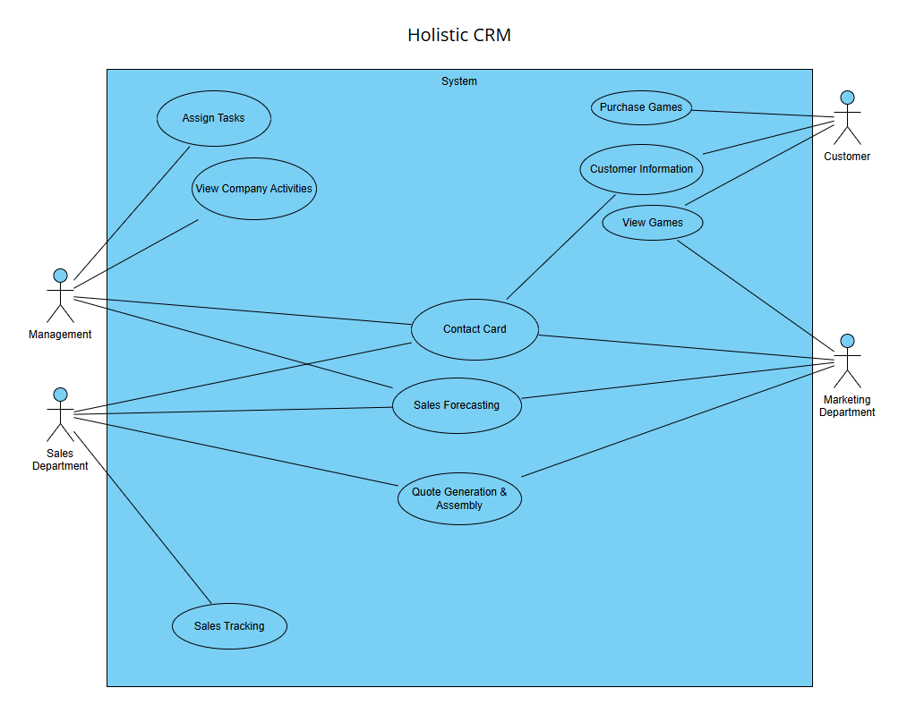

## Activity Diagram of holistic Crm

Below is an Activity Diagram of the process after an end user logs into MJ Logistic Gaming Company’s site and purchases a video game. This is then updated to Holistic CRM’s software and connects with all the features we have. The activity is registered to the Contact Card. A contract is created, order tracking is started, and opportunity management is updated. Through our opportunity management feature, MJ Logistics can access updated Sales Forecasts, track pipelines, and view product analysis for future growth.

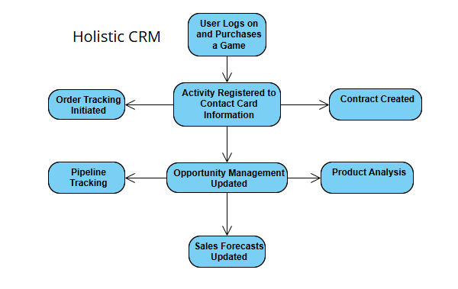

# Testing

# Contact management testing

|  |
| --- |
| Requirement to be tested: This code tests wither contacts are updated correctly when users have any activity. |
| Preconditions: Holistic CRM is operational and online, servers are functional and stable, test contact information & test sales data (account with fake name, date of birth, etc prepared with fake software that can be “purchased” so real inventory will not change). |
| Steps:   1. Add test contact information into new account. 2. Add test inventory into system. 3. Purchase the test inventory through the new account. 4. Update contact information in account with new information (change of address, new name). 5. Delete account. |
| Expected results:  With the above steps, we should see everything functioning in the system properly. A new account is created, this will create a new contact card in the system. The purchase of inventory should then create a ticket and the activity linked to the contact card. When the account information is updated this should also be reflected in the contact card. The deletion of the account should deactivate the account and it will be stored separately for retired accounts. |
| Pass: All contact card information is created with the entry of new data, a purchase, and updated information. A ticket is created in the system with purchase of inventory. Contact card information accurately reflects all of this. Contact card information is deactivated and retired with deletion of account.  Fail: Contact card is not created. Information to create the account does not store in the system or reflect in the contact card. Inventory does not change with purchase. Purchase does not create a ticket. Purchase also is not reflected in contact card. Ticket is not linked to contact card. When account is deleted the contact card is still active. Deleted account is not marked as deactivated and retired in system. |

# Ticket System testing

|  |
| --- |
| Requirement to be tested: Test that the ticketing system in Holistic CRM is operational and functioning as intended. We want to see all features are functional: tracking name of person calling on ticket, reason they called, the date and time they called, the follow-up to the call with relevant details, email replies appearing in system. |
| Preconditions: Holistic CRM is operational and online, servers are functional and stable, test ticket information (tickets with varying priorities and statuses) & test email data required. Test contact card & test fake inventory required from previous contact management test. These must have passed all tests to ensure working order. Test employee user accounts in system with appropriate permissions to manage tickets and test employee user accounts without permissions. |
| Steps:   1. Activate test contact card in system with test information from contact card management test. 2. Activate test user accounts in system with appropriate permissions and user accounts without appropriate permissions. 3. Create test tickets in system and assign to contact card and relevant user accounts. Attempt to assign tickets to irrelevant user accounts. 4. Add test notes and communication to the test tickets with both sets of test user accounts. 5. Respond to the tickets with communication tools in system with messaging and emails. 6. Resolve the ticket in the system. Use both sets of test user accounts to do so. |
| Expected results:  The first thing that should be expected is that the test user accounts have appropriate permissions to view the tickets and manage them. There should be user accounts that that also don’t have the appropriate permissions in the system that should be verified that they cannot see these tickets.  Once the user account permissions are verified we would expect to then see the test tickets created with the appropriate accounts viewing them. Those accounts will then be able to verify the information for the test tickets and that the information is correct. Those user accounts will then be adding test notes and communication with the tickets and this should be accurately reflected in the system and updated with the ticket. Once the ticket is marked as resolved by the appropriate account, the ticket should reflect that in the system with a ‘Resolved’ status. Only the accounts with the appropriate permissions should be allowed to do this and any account without the correct permissions would be unable to. |
| Pass: With the above expected results it would be pass, showing that the permissions are working correctly, the ticketing system is functioning as needed, and that the communication is working properly with tickets as well. |

# forecast testing

|  |
| --- |
| Requirement to be tested: Testing all the forecasting features in the system: forecast periods, currency, sales distributions, and baselining. |
| Preconditions: Holistic CRM is operational and online, servers are functional and stable, test data of previous sales & revenue of two different features to use with baselining tool, test time windows to use for forecast periods and future time windows for forecasting. Test manager account with appropriate permissions. Test regular employee account without appropriate permissions. |
| Steps:   1. Insert test sales data and revenue in system. 2. Insert test manager and test employee accounts. 3. Use both accounts to view product forecast and sales distributions for test product data. 4. Use both accounts to try baselining feature to compare view of forecast with two different test products. 5. Use both accounts to view forecast periods for test time window data and attempt to adjust currency. |
| Expected results:  The manager account should be able to see all the features execute with the test data. They should see the graphs of the data and the currency reflect a change in the graph relative to the currency. They should be able to enter in ranges of data for the forecasting periods and product forecasting.  The regular employee account should not be able to access any of this and should not be able to view any of this. |
| Pass: If the above is all seen it is considered a pass. We want to see the user accounts with the correct permissions be able to access the data, along with the data accurately reflected in the system with the features and showing graphs for forecasting. |

# Sources

*What’s the Difference? Agile vs Scrum vs Waterfall vs Kanban*. (2017). Smartsheet. https://www.smartsheet.com/agile-vs-scrum-vs-waterfall-vs-kanban?srsltid=AfmBOoqBN2uzxyTOSJBAjeupmFKVDqAHD2dMcl_JsLaDHYepOINcPzat