**Web Development Using XML**

Final Project Report

*Ken Dauer & Justin Tseko*

Table of Contents

I. XHTML Site

II. Mobile Site

III. PDF

IV. XML Technology Implementation

V. Extraordinary Distinction

VI. What We’re Proud of

VII. Lessons Learned

**I. XHTML Site**

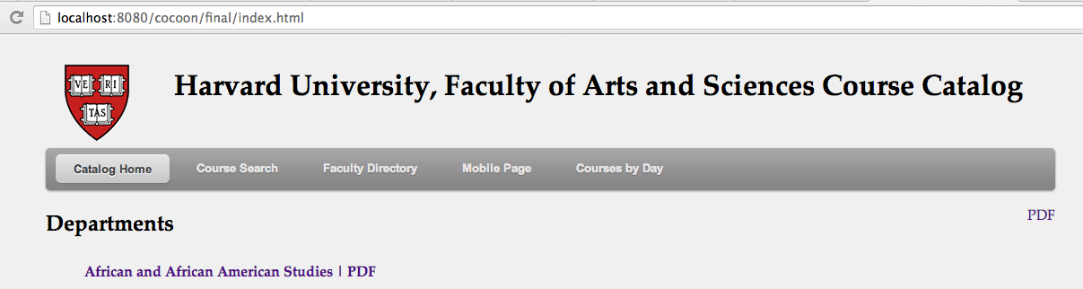

*XHTML Site Home Page (department_listing.xsl)*

Our XHTML site allows users to find course data in a number of different ways. Our home page, shown above, provides a listing of all departments of the site. In the top right corner of the content window is a link to a PDF containing a listing of all departments. Every page on our XHTML site contains a link to the PDF of the content of that page in the top right corner of the page. This consistency makes it easy for users to identify where to obtain a PDF for the particular page they’re on.

Our site also uses a common template (common.xsl) for all pages. This template provides a consistent look and feel to the site and allows for users to quickly navigate to the data they need. It also makes it simple to rapidly change the template for every page on the site. For instance, if in the future there needs to be a page dedicated to Harvard Business School courses, only one list item would need to be added to common.xsl in order to add a link to those courses from every other page on the site.

We anticipate users to have a lot questions and wanted to provide numerous easy-to-use ways to answer these questions. Fortunately, this assignment gave us some good starter questions to answer:

**“What are all the courses offered in a given department?”**

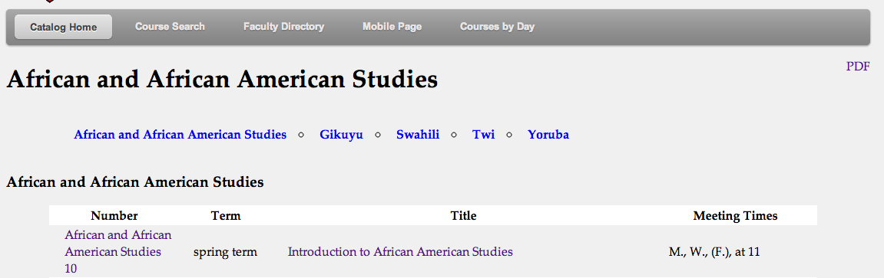

*Courses listed by department (department_courses.xsl)*

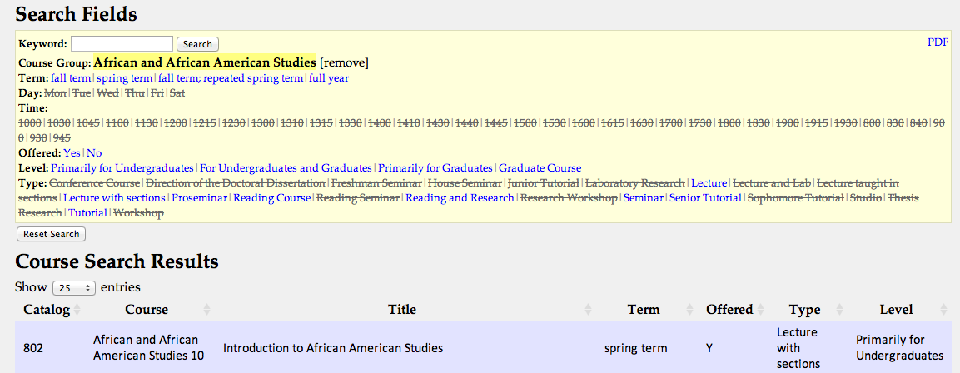

*Search results for the same department (search.html)*

The figures shown above show that there are two ways to answer this question. The user can navigate to the course listing page and browse through the courses or they can use the search page to search for courses by that department

**“What are the courses offered in a given department for a given term?”**

The figures above also illustrate that the user can browse courses at the department course page and see what term the courses are offered in, or they can search for the department and term using the search page. One area for expansion would be to modify department_courses.xsl so that users could sort by term or click a button to filter the results

**“What are all the French courses offered in the Romance Languages and Literature Department?”**

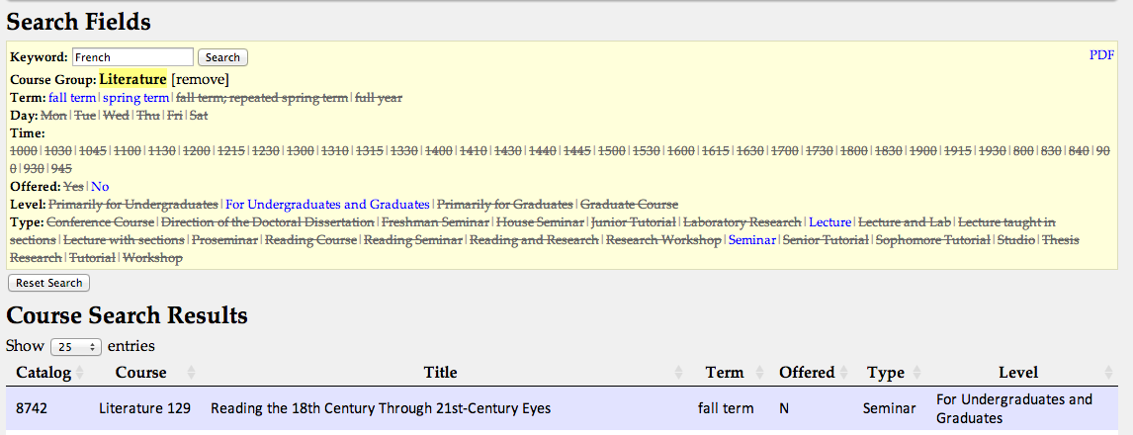

*Search results for keyword “French” and department “Literature”*

The best way for the user to find this data is simply to use the keyword search and add the department to the search. Note the PDF link in the top right corner. This link will generate a PDF document showing all the courses returned by the search, organized by department.

**“I have an open slot on MWF at 10am in the fall term -- what courses could fill that slot?”**

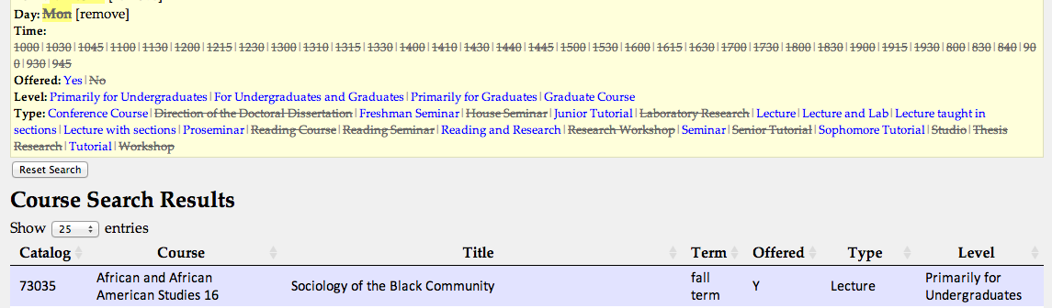

*Search results for courses offered on Monday in the fall term*

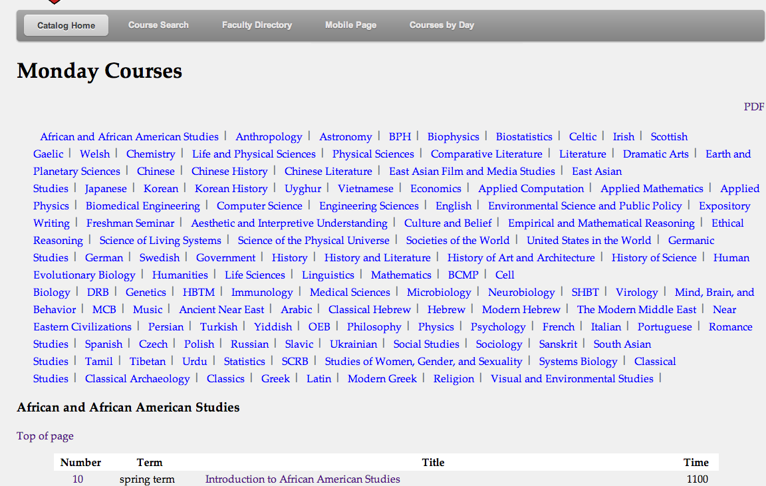

*Listing all courses offered on Monday (day_courses.xsl)*

This was the hardest question for us to answer and we could still improve on this question. We modified the searchfields.xsl, course_search_xml.js, and search.xsl to allow users to search by day of the week and time, but experienced difficulties allowing users to search for multiple days and combinations of date and time. To partially compensate for this, we developed sites where all courses for a particular date and time could be viewed.

**“What are all the courses that Robert Lue teaches?”**

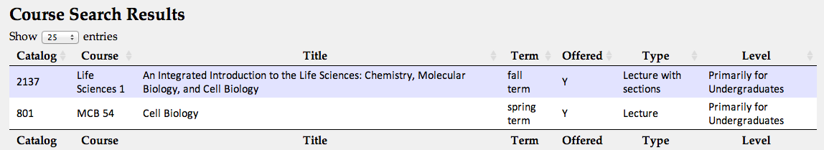

*Search results for keyword “Robert Lue” (search.html)*

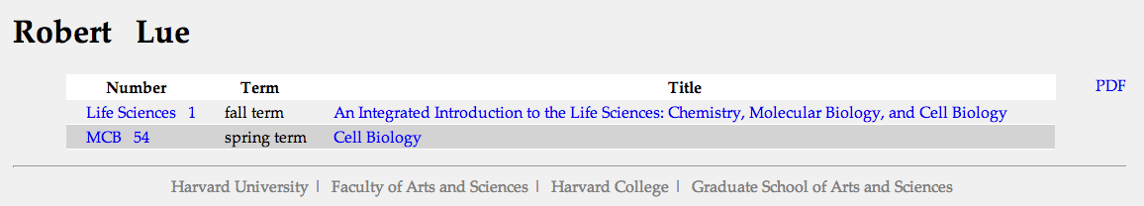

*Robert Lue faculty directory listing (faculty_courses.xsl)*

We offered two ways to answer this question. The users can search for “Robert Lue” using a keyword search or they can go to his faculty-listing page, accessible from the faculty directory. Note: we had some difficulty getting “Robert Lue” to return the correct results as the XML course data had his middle initial “A.” in his name. Some research led us to the solution of using the replace function to get rid of middle initials.

**“I'm looking for a course about "leadership" -- what are the options?”**

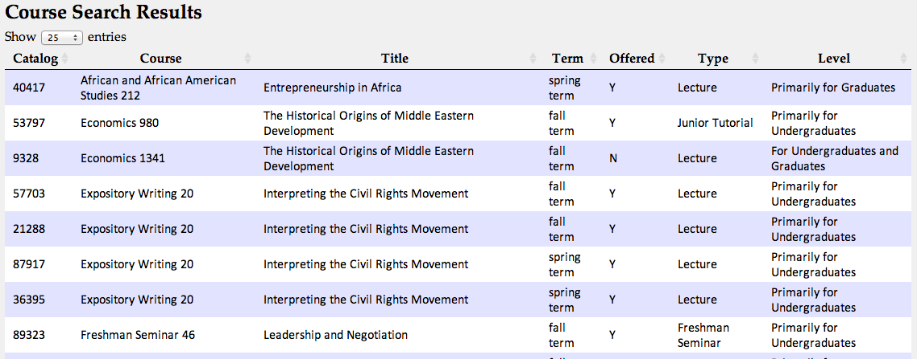

*Results of keyword search “leadership” (search.html)*

The best way for a user to answer this question is to simply do a keyword search for “leadership” in the search page.

**II. Mobile Site**

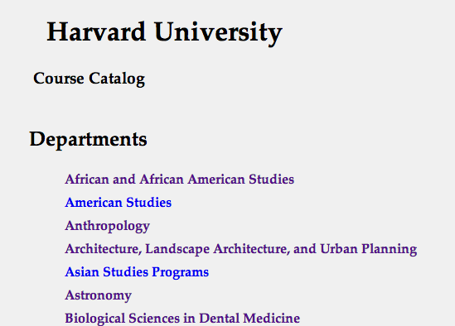

*Mobile Site Homepage (department_listing.xsl)*



*Mobile Site Footer (common.xsl)*

Our mobile site allows users to view a listing of all departments offering courses and then to view courses by department. The footer, present on every page, is pulled from common.xsl, and contains a link to the full site, should the user desire more functionality. All pages load quickly and display well on mobile devices, with a W3C mobileOK Checker score of 80% or better for all sites. Note: the actual score for the deployed site would likely be well over 90%. We lose points because of an “invalid HTTP response” error, which would not happen once deployed and for a “does not validate against XHTML Basic 1.1” error that appears to be invalid.



*Department listing for African and African American Studies (department_courses.xsl)*

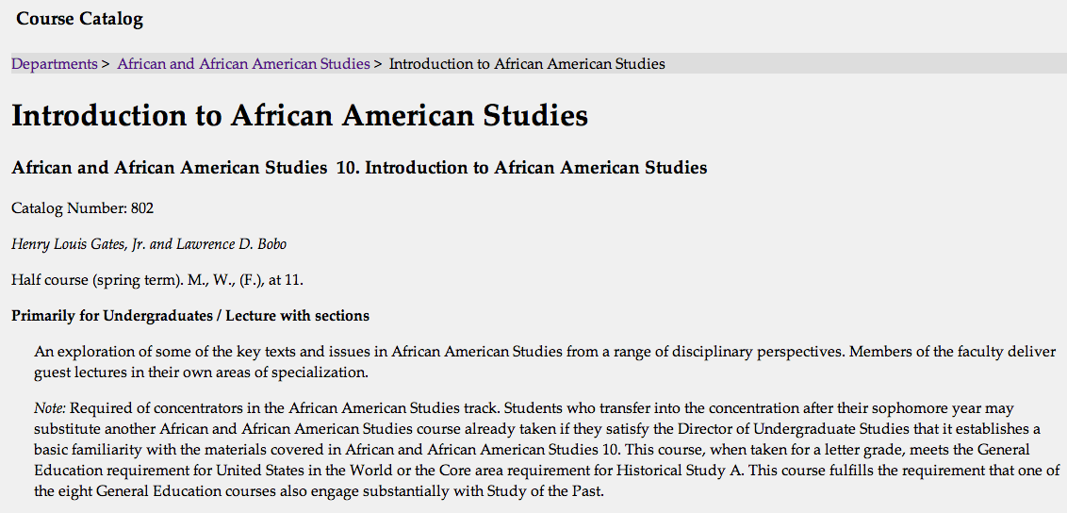

*Course detail for Introduction to African American Studies (course_detail.xsl)*

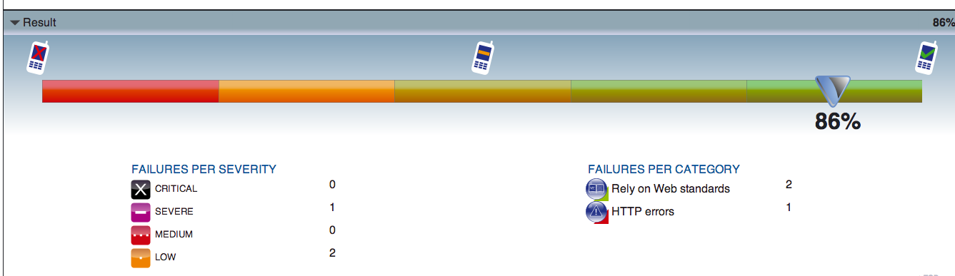

*MobileOk Checker Score*

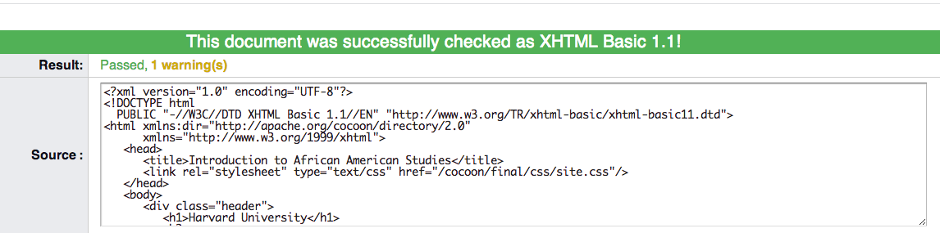

*W3C Validator validation*

As you can see above, our site also allows students to browse all the courses within a given department and to view detail on any course. The MobileOk Checker score of 86% for the course detail page includes the server invalid HTTP response error, which would not be present on the deployed site, and an error for invalid markup. However, as you can see, when we pasted the same code into the W3C validator, the markup came up as valid.

**III. PDF**

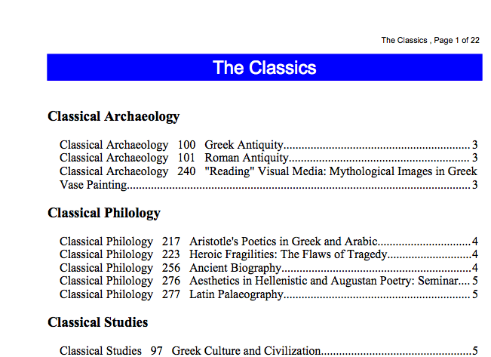

*PDF for The Classics Department (deparment_courses_PDF.xsl)*

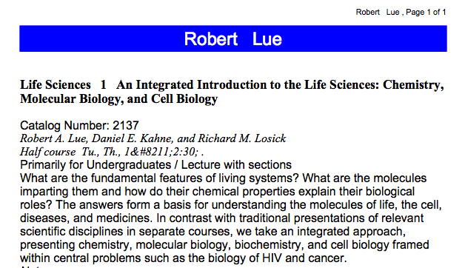

*PDF for Robert Lue’s courses (faculty_course_PDF.xsl)*

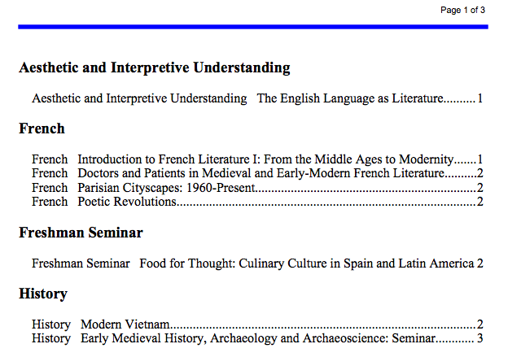

*PDF from search results keyword “French” and day Monday (search_results_PDF.xsl)*

As you can see from the samples above and on our actual site, we offer PDF documents for every single page on our site. PDFs can be generated of all courses within a department, single courses, courses offered by a particular faculty member, and for search results. The search results PDF is generated by a link on the search.html page. We modified the javacript for the searchfields so that, every time a user updates their search parameters, the link for the PDF document is automatically updated.

There is some room for improvements for our PDFS in terms of design and layout, but the essential elements are there. All PDFs containing lengthy listings of courses have a table of contents, with internal links, and all PDFS have page numbers listed on the top right corner. Additionally, course groups are used to logically group the documents together, which is particularly useful for the search results PDF.

**IV. XML Technology Implementation**

We separated our data and presentation in two separate ways. First, overall site layout is controlled by common.xsl files called by using xsl:import, for both mobile and XHTML sites. This allows for rapid expansion and changes to be made to the overall layout and navigation. Second, design is completely separated and is controlled by three simple CSS files. One for XHTML, one for Mobile, and one unique to the search results page.

It would be very easy to add new functionality to our site. If a new department was added to our source XML file, the project would automatically recognize it and if new pages needed to be added, all it would take is one line in the common.xsl to add a link to them. Any new XML elements added to the source xml file could be easily added to the appropriate pages without any major modifications. As an example of the flexibility of our site. I added two new departments, Justin’s Department and Ken’s Department to courses.xml and reloaded our site. The site automatically added two new departments to the department listing and placed them in the right order alphabetically:

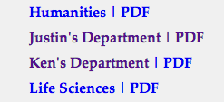

Outputting to new formats would be easy as well and would only require additional serializers and xsl files. The site design could easily accommodate another link in the top right corner for “Excel” files and no changes, other than adding the link, would be required to existing pages.

**V. Extraordinary Distinction**

Our page has a lot of internal consistency and there are almost always multiple ways for users to answer their questions. Using a simple and elegant CSS drop down menu, incorporated into our common.xsl, we made site navigation easy and useful. We made sure users could find courses by day by either searching or going to dedicated pages listing all courses on that day, and we added a faculty directory, which could be extended to provide other useful information, that provided listing of all courses taught be a particular factory. We feel we went above the basic specifications in providing more ways for users to find the data they need and by making the site very easy to navigate, while still leaving room for eventual expansion.

**VI. What We’re Proud of**

We are very proud of having successfully incorporated PDF documents on every page and expanding the usefulness of the search engine. We’re also proud of our site design, which is simple, clear, and very lightweight. Even our full site displays well on mobile devices and loads very quickly in low bandwidth environments. Every page validates with no errors and our mobile checker scores are all good to excellent.

**VII. Lessons Learned**

Not having a repository makes team-coding projects very difficult. We wasted a lot of time transferring documents via email and Google Drive. It also caused a lot of errors and frustration when it came to merging our course work. We found it best to have each of us work at separate times, then zip all of the files together, and then post the zip on Google Drive.

Merging codebases is very difficult. Justin started the project using a filter.xsl file to filter all the course data before it was touched by the XHMTL or Mobile pages, while Ken filtered the data using template matches and for-each-groups in his individual .xsl files. While Justin's filter.xsl file definitely had some advantages, in the end it was too difficult to get the two separate approaches to work together and we shelved the filter.xsl.

Pagination is extremely difficult to implement, at least for us. Justin spent a ton of time and effort trying to get it to work, including one on one time with Eric Parker in section, but after hours and days of trying, we couldn’t get it to work. This is probably the first area we’d seek to improve on our site, as it would make our mobile pages more useful.