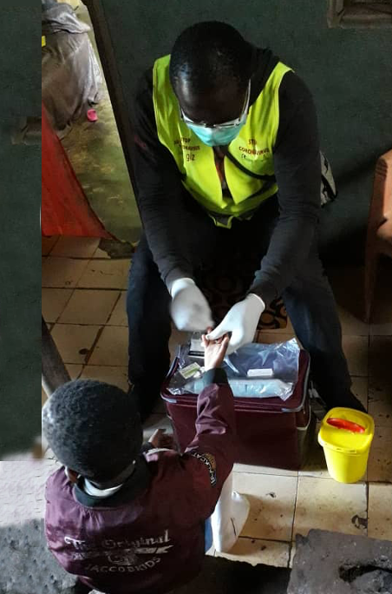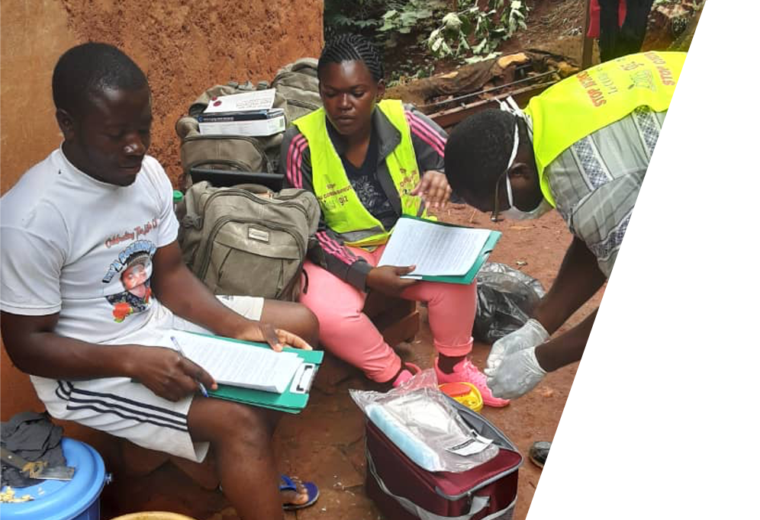

**EpiCO19 Final Report**

Epidemiological survey and active screening for COVID-19:

Investigating the circulation and impact of SARS-CoV-2 on the population of the health district of Cité Verte in Yaounde

Epidemiological survey and active screening for COVID-19:

Investigating the circulation and impact of SARS-CoV-2 on the population of the health district of Cité Verte in Yaounde

Epidemiological survey and active screening for COVID-19:

Investigating the circulation and impact of SARS-CoV-2 on the population of the health district of Cité Verte in Yaounde

Epidemiological survey and active screening for COVID-19:

Investigating the circulation and impact of SARS-CoV-2 on the population of the health district of Cité Verte in Yaounde

Epidemiological survey and active screening for COVID-19:

Investigating the circulation and impact of SARS-CoV-2 on the population of the health district of Cité Verte in Yaounde

Epidemiological survey and active screening for COVID-19:

Investigating the circulation and impact of SARS-CoV-2 on the population of the health district of Cité Verte in Yaounde

**Supported by:**

ASCRES • CIRES • MINSANTE Cité Verte • CIRCB • GIZ

Supported by:

ASCRES • CIRES • MINSANTE Cité Verte • CIRCB • GIZ

Supported by:

ASCRES • CIRES • MINSANTE Cité Verte • CIRCB • GIZ

Supported by:

ASCRES • CIRES • MINSANTE Cité Verte • CIRCB • GIZ

**Jan 04, 2020**

Epidemiological survey and active screening for COVID-19: Investigating the circulation and impact of SARS-CoV-2 on the population of the health district of Cité Verte in Yaounde

|  |  |
| --- | --- |
| **Principal Investigators** | **Affiliation** |
| Dr Laura Ciaffi | **ASCRES** - Association de soutien aux centres de recherches, d'enseignements et de soins  Tél : 00237 694 92 67 86  Mail : [lauraciaffi2002@yahoo.fr](mailto:lauraciaffi2002@yahoo.fr) |
| Dr Franck Wanda | **CIRES** – Centre International de Recherches, d'Enseignements et de Soins  Tél : 00237 699 73 46 89  Mail : [franck.wanda@cires.solutions](mailto:franck.wanda@cires.solutions) |

|  |  |
| --- | --- |
| **Investigators** | **Affiliation** |
| Dr Lucien Mama  District medical Officer | **Ministry of Public health**  District de Sante Cité Verte -Yaounde |
| Dr Joseph Fokam  Virologist | **CIRCB -** Centre International de recherche Chantal Biya Yaoundé |
| Dr Eric Comte  Public Health Specialist | **ASCRES** - Association de soutien aux centres de recherches, d'enseignements et de soins |
| Prof. Olivia Keiser  Head of division of Infectious Diseases and Mathematical Modelling | **University of Geneva**, Institute of Global Health |
| Prof. Nicolas Ray  Associate Professor | **University of Geneva,** Institute of Global Health |
| Erol Orel  Scientific Collaborator | **University of Geneva,** Institute of Global Health |
| Kene David Nwosu  Research Assistant | **University of Geneva,** Institute of Global Health |

|  |  |
| --- | --- |
| **Project Staff** | **Role** |
| Eric Mimbe | Data Manager |
| Jeanine Meke | Interviewers’ Team Leader |
| Armel Tassegning | Interviewers’ Team Leader |
| Thomas Eyinga | Interviewer |
| Evelyne Boyomo | Interviewer |
| Assana Gondio A Tiati | Interviewer |
| Yolande Maled | Interviewer |
| Josphine Embolo Manga | Interviewer |
| Michel Ntsama | Interviewer |

|  |  |
| --- | --- |
| **Sponsor** |  |
| GIZ Cameroun | Mr Josselin Guillebert director ProPASSaR/GIZ  Mme Patricia Ndongo |

Table of Contents

Background 3

Methods 4

Design 4

Population 4

Sampling 4

Testing 5

Questionnaire 5

Field work 5

Data management 6

Data analysis 6

Seroprevalence estimation 6

Risk factor analysis 6

Ethical considerations 7

Results 7

Participation rate 7

Respondent and household characteristics 8

Seroprevalence estimates 9

Risk factors for seropositivity 12

13

COVID-19 related symptoms and treatment 14

Risk factors for symptomatic COVID-19 15

Impact on individuals and households 16

Attitudes towards COVID-19 18

Conclusions 20

Bibliography 21

# Background

Coronavirus disease 2019 (COVID-19) is caused by the severe acute respiratory syndrome coronavirus-2 (SARS-CoV-2), which was identified for the first time in China at the end of 2019.1 The virus quickly spread globally, and the World Health Organization declared COVID-19 to be a pandemic on March 11, 2020. As at December 1, 2020, there have been over 67,000,000 notified cases, with over 1,500,000 reported deaths.2

Given the rapid spread of the epidemic in Europe and the Americas, and the handicapped response by countries with the richest health systems, the outlook for less developed countries, and sub-Saharan Africa in particular, seemed dire. High numbers of deaths were expected due to weaknesses in health systems, difficulties in enforcing hygiene measures, and perceived health vulnerabilities of the population.3,4 But the trajectory of the epidemic on the continent appears to have gone against expectation. Despite having over 2,200,200 infections as of December 1,2 Africa remains the least affected region and the mortality rate, even if not well documented, remains lower than expected.4

Multiple hypotheses have been advanced to explain the seemingly mild trajectory of the COVID-19 epidemic in Africa: researchers have pointed to the continent’s warm climate, young population, or cross-reactive immunity from other infections as possible mitigating factors.4 But an informed explanation of the epidemic trajectory requires accurate numbers on the actual extent of population infection. And, as is the case elsewhere,5 the officially reported case counts in Africa significantly underestimate the extent of spread.4

In this context, the use of serological antibody tests to detect exposure to SARS-CoV-2 is valuable. A number of validated SARS-CoV-2 antibody tests now exist on the market,6 and some of these are point-of-care lateral-flow immunoassays, which are affordable, easy to use and provide quick results. Although concerns about sensitivity and specificity remain, these antibody tests offer the opportunity to more accurately assess the prior infection rate of populations in regions where PCR-based testing has been uncommon.5

This report presents the protocol and results of our study using a lateral-flow immunoassay to assess the seroprevalence of anti-SARS-CoV-2 IgG and IgM antibodies in a region of Yaounde, the capital of Cameroon.

In addition to examining seroprevalence, our study also hopes to shed light on the broader impact of the epidemic on the socioeconomic wellbeing of the Cité Verte population. Soon after its first notified COVID-19 case (on March 6, 2020), Cameroon closed its borders and implemented significant social distancing measures, including mandatory bar closures after 6 PM, limitations on public transport occupancy, bans on gatherings of more than 50 people and the closing of in-person schools.7 Similar measures were taken in other African countries.

The effects of these measures on the wellbeing of the Cameroonian population have not been well examined. Studies in other contexts have noted that during the pandemic period, access to routine health care services has been disrupted. We designed and implemented a survey to assess whether such disruptions were common in the studied population. This survey was performed concurrently with the seroprevalence assays.

# Methods

The EpiCO 19 study is a community-based survey to estimate the circulation and the impact of SARS-CoV-2 and the COVID-19 pandemic on a district in Yaounde, which is one of the cities most affected by COVID-19 in Cameroon.

## Design

EpiCO 19 is a cross-sectional clinico-epidemiological and socio-economic study.

## Population

The Cité Verte district, located in the Mfoundi department of the Center Region of Cameroon, covers a surface area of 19 square kilometersin the administrative area of Yaounde II. The total estimated population is 432,858, of which the majority are young. It is located in the oldest part of the city of Yaounde and residents are from several different regions of Cameroon.

The dwellings are of two types: 60% are permanent built with standard building materials while 40% are temporary structures. Some neighbourhoods, notably Tsinga and Cité Verte (the Cité Verte neighbourhood of the Cité Verte district), are better equipped in services and roads than others.

Cité Verte is divided into nine health zones with a total of 63 health structures, of which eight are public and three are run by private, faith-based providers. In each of the health areas there is a referent health structure and a number of community health workers supporting public health activities that are carried out by the Ministry of health or other partners in the community. These personnel have been key for the study to facilitate access to the population.

## Sampling

The following formula was used to calculate the size of the sample for the study:

n = Z2 P(1− P)/d2

where n = sample size, Z = Z statistic for a level of confidence, P = expected prevalence or proportion (in proportion of one; if 20%, P = 0.2) and d = precision (in proportion of one; if 5%, d = 0.05).

With this formula, a level of confidence of 95% (Z=1.96), a precision of 5%, and an estimated prevalence of 20% in the general population, a sample of 245 people was calculated to be sufficient, but the sample was increased to 1000 people to provide for improved precision and better representativeness of the different parts of the community.

Houses were randomly selected from a pre-processed set of all buildings in the Cité Verte district. The building footprint came from the global participatory mapping project Open Street Map, and were initially filtered to exclude those buildings not informed as residential. A standard replacement procedure was used when the selected buildings were not residential.

Households, which were the sampling unit of the study, were defined as a group of people living in the same residence and sharing the kitchen.

In each household, all individuals between 5 and 80 years were included if they a), were living in the selected household, b) had been present in the household for at least 14 days and c) could give written informed consent (or had an adult guardian who could give consent). Children of less than 5 years and people with severe psychiatric illness were excluded.

Two hundred and fifty households were targeted for a total population of 1000 respondents living in the Cité Verte District.

## Testing

The EpiCO19 study used the Abbott Panbio™ COVID-19 IgG/IGM Rapid Test Device, an immunochromatographic test for the qualitative detection of IgG and IgM antibodies to SARS-CoV-2. The manufacturer-estimated sensitivity and specificity of the test are 95.8% and 94% respectively.

The serological tests were performed on capillary blood which was collected from a finger prick from all the consenting participants. All waste material was eliminated following safety procedures by the study team.

Additional steps were taken when active COVID-19 was suspected. (Such cases were identified if they matched the WHO COVID-19 criteria of symptoms, updated as at August 2020.) The national algorithm for further testing was applied to these suspected cases. First, a rapid antigen test was performed. If the result of the antigen test was negative, then a nasopharyngeal swab was taken. The swab was sent to the virological reference laboratory for an RNA PCR test for SARS-CoV-2. This PCR test was also proposed to all participants with a positive IgM result in the serological essay, since an IgM response can sometimes be observed concurrent with active infection.

The PCR tests were carried out at the virology laboratory of the CIRCB, the reference laboratory for diagnostic procedures in the Cité Verte District, following standard national procedures.

During sample collection all biosafety precautions were followed. The person in charge of swab collection was provided with full personal protection equipment (apron, gloves, face shield and FFP2 mask).

## Questionnaire

A questionnaire was created with KoboKollect©, a free software for epidemiological surveys.

The first few sections of the questionnaire focused on household composition, household income and recent deaths within the household. Then individual information about each survey respondent was surveyed. These sections included questions about the respondents’

* experience of symptoms compatible with COVID-19;
* health-seeking behavior during the pandemic;
* financing of healthcare during the pandemic;
* attitudes towards COVID-19; and
* respect of hygiene and physical distancing recommendations;

among others.

The questionnaire was field tested and modified following the feedback of the tests in the field.

## Field work

All the interviewers were trained over three days on research practice and ethics, and the specific study protocol.

In the first two weeks of study implementation, while waiting for the administrative authorization, a part of the team had time to conduct the geo-localisation of the majority of the households, supported by the health workers of each health area.

To increase receptiveness to the survey, awareness talks were carried out the day before, or a few hours before, the interviewers’ visit. On the interview days, study teams visited each household to interview them immediately or to arrange an appointment for a future interview.

Once residents were gathered, the study was presented and a signature of informed consent was given out to be signed. For anyone below 21 years, a signature was requested of their parent or legal guardian; but consent was still solicited from anyone above 15 years. The survey questionnaire was then administered to each household member.

In a quiet and private space, the material for the tests was set up and all the procedures for the test were respected. A picture of the test was taken and a paper result was handed out to the participant.

When active COVID-19 was suspected, a nasopharyngeal swab was done, information about prevention measures was given and the surveillance system of the district was alerted.

## Data management

Once the questionnaire was completed, it was uploaded to a secure server. Data were regularly monitored for completeness and coherence, and for agreement between the responses of different members of each household. Where doubts remained, the relevant interviewer was contacted for clarification.

## Data analysis

### Seroprevalence estimation

Seroprevalence values were weighted within each age or sex stratum to match the age-sex distribution of the Yaounde population, as sourced from the 2018 Cameroon DHS8.

We used the Rogan-Gladen formula to adjust IgG seroprevalence estimates to account for test performance.9 We used the sensitivity estimate provided by Batra and others’ validation study of the Abbott test, which found a sensitivity of 91.5% (75 correct diagnoses out of 82 samples) when applied on sera collected from hospitalized COVID-19 patients 14 – 56 days post symptom onset.10 We measured specificity by applying the test on a panel of 246 pre-pandemic (2017) samples from hospital patients in Yaounde. The IgG test correctly diagnosed 230 of 246 samples (93.5% specificity).

We did not apply test performance corrections to the IgM prevalence estimates; since IgM antibodies decline rapidly, becoming undetectable a few weeks after infection,11 a steady estimate of sensitivity for the IgM test cannot be obtained. Sensitivity estimates will vary very widely with time since infection. As we made no assumptions about the time of infection of those who tested positive, we are unable to conclude about the contextual sensitivity of this test. The same caveat also applies to the IgG test, but the slower decline of IgG antibodies means the assumption of stable test performance is more plausible for the IgG test.

Confidence intervals for test-adjusted estimates are Lang-Reiczigel intervals,12 which take into account the sample size of the antibody test validation study. Other confidence intervals for prevalences are Wilson score intervals.

### Risk factor analysis

For seropositivity risk factor analysis, we used logistic models with household random effects to account for within-household clustering. In the logistic models, the following prospective risk factors were analysed: sex, age, education, BMI group, occupation, contact with an international traveller since March 1st, contact with a suspected or confirmed COVID case since March 1st, presence of comorbidities (combining hypertension, respiratory illness, diabetes, tuberculosis, HIV, cardiovascular illness and “other illnesses” which were not explicitly listed in questionnaire), whether or not the respondent is the breadwinner, adherence to social distancing rules, location of the household (one of nine health zones), number of household members, and whether or not there are children in the household. Each variable was first analysed in a univariate model. Then variables with p < 0.10 for at least one factor level were entered into the multivariable analysis. All such variables are shown in the regression tables.

We used a simple logistic regression model to analyse risk factors for symptomatic COVID-19 among those who were seropositive. Respondents with symptomatic COVID-19 were taken to be those who tested positive for IgG or IgM antibodies and who experienced COVID-suspect symptoms since March 1st, 2020. COVID-suspect symptoms were defined, following WHO guidelines13, as:

* anosmia OR ageusia; or
* cough AND fever; or
* at least THREE of cough, fever, fatigue, headache, muscle pain, sore throat, runny/stuffy nose, shortness of breath, nausea, diarrhoea.

Based on clinical justification, we identified the following as potential risk factors for symptomatic COVID-19: sex, age, BMI group, pregnancy, smoking habit, hypertension, respiratory illness and diabetes. We used the same procedure as with the seropositivity regressions to select significant variables.

To analyse the determinants of formal healthcare utilization, we also used logistic models with household random effects. The following prospective risk factors were analysed: sex, age, fear of stigma from COVID diagnosis, income decrease during the pandemic, stated difficulty in paying for medical costs, stated difficulty in traveling to healthcare centres, and stated belief that healthcare centres are dangerous due to COVID-19. We repeated the same procedure as above to select significant variables.

For all regression analyses, age and sex were included as controls in all models, even when their effects were not significant in the univariate analysis.

Some factors analysed were individual-level variables, and others were household-level variables. The household-level variables were based on the answers of household “representatives”. The household representative was taken to be:

* the first interviewed adult (18 + ) who self-identified as the household head (“Chef du menage”); and, if no head was present,
* the first interviewed adult

Data were processed and analysed using R version 4.0.2 and RStudio. Key packages used included *lme4* for model fitting14, *DescTools* for the calculation of binomial confidence intervals15 and the *tidyverse* packages16 for data manipulation.

## Ethical considerations

The study protocol obtained the ethical clearance and the administrative authorization of the Ministry of Health of Cameroon. Every adult participant (21 years or above) signed an informed consent. For minors, a person with parental authority was asked to sign the consent form and, if the age was equal to or above 15 years, an assent was also requested. Questionnaires were coded and names of participants were recorded in a confidential list available only to the study team. Before starting the study, all the team members were trained on research ethics, good clinical practices and study protocol and procedures.

# Results

## Participation rate

From 14, October to 26, November 2020, 256 households were visited, of which 63 (24%) refused to give any information, one was excluded because not in the selected sample. In the end, 192 households were included for a total of 1007 participants.

Of the 192 included households, 128 were the originally sampled by the random system, while the remaining 64 (33%) were replaced through standard procedures because the identified buildings were non-residential.

Table 1: Households and individuals expected and included in the study.

|  |  |  |  |  |  |
| --- | --- | --- | --- | --- | --- |
|  | Inhabitants | N of household sampled | N of inclusions expected | N of households included | N of people included |
| Briqueterie | 52 850 | 31 | 124 | 24 (77%) | 109 (88%) |
| Carrière | 104 785 | 61 | 244 | 45 (73%) | 240 (98%) |
| Cité verte | 38 832 | 22 | 88 | 24 (109%) | 88 (100%) |
| Messa | 18 899 | 11 | 44 | 9 (81%) | 48 (109%) |
| Mokolo | 46 960 | 27 | 108 | 17 (63%) | 96 (89%) |
| Nkomkana | 41 953 | 24 | 96 | 15 (62%) | 81 (84%) |
| Tsinga | 35 349 | 20 | 80 | 16 (80%) | 83 (103%) |
| Tsinga Oliga | 37 572 | 22 | 88 | 14 (63%) | 71 (80%) |
| Ekoudou | 55 659 | 32 | 128 | 28 (87%) | 191 (149%) |
| Total | **432 859** | **250** | **1000** | **192** | **1007** |

All the health areas of the district were surveyed, but participation varied between the neighbourhoods (Table 1). All participants were to be tested for SARS-CoV2-antibodies, but in 35 cases (3%), some members of the household, despite responding to the questionnaire, refused the test.

## Respondent and household characteristics

Participants had a mean age of 29 years and 570 (56.6%) were women. The demographic characteristics of respondents are summarized in Table 2.

Households had a mean of 4.6 adult inhabitants (15 years or above) and 1.8 children. In the majority (92%) of the visited households, the head of the family was surveyed and in 136 households (70.8%), we accessed the person providing the main source of income. This was most often the father (55.7% of households) or the mother (36.5%).

Household members were most commonly in school (39.5%), working “small jobs” (21%) or working as traders (12.4%). This explains the high percentage of households who said their income arrives through irregular and informal sources (41%). Interestingly, despite only 5.7% of respondents reported regular waged work, formal regular income was the main source of revenues for 23% of the households, showing the possible contribution of other family members.

Only six households reported a prior positive COVID-19 test among their members, but 67 (7%) respondents reported having been tested for SARS-CoV-2 before, with nearly half of these as part of governmental mass testing campaigns.

One hundred eight participants (11%) reported suffering from a chronic condition, mainly hypertension (34%), respiratory conditions (16%) or diabetes (10%). With a mean BMI of 27.3 (versus 22.5 for men), women showed a higher frequency of overweight. Only 2 respondents reported HIV infection.

Table 2: Sociodemographic characteristics of the final sample

|  |  |  |  |
| --- | --- | --- | --- |
| Characteristic | Female | Male | Total |
| **n** | 570 | 437 | 1007 |
| Num. household heads | 77 | 101 | 178 |
| Mean Age (SD) | 29.6 (17.4) | 28.5 (17.6) | 29.1 (17.5) |
| Mean BMI (SD) | 27.3 (26.7) | 23.2 (6.26) | 25.5 (20.6) |
| **Age groups, n (% of sex in each group)** | | | |
| 5-15 | 137 (24%) | 128 (29.3%) | 265 (26.3%) |
| 16-29 | 186 (32.6%) | 136 (31.1%) | 322 (32%) |
| 30-45 | 140 (24.6%) | 89 (20.4%) | 229 (22.7%) |
| 46-65 | 79 (13.9%) | 66 (15.1%) | 145 (14.4%) |
| >65 | 28 (4.9%) | 18 (4.1%) | 46 (4.6%) |
| **Education Level, n (% of sex in each group)** | | | |
| Secondary | 258 (45.3%) | 184 (42.1%) | 442 (43.9%) |
| Primary | 191 (33.5%) | 137 (31.4%) | 328 (32.6%) |
| University | 76 (13.3%) | 81 (18.5%) | 157 (15.6%) |
| No formal instruction | 35 (6.1%) | 18 (4.1%) | 53 (5.3%) |
| Doctorate | 7 (1.2%) | 13 (3%) | 20 (2%) |
| Other | 3 (0.5%) | 4 (0.9%) | 7 (0.7%) |
| **Profession, n (% of sex in each group)** | | | |
| Student | 216 (36.5%) | 202 (43.3%) | 418 (39.5%) |
| Small jobs | 86 (14.5%) | 136 (29.1%) | 222 (21%) |
| Business/Trade | 81 (13.7%) | 50 (10.7%) | 131 (12.4%) |
| Housewife | 74 (12.5%) | 0 (0%) | 74 (7%) |
| Unemployed | 52 (8.8%) | 21 (4.5%) | 73 (6.9%) |
| Salaried worker | 38 (6.4%) | 22 (4.7%) | 60 (5.7%) |
| Retired | 18 (3%) | 17 (3.6%) | 35 (3.3%) |
| Other | 17 (2.9%) | 15 (3.2%) | 32 (3%) |
| Farmer | 10 (1.7%) | 4 (0.9%) | 14 (1.3%) |

## 

## Seroprevalence estimates

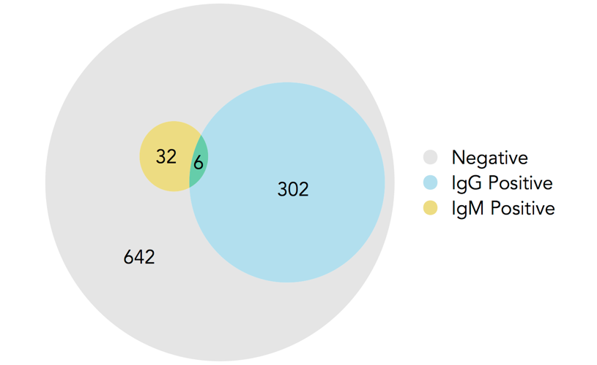

Of the 970 respondents tested for IgG and IgM antibodies, 340 (35.1%) tested were seropositive for at least one antibody type (Figure 1). IgM seropositivity was quite low, and the overlap between IgG and IgM seropositivity was minimal; among the 32 individuals who were IgM positive, only 6 were also IgG positive.

Figure 2 shows overall antibody seroprevalence (either IgG or IgM) in each age-sex stratum. Seroprevalence is higher in men, and increases with age. The highest values were seen in men above 65, where the seropositivity was 50%, although the sample size for that group is notably small.

Figure : Seropositivity of respondents by test type

Tables 3 and 4 show the adjustments for the age-sex distribution of the Yaounde population and for diagnostic test performance. Since women were oversampled relative to their share of the population (56.6% of sample was female), and women showed a lower seroprevalence, the crude estimates were downwardly biased. Thus, population weighting increased the overall estimate of seropositivity in nearly all age categories for both the IgG and IgM assays. Adjustments for specificity and sensitivity also increased the estimates slightly.

Following the WHO diagnostic criteria, 21 suspect cases were identified, and nasopharyngeal swabs were collected for PCR testing. Only one of the 21 RNA PCR tests was positive.



Figure : IgG seropositivity in each age-sex stratum.

Table 3: Population-weighted and test-adjusted seroprevalence estimates for anti-SARS-CoV-2 IgG antibodies

|  |  |  |  |  |  |
| --- | --- | --- | --- | --- | --- |
|  | Sample size, n | Seropos., n | Seroprevalence (95% Confidence Interval) | | |
|  |  |  | **Crude** | **Population- weighted** | **Population-weighted, test-adjusted** |
| Total | 971 | 302 | 31.1% (28.3 - 34.1) | 31.3% (28.4 - 34.3) | 29.2% (24.3 - 34.1) |
| Female | 549 | 154 | 28.1% (24.5 - 32.0) | 28.0% (24.4 - 31.9) | 25.3% (20.0 - 31.2) |
| Male | 422 | 148 | 35.1% (30.7 - 39.7) | 34.6% (30.2 - 39.3) | 33.1% (27.6 - 40.5) |
| 5 - 14 | 241 | 69 | 28.6% (23.3 - 34.6) | 28.7% (23.3 - 34.7) | 30.8% (22.9 - 39.5) |
| 15 - 29 | 325 | 98 | 30.2% (25.4 - 35.4) | 30.7% (25.9 - 35.9) | 26.1% (18.9 - 34.1) |
| 30 - 44 | 212 | 69 | 32.5% (26.6 - 39.1) | 32.7% (26.7 - 39.3) | 28.5% (21.4 - 35.1) |
| 45 - 64 | 153 | 51 | 33.3% (26.4 - 41.1) | 34.1% (27.0 - 41.9) | 32.5% (22.8 - 41.8) |
| 65 + | 40 | 15 | 37.5% (24.2 - 53.0) | 39.4% (25.8 - 54.8) | 38.7% (20.5 - 55.8) |

Table 4: Population-weighted seroprevalence estimates for anti-SARS-CoV-2 IgM antibodies

|  |  |  |  |  |
| --- | --- | --- | --- | --- |
|  | Sample size, n | Seropos., n | Seroprevalence (95% Confidence Interval) | |
|  |  |  | **Crude** | **Population- weighted** |
| Total | 953 | 32 | 3.4% (2.39 - 4.7) | 3.4% (2.43 - 4.8) |
| Female | 549 | 17 | 3.1% (1.94 - 4.9) | 3.0% (1.90 - 4.8) |
| Male | 404 | 15 | 3.7% (2.26 - 6.0) | 3.8% (2.32 - 6.1) |
| 5 - 14 | 241 | 5 | 2.1% (0.89 - 4.8) | 2.1% (0.89 - 4.8) |
| 15 - 29 | 325 | 12 | 3.7% (2.12 - 6.3) | 3.6% (2.07 - 6.2) |
| 30 - 44 | 211 | 7 | 3.3% (1.62 - 6.7) | 3.9% (2.02 - 7.5) |
| 45 - 64 | 152 | 6 | 3.9% (1.82 - 8.3) | 4.1% (1.94 - 8.6) |
| 65 + | 24 | 2 | 8.3% (2.32 - 25.8) | 8.3% (2.32 - 25.8) |

## Risk factors for seropositivity

Variables that were associated with SARS-CoV-2 seropositivity in univariable analyses included sex, educational level, BMI group, contact with an international traveler, contact with a suspected or confirmed COVID case, health zone, and number of household members (Table 5). Age, sex, and any variables where a p-value below 0.1 was observed, were carried over into the multivariate analysis. The results are shown in the last two columns of Table 5. These are largely in line with the findings from the univariate analysis.

 Table 5: Risk factor analysis for IgG seropositivity among all participants tested for antibodies. n = 965

OR: Odds ratio. Asterisks indicate significance at a 0.05 alpha level. 41 individuals (4%) were dropped due to variable missingness. Recent contact indicates contact since March 1st, 2020. A “COVID case“ is a confirmed *or* suspected case. Variables that were not significant at a 0.10 alpha level, and which were not controlled for in the multivariate regression include occupation, presence of comorbidities, breadwinner status, adherence to social distancing rules and presence of children in the household.

The greatest odds ratio is seen for respondents who live in large households. Households with more than 5 residents had a five-fold greater odds of seropositivity than households with 1 or 2 residents. Figure 3 shows that this distribution may be partly explained by household size. The figure makes clear that the zone with the smallest households, Cité Verte (mean size 5.5 residents), is also the zone with the lowest prevalence.

## 

Figure : Geographic variation in seroprevalence levels. Map fill colour indicates overall SARS-CoV-2 antibody seroprevalence (IgG or IgM) in each region. Pie charts indicate household size, household location and the proportion of the household that is seropositive. Pie charts in dense regions are dodged to avoid overlap, so locations are not exact. Five households are not shown due to improperly-coded or missing coordinates.

## COVID-19 related symptoms

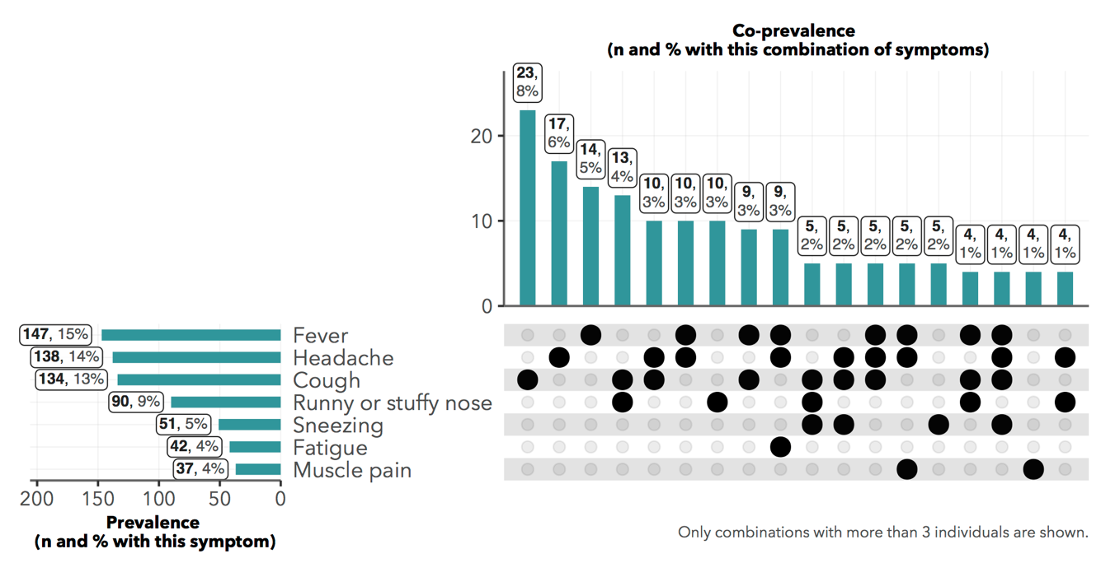Three hundred and two (30%) respondents reported having at least one symptom compatible with SARS-CoV-2 infection (frequency of symptoms is reported in Figure 1).

Figure : Common symptomatologies reported. Denominator of percentages is all 1007 respondents



Among those who were IgG seropositive, the most common symptoms reported were fever (18.5%), headache (17.5%), cough (17.9%) and runny/stuffy nose (12.3%), and all four were significantly more common in seropositive than in seronegative individuals (Figure 4). Surprisingly, agnosia or ageusia was only experienced by 4.3% of the seropositive respondents (and 1.9% of seronegative respondents).

About 83% of respondents with symptoms reported that those symptoms were of moderate severity. But for 44 individuals (15% of those with symptoms) the symptoms were considered severe.

Figure : Frequency of symptoms among IgG seropositive and seronegative individuals. 𝝌-square: * p < 0.05

## Risk factors for symptomatic COVID-19

Based on the WHO criteria for COVID-suspect symptoms13, 51 of 328 IgG/IgM seropositive individuals (15.6%) and 64 of 642 seronegative individuals (10%) reported COVID-suspect symptoms, suggesting that the WHO criteria may lack specificity for identifying true COVID symptoms. We analysed a range of variables for association with symptomaticity given antibody seropositivity, but only smoking status was a significant predictor (Table 6).

 Table 6: Risk factor analysis for symptomatic COVID-19 among antibody seropositive respondents (n = 324)

OR: Odds ratio. Asterisks indicate significance at a 0.05 alpha level. 4 individuals (1%) were dropped due to variable missingness. Variables that were not significant at a 0.10 alpha level and were not controlled for in the multivariate regression include BMI group, pregnancy status, the presence of hypertension, of respiratory illness, or of diabetes in the respondent, and the respondent’s smoking status.

## Health-seeking behaviour during the pandemic

We defined healthcare-needing respondents as those who reported any existing chronic condition or any acute symptom since March 1st, 2020. Based on these criteria, 368 individuals were prospectively healthcare-needing during the pandemic (Figure 6)

Among this population of healthcare-needing respondents, 13% visited private clinics and 8% visited general public hospitals and none went to a specialized COVID-19 care centre (Figure 7).

Figure : Euler diagram showing the sets of individuals with chronic conditions, acute symptoms and COVID-like symptoms

Forty-seven participants reported hospitalization, but only one hospitalization was in relation to COVID-19. Very few individuals reported additional health expenditure due to COVID-19; in cases when this was reported, the additional expenses were mainly for the purchase of personal protective equipment (7 participants paid for transport, 2 for the test and 2 for consultation).

In the group of people with chronic conditions, 14.8% experienced disruption in the continuity of care and 11% had difficulties in accessing their regular treatment.

Figure : Health services used by those who reported any acute symptom or chronic condition

Among those who reported acute symptoms, only 75 individuals (7%) sought medical attention; the majority (62%) used self-medication on the advice of a member of the family or a significant other. Paracetamol, traditional medicines and antibiotics were the most commonly used remedies for those who had symptoms (Figure 8).

Figure : Most common treatment combinations used by those who reported acute symptoms. (Denominator of percentages is the 302 respondents who reported any acute symptoms.)

In seeking care either for an acute event or for a chronic condition, a number of obstacles were reported. Fifty-four individuals (15%) answered that they had encountered financial difficulty in paying for care since March 1st, and 45 (12%) individuals said financial difficulty caused them to delay care. Notably, only 25 of these respondents (7%) have medical insurance (Figure 9).

Figure : Possible barriers to healthcare among those who reported at least one acute symptom or chronic condition.

## Determinants of health service utilization

We used random-effects logistic models to assess determinants of formal health service utilization among the healthcare-needing population. Formal healthcare included visits to a doctor, nurse, clinic, hospital or specialized COVID-19 care centre.

Only one predictor was significant at an alpha level of 0.05: respondents who felt that it was dangerous to go to clinics due to possible COVID-19 exposure were significantly less likely to have sought our formal care, unsurprisingly.

Table : Predictors of formal healthcare consultation among those with COVID-19-suspect symptoms (n = 116)



OR: Odds ratio. Asterisks indicate significance at a 0.05 alpha level. 3 individuals (2.5%) were dropped due to variable missingness. Variables that were not significant at a 0.10 alpha level and were not controlled for in the multivariate regression include income decrease during the pandemic, stated difficulty in paying for medical costs, and stated difficulty in traveling to healthcare centres.

## A picture containing timeline Description automatically generatedImpact on individuals and households

Concerning the impact of the epidemic on the households, 163 households (85%) reported that their income had fallen since March 1st. Households where the head was a salaried workers, or had a university degree appeared to be least financially impacted, with only 67% and 63% reporting an income reduction (Figure 10).

Of the included households, 11 reported a death in the household during the period of the epidemic. The mean age of people who died was 69.5 years and none of these deaths was reported to be COVID-related.

Concerning the impact of the epidemic on the daily living of the studied communities, 560 of the respondents (56%) reported having to reduce daily activities, including 492 (49%) who reported reduced work hours because of confinement.

Notably, more than 50% (543) of respondents reported an increase in stress and pressure in the family environment with 343 (34%) notifying having been victims of psychological or physical violence.

Facing all these constraints, external support was very limited, only 94 (9%) report having received external help. This help was primarily monetary, or in the form of free personal protective equipment. And the most common sources of these were the government and non-governmental organizations (53%) or other members of the family (40%).

Figure : % of household heads reporting income decreases since March 1st.

## 

## Attitudes towards COVID-19

Participants attitudes towards the COVID-19 were notable: around 825 (82%) reported fear of contamination (Figure 10), but only 23% said they fully followed the rules of physical distancing (Figure 11). Nearly half of the participants believed that people with COVID-19 are stigmatized, and 7% reported that they would conceal their illness to avoid this stigma.

Figure : Responses to question on the respect of distancing measures

Figure : Responses to questions on attitudes towards COVID-19

# Conclusions

SARS-CoV-2 appears to have circulated quite broadly in the Cité Verte district of Yaoundé. Nearly one person in three was found to be IgG or IgM positive, but more than 60% of these people had no symptoms between March and the date of survey, confirming that the asymptomatic form of the disease is more frequent than severe forms.

Survey results do not suggest significant health service disruption during the pandemic period. However, this may be explained by the fact that study participants did not seek out formal care when they had COVID-19 symptoms, turning instead to family and neighbours for advice on treatment, and using easily-acquired drugs and traditional remedies.

While the epidemic did not to seem affect the functioning of health services, it caused significant disruption to household incomes. Such disruptions are unsurprising, given that the majority of households acquire income from the informal sector, whose vibrance depends on the daily activities of the entire public.

Social and family activities were also significantly disrupted and this could have created a situation of conflict and stress, sometimes resulting in violence.

`

# Bibliography

1. Lu H, Stratton CW, Tang Y. Outbreak of pneumonia of unknown etiology in Wuhan, China: The mystery and the miracle. *J Med Virol*. 2020;92(4):401-402. doi:10.1002/jmv.25678

2. World Health Organization. Weekly epidemiological update - 1 December 2020. Accessed December 8, 2020. https://www.who.int/publications/m/item/weekly-epidemiological-update---1-december-2020

3. AFP. WHO warns Africa is ill-equipped to deal with coronavirus due to “weaker health systems.” TheJournal.ie. Accessed December 8, 2020. https://www.thejournal.ie/world-health-organisation-african-coronavirus-5017867-Feb2020/

4. Umviligihozo G, Mupfumi L, Sonela N, et al. Sub-Saharan Africa preparedness and response to the COVID-19 pandemic: A perspective of early career African scientists. *Wellcome Open Res*. 2020;5. doi:10.12688/wellcomeopenres.16070.2

5. Stringhini S, Wisniak A, Piumatti G, et al. Seroprevalence of anti-SARS-CoV-2 IgG antibodies in Geneva, Switzerland (SEROCoV-POP): a population-based study. *The Lancet*. 2020;396(10247):313-319. doi:10.1016/S0140-6736(20)31304-0

6. Dortet L, Ronat J-B, Vauloup-Fellous C, et al. Evaluating Ten Commercially-Available SARS-CoV-2 Rapid Serological Tests Using the STARD (Standards for Reporting of Diagnostic Accuracy Studies) Method. *J Clin Microbiol*. Published online November 25, 2020. doi:10.1128/JCM.02342-20

7. Chazai Partners. *Recueil Des Mesures Prises Par Le Gouvernement Camerounais Dans Le Cadre de La Lutte Contre La COVID-19*. Accessed December 8, 2020. https://www.chazai-partners.com/wp-content/uploads/2020/05/Chazai-Partners-Recueil-des-mesures-prises-par-le-gouvernement-Camerounais-dans-la-lutte-contre-la-COVID-19-29-05-20.pdf

8. *Enquête Démographique et de Santé Du Cameroun 2018*. Institut National de la Statistique/INS et ICF

9. Rogan WJ, Gladen B. Estimating prevalence from the results of a screening test. *Am J Epidemiol*. 1978;107(1):71-76. doi:10.1093/oxfordjournals.aje.a112510

10. Batra R, Olivieri LG, Rubin D, et al. A comparative evaluation between the Abbott PanbioTM COVID-19 IgG/IgM rapid test device and Abbott ArchitectTM SARS CoV-2 IgG assay. *J Clin Virol*. 2020;132:104645. doi:10.1016/j.jcv.2020.104645

11. Shu H, Wang S, Ruan S, et al. Dynamic Changes of Antibodies to SARS-CoV-2 in COVID-19 Patients at Early Stage of Outbreak. *Virol Sin*. Published online July 27, 2020. doi:10.1007/s12250-020-00268-5

12. Lang Z, Reiczigel J. Confidence limits for prevalence of disease adjusted for estimated sensitivity and specificity. *Prev Vet Med*. 2014;113(1):13-22. doi:10.1016/j.prevetmed.2013.09.015

13. Santé O mondiale de la. Surveillance de la santé publique dans le contexte de la COVID-19 : orientations provisoires, 7 août 2020. Published online 2020. Accessed December 29, 2020. https://apps.who.int/iris/handle/10665/333903

14. Bates D, Mächler M, Bolker B, Walker S. Fitting Linear Mixed-Effects Models Using **lme4**. *J Stat Softw*. 2015;67(1). doi:10.18637/jss.v067.i01

15. Andri et mult. al. *{DescTools}: Tools for Descriptive Statistics*.; 2020. https://cran.r-project.org/package=DescTools

16. Wickham H, Averick M, Bryan J, et al. Welcome to the Tidyverse. *J Open Source Softw*. 2019;4(43):1686. doi:10.21105/joss.01686