EpiCO 19 Preliminary Report

Epidemiological survey and active screening for COVID-19: Investigating the circulation and impact of SARS-CoV-2 on the population of the health district of Cité Verte in Yaounde

|  |  |
| --- | --- |
| **Principal Investigators** | **Affiliation** |
| Dr Laura Ciaffi | **ASCRES** - Association de soutien aux centres de recherches, d'enseignements et de soins  Tél : 00237 694 92 67 86  Mail : [lauraciaffi2002@yahoo.fr](mailto:lauraciaffi2002@yahoo.fr) |
| Dr Franck Wanda | **CIRES** – Centre International de Recherches, d'Enseignements et de Soins  Tél : 00237 699 73 46 89  Mail : [franck.wanda@cires.solutions](mailto:franck.wanda@cires.solutions) |

|  |  |
| --- | --- |
| **Investigators** | **Affiliation** |
| Dr Lucien Mama  District medical Officer | **Ministry of Public health**  District de Sante Cité Verte -Yaounde |
| Dr Joseph Fokam  Virologist | **CIRCB -** Centre International de recherche Chantal Biya Yaoundé |
| Dr Eric Comte  Public Health Specialist | **ASCRES** - Association de soutien aux centres de recherches, d'enseignements et de soins |

|  |  |
| --- | --- |
| **Project Staff** | **Role** |
| Eric Mimbe | Data Manager |
| Jeanine Meke | Interviewers Team Leader |
| Armel Tassegning | Interviewers Team Leader |
| Thomas Eyinga | Interviewer |
| Evelyne Boyomo | Interviewer |
| Assana Gondio A Tiati | Interviewer |
| Yolande Maled | Interviewer |
| Josphine Embolo Manga | Interviewer |
| Michel Ntsama | Interviewer |

|  |  |
| --- | --- |
| **Sponsor** |  |
| GIZ Cameroun | Mr Josselin Guillebert director ProPASSaR/GIZ  Mme Patricia Ndongo |

Table of Contents

Background 3

Methods 4

Design 4

Population 4

Sampling 5

Testing 5

Questionnaire 6

Field work 7

Data management 7

Data analysis 7

Ethical considerations 8

Results 8

Household-level findings 9

Conclusions 17

Bibliography 18

# Background

Coronavirus disease 2019 (COVID-19) is caused by the severe acute respiratory syndrome coronavirus-2 (SARS-CoV-2), which was identified for the first time in China at the end of 20191. The virus quickly spread globally, and the World Health Organization declared COVID-19 to be a pandemic on March 11, 2020. As at December 1, 2020, there have been over 67,000,000 notified cases, with over 1,500,000 reported deaths.2

Given the rapid spread of the epidemic in Europe and the Americas, and the handicapped response by countries with the richest health systems, the outlook for less developed countries, and sub-Saharan Africa in particular, seemed dire. High numbers of deaths were expected due to weaknesses in health systems, difficulties in enforcing hygiene measures, and perceived health vulnerabilities of the population.3,4 But the trajectory of the epidemic on the continent appears to have gone against expectation. Despite having over 2,200,200 infections as of December 1,2 Africa remains the least affected region and the mortality rate, even if not well documented, remains lower than expected.4

Multiple hypotheses have been advanced to explain the seemingly mild trajectory of the COVID-19 epidemic in Africa: researchers have pointed to the continent’s warm climate, young population, or cross-reactive immunity from other infections as possible mitigating factors.4 But an informed explanation of the epidemic trajectory requires accurate numbers on the actual extent of population infection. And, as is the case elsewhere,5 the officially reported case counts in Africa significantly underestimate the extent of spread.4

In this context, the use of serological antibody tests to detect exposure to SARS-CoV-2 is valuable. A number of validated SARS-CoV-2 antibody tests now exist on the market,6 and some of these are point-of-care lateral-flow immunoassays, which are affordable, easy to use and provide quick results. Although concerns about sensitivity and specificity remain, these antibody tests offer the opportunity to more accurately assess the prior infection rate of populations in regions where PCR-based testing has been uncommon.5

This report presents the protocol and results of our study using a lateral-flow immunoassay to assess the seroprevalence of anti-SARS-CoV-2 IgG and IgM antibodies in a region of Yaounde, the capital of Cameroon.

In addition to examining seroprevalence, our study also hopes to shed light on the broader impact of the epidemic on the socioeconomic wellbeing of the Cité Verte population. Soon after its first notified COVID-19 case (on March 6, 2020), Cameroon closed its borders and implemented significant social distancing measures, including mandatory bar closures after 6 PM, limitations on public transport occupancy, bans on gatherings of more than 50 people and the closing of in-person schools7. Similar measures were taken in other African countries.

The effects of these measures on the wellbeing of the Cameroonian population has not been well examined. Studies in other contexts have noted that during the pandemic period, access to routine health care services has been disrupted. We designed and implemented a survey to assess whether such disruptions were common in the studied population. This survey was performed concurrently with the seroprevalence assays.

# Methods

The EpiCO 19 study is a community-based survey to estimate the circulation and the impact of SARS-CoV-2 and the COVID-19 pandemic on a district in Yaounde, which is one of the cities most affected by COVID-19 in Cameroon.

## Design

EpiCO 19 is a cross-sectional clinico-epidemiological and socio-economic study.

## Population

The Cité Verte district, located in the Mfoundi department of the Center Region of Cameroon, covers a surface area of 19 square kilometersin the administrative area of Yaounde II. The total estimated population is 432,858, of which the majority are young. It is located in the oldest part of the city of Yaounde and residents are from several different regions of Cameroon.

The dwellings are of two types: 60% are permanent built with standard building materials while 40% are temporary structures. Some neighbourhoods, notably Tsinga and Cité Verte (the Cité Verte neighbourhood of the Cité Verte district), are better equipped in services and roads than others.

Cité Verte is divided into nine health zones with a total of 63 health structures, of which eight are public and three are run by private, faith-based providers. In each of the health areas there is a referent health structure and a number of community health workers supporting public health activities that are carried out by the Ministry of health or other partners in the community. These personnel have been key for the study to facilitate access to the population.

## Sampling

The following formula was used to calculate the size of the sample for the study:

n = Z2 P(1− P)/d2

where n = sample size, Z = Z statistic for a level of confidence, P = expected prevalence or proportion (in proportion of one; if 20%, P = 0.2) and d = precision (in proportion of one; if 5%, d = 0.05).

With this formula, a level of confidence of 95% (Z=1.96), a precision of 5%, and an estimated prevalence of 20% in the general population, a sample of 245 people was calculated to be sufficient, but the sample was increased to 1000 people to provide for improved precision and better representativeness of the different parts of the community.

Houses were randomly selected from a geographic grid, and geo-localisation software was used to guide the interviewers to the locations of selected households. A standard replacement procedure was used when the selected buildings were not residential.

Households, which were the sampling unit of the study, were defined as a group of people living in the same residence and sharing the kitchen.

In each household, all individuals between 5 and 80 years were included if they a), were living in the selected household, b) had been present in the household for at least 14 days and c) could give written informed consent (or had an adult guardian who could give consent). Children of less than 5 years and people with severe psychiatric illness were excluded.

Two hundred and fifty households were targeted for a total population of 1000 respondents living in the Cité Verte District.

## Testing

The EpiCO19 study used the Abbott Panbio™ COVID-19 IgG/IGM Rapid Test Device, an immunochromatographic test for the qualitative detection of IgG and IgM antibodies to SARS-CoV-2. The manufacturer-estimated sensitivity and specificity of the test are 95.8% and 94% respectively.

The serological tests were performed on capillary blood which was collected from a finger prick from all the consenting participants. All waste material was eliminated following safety procedures by the study team.

Additional steps were taken when active COVID-19 was suspected. (Such cases were identified if they matched the WHO COVID-19 criteria of symptoms, updated as at August 2020.) The national algorithm for further testing was applied to these suspected cases. First, a rapid antigen test was performed. If the result of the antigen test was negative, then a nasopharyngeal swab was taken. The swab was sent to the virological reference laboratory for an RNA PCR test for SARS-CoV-2. This PCR test was also proposed to all participants with a positive IgM result in the serological essay, since an IgM response can sometimes be observed concurrent with active infection.

The PCR tests were carried out at the virology laboratory of the CIRCB, the reference laboratory for diagnostic procedures in the Cité Verte District, following standard national procedures.

During sample collection all biosafety precautions were followed. The person in charge of swab collection was provided with full personal protection equipment (apron, gloves, face shield and FFP2 mask).

## Questionnaire

A questionnaire was created with KoboKollect©, a free software for epidemiological surveys.

The first few sections of the questionnaire focused on household composition, household income and recent deaths within the household. Then individual information about each survey respondent was surveyed. These sections included questions about the respondents’

* experience of symptoms compatible with COVID-19;
* health-seeking behavior during the pandemic;
* financing of healthcare during the pandemic;
* attitudes towards COVID-19; and
* respect of hygiene and physical distancing recommendations;

among others.

The questionnaire was field tested and modified following the feedback of the tests in the field.

## Field work

All the interviewers were trained over three days on research practice and ethics, and the specific study protocol.

In the first two weeks of study implementation, while waiting for the administrative authorization, a part of the team had time to conduct the geo-localisation of the majority of the households, supported by the health workers of each health area.

To increase receptiveness to the survey, awareness talks were carried out the day before, or a few hours before, the interviewers’ visit. On the interview days, study teams visited each household to interview them immediately or to arrange an appointment for a future interview.

Once residents were gathered, the study was presented and a signature of informed consent was given out to be signed. For anyone below 21 years, a signature was requested of their parent or legal guardian; but consent was still solicited from anyone above 15 years. The survey questionnaire was then administered to each household member.

In a quiet and private space, the material for the tests was set up and all the procedures for the test were respected. A picture of the test was taken and a paper result was handed out to the participant.

When active COVID-19 was suspected, a nasopharyngeal swab was done, information about prevention measures was given and the surveillance system of the district was alerted.

## Data management

Once the questionnaire was completed, it was uploaded to a secure server. Data were regularly monitored for completeness and coherence, and for agreement between the responses of different members of each household. Where doubts remained, the relevant interviewer was contacted for clarification.

## Data analysis

Household-level statistics were calculated based on the answers of household representatives. The household representative was taken to be:

* the first interviewed household head; and, if no head is present,
* the first interviewed adult

Data were processed and analyzed using R version 3.6.1 and RStudio.

## Ethical considerations

The study protocol obtained the ethical clearance and the administrative authorization of the Ministry of Health of Cameroon.

Every adult participant (21 years or above) signed an informed consent. For minors, a person with parental authority was asked to sign the consent form and, if the age was equal to or above 15 years, an assent was also requested.

Questionnaires were coded and names of participants were recorded in a confidential list available only to the study team.

Before starting the study, all the team members were trained on research ethics, good clinical practices and study protocol and procedures.

# Results

From 14, October to 26, November 2020, 256 households were visited, of which 63 (24%) refused to give any information, one was excluded because not in the selected sample. In the end, 192 households were included for a total of 1007 participants.

Of the 192 included households, 128 were the originally sampled by the random system, while the remaining 64 (33%) were replaced through standard procedures because the identified buildings were non-residential.

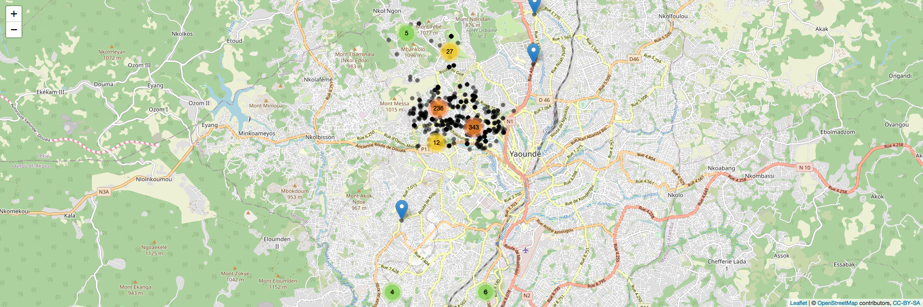

***Table 1:*** *Households and individuals expected and included in the study.*

|  |  |  |  |  |  |
| --- | --- | --- | --- | --- | --- |
|  | **Inhabitants** | **N of household sampled** | **N of inclusions expected** | **N of households included** | **N of people included** |
| Briqueterie | 52 850 | 31 | 124 | 24 (77%) | 109 (88%) |
| Carrière | 104 785 | 61 | 244 | 45 (73%) | 240 (98%) |
| Cité verte | 38 832 | 22 | 88 | 24 (109%) | 88 (100%) |
| Messa | 18 899 | 11 | 44 | 9 (81%) | 48 (109%) |
| Mokolo | 46 960 | 27 | 108 | 17 (63%) | 96 (89%) |
| Nkomkana | 41 953 | 24 | 96 | 15 (62%) | 81 (84%) |
| Tsinga | 35 349 | 20 | 80 | 16 (80%) | 83 (103%) |
| Tsinga Oliga | 37 572 | 22 | 88 | 14 (63%) | 71 (80%) |
| Ekoudou | 55 659 | 32 | 128 | 28 (87%) | 191 (149%) |
| **Total** | **432 859** | **250** | **1000** | **192** | **1007** |

All the health areas of the district were surveyed, but participation varied between the neighborhoods (Table 1). All participants were to be tested for SARS-CoV2-antibodies, but in 35(3%) cases, some members of the household, despite responding to the questionnaire, refused the test.

## Household-level findings

Households had a mean of 4.6 adult inhabitants (15 years or above) and 1.8 children.

In the majority (92%) of the visited households, the head of the family was surveyed and in 136 households (70.8%), we accessed the person providing the main source of income. This was most often the father (55.7% of households) or the mother (36.5%). Respondents were most commonly in school (39.5%), working “small jobs” (21%) or working as traders (12.4%). This explains the high percentage of households who said their income arrives through irregular and informal sources (41%). Interestingly, despite only 5.7% of respondents reported regular waged work, formal regular income was the main source of revenues for 23% of the households, showing the possible contribution of other family members.

Concerning the impact of the epidemic on the households, 163 households (85%) reported that their income had fallen since March 1st. Only in eight households (4%) was someone reported to have completely lost the source of income, and 24 (12%) reported no change at all.

Of the included households, 11 reported a death in the household during the period of the epidemic. The mean age of people who died was 69.5 years and none of these deaths was reported to be COVID-related.

Only six households reported a prior positive COVID-19 test among their members, but 67 (7%) respondents reported having been tested for SARS-CoV-2 before, with nearly half of these as part of governmental mass testing campaigns.

## Individual-level findings

Participants had a mean age of 29 years and 570 (56.6%) were women. In Table 2 the demographic characteristics of respondents are summarized.

***Table 2:*** *Sociodemographic characteristics of the final sample*

|  |  |  |  |
| --- | --- | --- | --- |
| **Characteristic** | **Female** | **Male** | **Total** |
| **n** | 570 | 437 | 1007 |
| Num. household heads | 77 | 101 | 178 |
| Mean Age (SD) | 29.6 (17.4) | 28.5 (17.6) | 29.1 (17.5) |
| Mean BMI (SD) | 27.3 (26.7) | 23.2 (6.26) | 25.5 (20.6) |
| **Age groups, n (% of sex in each group)** | | | |
| 5-15 | 137 (24%) | 128 (29.3%) | 265 (26.3%) |
| 16-29 | 186 (32.6%) | 136 (31.1%) | 322 (32%) |
| 30-45 | 140 (24.6%) | 89 (20.4%) | 229 (22.7%) |
| 46-65 | 79 (13.9%) | 66 (15.1%) | 145 (14.4%) |
| >65 | 28 (4.9%) | 18 (4.1%) | 46 (4.6%) |
| **Education Level, n (% of sex in each group)** | | | |
| Secondary | 258 (45.3%) | 184 (42.1%) | 442 (43.9%) |
| Primary | 191 (33.5%) | 137 (31.4%) | 328 (32.6%) |
| University | 76 (13.3%) | 81 (18.5%) | 157 (15.6%) |
| No formal instruction | 35 (6.1%) | 18 (4.1%) | 53 (5.3%) |
| Doctorate | 7 (1.2%) | 13 (3%) | 20 (2%) |
| Other | 3 (0.5%) | 4 (0.9%) | 7 (0.7%) |
| **Profession, n (% of sex in each group)** | | | |
| Student | 216 (36.5%) | 202 (43.3%) | 418 (39.5%) |
| Small jobs | 86 (14.5%) | 136 (29.1%) | 222 (21%) |
| Business/Trade | 81 (13.7%) | 50 (10.7%) | 131 (12.4%) |
| Housewife | 74 (12.5%) | 0 (0%) | 74 (7%) |
| Unemployed | 52 (8.8%) | 21 (4.5%) | 73 (6.9%) |
| Salaried worker | 38 (6.4%) | 22 (4.7%) | 60 (5.7%) |
| Retired | 18 (3%) | 17 (3.6%) | 35 (3.3%) |
| Other | 17 (2.9%) | 15 (3.2%) | 32 (3%) |
| Farmer | 10 (1.7%) | 4 (0.9%) | 14 (1.3%) |

Three hundred and two (30%) respondents reported having at least one symptom compatible with SARS-CoV-2 infection (frequency of symptoms is reported in Figure 1).

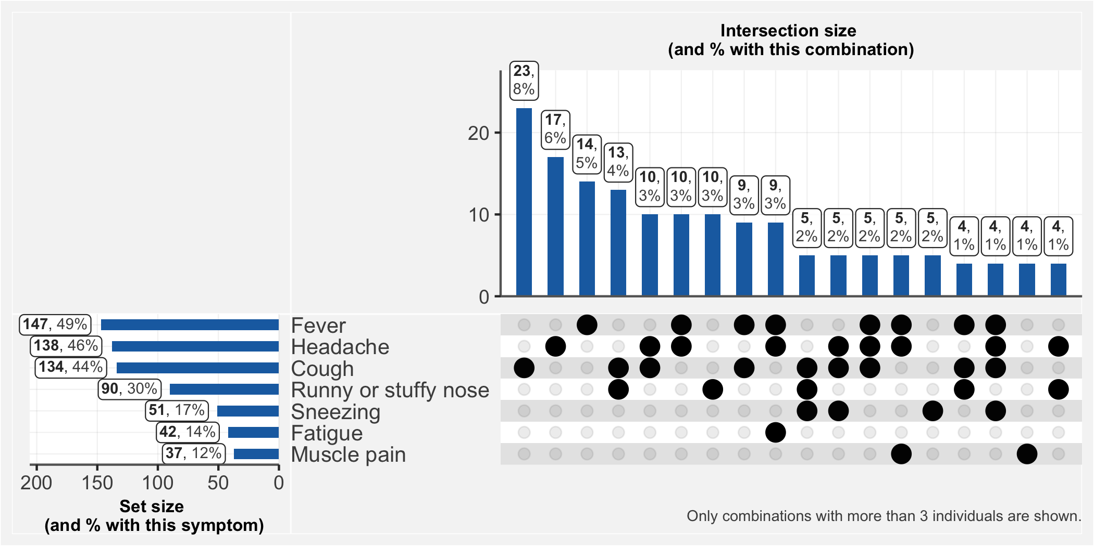

*Figure 1: frequency of symptoms*

Most of these (83%) were considered to be of moderate severity while for 44 (15%) they were severe, but only 75 (7%) sought medical attention; the majority (62%) used self-medication on the advice of a member of the family or a significant other. Paracetamol, traditional medicines and antibiotics were the most commonly used remedies for those who had symptoms (Figure 2).

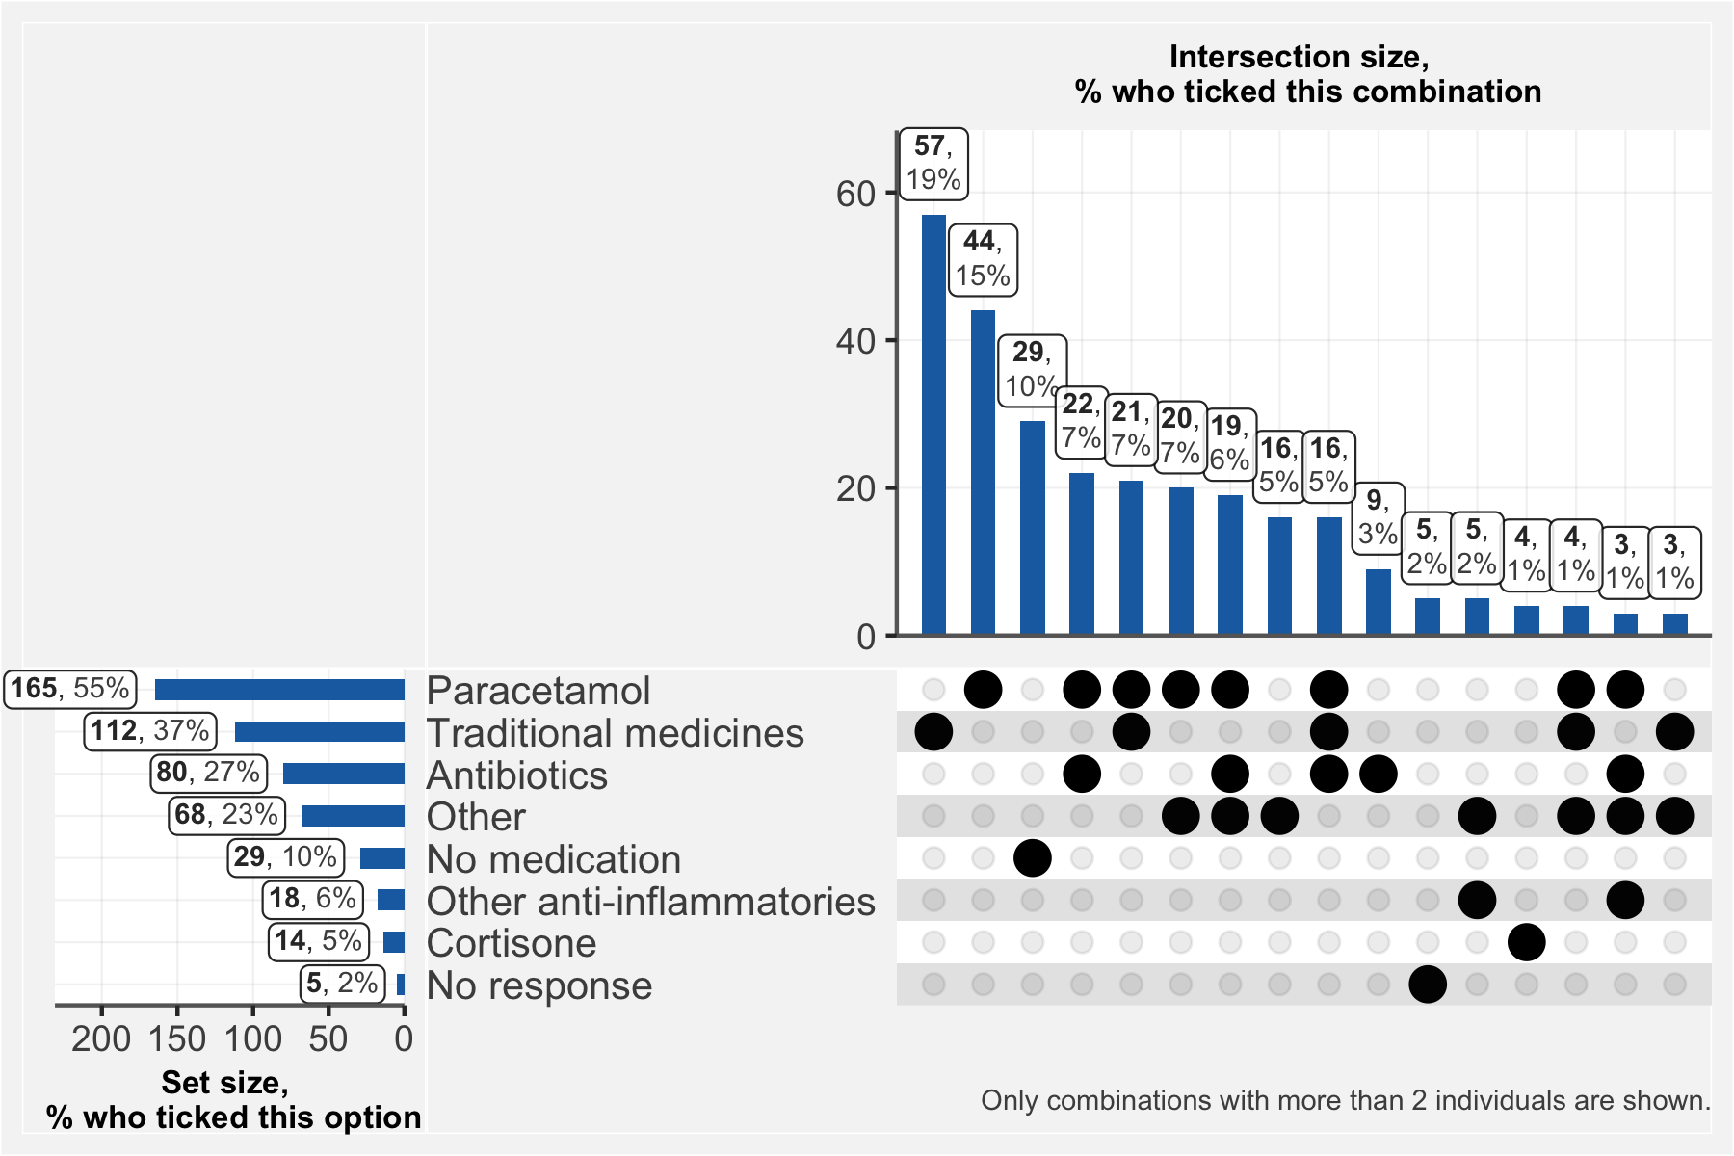

*Figure 2. Use of drugs in respondents with symptoms*

Among those who actually consulted formal health services, none went to a specialized COVID-19 care center; 40% visited private clinics and 20% visited general public hospitals. Forty-seven participants reported hospitalization, but only one hospitalization was in relation to COVID-19. Very few individuals reported additional health expenditure due to COVID-19; in cases when this was reported, the additional expenses were mainly for the purchase of personal protective equipment (7 participants paid for transport, 2 for the test and 2 for consultation).

One hundred eight participants (11%) reported suffering from a chronic condition, mainly hypertension (34%), respiratory conditions (16%) or diabetes (10%). With a mean BMI of 27.3 (versus 22.5 for men), women showed a higher frequency of overweight. Only 2 respondents reported HIV infection.

In the group of people with chronic conditions, 14.8% experienced disruption in the continuity of care and 11% had difficulties in the access to their regular treatment.

In seeking care either for an acute event or for a chronic condition, a number of obstacles were reported. Fifty-four individuals (15%) answered that they had encountered financial difficulty in paying for care since Match 1st, and 45 (12%) individuals said financial difficulty caused them to delay care. Notably, only 41 respondents (4%) have medical insurance.

Despite the fact that 57.8% reported complete or partial compliance with preventive measures (see Figure 3), the 972 serological tests done showed an IgG positivity rate of nearly 30% (302), while 3% (32) were positive for IgM antibodies. Only one of the 21 RNA PCR tests was positive. When seroprevalence is broken down by age and sex (Figure 4), the group with the highest prevalence is men between age 50 and age 70.

Adjustments for test performances will need to be done to take into account test specificity and sensitivity.

***Figure 3****: Proportion of respondents following prevention measures according to serology test result*

***Figure 4:*** *Positive serological test by sex and age.*

There were no major differences in sociodemographic characteristics between exposed and not exposed participants (Table 3); but further statistical analysis is necessary to test for significancy. There may be slightly lower risk of exposure in the group with no formal education. Surprisingly, seropositive individuals do not show a much greater prevalence of symptoms than seronegative individuals.

Concerning the impact of the epidemic on the daily living of the studied communities, 560 of the respondents (56%) reported having to reduce daily activities, including 492 (49%) who reported reduced work hours because of confinement. About 82% of the households reported a reduction of living income.

Participants attitudes towards the COVID-19 were notable: around 825 (82%) reported fear of contamination, but only 48% said they fully respected the basic prevention measures like washing hands or cough etiquette, and only 23% said they fully followed the rules of physical distancing. Nearly half of the participants believed that people with COVID-19 are stigmatized, and 7% reported that they would conceal their illness to avoid this stigma.

Notably, more than 50% (543) of respondents reported an increase in stress and pressure in the family environment with 343 (34%) notifying having been victims of psychological or physical violence.

Facing all these constraints, external support was very limited, only 94 (9%) report having received external help. This help was primarily monetary, or in the form of free personal protective equipment. And the most common sources of these were the government and non-governmental organizations (53%) or other members of the family (40%).

***Table 3:*** *Demographics and symptomatology of seropositive (IgG or IgM) and seronegative respondents.*

|  |  |  |  |  |  |
| --- | --- | --- | --- | --- | --- |
| Characteristic | | Seropositive | | Seronegative | |
| n | | 319 | | 623 | |
| Mean Age (SD) | | 30.6 (17.9) | | 28.2 (17) | |
| Mean BMI (SD) | | 27.4 (33) | | 24.6 (11) | |
| ***Sex groups, n (% of all positive/negatives that are of each sex)*** | | | | | |
| Female | | 164 (51.4%) | | 371 (59.6%) | |
| Male | | 155 (48.6%) | | 252 (40.4%) | |
| ***Age groups, n (% of all positive/negatives that are in each age group)*** | | | | | |
| 5-15 | | 76 (23.8%) | | 175 (28.1%) | |
| 16-29 | | 100 (31.3%) | | 196 (31.5%) | |
| 30-45 | | 76 (23.8%) | | 143 (23%) | |
| 46-65 | | 50 (15.7%) | | 87 (14%) | |
| above 65 | | 17 (5.3%) | | 22 (3.5%) | |
| ***Education Level, n (% of all positive/negatives that are in each education class)*** | | | | | |
| Secondary | | 135 (42.3%) | | 287 (46.1%) | |
| Primary | | 114 (35.7%) | | 195 (31.3%) | |
| University | | 52 (16.3%) | | 86 (13.8%) | |
| No formal instruction | | 11 (3.4%) | | 40 (6.4%) | |
| Doctorate | | 6 (1.9%) | | 10 (1.6%) | |
| Other | | 1 (0.3%) | | 5 (0.8%) | |
| ***Profession, n (% of all positive/negatives that are in each profession class)*** | | | | | |
| Student | | 124 (38.9%) | | 265 (42.5%) | |
| Small trader | | 78 (24.5%) | | 137 (22%) | |
| Businessperson | | 42 (13.2%) | | 80 (12.8%) | |
| Home-maker | | 26 (8.2%) | | 46 (7.4%) | |
| Unemployed | | 25 (7.8%) | | 44 (7.1%) | |
| Salaried worker | | 21 (6.6%) | | 31 (5%) | |
| Retired | | 9 (2.8%) | | 22 (3.5%) | |
| Other | | 8 (2.5%) | | 20 (3.2%) | |
| Farmer | | 5 (1.6%) | | 9 (1.4%) | |
| ***Symptoms, n (% of all positive/negatives that reported each symptom)*** | | | | | |
| No symptoms | 205 (64.3%) | | 456 (73.2%) | |
| Fever | 58 (18.2%) | | 74 (11.9%) | |
| Headache | 59 (18.5%) | | 69 (11.1%) | |
| Cough | 58 (18.2%) | | 65 (10.4%) | |
| Runny or stuffy nose | 38 (11.9%) | | 45 (7.2%) | |
| Sneezing | 23 (7.2%) | | 20 (3.2%) | |
| Fatigue | 14 (4.4%) | | 24 (3.9%) | |
| Muscle pain | 18 (5.6%) | | 17 (2.7%) | |
| Smell or taste loss | 13 (4.1%) | | 12 (1.9%) | |
| Sore throat | 8 (2.5%) | | 10 (1.6%) | |
| Stomach ache | 8 (2.5%) | | 8 (1.3%) | |
| Diarrhoea | 2 (0.6%) | | 11 (1.8%) | |
| Nausea, Vomiting | 4 (1.3%) | | 9 (1.4%) | |
| Shortness of breath | 1 (0.3%) | | 4 (0.6%) | |
| Other | 1 (0.3%) | | 3 (0.5%) | |

# Conclusions

SARS-CoV-2 appears to have circulated quite broadly in the Cité Verte district of Yaoundé. Nearly one person in three was found to be IgG or IgM positive, but more than 60% of these people had no symptoms between March and the date of survey, confirming that the asymptomatic form of the disease is more frequent than severe forms.

Survey results do not suggest significant health service disruption during the pandemic period. However, this may be explained by the fact that study participants did not seek out formal care when they had COVID-19 symptoms, turning instead to family and neighbors for advice on treatment, and using easily-acquired drugs and traditional remedies.

While the epidemic did not seem affect the functioning of health services, it caused significant disruption to household incomes. Such disruptions are unsurprising, given that the majority of households acquire income from the informal sector, whose vibrance depends on the daily activities of the entire public.

Social and family activities were also significantly disrupted and this could have created a situation of conflict and stress, sometimes resulting in violence.

`

# Bibliography

1. Lu H, Stratton CW, Tang Y. Outbreak of pneumonia of unknown etiology in Wuhan, China: The mystery and the miracle. *J Med Virol*. 2020;92(4):401-402. doi:10.1002/jmv.25678

2. World Health Organization. Weekly epidemiological update - 1 December 2020. Accessed December 8, 2020. https://www.who.int/publications/m/item/weekly-epidemiological-update---1-december-2020

3. AFP. WHO warns Africa is ill-equipped to deal with coronavirus due to “weaker health systems.” TheJournal.ie. Accessed December 8, 2020. https://www.thejournal.ie/world-health-organisation-african-coronavirus-5017867-Feb2020/

4. Umviligihozo G, Mupfumi L, Sonela N, et al. Sub-Saharan Africa preparedness and response to the COVID-19 pandemic: A perspective of early career African scientists. *Wellcome Open Res*. 2020;5. doi:10.12688/wellcomeopenres.16070.2

5. Stringhini S, Wisniak A, Piumatti G, et al. Seroprevalence of anti-SARS-CoV-2 IgG antibodies in Geneva, Switzerland (SEROCoV-POP): a population-based study. *The Lancet*. 2020;396(10247):313-319. doi:10.1016/S0140-6736(20)31304-0

6. Dortet L, Ronat J-B, Vauloup-Fellous C, et al. Evaluating Ten Commercially-Available SARS-CoV-2 Rapid Serological Tests Using the STARD (Standards for Reporting of Diagnostic Accuracy Studies) Method. *J Clin Microbiol*. Published online November 25, 2020. doi:10.1128/JCM.02342-20

7. Chazai Partners. *Recueil Des Mesures Prises Par Le Gouvernement Camerounais Dans Le Cadre de La Lutte Contre La COVID-19*. Accessed December 8, 2020. https://www.chazai-partners.com/wp-content/uploads/2020/05/Chazai-Partners-Recueil-des-mesures-prises-par-le-gouvernement-Camerounais-dans-la-lutte-contre-la-COVID-19-29-05-20.pdf